Factors impacting hemoglobin A clearance in adults with sickle cell anemia on chronic transfusion therapy
  - Investigators: Alexandre Soares
Table of Contents

Every analysis above were execute using the language R version 4.5.1 (2025-06-13 ucrt) and o software IDE (Integrated Development Environment) RStudio. Also the reports in format PDF was development for library rmarkdown.
Welinton Yoshio Hirai

Análise 1 - Nomograma
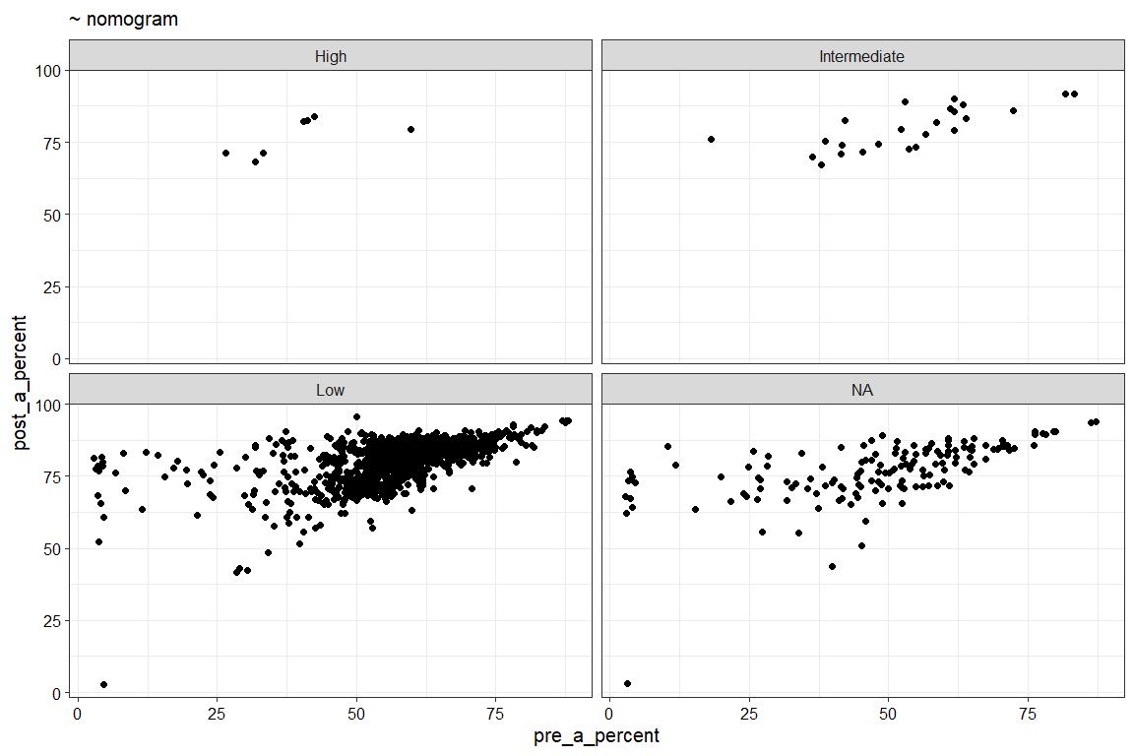

Análise 2a - Verificar a correlação entre adminissão de Delta HBC (%)
Seleção dos dados de ED e Admission para os códigos 1, 2, 3, 4, …, 9; excluindo os códigos 10, 11, e 12;
Tabela contagem ED Coding
value | n
1 | 276
1a | 8
1b | 31
1c | 5
1d | 1
2 | 2
2a | 2
2b | 1
2c | 1
2d | 1
3 | 2
3a | 4
3b | 15
3c | 5
3d | 2
3e | 1
4 | 13
5 | 2
7 | 42
7a | 2
7b | 3
7c | 5
8 | 2
9 | 9
9a | 1
9b | 1
 | 44,014
## # A tibble: 1 × 6
## var1 var2 cor statistic p method
## <chr> <chr> <dbl> <dbl> <dbl> <chr>
## 1 n DeltaHbA -0.17 1407753. 0.015 Spearman
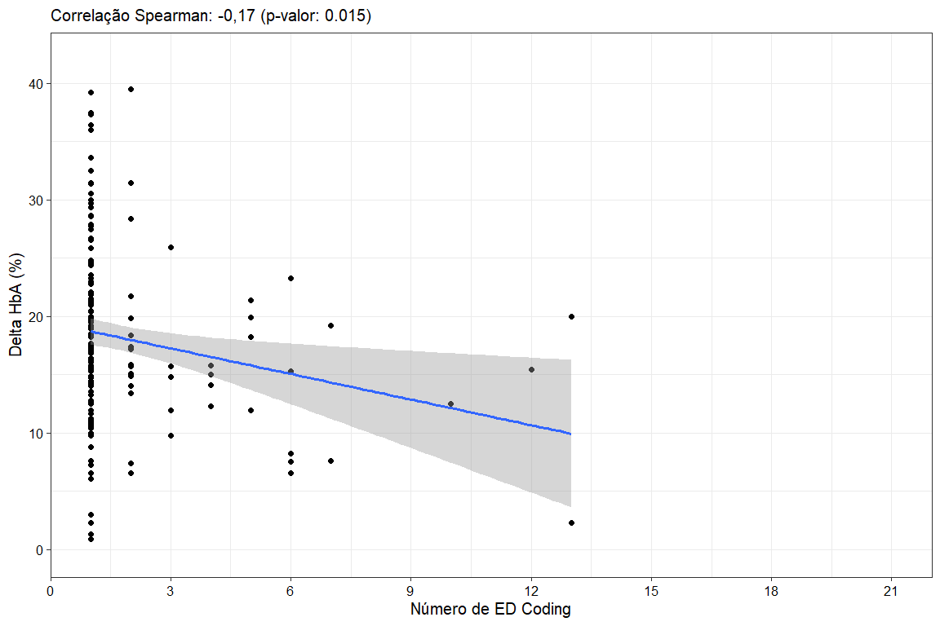
Tabela contagem Hospital Admission
value | n
1 | 110
1a | 2
1b | 4
1c | 5
2 | 4
2a | 1
2c | 1
2d | 3
3a | 8
3b | 1
3c | 1
3e | 3
5 | 3
7 | 12
7a | 1
7c | 2
8 | 1
9 | 2
9a | 1
 | 20,070
## # A tibble: 1 × 6
## var1 var2 cor statistic p method
## <chr> <chr> <dbl> <dbl> <dbl> <chr>
## 1 n DeltaHbA -0.025 108679. 0.817 Spearman
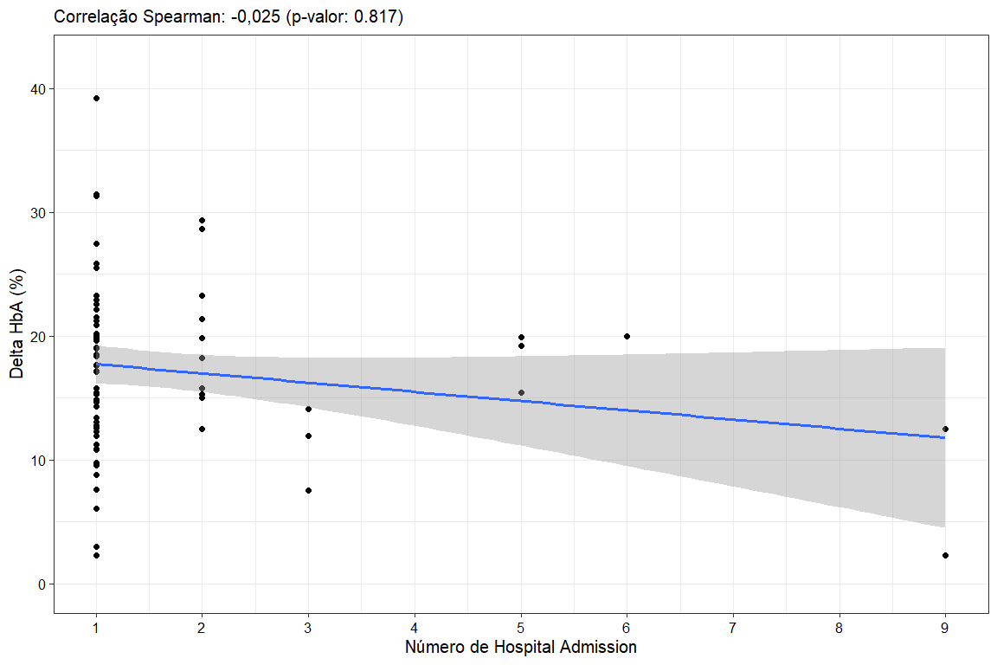

Análise 2a - Verificar a correlação entre adminissão de Delta HBC (g/dL)
Seleção dos dados de ED e Admission para os códigos 1, 2, 3, 4, …, 9; excluindo os códigos 10, 11, e 12;
Tabela contagem ED Coding
value | n
1 | 276
1a | 8
1b | 31
1c | 5
1d | 1
2 | 2
2a | 2
2b | 1
2c | 1
2d | 1
3 | 2
3a | 4
3b | 15
3c | 5
3d | 2
3e | 1
4 | 13
5 | 2
7 | 42
7a | 2
7b | 3
7c | 5
8 | 2
9 | 9
9a | 1
9b | 1
 | 44,014
## # A tibble: 1 × 6
## var1 var2 cor statistic p method
## <chr> <chr> <dbl> <dbl> <dbl> <chr>
## 1 n DeltaHbA_gdL -0.22 1397404. 0.00204 Spearman
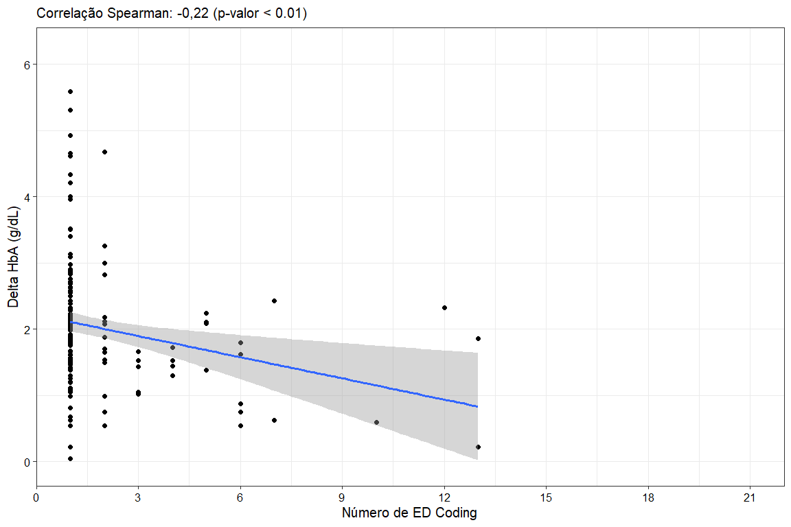
Tabela contagem Hospital Admission
value | n
1 | 110
1a | 2
1b | 4
1c | 5
2 | 4
2a | 1
2c | 1
2d | 3
3a | 8
3b | 1
3c | 1
3e | 3
5 | 3
7 | 12
7a | 1
7c | 2
8 | 1
9 | 2
9a | 1
 | 20,070
## # A tibble: 1 × 6
## var1 var2 cor statistic p method
## <chr> <chr> <dbl> <dbl> <dbl> <chr>
## 1 n DeltaHbA_gdL -0.076 110101. 0.49 Spearman
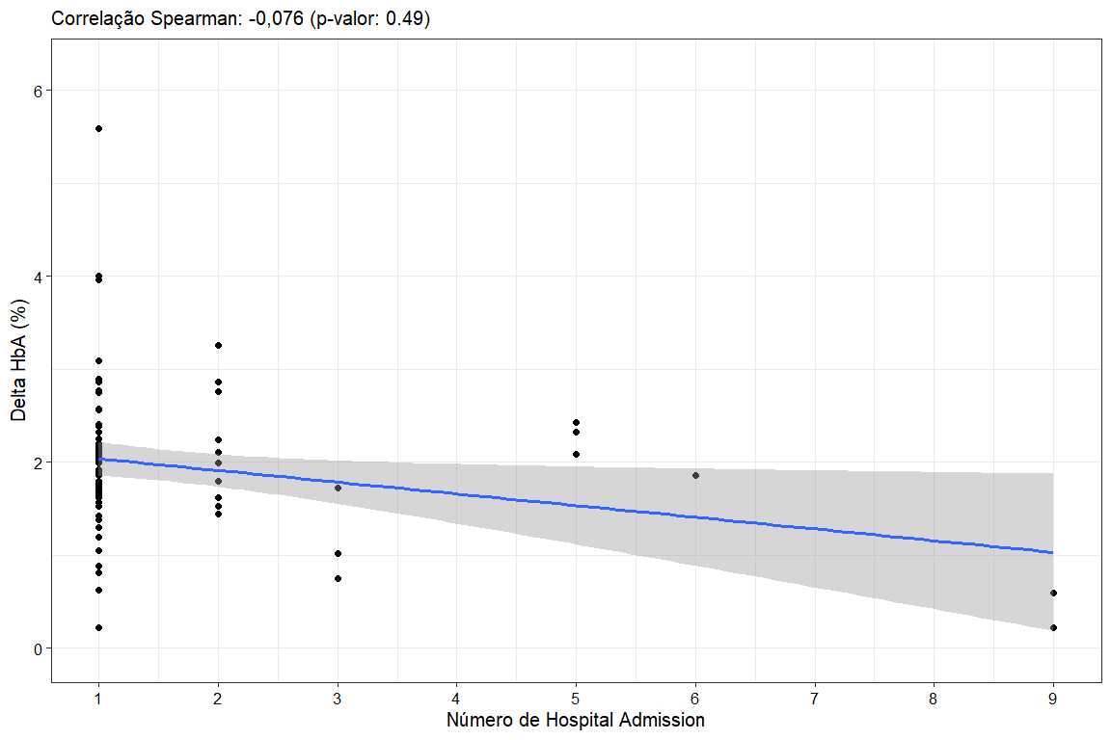

Análise 2b - Correlação entre nível de admissão para as variáveis de Goal/Target Post-RCE HCT (%) com Post-RCE HT (%);
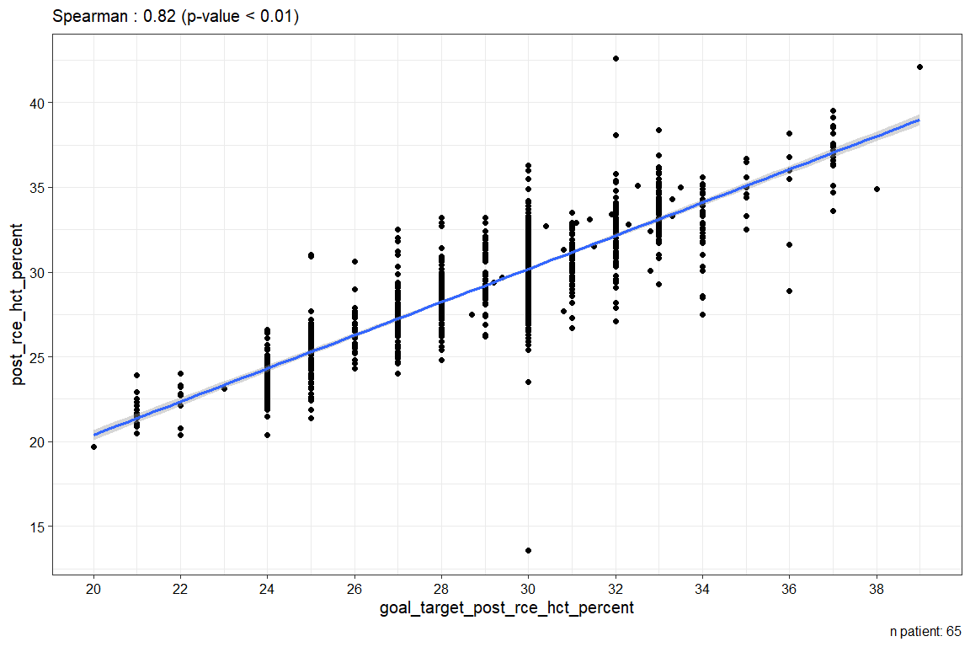

Análise 3 - created a variables rbc_antibodies_new que utiliza H/O RBC Allontibodies ? H/O RBC Autoantibodies e allob (1 = yes, 0 = no)
Nova variável
rbc_antibodies_new | h_o_rbc_alloantibodies | h_o_rbc_autoantibodies | allo_ab_1_yes_0_no | n
Group 1 | Yes | No | 0 | 2
Group 1 | Yes | Yes | 0 | 2
Group 3 | Yes | No | 1 | 17
Group 3 | Yes | Yes | 1 | 10
Group 4 | No | No | 0 | 34

Análise Univariada para Delta HBC (%)
Modelo de regressão linear simples
Covariables | N | Beta | 95% CI | p-value
rbc_antibodies_new | 65
Group 1 |  | — | —
Group 3 |  | 0.45 | -5.0, 5.9 | 0.9
Group 4 |  | 0.53 | -4.8, 5.9 | 0.8
Abbreviation: CI = Confidence Interval

Análise 4 - Created new group to SCD Genotype. Excluding HbS beta Indianopolis, Other e sickle cell beta plus thalassemia and grouped S/beta zero thalassemia with SS for Group 1, and SS for group 2 (SCD_genotype_2CAT)
O paciente 52 era o único que tinha gene: S/beta zero thalassemia
SCD_genotype_2CAT | scd_genotype_32 | n
Group 1 - SS/SBO thal | SB0 thal | 3
Group 1 - SS/SBO thal | SS | 56
Group 2 - SC | SC | 3
 | HbS beta Indianapolis | 1
 | Other | 1
 | sickle cell beta plus thalassemia | 1

Análise Univariada para Delta HBC (%)
Modelo de regressão linear simples
Covariables | N | Beta | 95% CI | p-value
SCD_genotype_2CAT | 62
Group 1 - SS/SBO thal |  | — | —
Group 2 - SC |  | 4.8 | -0.49, 10 | 0.074
Abbreviation: CI = Confidence Interval

Regressão Multiplo para Delta HBC (%)
Regressão Linear Múltipla Mista
Covariables | Beta | 95% CI | p-value
rbc_antibodies_new
Group 1 | — | —
Group 3 | 0.05 | -5.6, 5.7 | >0.9
Group 4 | 1.1 | -4.6, 6.7 | 0.7
age_years_2 | -0.12 | -0.24, -0.01 | 0.039
height_cm_5 | 0.03 | -0.12, 0.19 | 0.7
weight_kg_6 | 0.02 | -0.07, 0.12 | 0.7
sex_3
Female | — | —
Male | 2.1 | -1.1, 5.2 | 0.2
SCD_genotype_2CAT
Group 1 - SS/SBO thal | — | —
Group 2 - SC | 9.6 | 3.1, 16 | 0.005
goal_target_post_rce_hct_percent | -0.87 | -1.0, -0.69 | <0.001
goal_target_post_rce_hb_s_percent | -0.10 | -0.20, 0.00 | 0.057
dhtr_likelihood_nomogram_results
Low | — | —
High | 2.3 | -1.2, 5.8 | 0.2
Intermediate | -1.1 | -3.0, 0.85 | 0.3
mean_age_unit | 0.08 | 0.04, 0.12 | <0.001
received_a_c_trait_unit
No | — | —
Yes | 0.64 | -0.56, 1.8 | 0.3
Abbreviation: CI = Confidence Interval

Análise 4 - Created new group to SCD Genotype. Excluding HbS beta Indianopolis, Other e sickle cell beta plus thalassemia and grouped S/beta zero thalassemia with SS for Group 1, and SS for group 2 (SCD_genotype_2CAT)

Análise Univariada para Delta HBC (g/dL)
Modelo de regressão linear simples
Covariables | N | Beta | 95% CI | p-value
SCD_genotype_2CAT | 62
Group 1 - SS/SBO thal |  | — | —
Group 2 - SC |  | -0.68 | -1.4, 0.01 | 0.054
Abbreviation: CI = Confidence Interval

Regressão Multiplo para Delta HBC (g/dL)
Regressão Linear Múltipla Mista
Covariables | Beta | 95% CI | p-value
rbc_antibodies_new
Group 1 | — | —
Group 3 | 0.13 | -0.46, 0.72 | 0.7
Group 4 | 0.26 | -0.32, 0.85 | 0.4
age_years_2 | 0.00 | -0.01, 0.01 | >0.9
height_cm_5 | -0.01 | -0.03, 0.01 | 0.3
weight_kg_6 | 0.00 | -0.01, 0.01 | 0.5
sex_3
Female | — | —
Male | 0.16 | -0.17, 0.49 | 0.3
SCD_genotype_2CAT
Group 1 - SS/SBO thal | — | —
Group 2 - SC | -0.66 | -1.3, 0.02 | 0.056
goal_target_post_rce_hct_percent | 0.05 | 0.02, 0.07 | <0.001
goal_target_post_rce_hb_s_percent | -0.02 | -0.04, -0.01 | <0.001
dhtr_likelihood_nomogram_results
Low | — | —
High | 0.14 | -0.28, 0.55 | 0.5
Intermediate | -0.14 | -0.37, 0.10 | 0.3
mean_age_unit | 0.01 | 0.00, 0.01 | 0.009
received_a_c_trait_unit
No | — | —
Yes | 0.13 | -0.02, 0.27 | 0.091
Abbreviation: CI = Confidence Interval

wyhirai@gmail.com

