# HashMap底层

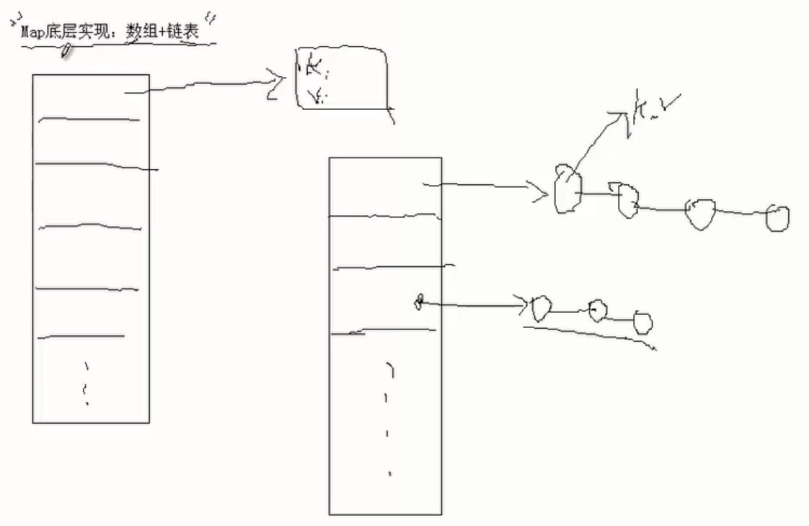

Map map = **new** HashMap();

String s1 = **new** String("aaa");

String s2 = **new** String("aaa");

//字符串s1和s2的equals()方法返回值相等。会覆盖

map.put(s1, "AAA");

map.put(s2, "BBB");

//把String改成Integer也会是输出：1

System.***out***.println(map.size()); //1