Land use and Biodiversity in Iowa
Background:
Healthy ecosystems are crucial for nutrient cycling, water retention and cleaning, soil fertility, carbon sequestration, human health and wellbeing, and much more (6). Biodiversity is a crucial component of maintaining ecosystem health. To have productive, resilient ecosystems, biodiversity must be maintained (2)(3)(5)(6). Agriculture, through expansion and intensification, is currently the leading cause of biodiversity loss globally (7).
Studies have highlighted the adverse effects of intensive agriculture, characterized by monoculture and extensive pesticide use, on biodiversity, particularly in terms of soil and insect diversity (3)(4). This decline of diversity can impact crop yield (3)(4)(5). Insect and microbial biodiversity are easier to quantify than mammal diversity. However, these insect and microbial biodiversity metrics may not give the entire picture of ecosystem biodiversity. While animal biodiversity is more challenging to quantify, attempts must be made. We focus on Iowa, a state with a high percentage of cropland.
The scarcity of comprehensive biodiversity data, especially for mammals and birds, has prompted us to rely on civilian sightings. While this approach introduces certain limitations and challenges (how accurate are civilian sightings?), it provides an initial framework for understanding the distribution of wildlife across different land use types. By leveraging geospatial information and citizen science data, we seek to clarify the relationship between land use and biodiversity. We focus on using mammal and bird observation data as a proxy for real biodiversity. From these observations, we can create indices of both species diversity and species abundance, both of which can provide valuable insights to ecosystem health.
A geodatabase will allow us to integrate different spatial datasets and manage our data in a structured way, ensuring data integrity and consistency. We can manage our coordinate reference systems (CRS) more easily, or enforce one. The database can include checks and constraints to validate geometries, which can ensure that spatial data adheres to predefined rules and standards, preventing the introduction of invalid or erroneous geometries. Database spatial indexing can improve querying times. Additionally, databases make it easy to update or add files later on as research continues.
We believe data will show less species richness and abundance in areas of intensive agriculture. We can generate metrics of biodiversity and use these to compare farmland to other land use areas. Then, we can begin to answer if cropland is uniquely bad for biodiversity compared to other forms of land use, such as wild lands or urban areas. By addressing these questions through a geospatial lens and utilizing SQL queries on our database, we aim to unravel the complex interactions between land use and biodiversity, contributing valuable insights to conservation efforts and sustainable land management practices in Iowa.

Key Motivations:
1. Cropland Dominance in Iowa: The predominance of croplands in Iowa serves as a critical motivator for our project, given the potential impact on biodiversity.
2. Biodiversity Decline in Croplands: Existing research suggests a decline in biodiversity, particularly in terms of soil and insect diversity, in cropland environments. This forms the basis for our exploration into mammal and bird biodiversity.
3. Civilian Sightings as Data Source: With sparse biodiversity data, leveraging civilian sightings becomes essential for understanding wildlife distribution in different land use categories.
4. Hypothesis Generation: Despite the limitations in data availability, the project aims to explore current available data and generate hypotheses to lay the foundation for future, more comprehensive studies.

Data: SRID: 4326
- ICDL_vector
  - Source: USDA, National Agricultural Statistics Service, 2009 Iowa Cropland Data Layer
  - Converted ICDL raster to vector and convert CRS to project CRS
    - Created a column for a legend that corresponds to the key numbers
  - Shows Iowa land use in detail, with many categorizations (crop, pasture, non-crop, wild lands, and urban lands)

- County Boundaries
  - Polygons
  - Columns: ID (primary key), geom, fid, perimeter, domcountyi, fips, fips_int, countyname, stateabbr, shape_leng, shape_area
  - Row count: 99
  - Spatial and Temporal Extent:
    - Current Iowa County boundaries

- Mammal Observations From INaturalist
  - Mammal observations within Iowa from 2022-01-01 to 2023-01-01 with latitude and longitude coordinates
  - Row count: 1797 mammal observations
  - Columns: id, observed_on_string, latitude, longitude, common_name
  - Uncertainty: Citizen sourced observations
    - Although dataset is limited to “confirmed” sightings that are considered “research grade”, there is still some uncertainty in the validity of these sightings
  - Latitude and longitude columns used to generate “geom” column and its spatial index

- Bird Data from eBird
  - Bird observations within Iowa from 2022-01-01 to 2023-01-01 with latitude and longitude coordinates
  - 686,334 rows
  - Columns: id, observed_on_string, obs_count, latitude, longitude, common_name

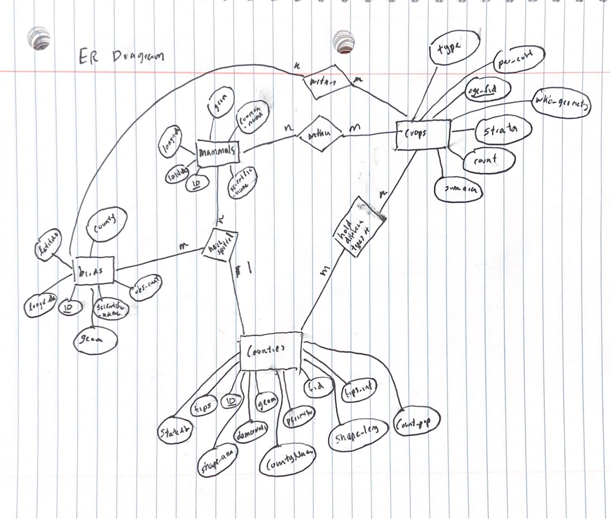

Exploration and results:
- What is the breakdown of land use within Iowa?

SELECT
lu_type,
ROUND(SUM(ST_Area(geom))::numeric ,2) AS total_area,
CAST((SUM(ST_Area(geom)) / (SELECT SUM(ST_Area(geom)) FROM icdl_vector)) * 100 AS NUMERIC(10,2)) AS percent_area
FROM
icdl_vector
GROUP BY
lu_type
ORDER BY
lu_type;

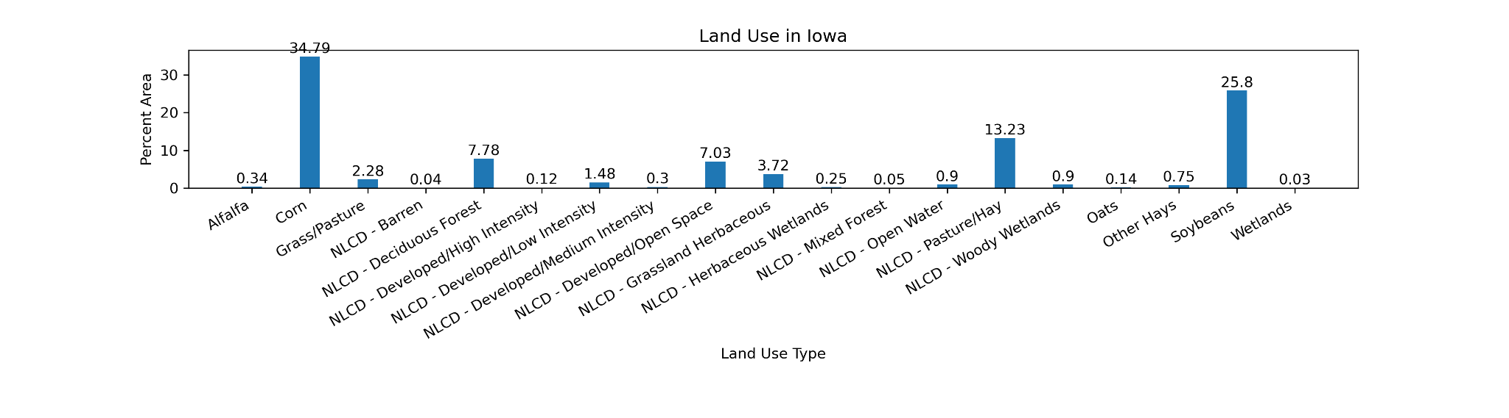
Corn and soy are the most common land use types in Iowa. To have a clearer understanding of categories of land use in Iowa, we can aggregate these categories:

UPDATE icdl_vector
SET general_type =
CASE
WHEN dn IN (5, 1,23,59,43,53,43,21,27,36,58,12,28,13,37,24) THEN 'Crops'
WHEN dn IN (62, 181) THEN 'Grass/Pasture'
WHEN dn IN (121, 122, 123, 124) THEN 'Urban'
WHEN dn IN (141,171,190,111,195,143,131,87,152,142,63) THEN 'Wild'
WHEN dn IN (61) THEN 'Idle'
ELSE 'Unknown'
END;

Then, if we query again using the above query now with these general_types, we find:

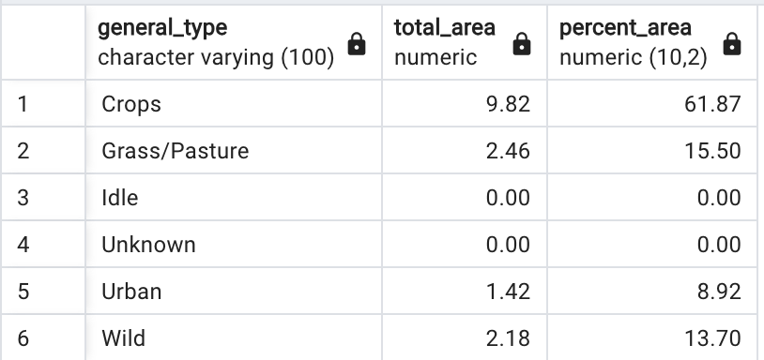


Cropland takes up the majority of Iowa land.

- What type of land has the most animals? (sheer count of animals)
To answer this, we can find bird and mammal observation counts among each land use type. However, it is difficult to compare numbers among different land use types. For example, it may not be fair to compare cropland with x number of birds, to urban land with y number of birds, if cropland has so much more area in Iowa.
So, we include a “normalized counts” column which shows animal count per area.

SELECT
icdl_vector.general_type,
SUM(birds.obs_count::numeric) AS total_bird_obs_count,
ROUND(SUM(birds.obs_count::numeric) / SUM(ST_Area(icdl_vector.geom))::numeric, 2) AS normalized_bird_count,
COUNT(mammals.id) AS total_mammal_obs_count,
ROUND(COUNT(mammals.id) / SUM(ST_Area(icdl_vector.geom))::numeric, 2) AS normalized_mammal_count
FROM
icdl_vector, birds, mammals
WHERE
ST_Within(birds.geom, icdl_vector.geom) AND birds.common_name IS NOT NULL
AND ST_Within(mammals.geom, icdl_vector.geom) AND mammals.common_name IS NOT NULL
GROUP BY
icdl_vector.general_type
ORDER BY
normalized_bird_count DESC;

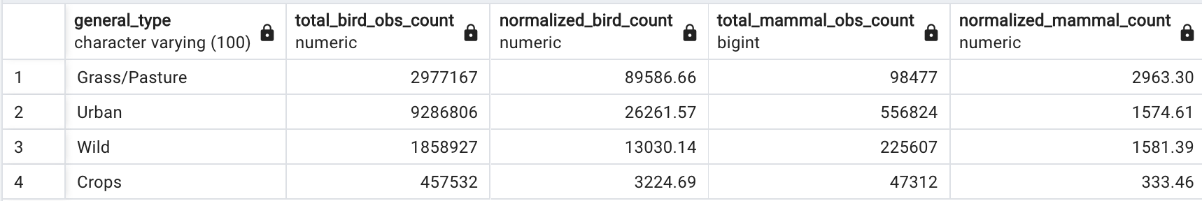
Raw bird count:
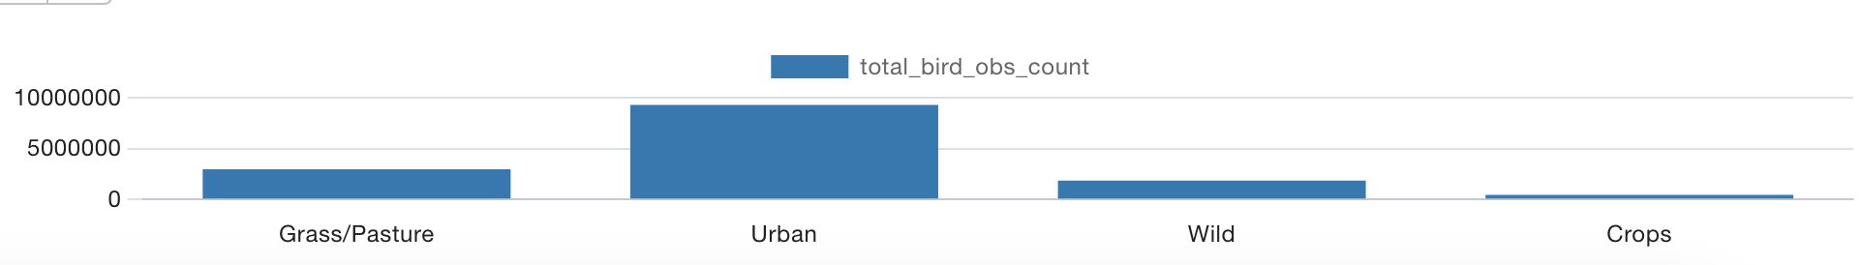

Here, we see that normalization to land use area changes the results dramatically:
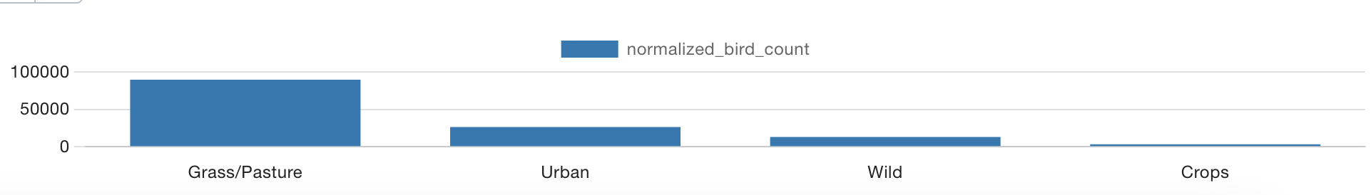
Results are qualitatively the same for mammals (initially, it appears they are most common in Urban areas, but when normalized to area, they are most commonly seen in grass/pasture land).
If we look at the more specific categories of land use, we see some interesting trends:

SELECT
icdl_vector.lu_type,
SUM(ST_Area(icdl_vector.geom)) as land_area,
SUM(birds.obs_count::numeric) AS total_bird_obs_count,
ROUND(SUM(birds.obs_count::numeric) / SUM(ST_Area(icdl_vector.geom))::numeric, 0) AS normalized_bird_count
FROM
icdl_vector, birds
WHERE
ST_Within(birds.geom, icdl_vector.geom) AND birds.common_name IS NOT NULL
GROUP BY
icdl_vector.lu_type
ORDER BY
normalized_bird_count DESC;

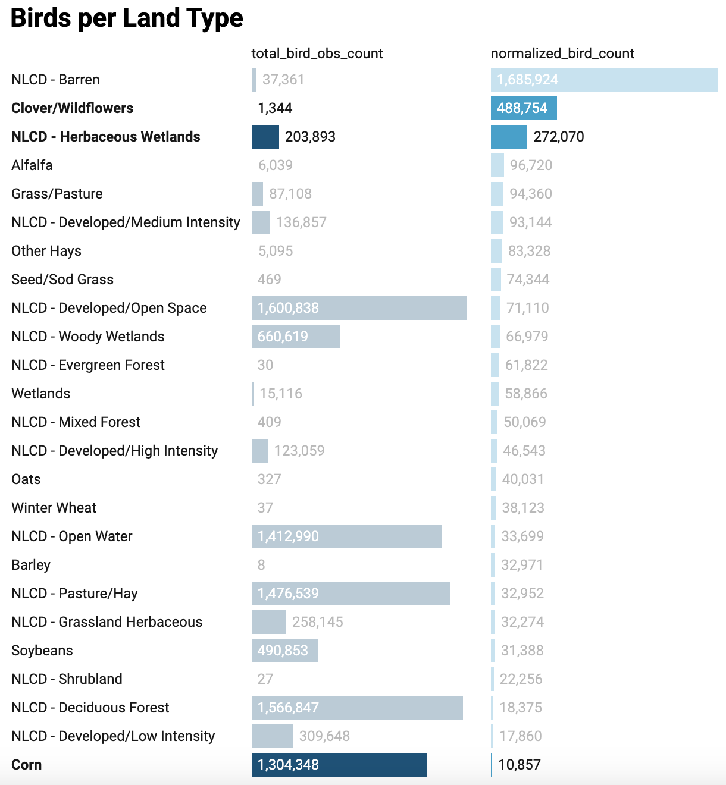

Interestingly, “barren” shows a massively disproportionate amount of bird observations compared to land area. For “general land use” queries, “barren” was considered as part of “wild land”. This likely didn’t change results much for the aggregate queries, since “barren” would’ve only been a small fraction of the land in the “wild category”. However, this indicates that aggregation of categories should be done carefully in the future, with more research.
What defines “barren”? NLCD says:
“Barren: (Rock/Sand/Clay) - areas of bedrock, desert pavement, scarps, talus, slides, volcanic
material, glacial debris, sand dunes, strip mines, gravel pits and other accumulations of earthen
material. Generally, vegetation accounts for less than 15% of total cover.”
When filtered in QGIS, the barren land shows as a random few pixels throughout Iowa, fairly randomly distributed and a very small amount. This would be a great area to explore more in future research. Why does barren land have such a disproportionate amount of bird sightings? What is the barren land in Iowa (unused crop land? dirt lots?)
Next highest are clover/wildflower, and herbaceous wetlands. Clover and wildflower fields are known to promote insect diversity, so it makes sense that many birds would be seen in these crops. Wetlands are also known to be very diverse. Interestingly, corn performs the absolute worst compared to its land area, but this may be because of few observers located throughout corn farmland.

- Which land use has the highest biodiversity?
Again, we can include a “normalized biodiversity” column to take into account differing areas.

SELECT
general_type,
COUNT(DISTINCT bird_common_name) AS bird_species_count,
COUNT(DISTINCT mammal_common_name) AS mammal_species_count,
COUNT(DISTINCT COALESCE(bird_common_name, mammal_common_name)) AS distinct_animal_species,
ROUND(COUNT(DISTINCT COALESCE(bird_common_name, mammal_common_name)) / SUM(area)::numeric, 2) AS normalized_species_count
FROM (
SELECT
icdl_vector.general_type,
birds.common_name AS bird_common_name,
mammals.common_name AS mammal_common_name,
ST_Area(icdl_vector.geom) AS area
FROM
icdl_vector, birds, mammals
WHERE
ST_Within(birds.geom, icdl_vector.geom) AND birds.common_name IS NOT NULL
AND ST_Within(mammals.geom, icdl_vector.geom) AND mammals.common_name IS NOT NULL
AND icdl_vector.general_type != 'Unknown'
) AS subquery
GROUP BY
general_type
ORDER BY
bird_species_count DESC;
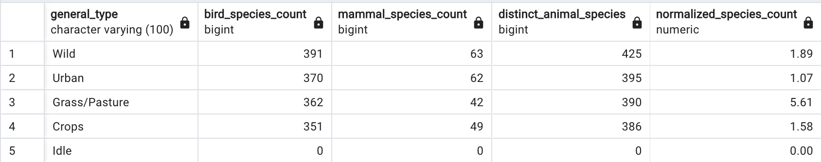

We see similar results from normalizing to land use. While it seems initially wild land has the most bird and mammal species, if we look at species per area, grass/pasture land outperforms all categories by far. Interestingly, it appears that cropland still has more diversity than urban land when accounting for land area. However, by raw values, wild land does have the greatest biodiversity, and crop land has the least.
When we revise the above SQL query to give us results for specific land types, we get the following:

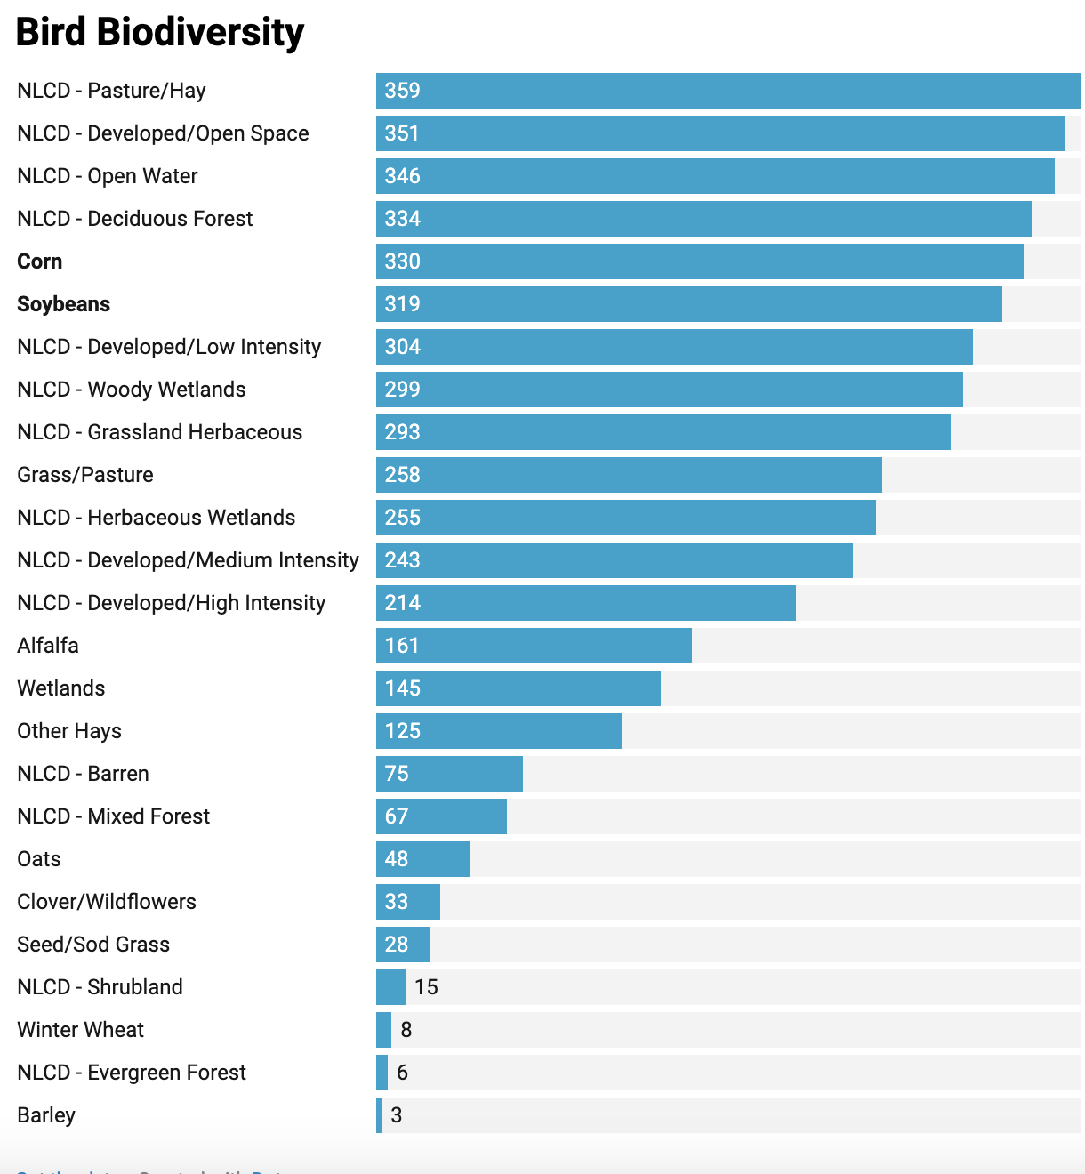
Biodiversity is favored in hay/pasture lands, and secondarily urban land. Corn and soy still have a surprising amount of bird diversity seen.

- Which counties in Iowa exhibit the highest concentration of croplands, and how does this correlate with observed biodiversity?

WITH ObservationCounts AS (
SELECT
c.type,
COUNT(*) AS observation_count FROM
public.crops c
LEFT JOIN
public.birds b ON ST_Within(b.geom, c.wkb_geometry)
GROUP BY
c.type
)
SELECT
type,
observation_count
FROM
ObservationCounts
ORDER BY
observation_count DESC;
WITH ObservationCounts AS (
SELECT
c.type,
COALESCE(b."COMMON NAME", m.common_name) AS combined_common_name,
COUNT(*) AS observation_count
FROM
public.crops c
LEFT JOIN
public.birds b ON ST_Within(b.geom, c.wkb_geometry)
LEFT JOIN
public.mammals m ON ST_Within(m.geom, c.wkb_geometry) AND m.common_name != 'Human'
GROUP BY
c.type, combined_common_name
)
SELECT
type,
combined_common_name,
observation_count
FROM
ObservationCounts
ORDER BY
observation_count DESC;

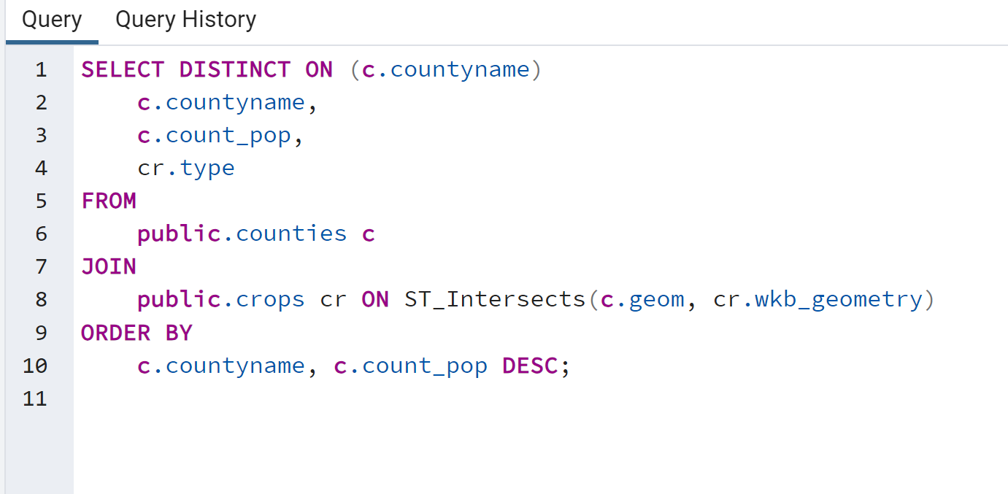
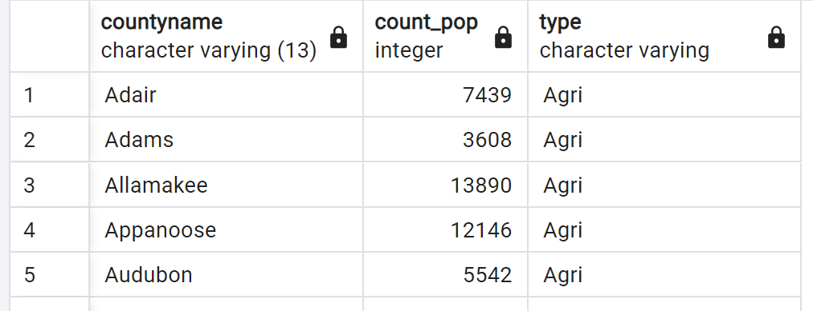

5. Are there seasonal variations in wildlife observations, and do they correlate with specific agricultural practices or crop cycles?

For this query, we performed a concatenation on the dates and split it by months to see whether or not there is a trend with certain animals and certain months. However, there was a limitation to the data. Since the animals were human spotted, it was evident that the data was not a great representation of animals spotted. It was followed around populous areas of population density. Furthermore, the trends that were present were the white tail deer were all year around. The cotton tail and american beaver were prevalent in the months of the spring. The Fox Squirrel dominated the summer months. However, since there was not enough evidence to say there was a seasonality within crops, it is still undetermined.

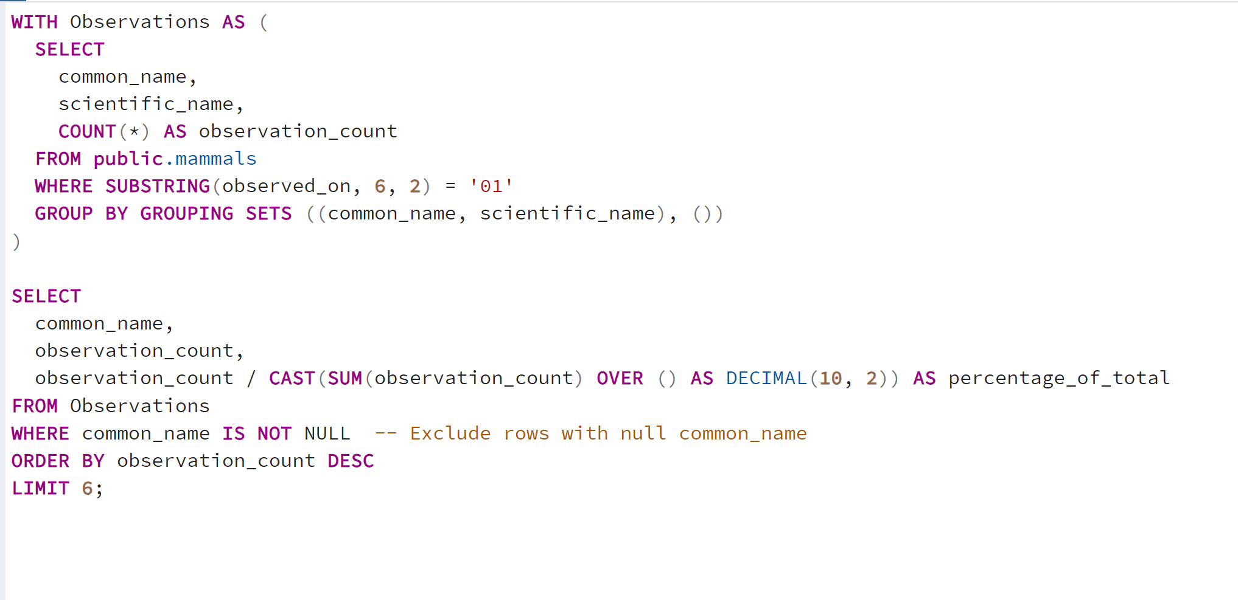
In “WHERE SUBSTRING (OBSERVED_ON, 6, 2) = 01 This represents the month of January

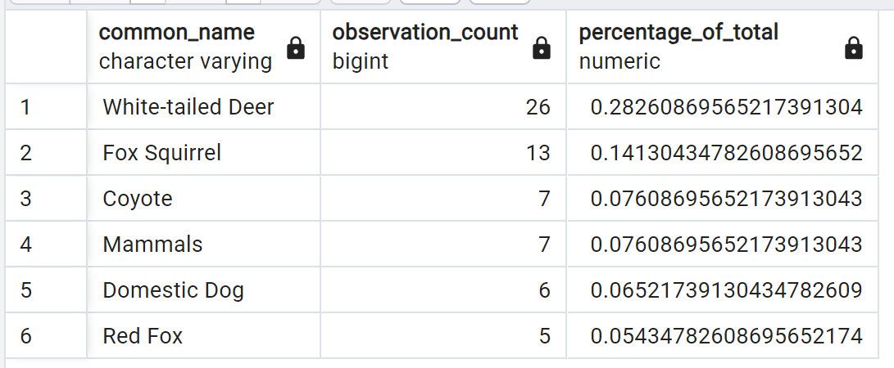.
This is an example of the query for the total animals spotted within the month of January.

Conclusion:
Biodiversity and species counts seem to favor wild land or grass/pasture land (when accounting for area). However, there are a few major concerns to address in the future. Our statistics are biased due to uneven distribution of citizen observers within Iowa. Most animal observations are clustered around Des Moines and Iowa City, within a few hundred miles.
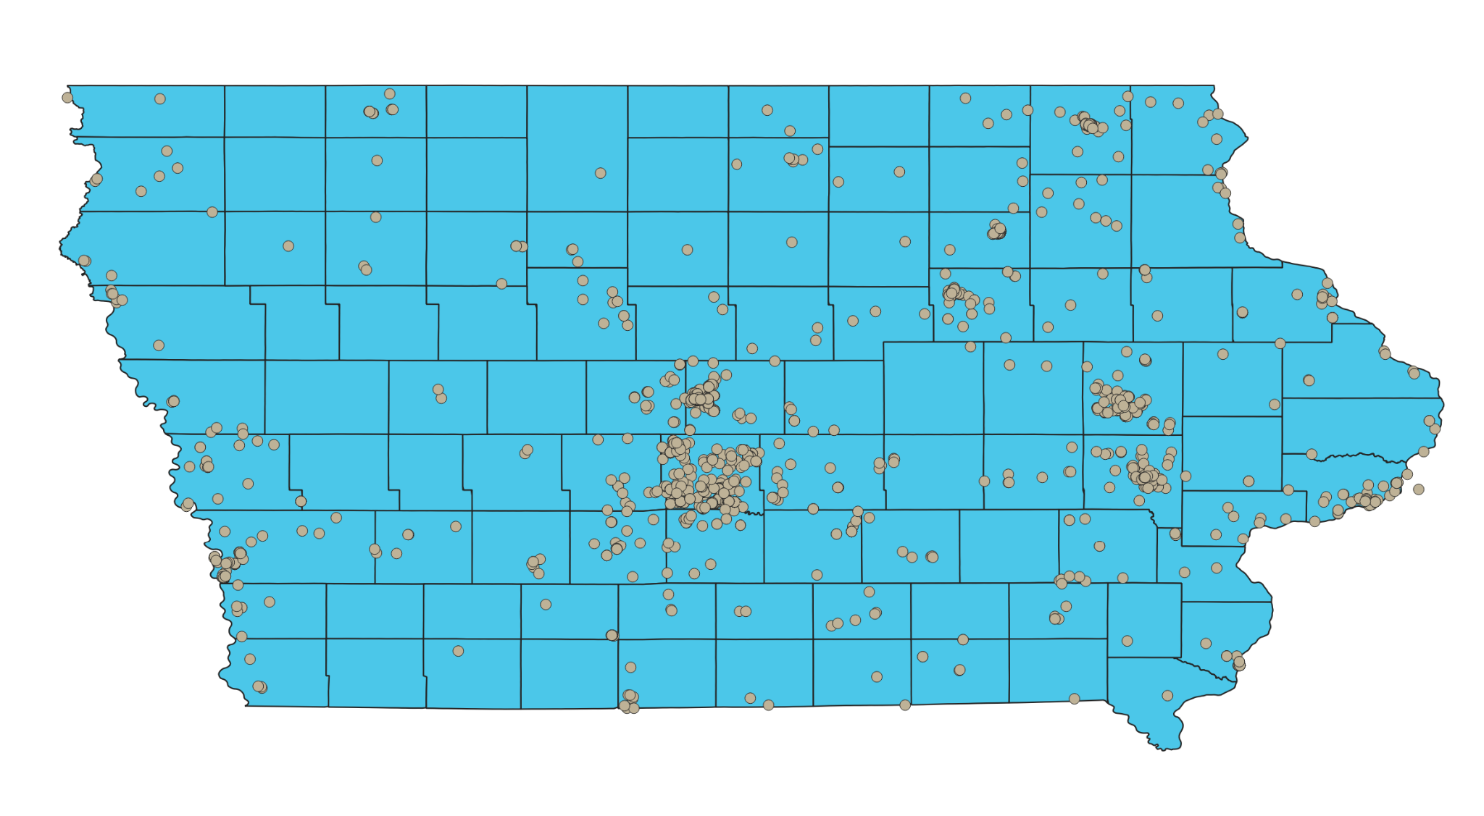
Biodiversity may be fairly accurate compared to species counts when considering biased citizen data. Biodiversity queries will be less affected by unequal distribution of citizens (a person must only see one species one time to be included), while species counts will be much more biased. More research should be done to establish whether or not crop land in Iowa is significantly impacting biodiversity.

Citations:
- https://pubmed.ncbi.nlm.nih.gov/37246379/
- https://www.usgs.gov/news/biodiversity-critical-maintaining-healthy-ecosystems
- https://www.frontiersin.org/articles/10.3389/fmicb.2021.660749/full
- https://www.nature.com/articles/s41586-022-04644-x
- https://www.sciencedirect.com/science/article/pii/S0048969723023045
- https://besjournals.onlinelibrary.wiley.com/doi/full/10.1002/pan3.10421
- https://www.nature.com/articles/s41559-017-0234-3
- https://www.pnas.org/doi/10.1073/pnas.1620229114
- https://civileats.com/2022/03/25/can-nature-reclaim-iowa/
- Population of Counties in Iowa 2023 (worldpopulationreview.com)

