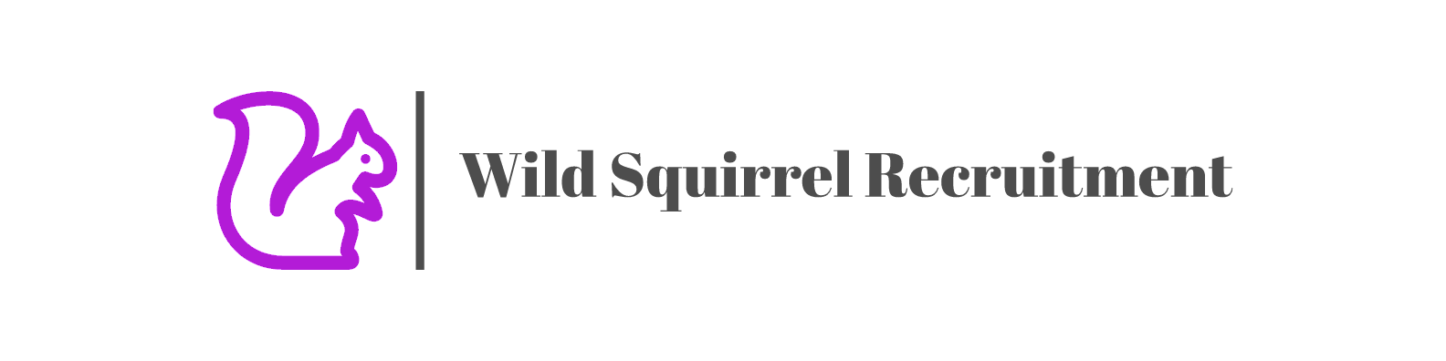

Patrick Stileman – Senior Strategist

Profile
An experienced strategist that’s led and delivered communication plans for a range of brands. I have specialist knowledge of content & social media combined with strong brand and communications planning experience. I’m personable and collaborative and an effective presenter. I find consumer insights fast and am quick to turn these into rich strategic areas. I have experience setting roles for comms and channels along the journey and setting ambitious yet achievable KPI’s. I follow the socio-political discourse closely and am plugged into pop culture. I love strategy as a career because it brings together my interests in philosophy, psychology, comedy and creative writing.

Experience

Pearson (Educational Publisher) – Freelance Senior Strategist (June – Present)

Developing a social media and influencer led brand campaign to boost awareness of the BTEC qualification amid COVID career & exam chaos. Aiming to establish the perception that BTEC provides key skills that start rewarding careers and is perfect if you want a career that makes a difference and makes you feel good inside. I led the project from interview based qualitative research, to proposition development and communications plan.

FRUKT – Freelance Senior Strategist, specialising in esports (March – May)

I developed a sensitive understanding of esports culture, which enabled me to write credible activation strategies for Cisco, BMW, ABInbev and The Open. Each of my strategies involved understanding what motivates fans of different titles (League of Legends, Call Of Duty, F1 Pro Series), and finding a way for the brands to add value in a way that felt natural based on their distinctive attributes.

Oliver – Freelance Senior Strategist (October 2019 – February 2020)

Developing brand and content strategy for Pearson BTEC. Aiming to reposition BTECs among British teenagers, so they see it as a credible path to a purposeful career that gives them fulfillment via authentic, influencer driven video content.

Leading global content strategy for Pearson’s higher education partners. Aiming to drive applications of online, international masters programs via interactive content that made it easier for graduates to discover their calling.

Mullen Lowe London – Freelance Senior Strategist (February 2019 – July)

Leading global digital strategy for Magnum’s partnership with Cannes Film Festival & 90 year old fashion icon, Iris Apfel. We aimed to get Pleasure Seekers between 18-24 to share the brands ‘Never Stop Playing’ attitude to life, via thumb stopping and irreverent Instagram films and Stories featuring Iris and influencers from passion areas such as food, fashion and music.

Developed the global content strategy for Rexona. Aiming to translate the brand purpose ‘The More You Move, The More You Live’ into content that inspired, enabled and celebrated behavior change. All content was adapted for different personae and local markets.

VCCP Kin, Senior Strategist, June 2014 – January 2019

MoreThan Pet Insurance – There is an obesity epidemic among cats and dogs in the UK caused by owners that love their pets too much, treating them like children and not giving them enough exercise. “Bark In The Park” was a brand experience and social media campaign that invited owners to bring their cats and dogs to our playground for pets. Activities such as ‘Doggy Diving’ and ‘Frisbee Catch’ were designed to get dogs and cats releasing their wild side, while generating entertaining short form content to reach and engage a wider audience of pet lovers who share funny pet related content on social. The campaign drove a huge amount of earned media and won the Insurance Marketing Awards.

Coors Light – The Jean Claude Van Damme advertising campaign was struggling for relevance among Coors Light’s target audience of Social Explorers, who value unique experiences around their passions for travel and dance music. The Ice Cave Rave was a brand experience and social media campaign that invited adventurous Millennials to party with Coors Light and their favorite DJs in the mountains. We partnered with Mixmag to promote the event through a social media DJ competition. The winning DJ was able to play alongside their heroes at the festival and their mix were recorded and live streamed on social.

Royal Institute of Chartered Surveyors (R.I.C.S) – RICS were struggling to attract the next generation of surveyors into the industry. Millennials are increasingly choosing careers that ‘make a difference’, but don’t realize the impact that surveying has on society. It’s poorly built buildings that kill people, not earthquakes, and Chartered Surveyors are central to the safe construction of cities. The Cities For Our Future Challenge was a global competition that targeted students of related fields on social media and invited them to solve the most pressing issues facing cities. Consideration of surveying as a career increased dramatically and the winning idea made the national news.

O2 x NSPCC - Based on the insight that 94% of children between 8-11 play Minecraft everyday, and 64% of parents claim to be worried about the effects of online gaming, we created a series of entertaining video content that also educated parents about the risks of Minecraft and how to reduce them.

Tribal DDB London, Social Strategist, April 2012 – June 2014 (2.5 years)

Adidas - For Originals, we came up with an hour-long crowd sourced freestyle for Sound cloud. Adidas had asked us to come up with an idea that activated Unite All Originals. Our insight was that for Millenials originality is found in collaboration and curation, so we invited them to rap over an A-Track beat.

Guinness - Global Social Strategy resulting in record-breaking Engagement Rate with target audience across key platforms throughout 2013 / 14. The brief was to translate the global “Made Of More” brand platform into engaging content for men between 25-34 in the UK.

Volkswagen - Wrote 2013 / 14 social strategy for Volkswagen Commercial Vehicles helping them become the 5th most engaged with automotive brand on Facebook. The strategy to help and inspire small business owners came from the insight that they were finding it hard to cope when starting out.

Candi (LBi), Junior Planner, 2 years, April 2010 - 2012
Morrisons - Consistently writing clear and emotive creative briefs and working with creative teams to ensure the Morrisons tone of voice and relevant proposition comes across in all website / mobile site / social media content.

Redmandarin, Copywriter, 18 months from August 2007
Lloyds TSB - Commissioned by Lloyds TSB to write human interest articles on each and every Local Hero as part of building awareness of the campaign in the lead up to London 2012.

Education

Bucks Ad School, Masters in Creative Planning 2009 - 2010
A rigorous introduction to account planning that saw me present back on live briefs from Mother, AMV BBDO, RAPP and BBH. Developed a keen interest in social media and wrote my thesis on the impact of social on the brand traditional broadcast communication model.

EDUCATION SUMMARY
MA Advertising (Bucks New University), Awarded Jan 2010 (68%)
BAhons Culture and Media Studies , Bristol UWE, 2003 - 2006
A-Levels: History, Psychology and Media Studies

COMPUTER SKILLS
POWERPOINT / KEYNOTE / SOCIAL LISTENING TOOLS / GWI & TGI

HOBBIES

Music – Love all kinds of music particularly electronic.
Sport – Love cricket. Stay fit through running, swimming and cycling.

