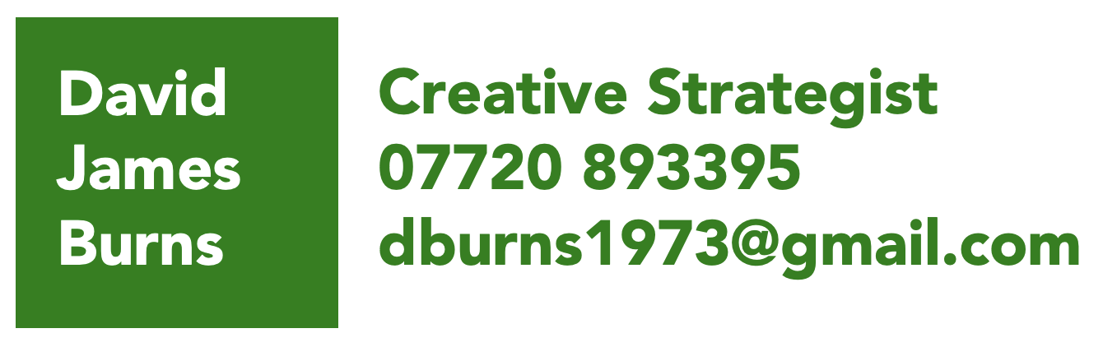

About me, in thirty seconds…

A unique thinker with a rare combination of upstream strategy; brand and channel smarts and solid business understanding, with experience in almost every marketing discipline.

I make complex problems simple, add clarity to uncertain briefs, build businesses through strong creative and strategic thought and move at the speed of culture.

I can also pitch in with copywriting and creative concepting when asked to, but I’m happiest simply being a planner with a strong creative edge.

Headline work...

- Worked on the three of the four biggest sportswear brands in the world in the last three years– Nike, adidas and New Balance.
- Devised Nike’s ‘Plus Sized Mannequin’ which gained national coverage without a penny spent on paid media. Coverage included ITV’s GMB and in national press.
- Led a reinvigoration of the Absolut brand in the UK, Re-establishing them in the arts community via a unique mobile to real life gameplay working with Punchdrunk and the estate of Andy Warhol. The first time Punchdrunk had worked with a brand.
- Conceived and devised ad-funded programming for Clarks Gloforms with Cartoon Network – The brand’s maiden voyage into broadcast content production.
- Brand launch for Detroit Electric, the first electric vehicle to be made in Detroit in a century, responsible for sales of $80 million from launch, and secured a second round of funding.

David Burns Communications Limited (September 2016 – Present)

Hey Human (January 2022 – Present)
- Running a team of three – one midweight, one planner and one social strategist, working on Diageo brands including Guinness Africa Football, Cîroc and Johnny Walker leading the strategy on the successful Cîroc UK social media pitch.
TBWA London (September 2021 – December 2021)
- Short Stint on Green Flag pitch and some additional work on AMD
OMG Group – OMD UK & EMEA (September 2019 – September 2021)
- Strategy lead on McDonalds – McDelivery, McCafé, Grand Mac, McFlurry and ‘Great Tastes of the World’ promotions; Channel 4 – Paralympics, Great British Bake Off, Taskmaster; Doritos (Gaming and Stax) and Quaker Oats.
- Creative lead on Google, working to develop partnerships with broadcast brands like Netflix, Disney and Amazon Prime Video for Chromebook, and a key opinion formers partnership focused on YouTube’s contribution to the creative economy with Netflix
ZAK Agency (May 2019 – August 2019)
- Working on New Balance Football on a wide range of projects from brand proposition development, and creative inspiration for the design and development of the Furon and Tekela boots in season SS21, working on Liverpool F.C. amongst other partners.

Fortnight Collective (April 2019 – Ongoing)
- A global creative collective based in Boulder Colorado, but who put strategic and creative hit teams together all over the world to work on projects for some of the world’s biggest brands, often performing as a supplementary copywriter.
- Most recently I worked on MacMillan Cancer research and Nike Women’s sport.
The7Stars (November 2018 – May 2019)
- Taken on to work with the7stars’ creative department – Polaris - developing bespoke solutions for clients including Ladbrokes Coral, Associated British Foods, and pitch ideation for L’Oréal and Starbucks.
Mullen Lowe London (April 2018 – November 2018)
- Leading the strategy on The Post Office across all campaigns and also in a copywriting capacity to handle overflow in the creative department.
- Led strategy on Eurosport – Brand, ATL and comms.
- New business win and development for Fulfil protein bars.
Pulse Creative London (January 2018 – March 2018)
- WPP in house agency for News International, working on World Cup above the line strategy and creative ideation on all of their titles, winning gold and a bronze Kinsale Sharks.
U-Dox (January 2017 – December 2017)
- Brand relaunch of an under-performing part of the adidas portfolio.
- Making adidas’s classics of the 20th Century into ‘Icons’ of the 21st Century.
- Insight and strategic piece on the ‘Creative Class’ for MINI which led to brand positioning and creative comms for MINI A/D/O in Brooklyn, making it a vital part of the brand’s evolution towards their electric vehicle launch in 2020.
Bountiful Cow (June 2017 – Ongoing)
- Brand and comms strategy for Jura, Shackleton, Propercorn and Groupon.
The Grid Creative (November 2016)
- Brand development pitch for BBC 1Xtra Live, which required extensive qualitative and ethnographic research amongst young black music fans in the UK, subsequently developed into design language, copy strategy and brand redesign.
Pulse Group (October 2016)
- Brand pitch strategy for Amstel Gold Race UK launch, creating a tech partnership with Strava to replicate the famous race in the UK.
ODD London (September 2016)
- Communications strategy for the launch of Kingsman 2.

Havas Media, Strategy Director (Jan 2015 – August 2016)

- Strategic lead on Pernod-Ricard, including launching a Father’s Day gifting and fulfilment campaign via Facebook which delivered over 300% uptake on target
- ‘Future of Nightlife’ project with Absolut Vodka, which comprised of a partnership with Marshmallow Laserfeast and R&S records for an evening of music, light and technology at bankside Studios.
- 2016 planning for all O2 products and managing the strategists in the team.
- Led a radical reworking of Clarks’ media output, reducing paid media, in favour of creating a cartoon, Ad Funded Programming and creative partnerships.
- Also, strategic lead on Nando’s and Jacobs Douwe Egberts

David Burns Communications Limited (July 2011 – December 2014)

Rocket Network (Extended Twice, April 2014 – Dec 2014)

Worked on Ferrero, Co-op Food and Bank and various brand culture pieces.

POSSIBLE London (Extended twice, June 2013 – April 2014)

Working in the GreyPOSSIBLE joint venture, on GSK and Brother, and Led the brand and digital strategy on the valuable Peroni, pitch win.

Amp London (Extended, Aug 2012 – June 2013)

Main clients were; Detroit Electric, Sony TV Europe, Four Four Two magazine, Carluccio’s and Russell Investments.

Working with Lotus’s head engineers and a former right hand man of Steve Jobs at Apple for Detroit Electric, required Apple-sized thinking to keep the lights on.

Flamingo International (April 2012 –July 2012)
- Protected Guinness in Ireland against the onslaught of Heineken by leveraging Diageo’s lagers portfolio and insulating the jewel in their crown from threat.
- Positioned Brown Forman’s American whiskies, as ‘urban bourbons’, modernising them and taking them out of the Deep South and into the minds of the cognoscenti.
Euro RSCG Global – Creative Strategist, Reckitt Benckiser (July 2011 – Jan 2012)
- Delivered the 14th most awarded piece of creative worldwide in 2012 for Durex Performax, and stabilised their income on a brand with serious supply issues.
- Awards included...
- Gold Clio award
- Golden Rose of Montreaux winner
- Shortlisted at Cannes, D&AD and Creative Circle

Carat UK, Strategy Director (March 2010 – June 2011)
- Launched the campaign which eventually became the single most awarded campaign in UK media history - NIVEA's ASOS partnership for their Black & White Deodorant, delivering £2.4m of incremental revenue.

Prior career…
- BD Network, Senior Planner (September 2008 – January 2010)
- Twentysix London Digital, Head of Strategy (June 2007 – September 2008)
- XM London Digital – Deputy Head of Strategy (August 2004 – June 2007)
- Manning Gottlieb OMD – Digital Strategist (January 2001 – July 2004)

Other Things…
I am a former amateur boxer, nearly pursuing it as a career. I remain involved in the sport through charity work with disadvantaged youths in the Bermondsey and Rotherhithe area.

I am a lifelong collector of clothing, which has led to a huge collection of rare pieces. I have a passion for bespoke, and design suits using inspiration and references from cinematic past eras and some of history’s most stylishly dressed men. I personally source the materials and makers with whom I work.

I also read relentlessly, everything from social science to boxing and football biographies. I am equally passionate about design and film, writing mini scripts when I have time.

Excellent references are available upon request.

