Peter Carroll – Creative Brand Strategy Director
Focusing on storytelling, proposition, platform, channels and visual direction

M: 07714 749 599 – E: thecarrollservice@gmail.com

Personal Summary:

Accomplished Creative Brand Strategist with extensive experience in B2B, B2C and B2Tech markets. I have worked both agency and client side with national and international brand owners delivering digital, online and offline brand and marketing solutions.

I have very strong skills in brand strategy, creative development and crafting value propositions.

My specialism is in developing and positioning brands against a background of rapid business and cultural change.

I help brand owners tell their story, build a value proposition, discover their path and set them on their journey. I help creative teams see the big idea, articulate the opportunity and innovate the solution. I focus on:

- The business case (market opportunity, value proposition, price point and purpose)
- The visual and tonal brand (design, voice, storytelling and communication)
- The Technology and Digital platforms that drive the channels (awareness, amplification and demand), and
- The Sustainability, Environmental and Social Purpose platform (values and purpose)

Entrepreneurial by nature, I use strategic brand development tools to reveal insights and explore market opportunities.

With skills across design software and business software, I’m a strong digital advocate. Technology and digital, with its power to automate, track, monitor, analyse and cut through plays an important part in what I do.
Increasingly involved in business development, I am very client facing and a strong relationship builder. Confident in pitches and high level presentations, I‘m experienced with facilitating workshops, focus groups and strategy sessions.

Work Experience:

August 2022 – current (Contracting)

Brand Strategy Consultant. Brand Strategy, Marketing and Business Development
- IKEA – ‘Life at Home’ Insights strategy
- JLR (Jaguar Land Rover) – ‘Innovation For Good’ Sustainability strategy
- Practical Action – Trends Strategy for NGO focusing on global poverty
- Kingdom of Saudi Arabia – NEOM – Channel Strategy around sustainable living
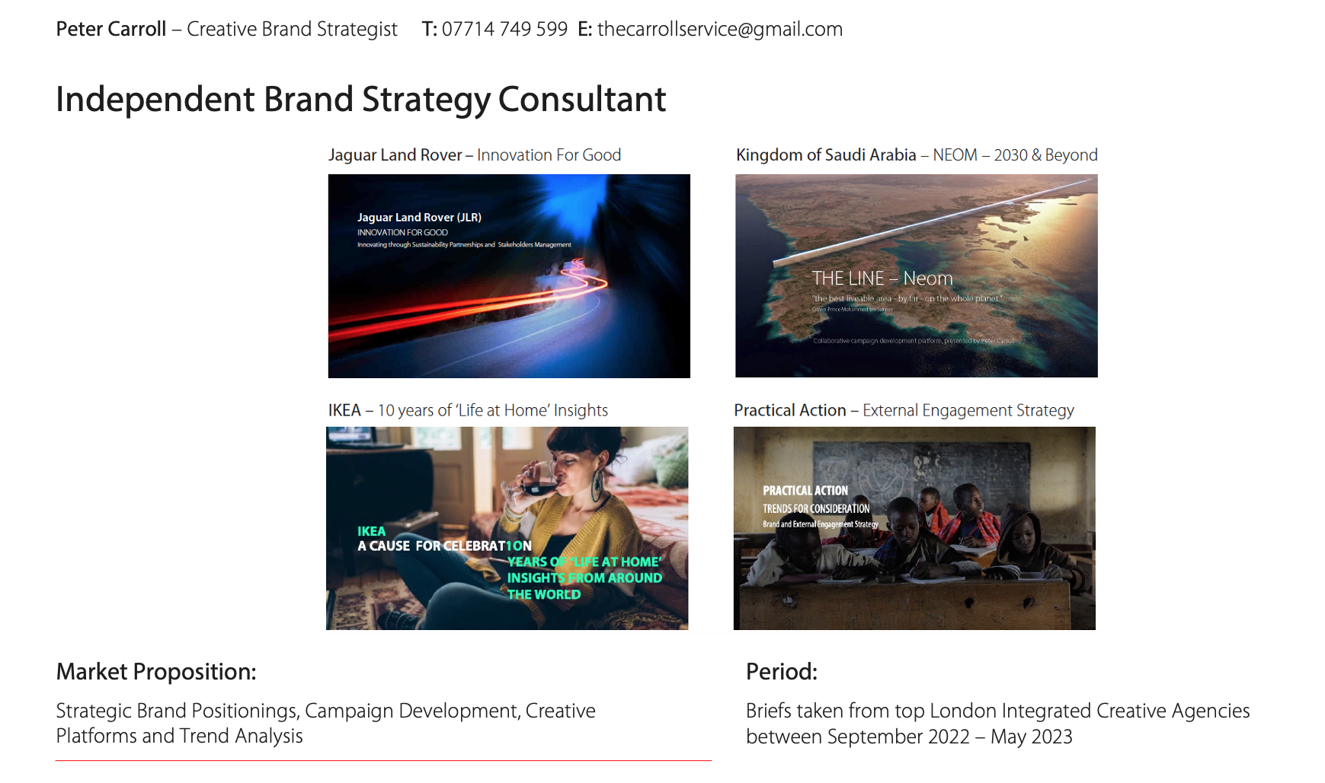

2014 – 2022
Brand Creed, London and Oxfordshire
Strategic Development Director Business Development
Working with ‘C-Level’ and senior marketing teams to deliver value propositions and go-to-market strategies.

Wins include:
- Canon – The DRBG Territories Central & North Africa, Central & Eastern Europe, Middle East, South Africa, Eurasia: Multi channel marketing campaigns to promote a variety of global consumer products to a highly segmented, culturally diverse market. Consumer and Prosumer cameras, lenses, printers and connectivity apps
- Climate-KIC (EU Foundation) – climate change, sustainability and innovation foundation
- Verita/Microsoft – Marketing and Brand Strategy for ai driven healthcare management Scottish Widows – Major brand repositioning. Realigned values and delivered brand communications strategy
- ASSA ABLOY, global manufacturing giant – Trade focused marketing strategies
- IBM – Building the case for Account Based Marketing (ABM)

2010 – 2012
1HQ Branding Agency, Windsor. (FMCG, B2B, B2C) Strategic Development Director
Brand Strategy and Innovation, Product and FMCG Packaging Design. 4 global locations. 300 staff.

Working with highly visible global brands using research and insight tools to analyse, identify value and validate unique product propositions, translating these into market opportunities.

Clients include:
- Alere Wellbeing. Brand positioning and strategic propositions around ‘connected health’
- Honeywell. Product proposition, design and marketing development around lighting control ranges
- Morphy Richards. Product proposition and design for their kitchen futures range – insights and trends led
Research skills used: Qualitative, Quantitative(commissioning and evaluation), Semiotics and Ethnographic research

2004 – 2010
Life on Mars. London – CSR Consultants, Brand Development Director
Strategic development for Corporate Social Responsibility (CSR), Sustainability and Climate Change organisations.
Clients include:
- Green Alliance – Lobby group addressing climate change, sustainability and ethics. Marketing and membership
- Global Action Plan – Marketing strategy, around waste and carbon footprint. Partnership development
- HSBC – Delivered a firm-wide zero-carbon internal communications campaign, toolkit and guidelines
Research skills used: Qualitative, Quantitative (evaluation), Discourse and Trends Analysis

MAJOR LONDON CREATIVE AGENCIES

2000 – 2004
Gensler, London Creative Director – Branding
Gensler, a global architecture, design and planning firm with over 50 global locations and more than 6,000 staff
PROJECTS: IBM SOUTHBANK C.O.E. GCHQ. LONDON STOCK EXCHANGE. CLIFFORD CHANCE. HUMANSCALE.

1993 – 1995
FutureBrand (formerly Davies Baron - David Davies Associates), London. Associate Director – Branding
A global brand transformation company. 20 locations. 600 staff.
PROJECTS: NEXT RETAIL. DESIGN COUNCIL SHOP. CABLE & CO. FOR BRITISH SHOE.

1990 – 1993
Fitch &Co, London Senior Designer – Branding
7 locations. 300 staff.
PROJECTS: HSBC 24HR BANKING. GUINNESS CTN FUTURES. BT SHOPS. WOOLWORTHS FUTURES

Education: BA Hons. Graphic Design (Kingston). BSc Hons. Economics and Management (Manchester)
Software skills: Adobe Creative Suite, Office 365, Salesforce and other CRM programs.

