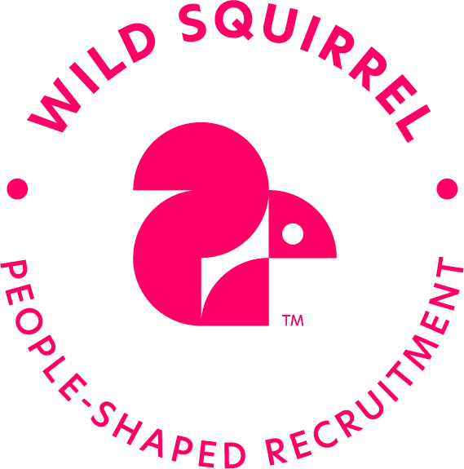

Olly Lawder

My purpose is to empower people to rise to the shared social and environmental challenges humanity faces. My career has focused on aligning this agenda with communications to create powerful levers for change. I work with leaders to identify purpose, align values, evolve brands, create culture and strategically embed sustainability across communications.

Delivering this work has required the development of a wide skillset including; facilitation, storytelling, brand positioning, internal comms, behaviour change and a depth of knowledge across social and environmental sustainability. For the last nine years I’ve done this at one of the world’s leading change agencies, Futerra.

I’m looking for my next step and an opportunity to take a leading role.

CV TLDR?

***I have 10+ years’ experience, as a sustainability communications consultant.***

Depth of knowledge in sustainability, cause and purpose

Positioning, narrative writing and key messaging

Vision, Mission, Purpose and Values creation

Campaign strategy and planning

Working with national and global businesses

Working with, leading and building multi-disciplinary teams

Key Experience

**Futerra:**

**Planning Director (9 years)**

*Consultancy*

* Designing and leading projects with major global and national clients. I take responsibility for owning the key client relationships, growing accounts, and selling in the best solution to the client’s needs.
* I have extensive experience directing mixed level teams across multiple skillsets, typically including subject matter specialists, consultants, copy writers and graphic designers.
  + - Building the case for change: I develop and maintain insight into the driving motivations of key audiences, including Millennials and Gen Z, and stay informed across a broad range of business and sustainability trends. I’m experienced in helping clients understand how their world is changing and identifying opportunities for their business to progress. I believe in continually improving the value and experience of the workshops I design and facilitate.
    - Identifying the new direction: An organisation’s Northstar can come in many formats, from purpose, to brand positioning, mission and vision. I have created dozens of Northstars - and the stories and messaging needed to bring them to life - while aligning them with sustainability and responsible business strategies. I believe this alignment is a potent force for creating material change across the modern business world.
    - Embedding the new frameworks: I have extensive experience creating communications strategies and plans, advising clients on how to target and engage customers, consumers, stakeholders and employees. I have worked with creative and production teams to plan and deliver a wide range of print and digital assets. I believe good ideas don’t sell themselves and need excellent communication to make them a reality.

*Company Culture*

* I’ve worked in some tough environments. As a result, I have a passion for building supportive cultures that set people up to succeed. I believe good leadership must be modelled which is why I have pushed hard for greater transparency, improved HR policies and authentic management/staff dialogue.
* The pandemic was challenging for all of us. I felt a need within the business and set up a series of all-team discussions to enable us all to better adapt to the pandemic. I led a process of reflection (sharing our experiences), projection (imagining our ideal pandemic working experience), solutions (exploring how we can best deliver on our ideal).

*Product and service innovation*

* I developed and trialled a new strategy to expand the agency’s offer medium sized clients. Called ‘Futerra Labs’ it was built on an agile approach to project management and client service we had some early success before icing the workstream at the beginning of the pandemic. Several of the piloted processes and client insights were brought over to improve the agency’s core offer.

**TRANSFORMATIVE CHANGE**

***The Crown Estate: Corporate Purpose and Values***

Leading this project with the COO and incoming CEO to articulate a new purpose and values for this historic corporation. This project helped unleash the potential of an organisation with a major role to play in the UK’s renewable energy and sustainable property future.

* Key achievements include designing and facilitating a virtual workshop programme to adapt to the challenges of the pandemic. Achieving consensus behind a new purpose that unites a diverse portfolio of business units. The project is now held up as best practice across the business and the account continues to grow as we move to the embedding phase of work.

***Heathrow 2.0***

Leading this project was an enormous opportunity to help set a new direction in an industry in need of change. I worked with Heathrow to move the narrative beyond ‘aviation exceptionalism’ to ‘aviation integration’ with people, place and planet.

* Key achievements include driving the commitment to carbon neutral expansion and upselling what started as a small comms job into a full strategy and story project with a near 10x growth in budget. I content-planned and co-wrote the signature [report](https://your.heathrow.com/wp-content/uploads/2018/07/Heathrow2.0.pdf) that marked the launch of the new strategy. The Heathrow Team subsequently won the 2019 Edie Award for Best Sustainability Strategy.

***SABMiller***

Leading the delivery of an integrated campaign to launch the business’s new awards program was a great opportunity to embed the new sustainability strategy within the company’s culture. I wrote the narrative for the campaign, planned the roll out, scoped the necessary assets and help deliver them with a multi-disciplinary team.

* Key achievement for the awards was that they were oversubscribed across all divisions that could enter. So much content was gathered that a new channel was created – podcasts – to create a year-long series digging deeper into some of the most interesting and insightful entries.

**THOUGHT LEADERSHIP**

***Covestro, Carbon Productivity***

Working for Covestro, in partnership with Volans, I crafted the story for this piece of breakthrough [thought leadership](http://carbonproductivity.com/). It was a great opportunity to provoke industry to reimagine its relationship to carbon and value creation.

* Key achievements include turning a complex, abstract idea into simple, accessible language without losing the subtlety of the message. Navigating the varying needs and perspectives of a multi-stakeholder consortium.

***Interface, Climate Take Back***

The opportunity to shape the [new mission](https://www.interface.com/EU/en-GB/campaign/climate-take-back/Climate-Take-Back-en_GB) for the pioneering Interface was a chance to raise the bar for the entire sustainable business community. Their desire was to not only tackle emissions but to reverse global warming.

* Key achievements include positioning their new mission with the simple phrase, “if we changed the climate by mistake, we can change it with intent,” and creating the mission rationale, communications content and plan for engaging stakeholders globally.

Further Experience

**Spencer Du Bois: Charity and NFP brand agency**

**Brand Planner / Qual Researcher (3 Years)**

I worked directly with Max DuBois through a highly co-creative approach tailored to meet the engagement needs of charity and non-profit clients.

* Delivered focus groups across the country, bringing our research function in house
* Facilitated why/how/what workshops to put values at the heart of our clients’ brand and campaigns.
* Worked in multiple stakeholder environments to deliver an inclusive process that would move our clients along a participatory, co-creation process.
* Key Accounts: The Ramblers Association, Motor Neurone Disease Association, Together (mental health), Dimensions (disability).

**Education:** Imperial College London, Business and the Environment (MSc), Distinction.University of Birmingham, Sociology (BA), 2:1.

A-Levels: AABA GCSEs: 10x A-A*

I won the school prize for Excellence In Design.

**Recent Side Projects**: GoodPAYE, [Freda](https://myfreda.com/), [Energy Gardens](http://energygarden.org.uk/), [Londoners The Board Game](https://www.kickstarter.com/projects/298541877/londoners-the-board-game)