# PUBH 7800: Public Health Practicum

## Finding a Practicum Site

Ultimately, it is up to the student to find a site – you are going to have to find something. But before you panic or get frustrated, realize that all students find their own sites. Sometimes it takes a little while. Sometimes organizations say no.

A useful approach is to think broadly about what types of organizations serve public health functions in your area. There are many of them, even ones you might not think of as public health. Look at the image below. It is a simple illustration to show you the range of organizations you could approach. Think creatively. What is around you?

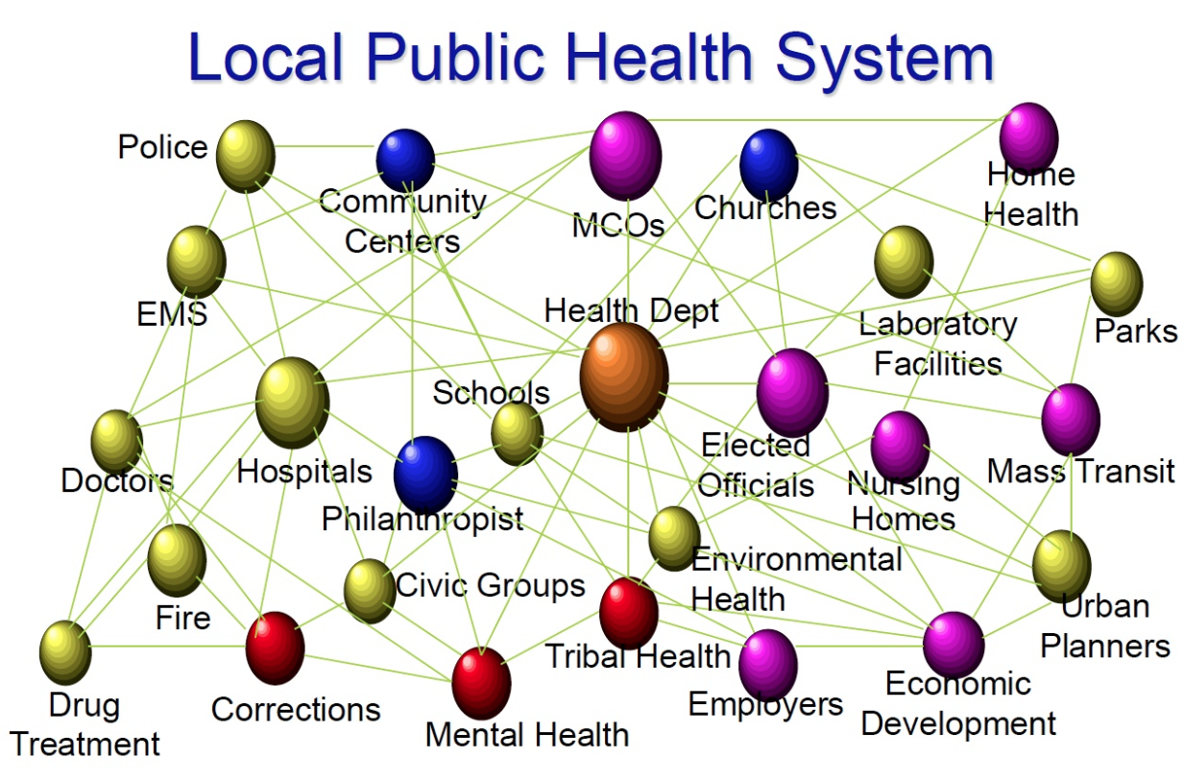

Next, think about how you present the practicum and yourself to the organization when you approach them. The practicum is essentially you offering to help them. And you are not volunteering to clean up or to file papers. You are offering a skill set to help them with something substantial that they might want or need. The skills you have acquired in this program are substantial. You can do things they value. Make it clear that you are asking if you can become involved with a task or project they want accomplished.

Now, you might need them to help you figure out what it is they need or want help with, but that is not a bad thing. Some places may expect you to have a project in mind, but many will be happy to have you build something with or for them.

In terms of time, setting up practicums with state entities (e.g., Department of Public Health, court system, state hospital system) often takes more time than working with a smaller and/or private organization. Keep that in mind. The big public health entities are great if you can get on with one, and don’t hesitate to try. But approach a range or organizations. Apply to more than one and then take whichever says yes or whichever you prefer.

One the one hand, everyone says you should find something you are really interested in. I often say that is a great idea if you can find the site easily, and it is definitely worth looking for a place and an issue that you care about. At the same time, there is value in getting the practicum (and your degree) done and then moving on to things you are interested in. So don’t be afraid to find a new site with a public health focus you might not have thought about. This can be a great learning experience.

The best option is to go to the site and meet face-to-face. That isn’t always possible, obviously. If you’ve called someone and haven’t heard back in more than 4 or 5 days, call again. People forget. Or they don’t prioritize you because they are busy. What is the worst that can happen? You call a few times, you annoy them, they say they don’t have anything, you move on. At least you have an answer and aren’t waiting and wondering.

You will be more successful in finding a place if you are persistent and enthusiastic. Finding a site might entail that you approach many and most say “no thank you” for whatever reason. Don’t take it personally; it’s not necessarily about you. You’re just trying to find a place that wants some help that you can build into a practicum project. Sell them on the idea that the practicum project and your service will be helpful to them.