聖公會呂明才中學
S.K.H. Lui Ming Choi Secondary School
創科班（Little Makers Class）
S2 Unit 1：進階創科人
S2 Unit 1: Advanced Innovators
第一堂
創科人 2.0：逆向工程
Innovator 2.0: Reverse Engineering
【家課】
[Homework]
姓名：____________________ 班別：________ 學號：________ 日期：____________
Name: ____________________ Class: ________ No.: ________ Date: ____________
家課題目
Homework questions
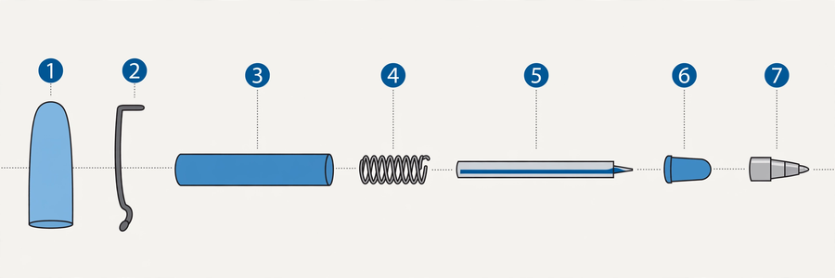
（答案請勿寫在此檔；參考答案見教師筆記。）
(Do not write answers here; see the teacher notes for reference answers.)
甲部：選擇題
Section A: Multiple choice
1. 逆向工程的定義是甚麼？
1. What is the definition of reverse engineering?
(A) 由想法設計出成品的過程
(A) The process of designing a product from an idea
(B) 透過拆解成品，倒推其設計原理與製作方法的分析過程
(B) The analytical process of working backwards from a finished product to its design principles and manufacturing methods
(C) 把產品拆毀的過程
(C) The process of breaking a product apart
(D) 複製別人產品的過程
(D) The process of copying someone else's product

2. 「記錄」步驟不包括以下哪一項？
2. Which of the following is NOT part of the "document" step?
(A) 繪圖記錄
(A) Drawing-based records
(B) 部件清單
(B) Parts list
(C) 推測設計意圖
(C) Inferring design intentions
(D) 寫下觀察所得
(D) Writing down observations

3. 以下哪項不符合結構圖的繪製規範？
3. Which does NOT meet the conventions for structural diagrams?
(A) 標示至少五個主要部件
(A) Labelling at least five major components
(B) 說明部件之間的連接方式
(B) Describing how components connect
(C) 畫出物件的外觀輪廓
(C) Drawing the object's outer outline
(D) 只用文字描述代替繪圖
(D) Replacing the drawing with text only

4. 拆解時，細小的螺絲應如何處理？
4. During dismantling, how should small screws be handled?
(A) 放入口袋保管
(A) Keep them in your pocket
(B) 放入收納盤，課後清點
(B) Put them in the tray and count them after class
(C) 放在桌上即可
(C) Leave them on the desk
(D) 直接丟掉
(D) Throw them away

5. 以下哪項最可能是「玩具車車輪用橡膠而非塑膠」的設計意圖？
5. Which is the most likely design intention behind "a toy car's wheels are rubber rather than plastic"?
(A) 橡膠比較便宜
(A) Rubber is cheaper
(B) 增加摩擦力，防止打滑
(B) To increase friction and prevent slipping
(C) 橡膠顏色比較美觀
(C) Rubber looks nicer
(D) 塑膠缺貨
(D) Plastic was out of stock

乙部：問答題
Section B: Short questions
1. 解釋「由外而內」和「由整體到部件」兩種結構分析方法的分別，並各舉一個拆解時的具體做法。
1. Explain the difference between the "outside-in" and "whole-to-parts" methods of structural analysis, giving one concrete dismantling practice for each.
2. 有同學認為「拆解舊玩具」只是貪玩，不是學習。你會如何反駁？試寫出兩個理由。
2. A classmate claims that "dismantling old toys" is just playing around, not learning. How would you argue back? Give two reasons.
3. 觀察你家中一件可拆式的物品（例如可替換筆芯的原子筆、拼裝玩具），寫出一個設計特點，並推測其設計意圖及理由。
3. Observe a separable item at home (e.g. a refillable pen, a construction toy), describe one design feature, and infer its design intention with reasons.

