聖公會呂明才中學
S.K.H. Lui Ming Choi Secondary School
創科班（Little Makers Class）
S2 Unit 1：進階創科人
S2 Unit 1: Advanced Innovators
第一堂
創科人 2.0：逆向工程
Innovator 2.0: Reverse Engineering
【學生筆記】
[Student Notes]
姓名：____________________ 班別：________ 學號：________ 日期：____________
Name: ____________________ Class: ________ No.: ________ Date: ____________
本堂物資表 Materials List
以下為本堂分組活動所需物資（每組一份）。請在老師派發時核對。
品名 Item | 數量（每組） Quantity (per group) | 安全注意 Safety notes
舊玩具或小型無電器具（例如舊鬧鐘、已移除電池的舊滑鼠、舊玩具車） | 每組 1 件 | 只可拆解無電池、無插電的物品；嚴禁拆解曾接駁電源的電器
螺絲批套裝（十字、一字） | 每組 1 套 | 使用時必須佩戴防護手套；不可對準他人或自己身體用力
防護手套（工作手套） | 每人 1 對 | —
放大鏡 | 每組 1 個 | —
A3 白紙 | 每組 2 張 | —
鉛筆、間尺、擦膠 | 每組 1 套 | —
零件收納盤／小盒 | 每組 1 個 | 細小零件必須放入盤內，課後清點
學習目標
Learning objectives
1. 列出逆向工程的三個基本步驟（拆解、記錄、分析）。
1. List the three basic steps of reverse engineering (disassemble, document, analyse).
2. 繪製所拆解物件的結構圖，正確標示至少五個主要部件的名稱與連接方式。
2. Draw a structural diagram of the dismantled object, correctly labelling the names and connections of at least five major components.
3. 推測至少兩項設計決定的意圖，並以書面寫出推測理由。
3. Infer the intentions behind at least two design decisions and state the reasons in writing.
一、什麼是逆向工程
1. What is reverse engineering
逆向工程是指：透過拆解成品，倒推其設計原理與製作方法的分析過程。
Reverse engineering is the analytical process of working backwards from a finished product to infer its design principles and manufacturing methods.
關鍵在於「逆向」二字：一般的設計流程是由想法到成品（正向）；逆向工程則相反，由成品倒推回當初的設計想法。
The key word is "reverse": the ordinary design process goes from idea to product (forward); reverse engineering goes the other way, from the finished product back to the original design thinking.
工程師進行逆向工程的原因包括：維修故障產品時找出損壞的部件；研究同類產品，學習別人設計的優點；了解舊產品的構造，以便進一步改良。
Engineers use reverse engineering to locate faulty parts when repairing products, to study similar products and learn from the strengths of others' designs, and to understand the structure of an existing product so it can be improved.
承接中一的學習：中一學過由零開始的設計思維；中二則學習由成品開始的逆向思維。兩種思維都是創科人的基本功。
Building on S1: in S1 you learned design thinking that starts from zero; in S2 you learn reverse thinking that starts from a finished product. Both are essential skills of an innovator.
二、三個基本步驟
2. The three basic steps
- 第一步：拆解——由外而內，小心分離各部件；只可拆解無電、無電池的物品；按次序把零件排列好。
Step 1: Disassemble — work outside-in and separate parts with care; dismantle only unpowered, battery-free items; lay out parts in order.
- 第二步：記錄——邊拆邊記，包括繪圖記錄和部件清單（拆解次序、部件名稱、數量、物料、觀察所得）。
Step 2: Document — record as you dismantle, using drawings and a parts list (disassembly order, part name, quantity, material, observations).
- 第三步：分析——從記錄中推測設計者的意圖，例如為何選用這種物料、為何這樣安排結構。
Step 3: Analyse — infer the designer's intentions from the records, e.g. why this material was chosen or why the structure is arranged this way.
三、結構分析的方法
3. Methods of structural analysis
- 由外而內：先觀察物件的外觀整體，再逐層拆入內部。
Outside-in: observe the overall appearance first, then work layer by layer into the interior.
- 由整體到部件：先看物件由哪幾大部分組成，再細看每個部件的構造。
Whole-to-parts: first identify the main sections of the object, then examine each component in detail.
四、結構圖的繪製規範
4. Conventions for structural diagrams
- 畫出物件的外觀輪廓。
Draw the object's outer outline.
- 標示至少五個主要部件的名稱。
Label the names of at least five major components.
- 說明部件之間的連接方式（例如：以螺絲固定、以卡榫接合）。
Describe how components connect (e.g. fixed with screws, joined with clips).
- 比例大致準確，線條清晰，圖面整潔。
Keep proportions roughly accurate, with clear lines and a neat presentation.
五、安全規則
5. Safety rules
- 只可拆解無電池、無插電的物品；嚴禁拆解曾接駁電源的電器。
Dismantle battery-free, unpowered items only; never dismantle appliances that have been connected to mains power.
- 使用螺絲批時必須佩戴防護手套；不可對準他人或自己的身體用力。
Wear protective gloves when using screwdrivers; never apply force towards another person or your own body.
- 細小零件必須放入收納盤，課後清點。
Keep small parts in the tray and count them after class.
- 拆解後須洗手。
Wash your hands after dismantling.
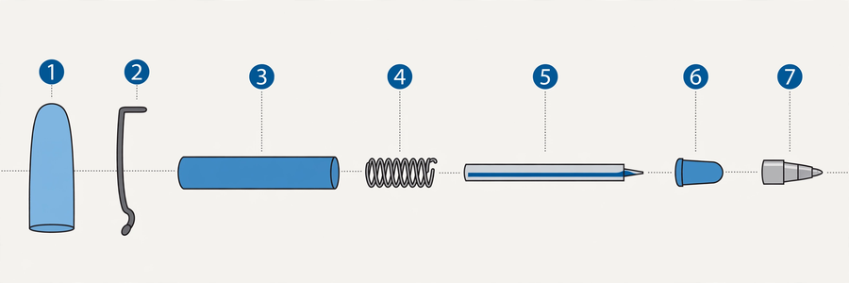
六、例子：從成品倒推設計意圖
6. Examples: reasoning backwards from products
例一：可替換筆芯的原子筆
Example 1: a refillable ballpoint pen
設計師為何不把筆造成一次性的？從成品（可以拆開更換筆芯的筆身）倒推：更換筆芯比整支棄掉更減少浪費，筆身壽命更長，長期成本更低。設計意圖很可能與環保及成本有關。
Why didn't the designer make the pen disposable? Reasoning backwards from the product (a body that opens for refills): replacing a refill wastes less than discarding the whole pen, the body lasts longer, and the long-term cost is lower. The intention was probably environmental and cost-related.
例二：玩具車的車輪用橡膠而非塑膠
Example 2: a toy car's wheels are rubber, not plastic
推測：橡膠的摩擦力較塑膠大，可以增加抓地力，防止車輪打滑。這是從物料選擇倒推設計意圖的例子。
Inference: rubber provides greater friction than plastic, improving grip and preventing the wheels from slipping. This is an example of inferring intention from material choice.
例三：車殼用三顆螺絲而非兩顆固定
Example 3: the shell is fixed with three screws, not two
推測：三點固定比兩點更穩固，受力更平均，車殼不易鬆脫或變形。這是從結構安排倒推設計意圖的例子。
Inference: three-point fixing is more stable than two-point fixing, distributes force more evenly, and keeps the shell from loosening or warping. This is an example of inferring intention from structural arrangement.
簡單問答題
Quick questions
問題 1：逆向工程的三個基本步驟是什麼？
Q1: What are the three basic steps of reverse engineering?
答：
Answer:
問題 2：拆解時為何要按次序擺放零件並加以記錄？
Q2: Why lay out parts in order and record the process during dismantling?
答：
Answer:
問題 3：結構圖最少要標示多少個主要部件？
Q3: What is the minimum number of major components a structural diagram must label?
答：
Answer:
問題 4：以下哪項不是安全規則？(A) 只拆解無電物品 (B) 戴手套使用螺絲批 (C) 把細小零件放入口袋保管 (D) 拆解後洗手
Q4: Which of the following is NOT a safety rule? (A) Dismantle unpowered items only (B) Wear gloves when using screwdrivers (C) Keep small parts in your pocket (D) Wash hands after dismantling
答：
Answer:
問題 5：「拆解」和「破壞」有何分別？
Q5: What is the difference between "dismantling" and "destroying"?
答：
Answer:
思考題
Thinking questions
問題 1：如果一件產品的設計者知道它將來會被拆解研究，他可能會怎樣設計？（提示：方便維修／防止拆解）
Q1: If a product's designer knew it would one day be taken apart and studied, how might they design it? (Hint: easy to repair / hard to dismantle)
答：
Answer:
問題 2：逆向工程只能用在實物上嗎？試舉一個非實物的例子。
Q2: Is reverse engineering limited to physical objects? Give a non-physical example.
答：
Answer:
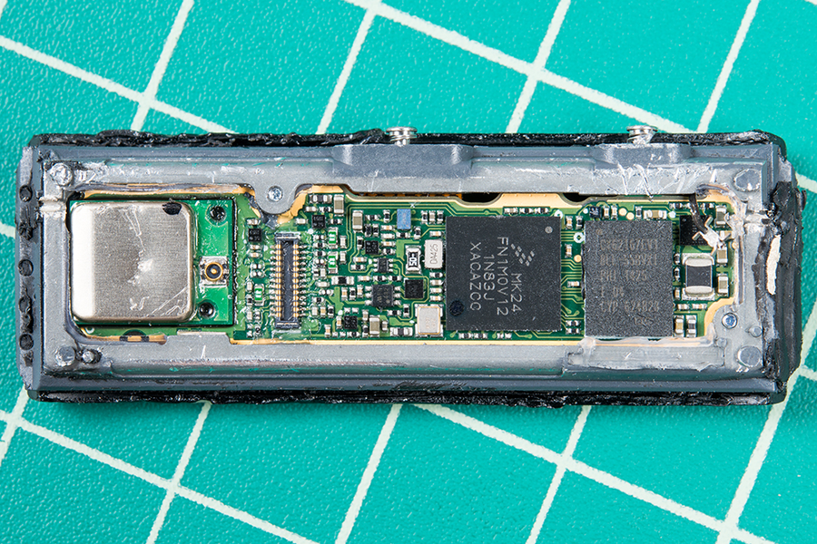
七、分組活動：拆解與記錄
7. Group task: dismantle and document
- 四人一組，佩戴防護手套，用螺絲批拆解舊玩具或小型器具。
In groups of four, wear protective gloves and dismantle an old toy or small device with screwdrivers.
- 按拆解次序擺放零件，填寫下方的拆解記錄表。
Lay out parts in disassembly order and complete the dismantling record sheet below.
- 繪製結構圖，標示至少五個主要部件及連接方式。
Draw a structural diagram labelling at least five major components and their connections.
- 小組討論，寫下至少兩項設計意圖推測及理由。
Discuss and write down at least two design-intention inferences with reasons.
拆解記錄表
Dismantling record sheet
拆解次序  Order | 部件名稱  Part name | 數量  Qty | 物料  Material | 觀察所得  Observations

設計意圖推測（至少兩項）
Design-intention inferences (at least two)
設計特點  Design feature | 推測原因  Inferred reason

八、總結
8. Summary
- 逆向工程＝由成品倒推設計原理與製作方法的分析過程。
Reverse engineering = the analytical process of working backwards from a finished product to its design principles and manufacturing methods.
- 三個步驟：拆解 → 記錄 → 分析。
Three steps: disassemble → document → analyse.
- 結構圖須包括外觀輪廓、至少五個部件標示、連接方式說明。
A structural diagram needs an outer outline, labels for at least five components, and descriptions of connections.
- 安全第一：只拆無電物品，戴手套，細零件入盤，拆完洗手。
Safety first: dismantle unpowered items only, wear gloves, keep small parts in the tray, wash hands afterwards.
- 下一堂，我們會把「分析」的對象由物件轉向人物：學習如何訪問和理解他人。
Next lesson we shift our analysis from objects to people: learning how to interview and understand others.
小測驗
Mini quiz
（請在課堂或課後完成；答案見教師版本。）
(Complete in class or after class; answers are in the teacher version.)
1. 以下哪項是逆向工程正確的步驟次序？
1. Which is the correct order of the reverse-engineering steps?
(A) 記錄 → 拆解 → 分析
(A) Document → disassemble → analyse
(B) 拆解 → 記錄 → 分析
(B) Disassemble → document → analyse
(C) 分析 → 拆解 → 記錄
(C) Analyse → disassemble → document
(D) 拆解 → 分析 → 記錄
(D) Disassemble → analyse → document

2. 繪製結構圖時，以下哪項做法正確？
2. When drawing a structural diagram, which practice is correct?
(A) 只畫外形，不用標示
(A) Draw the outline only, no labels needed
(B) 標示至少五個主要部件及連接方式
(B) Label at least five major components and their connections
(C) 用文字描述代替繪圖
(C) Replace the drawing with a written description
(D) 畫得愈複雜愈好
(D) The more complicated, the better

3. 拆解時可以拆解仍插著電源的電器，只要小心即可。（是／非）
3. It is acceptable to dismantle an appliance that is still plugged in, as long as you are careful. (True / False)

4. 寫出結構分析的兩種方法。
4. Write down the two methods of structural analysis.

5. 為什麼「記錄」是三個步驟中不可或缺的一環？試寫出一個原因。
5. Why is "document" an indispensable step? Give one reason.

課業
Assignments
- 完成結構圖：為課堂繪製的結構圖上色，並清楚標示各部件名稱與連接方式（用 A3 紙）。
Complete the structural diagram: colour the diagram drawn in class and clearly label each component's name and connections (on A3 paper).
- 書面反思（約二百字）：寫出拆解過程中最令你意外的發現，並推測一項設計決定的原因（例如：為何選用塑膠而非金屬）。
Written reflection (about 200 words): describe the most surprising discovery during dismantling, and infer the reason behind one design decision (e.g. why plastic was chosen over metal).
- 延伸參考：在 YouTube 搜尋「逆向工程例子」，觀看工程師拆解產品的短片。（文字描述，不附連結）
Further reference: search YouTube for reverse-engineering examples and watch short videos of engineers dismantling products. (Text description; no link attached.)

