聖公會呂明才中學
S.K.H. Lui Ming Choi Secondary School
創科班（Little Makers Class）
S2 Unit 1：進階創科人
S2 Unit 1: Advanced Innovators
第二堂
深入認識弱勢社群
Understanding Vulnerable Groups in Depth
【家課】
[Homework]
姓名：____________________ 班別：________ 學號：________ 日期：____________
Name: ____________________ Class: ________ No.: ________ Date: ____________
家課題目
Homework questions
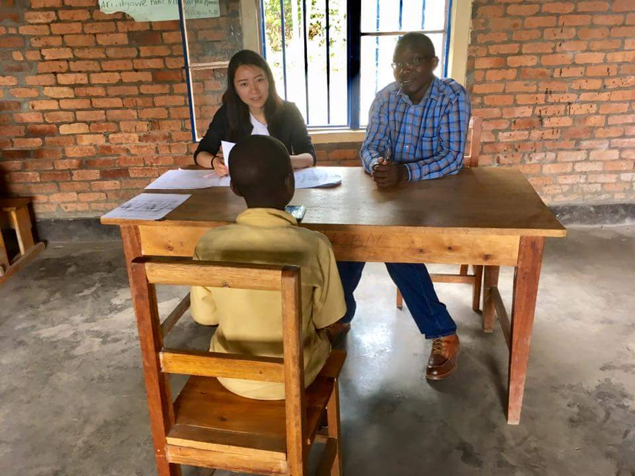
（答案請勿寫在此檔；參考答案見教師筆記。）
(Do not write answers here; see the teacher notes for reference answers.)
甲部：選擇題
Section A: Multiple choice
1. 以下哪項不是有效訪問的技巧？
1. Which of the following is NOT an effective interview skill?
(A) 提出開放式問題
(A) Asking open-ended questions
(B) 專心聆聽
(B) Listening attentively
(C) 打斷對方以節省時間
(C) Interrupting to save time
(D) 尊重私隱
(D) Respecting privacy

2. 「你通常幾點起床？」屬於哪類問題？
2. What type of question is "What time do you usually get up?"?
(A) 開放式
(A) Open-ended
(B) 封閉式
(B) Closed
(C) 引導性
(C) Leading
(D) 以上皆非
(D) None of the above

3. 訪問前最重要的準備是甚麼？
3. What is the most important preparation before an interview?
(A) 準備二十條問題
(A) Preparing twenty questions
(B) 先徵得對方同意
(B) Seeking consent first
(C) 帶備錄音筆
(C) Bringing a voice recorder
(D) 約在受訪者家中見面
(D) Meeting at the interviewee's home

4. 以下哪條問題最恰當？
4. Which question is the most appropriate?
(A) 你每個月收入多少？
(A) How much do you earn each month?
(B) 可否分享你平日的生活安排？
(B) Could you share how you usually organise your daily life?
(C) 你是不是覺得自己很可憐？
(C) Do you think you are pitiful?
(D) 你為什麼不去找工作？
(D) Why don't you go and find a job?

5. 設計問卷時，問題應如何排列？
5. How should questionnaire questions be ordered?
(A) 由深入到淺出
(A) From specific to general
(B) 隨機排列
(B) Randomly
(C) 由淺入深
(C) From general to specific
(D) 先問私隱問題
(D) Private questions first

乙部：問答題
Section B: Short questions
1. 將以下三條封閉式問題改寫為開放式問題：(a) 你喜歡看電視嗎？(b) 你有沒有去過社區中心？(c) 你覺得一個人住方便嗎？
1. Rewrite these three closed questions as open-ended ones: (a) Do you like watching TV? (b) Have you been to the community centre? (c) Do you find living alone convenient?
2. 承接社區探訪主題「了解視障人士的日常出行需要」，設計兩條開放式問題，並為每條寫一句設計用意。
2. For the community-visit theme "understanding the daily travel needs of the visually impaired", design two open-ended questions, each with a one-sentence design purpose.

