聖公會呂明才中學
S.K.H. Lui Ming Choi Secondary School
創科班（Little Makers Class）
S2 Unit 1：進階創科人
S2 Unit 1: Advanced Innovators
第三堂
從同情到同理
From Sympathy to Empathy
【學生筆記】
[Student Notes]
姓名：____________________ 班別：________ 學號：________ 日期：____________
Name: ____________________ Class: ________ No.: ________ Date: ____________
本堂物資表 Materials List
以下為本堂分組活動所需物資（每組一份）。請在老師派發時核對。
品名 Item | 數量（每組） Quantity (per group) | 安全注意 Safety notes
眼罩（遮光眼罩） | 每人 1 個 | 蒙眼活動時桌椅固定、通道暢通，教師全程在場；眼罩一人一用或課後清洗
個案研討卡（打印） | 每組 1 套 | —
對照工作紙、分析框架工作紙 | 每人各 1 張 | —
文具（筆、記事貼） | 每組 1 套 | —
學習目標
Learning objectives
1. 以自己的話解釋「同情」與「同理」的分別，並能各舉一個生活例子。
1. Explain in your own words the difference between "sympathy" and "empathy", giving one everyday example of each.
2. 分析指定個案，指出當中至少兩處體現同理心的設計特點。
2. Analyse a given case and identify at least two design features that demonstrate empathy.
3. 針對個案提出一項具體的改善建議，並以書面說明理由。
3. Propose one concrete improvement to the case and state the reasons in writing.
一、蒙眼體驗：活動與反思
1. Blindfold experience: activity and reflection
- 戴上眼罩，僅憑觸覺，在兩分鐘內從筆袋中找出指定的文具（例如擦膠）。
Wear a blindfold and, by touch alone, find a specified stationery item (e.g. an eraser) from your pencil case within two minutes.
- 完成後除下眼罩，分享感受：哪些地方不便？什麼時候需要協助？
After removing the blindfold, share your feelings: what was inconvenient? When did you need help?
重要提醒：短暫的體驗只是引起反思的起點，絕不等於真正理解視障人士的生活。切勿輕率下結論，更不要產生優越感。尊重，是體驗活動的第一課。
Important: a brief simulation is only a starting point for reflection — never equivalent to truly understanding the lives of the visually impaired. Do not draw hasty conclusions, and never feel superior. Respect is the first lesson of any experiential activity.
二、同情與同理
2. Sympathy vs empathy
同情
Sympathy
由上而下的憐憫：「我為你難過。」重點在「我」的感受。例子：見到視障人士，心想「他很可憐」。
Top-down pity: "I feel sorry for you." The focus is on my feelings. Example: seeing a visually impaired person and thinking "how pitiful".
同理
Empathy
設身處地理解：「我明白你的處境。」重點在理解對方的需要，並作出回應。例子：理解視障人士需要可靠的過路提示，支持並善用行人過路處的發聲裝置。
Putting oneself in another's shoes: "I understand your situation." The focus is on understanding the other person's needs and responding. Example: understanding that visually impaired people need reliable crossing cues, and supporting the audible signals at pedestrian crossings.
項目  Aspect | 同情  Sympathy | 同理  Empathy
出發點  Starting point | 憐憫，由上而下  Pity, top-down | 理解，設身處地  Understanding, putting oneself in their shoes
焦點  Focus | 自己的感受：「我為你難過」  One's own feelings: "I feel sorry for you" | 對方的需要：「我明白你的處境」  The other's needs: "I understand your situation"
例子  Example | 見到視障人士，覺得「他很可憐」  Seeing a visually impaired person and thinking "how pitiful" | 明白視障人士需要可靠的過路提示  Understanding that visually impaired people need reliable crossing cues
結果  Outcome | 停留在感受，未必帶來改變  Stays at the level of feeling; may bring no change | 促成針對需要的行動或設計  Leads to actions or designs addressing real needs

三、分析框架
3. Analytical framework
研討社會創新個案時，可用以下三欄框架分析，最後作出「同情還是同理」的判斷：
When studying social-innovation cases, analyse them with this three-column framework, then judge "sympathy or empathy":
- 使用者需要：使用者真正面對什麼困難？
User needs: what difficulties do users genuinely face?
- 設計回應：設計如何回應這些需要？
Design response: how does the design address these needs?
- 成效反思：設計是否有效？有沒有不足之處？
Effectiveness reflection: does the design work? Any shortcomings?
- 判斷：這個設計屬於同情還是同理？理據是什麼？
Judgement: is this design sympathy or empathy? What are the reasons?

四、個案一：點字標籤生活用品
4. Case 1: Braille-labelled daily products
設計背景
Design background
視障人士無法閱讀印刷文字，日常用品（例如藥物）的說明看不懂；誤服藥物可危害健康。如何讓他們獨立、安全地辨認生活用品，是一個真實而迫切的需要。
Visually impaired people cannot read printed text, so they cannot read instructions on daily items such as medicines; taking the wrong medicine endangers health. Enabling them to identify daily items independently and safely is a genuine and pressing need.
設計特點
Design features
- 為藥物等生活用品加上點字標籤，把重要資訊轉為可觸讀的形式。
Braille labels are added to medicines and daily items, converting key information into a touch-readable form.
- 標籤設於瓶身固定位置，方便視障人士憑觸覺穩定地找到。
Labels are placed at a fixed position on the container so visually impaired users can reliably locate them by touch.
相關機構
Related organisation
香港盲人輔導會（成立於 1956 年的慈善機構）設有點字製作等服務，支援視障人士獲取資訊。參考：https://www.hksb.org.hk/tc/
The Hong Kong Society for the Blind (a charity founded in 1956) provides Braille production and other services supporting access to information. Reference: https://www.hksb.org.hk/tc/
體現同理心之處
Where empathy shows
設計理解視障人士依賴觸覺的習慣（標籤設於固定位置）；針對真正的用藥安全需要，而不是流於表面的關懷。
The design understands visually impaired users' reliance on touch (labels at a fixed position) and addresses the genuine need for medication safety, rather than offering superficial care.
五、個案二：具語音提示的家用產品
5. Case 2: a household product with voice prompts
設計背景
Design background
以語音血壓計為例：視障人士或長者無法看清血壓計螢幕上的數字，難以自行量度血壓，長期監察健康變得困難。
Taking the talking blood pressure monitor as an example: visually impaired or elderly users cannot read the numbers on the monitor's screen, making it hard to measure blood pressure independently and monitor health over time.
設計特點
Design features
- 完成量度後以語音報讀結果，使用者不用看螢幕也知道讀數。
Results are read aloud after measurement, so users know the reading without seeing the screen.
- 按鍵設計簡單，操作步驟少，方便長者及視障人士使用。
Simple buttons and few steps make it easy for elderly and visually impaired users.
這類語音提示產品在市面真實有售，是視障輔助器具的一種。參考：https://askjan.org/solutions/Talking-Blood-Pressure-Monitors.cfm
Such voice-prompt products are genuinely available on the market as assistive devices for the visually impaired. Reference: https://askjan.org/solutions/Talking-Blood-Pressure-Monitors.cfm
體現同理心之處
Where empathy shows
設計讓使用者能獨立完成量度，不必長期依賴他人，維護其自主與尊嚴。
The design enables users to measure independently without long-term reliance on others, preserving their autonomy and dignity.
六、如何判斷一件設計是同情還是同理
6. How to judge: sympathy or empathy?
- 設計者有否真正諮詢使用者，了解他們的真實需要？
Did the designer genuinely consult users and understand their real needs?
- 設計是否針對使用者的真正需要，還是只為令設計者自我感覺良好？
Does the design address users' genuine needs, or just make the designer feel good?
- 科技愈先進，不等於愈有同理心；同理心在於是否真正理解使用者需要，與技術複雜程度無關。
More advanced technology does not mean more empathy; empathy lies in genuinely understanding user needs, not in technical sophistication.
簡單問答題
Quick questions
問題 1：用自己的話說出「同情」和「同理」的分別。
Q1: In your own words, explain the difference between "sympathy" and "empathy".
答：
Answer:
問題 2：蒙眼體驗後，我們應避免哪種結論？
Q2: After the blindfold experience, what kind of conclusion should we avoid?
答：
Answer:
問題 3：個案分析框架的三欄是什麼？
Q3: What are the three columns of the case-analysis framework?
答：
Answer:
問題 4：點字標籤設於「固定位置」，體現了什麼同理心？
Q4: What empathy does placing Braille labels at a "fixed position" demonstrate?
答：
Answer:
問題 5：以下哪項最能體現同理心？(A) 為災民送去大量自己不需要的舊衣並拍照宣傳 (B) 了解災民需要後，按尺碼整理衣物並安排試穿 (C) 在社交媒體表示同情 (D) 捐款後要求對方公開致謝
Q5: Which best demonstrates empathy? (A) Donating lots of unwanted old clothes to disaster victims and publicising it with photos (B) Learning victims' needs, then sorting clothes by size and arranging try-ons (C) Expressing sympathy on social media (D) Donating and demanding public thanks
答：
Answer:
思考題
Thinking questions
問題 1：「這個設計是同情還是同理？為什麼？」試以個案一或個案二作答，並提出理據。
Q1: “Is this design sympathy or empathy, and why?” Answer with reference to Case 1 or Case 2, with reasons.
答：
Answer:
問題 2：有人認為「科技愈先進，產品就愈有關愛」。你同意嗎？為什麼？
Q2: Some claim "the more advanced the technology, the more caring the product". Do you agree? Why?
答：
Answer:
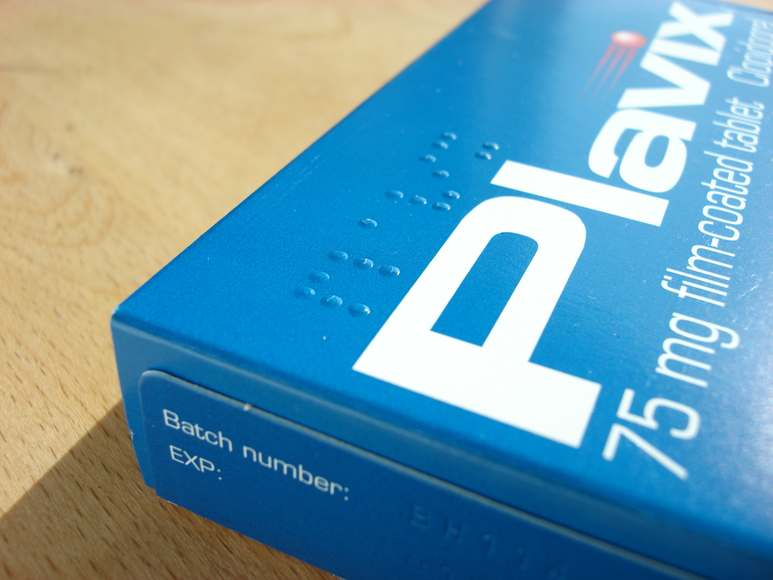
七、分組研討：個案分析
7. Group discussion: case analysis
- 四人一組，研讀個案卡（個案一或個案二）。
In groups of four, study the case card (Case 1 or Case 2).
- 運用分析框架（使用者需要 — 設計回應 — 成效反思）討論，並填寫下方的研討工作紙。
Discuss using the framework (user needs — design response — effectiveness reflection) and complete the worksheet below.
- 找出至少兩處體現同理心的設計特點。
Identify at least two design features demonstrating empathy.
- 準備小組匯報，並參與全班辯論：「這個設計是同情還是同理？為什麼？」
Prepare a group presentation and join the class debate: "Is this design sympathy or empathy, and why?"
個案研討工作紙
Case discussion worksheet
使用者需要  User needs | 設計回應  Design response | 成效反思  Effectiveness reflection

判斷：這個設計屬於同情還是同理？
Judgement: sympathy or empathy?
判斷：____________________（圈出其一：同情／同理）
Judgement: ____________________ (circle one: sympathy / empathy)
理據：
Reasons:
___________________________________________________________________________
___________________________________________________________________________
___________________________________________________________________________
___________________________________________________________________________
八、總結
8. Summary
- 同情＝由上而下的憐憫；同理＝設身處地理解對方需要。
Sympathy = top-down pity; empathy = understanding others' needs in their shoes.
- 同理心的設計，來自真正理解使用者需要，而非技術有多先進。
Empathetic design comes from genuinely understanding user needs, not from advanced technology.
- 分析框架：使用者需要 — 設計回應 — 成效反思 — 同情／同理判斷。
Framework: user needs — design response — effectiveness reflection — sympathy/empathy judgement.
- 扣連全年主題：正能量——用創科關愛弱勢社群。
Connecting with the annual theme: positive energy — caring for vulnerable groups through innovation and technology.
- 下一單元：社區探訪＋動手製作關愛產品，把同理心化為行動。
Next unit: community visits and hands-on caring-product projects — turning empathy into action.
小測驗
Mini quiz
（請在課堂或課後完成；答案見教師版本。）
(Complete in class or after class; answers are in the teacher version.)
1. 以下哪句屬於「同理」？
1. Which of the following shows "empathy"?
(A) 「你真可憐，我為你難過。」
(A) "How pitiful; I feel sorry for you."
(B) 「我明白一個人覆診要處理很多程序，一定很不容易；我們可以怎樣令流程更方便？」
(B) "I understand handling many procedures alone for a clinic visit is hard; how can we make it easier?"
(C) 「你要加油！」
(C) "Keep it up!"
(D) 「我比你更慘。」
(D) "I have it worse than you."

2. 分析社會創新個案時，以下哪個問題最有助判斷設計是否具同理心？
2. When analysing a social-innovation case, which question best helps judge whether the design is empathetic?
(A) 產品用了什麼先進技術？
(A) What advanced technology does the product use?
(B) 設計者有否真正諮詢使用者？
(B) Did the designer genuinely consult users?
(C) 產品外觀是否美觀？
(C) Is the product good-looking?
(D) 產品售價多少？
(D) How much does the product cost?

3. 蒙眼兩分鐘的體驗，足以讓我們完全理解視障人士的日常生活。（是／非）
3. A two-minute blindfold experience is enough for us to fully understand the daily life of the visually impaired. (True / False)

4. 寫出「同情」與「同理」在「出發點」上的分別。
4. Write down how "sympathy" and "empathy" differ in their starting points.

5. 為個案二（語音血壓計）提出一項具體的改善建議，並說明理由。
5. Propose one concrete improvement to Case 2 (the talking blood pressure monitor) and explain your reasons.

課業
Assignments
- 選擇本堂其中一個個案，撰寫約三百字短評：一、指出個案中兩處體現同理心的設計特點；二、提出一項具體的改善建議，並說明理由。
Choose one case from this lesson and write a commentary of about 300 words: 1. identify two design features in the case that demonstrate empathy; 2. propose one concrete improvement and explain your reasons.
- 延伸閱讀（以下連結已核實）：香港盲人輔導會 https://www.hksb.org.hk/tc/ ；語音血壓計產品資訊 https://askjan.org/solutions/Talking-Blood-Pressure-Monitors.cfm
Further reading (verified links): Hong Kong Society for the Blind https://www.hksb.org.hk/tc/ ; talking blood pressure monitors https://askjan.org/solutions/Talking-Blood-Pressure-Monitors.cfm

