S2 Little Makers Class ｜ 中二創科班
S2 Little Makers Class
Unit 2 Lesson 4
Unit 2: Advanced Hands-on STEAM
液壓機械臂
Hydraulic Robotic Arm
學生筆記 ｜ Student Notes
姓名 Name：__________ 班別 Class：______ 學號 No.：______ 日期 Date：__________
本堂物資表 Materials List
以下為本堂分組活動所需物資（每組一份）。請在老師派發時核對。
品名 Item | 數量（每組） Quantity (per group) | 安全注意 Safety notes
針筒（10 毫升，不連針頭） Syringes (10 mL, without needles) | 4 支 | 不可使用針頭；用後清洗，可重用。
透明膠喉（約 50 厘米） Plastic tubing (approx. 50 cm) | 2 條 | 接駁必須穩固；注水前檢查有否漏水。
紙皮／卡紙 Cardboard | 2 塊 | 紙皮邊緣或較鋒利，小心使用。
熱熔膠槍及膠條（全班共用） Glue guns and glue sticks (shared) | 每班 4–5 把 | 只准在教師指導下使用，小心燙傷。
膠紙 Adhesive tape | 1 卷 | —
波子及目標杯 Marbles and target cup | 5 粒＋1 隻杯 | 不可拋擲波子。
水、杯、紙巾 Water, cups, paper towels | 1 套 | 漏水須即時抹乾，避免弄濕地面及電源範圍。
工作紙 Worksheet | 每人 1 張 | —
一、課堂目標 ｜ Lesson Objectives
- 說出帕斯卡原理的內容，並以自己的話解釋液壓傳動的運作方式。 State Pascal's principle and explain hydraulic transmission in your own words.
- 製作一只能以液壓控制開合及擺動的簡易機械臂。 Build a simple robotic arm controlled hydraulically.
- 在限時內操控機械臂，準確夾起最少三粒波子並放進目標容器。 Pick up at least three marbles accurately into a target container within the time limit.
- 舉出最少兩個液壓技術在現實生活中的應用例子。 Give at least two real-life applications of hydraulic technology.
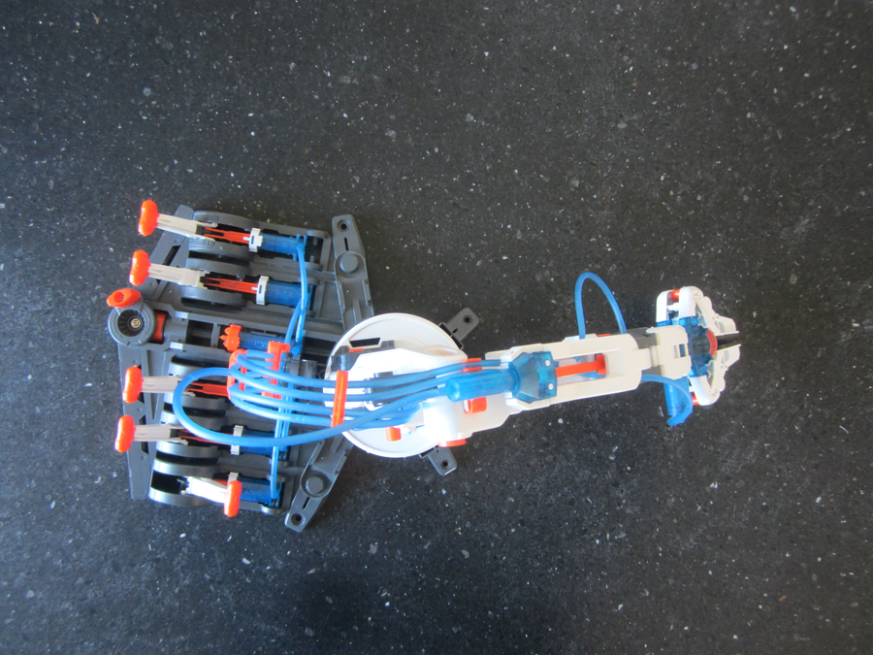
二、理論：帕斯卡原理與液壓傳動 ｜ Theory: Pascal's Principle and Hydraulic Transmission
帕斯卡原理（Pascal's principle）：施加於密閉容器內靜止液體的壓力，會以相同的大小傳遞到液體的每一部分。液體近乎不可被壓縮，因此壓力可以經液體由一端傳到另一端，推動另一端的活塞。
Pascal's principle: pressure applied to an enclosed fluid at rest is transmitted undiminished to every part of the fluid. Liquids are virtually incompressible, so pressure can travel through the liquid from one end to the other and push the piston at the far end.
力的放大：壓力相同，面積不同 ｜ Force Multiplication: Same Pressure, Different Areas
壓力 P ＝ 力 F ÷ 活塞面積 A。當兩支針筒以水管相連，兩邊壓力相等：F₁/A₁ ＝ F₂/A₂，因此 F₂ ＝ F₁ × (A₂/A₁)。
Pressure P = force F ÷ piston area A. When two syringes are joined by tubing, the pressure is equal on both sides: F₁/A₁ = F₂/A₂, so F₂ = F₁ × (A₂/A₁).
小針筒活塞面積 1 cm²，用 6 N 的力推動；大針筒活塞面積 4 cm²。則大針筒產生的力 F₂ ＝ 6 × (4/1) ＝ 24 N，是原來的 4 倍。但液體體積守恆（A₁×d₁ ＝ A₂×d₂），大針筒移動的距離只有小針筒的 1/4 —— 力大了，行程就短了。
A small syringe (piston area 1 cm²) is pushed with 6 N; a large syringe has piston area 4 cm². The large syringe exerts F₂ = 6 × (4/1) = 24 N — four times the force. But liquid volume is conserved (A₁×d₁ = A₂×d₂), so the large syringe moves only 1/4 of the distance — greater force means shorter travel.
液壓系統的三要素 ｜ Three Elements of a Hydraulic System
- 密閉的液體（本課用水）：不可壓縮，負責傳遞壓力。 Enclosed liquid (water in this lesson): incompressible, transmits pressure.
- 壓力傳遞：推動一端，壓力即時傳到另一端。 Pressure transmission: push one end and the pressure reaches the other end instantly.
- 活塞面積：面積差決定力量放大或縮小。 Piston area: the area difference determines force multiplication or reduction.
三、現實生活中的應用例子 ｜ Real-life Applications
- 液壓挖土機：司機在駕駛室內操作控制桿，液壓油把力量放大，推動沉重的挖臂。 Hydraulic excavator: the driver moves levers in the cab; hydraulic oil multiplies the force to drive the heavy digging arm.
- 汽車制動（煞車）系統：腳踏煞車踏板的力經煞車油傳到四個車輪的制動器。 Car braking system: the force on the brake pedal is transmitted by brake fluid to the brakes at all four wheels.
- 液壓千斤頂／升降機：用人手較小的力，把汽車或重物抬起。 Hydraulic jack / lift: a small manual force lifts a car or heavy load.
四、簡單問答題 ｜ Short Questions
1. 以自己的話寫出帕斯卡原理的內容。 State Pascal's principle in your own words.
2. 為甚麼「液體近乎不可壓縮」對液壓傳動十分重要？ Why is it important that liquids are virtually incompressible for hydraulic transmission?
3. 用小針筒推動大針筒時，大針筒的力及移動距離有何變化？ When a small syringe drives a large syringe, how do the force and travel distance at the large syringe change?
4. 舉出兩個液壓技術在現實生活中的應用。 Give two real-life applications of hydraulic technology.
五、思考題 ｜ Thinking Questions
1. 水管內若留有氣泡，傳動反應會變慢、變得不靈敏，試解釋原因。（提示：空氣與水有何不同？） If air bubbles remain in the tubing, transmission becomes slow and unresponsive. Explain why. (Hint: how does air differ from water?)
2. 若要設計一款幫助手部乏力長者的省力夾物器，針筒的大小應如何配搭？為甚麼？ To design a labour-saving gripper for elderly people with weak hands, how should the syringe sizes be matched? Why?
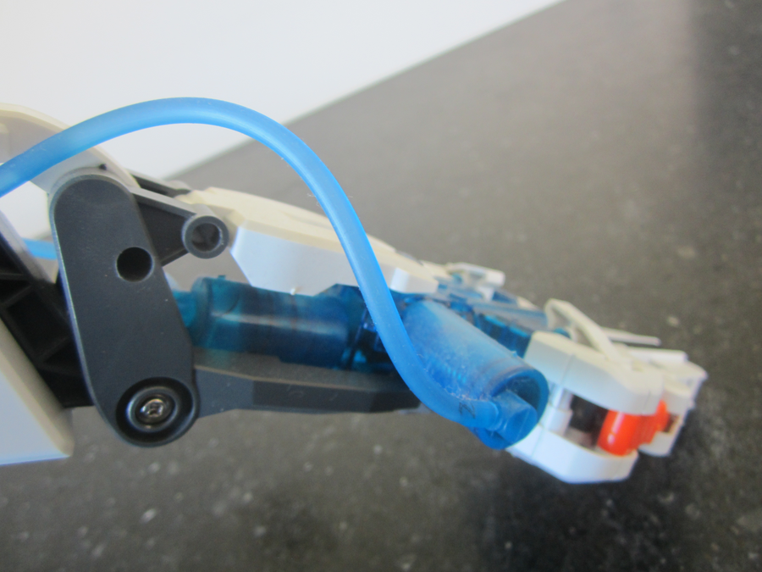
六、分組活動：夾波子比賽 ｜ Group Activity: Marble-pickup Competition
- 按設計圖製作機械臂：底座、臂身、液壓夾；注水時把針筒垂直向上，慢慢推走水管內的氣泡。 Build the arm (base, arm, hydraulic gripper) according to the design sketch. When filling with water, hold syringes vertically and expel air bubbles slowly.
- 比賽規則：每組限時 2 分鐘，操控機械臂夾起波子並放進目標容器，以準確夾起的數目計分。 Rules: 2 minutes per group; pick up marbles with the arm and place them into the target cup; score by the number picked up accurately.
- 成功關鍵：緩慢、穩定的操作，而非大力猛推。 Key to success: slow, steady operation — not pushing hard.
七、安全須知及物料 ｜ Safety Notes and Materials
- 針筒不連針頭使用，不可嬉戲或指向他人。 Use syringes without needles; do not play with them or point them at others.
- 水管接駁必須穩固；漏水須即時抹乾，避免弄濕地面及電源範圍。 Tubing joints must be secure; wipe up any leak immediately to keep floors and power areas dry.
- 熱熔膠槍只准在教師指導下使用，小心燙傷。 Glue guns may only be used under teacher supervision — beware of burns.
- 不可拋擲波子。 Do not throw marbles.
物料（每組，大約成本，僅供參考）：針筒（10 毫升，不連針頭）4 支約 HK$16；透明膠喉 2 條約 HK$10；紙皮 2 塊（循環再用）；熱熔膠槍（全班共用）；波子 5 粒＋目標杯約 HK$8（可重用）；水、杯、紙巾約 HK$2。
Materials (per group, approximate costs for reference only): 4 syringes (10 mL, without needles) ≈ HK$16; 2 plastic tubes ≈ HK$10; 2 pieces of cardboard (reused); glue guns (shared); 5 marbles + target cup ≈ HK$8 (reusable); water, cups, paper towels ≈ HK$2.
八、總結 ｜ Summary
- 帕斯卡原理：密閉液體的壓力會均勻傳遞到各部分。 Pascal's principle: pressure in an enclosed fluid is transmitted undiminished to all parts.
- 面積差可放大力量，但移動距離會相應縮短（體積守恆）。 Area differences multiply force, but travel distance shortens correspondingly (volume conserved).
- 液壓技術廣泛應用於挖土機、汽車制動、升降機等。 Hydraulics is widely used in excavators, car brakes, lifts and more.
- 精準控制靠穩定緩慢的操作；工程設計需經歷「設計—測試—改良」。 Precise control needs slow, steady operation; engineering design follows design–test–improve.
九、小測驗 ｜ Mini Quiz
（一）選擇題 Multiple choice（每題 2 分）
1. 帕斯卡原理是指：(A) 液體受壓會被壓縮 (B) 密閉液體所受的壓力會均勻傳遞到各部分 (C) 氣體比液體更適合傳遞壓力 (D) 壓力只會向下傳遞。 Pascal's principle states that: (A) liquids compress under pressure (B) pressure applied to an enclosed fluid is transmitted undiminished to all parts (C) gases transmit pressure better than liquids (D) pressure only travels downwards.
2. 小針筒（活塞面積 2 cm²）以 10 N 推動大針筒（活塞面積 6 cm²），大針筒產生的力約為：(A) 3.3 N (B) 10 N (C) 20 N (D) 30 N。 A small syringe (area 2 cm²) pushed with 10 N drives a large syringe (area 6 cm²). The force at the large syringe is about: (A) 3.3 N (B) 10 N (C) 20 N (D) 30 N.
3. 下列哪項不是液壓系統的要素？(A) 密閉液體 (B) 壓力傳遞 (C) 活塞面積 (D) 電池供電。 Which is NOT an element of a hydraulic system? (A) enclosed liquid (B) pressure transmission (C) piston area (D) battery power.
（二）問答題 Short questions（每題 2 分）
1. 解釋為何推動小針筒能令另一端的大針筒產生較大的夾緊力，但移動距離較短。 Explain why pushing the small syringe produces a larger gripping force at the large syringe, but over a shorter distance.
2. 為手部乏力的長者設計液壓輔助夾物器時，為甚麼宜用「小針筒推動大針筒」的配搭？ When designing a hydraulic assistive gripper for elderly people with weak hands, why is a "small syringe driving a large syringe" arrangement preferable?

