S2 Little Makers Class ｜ 中二創科班
S2 Little Makers Class
Unit 2 Lesson 6
Unit 2: Advanced Hands-on STEAM
意粉橋
Spaghetti Bridge
學生筆記 ｜ Student Notes
姓名 Name：__________ 班別 Class：______ 學號 No.：______ 日期 Date：__________
本堂物資表 Materials List
以下為本堂分組活動所需物資（每組一份）。請在老師派發時核對。
品名 Item | 數量（每組） Quantity (per group) | 安全注意 Safety notes
乾意粉 Dry spaghetti | 約 100 克 | 避免浪費；用剩的意粉可帶走。
白膠漿 White glue | 1 支 | 如用熱熔膠槍，只准在教師指導下使用，小心燙傷。
電子磅（全班共用） Electronic scales (shared) | 每班 2–3 個 | 輕放。
砝碼／硬幣（作負重，教師準備） Weights / coins for loading (teacher-prepared) | 1 套 | 加重時動作要輕，避免砸傷。
墊板、鉸剪 Cutting mats, scissors | 每組 1 套 | 鉸剪小心使用。
工作紙 Worksheet | 每人 1 張 | —
一、課堂目標 ｜ Lesson Objectives
- 說出三角形結構較四邊形穩定的原因。 Explain why triangular structures are more stable than quadrilateral ones.
- 設計並搭建一座跨距不少於 30 厘米的意粉橋。 Design and build a spaghetti bridge spanning at least 30 cm.
- 量度橋身重量及最大承重，並正確計算效率值。 Measure bridge weight and maximum load, and calculate the efficiency value correctly.
- 清楚解釋自己在設計中所作的一個取捨決定。 Clearly explain one trade-off decision in the design.
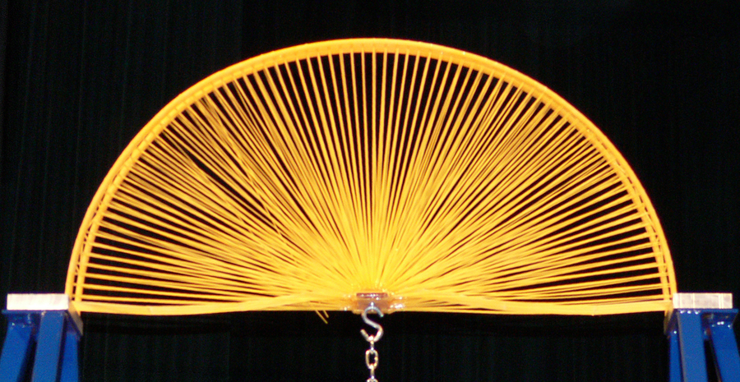
二、理論：為甚麼三角形最穩定？ ｜ Theory: Why Are Triangles the Most Stable?
三角形的三條邊長度固定後，它的形狀就唯一確定 —— 無論怎樣擠壓，角度都不會改變。這種「剛性」令三角形成為最穩定的平面圖形。相反，四邊形的邊長固定，形狀仍可改變（正方形可被壓成菱形），因此容易變形。
Once its three side lengths are fixed, a triangle's shape is uniquely determined — no amount of squeezing changes its angles. This rigidity makes the triangle the most stable plane figure. A quadrilateral with fixed side lengths can still deform (a square can be squeezed into a rhombus), so it deforms easily.
橋樑的桁架（truss）正是由無數個三角形單元組成：每個三角形把外力分散到三條邊上，整體結構既輕又堅固。接駁點是結構的弱點，須特別加固。
A bridge truss is made of countless triangular units: each triangle spreads external forces across its three members, making the whole structure light yet strong. Joints are the weak points and need reinforcement.
三、雙評分制：承重與效率值 ｜ Dual Scoring: Load Capacity and Efficiency
比賽有兩個獎項：「承重王」（最大承重最高）及「效率王」（效率值最高）。效率值 ＝ 最大承重 ÷ 橋身重量，量度「每一克物料換來多少承重」。
Two awards: "Load Champion" (greatest maximum load) and "Efficiency Champion" (highest efficiency value). Efficiency = maximum load ÷ bridge weight — how much load each gram of material buys.
A 組：橋重 50 克，最大承重 2,000 克，效率值 ＝ 2000 ÷ 50 ＝ 40。B 組：橋重 90 克，最大承重 2,700 克，效率值 ＝ 2700 ÷ 90 ＝ 30。B 組承重較高，但 A 組效率值較高 —— 這就是「承重」與「輕量化」之間的取捨。
Numerical example: Group A — bridge 50 g, max load 2,000 g, efficiency = 40. Group B — bridge 90 g, max load 2,700 g, efficiency = 30. Group B carries more, but Group A is more efficient — the trade-off between load capacity and light weight.
四、簡單問答題 ｜ Short Questions
1. 為甚麼三角形比四邊形穩定？試以「邊長固定後形狀能否改變」解釋。 Why is a triangle more stable than a quadrilateral? Explain using whether the shape can change once side lengths are fixed.
2. 寫出效率值的公式，並解釋它的意義。 State the efficiency formula and explain what it means.
3. 某橋重 60 克，最大承重 1,800 克，效率值是多少？ A bridge weighs 60 g and bears a maximum load of 1,800 g. What is its efficiency value?
4. 為甚麼接駁點是結構的弱點？ Why are joints the weak points of a structure?
五、思考題 ｜ Thinking Questions
1. 有同學想「用多一倍意粉，承重一定多一倍」。這個想法有何問題？試以效率值的角度分析。 A classmate thinks "double the spaghetti, double the load". What is wrong with this idea? Analyse it using efficiency.
2. 若只能在「橋面加一層橫樑」或「把接駁點全部加固」之間二選一，你會選哪個？為甚麼？ If you could only choose between "adding a layer of cross beams on the deck" or "reinforcing all joints", which would you pick? Why?
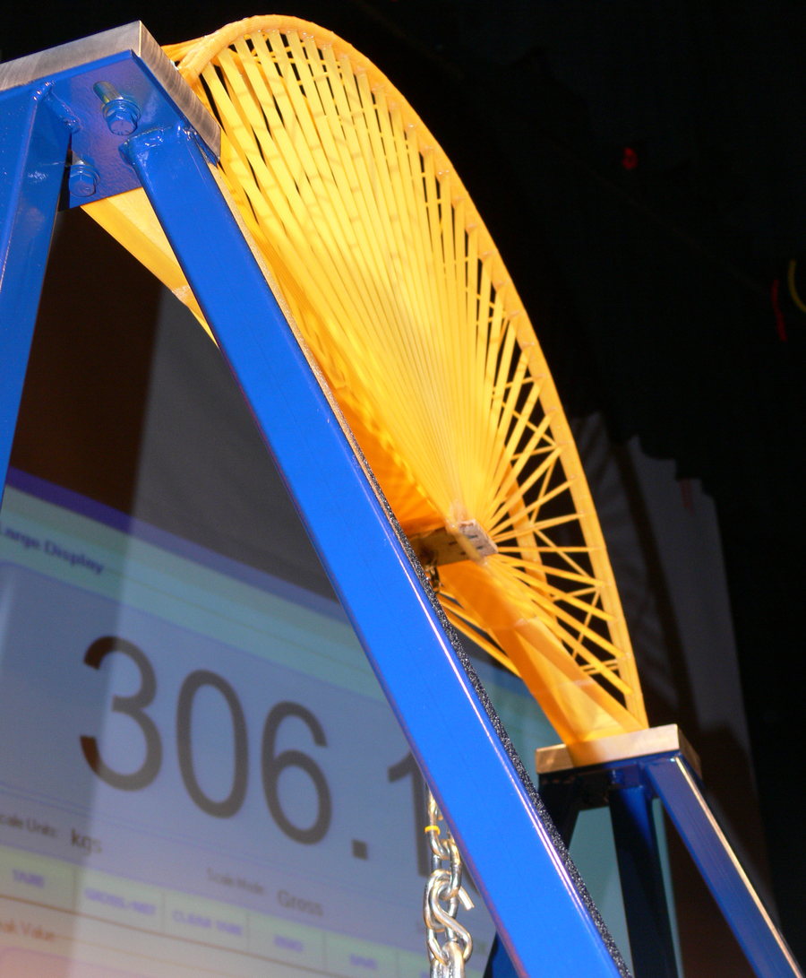
六、分組活動：搭建與承重測試 ｜ Group Activity: Building and Load Testing
- 先擠壓三角形與四邊形意粉框架，親身感受穩定性差異。 Squeeze triangular and quadrilateral frames to feel the stability difference.
- 繪畫設計圖（橋樑正視圖＋標示尺寸），估算用料；跨距不少於 30 厘米。 Draw the design (front elevation with dimensions); span at least 30 cm.
- 搭建要點：膠水只塗於接點；以小段意粉加固弱點；及早完成主體，預留時間讓膠水乾透。 Tips: glue only at joints; reinforce weak points with short segments; finish the main structure early so glue dries.
- 測試：量度橋重 → 把橋架在兩個支座上 → 逐漸加重至橋斷裂，記錄最大承重 → 計算效率值。 Test: weigh the bridge → span it across two supports → add load gradually until it breaks → record max load → calculate efficiency.
七、安全須知及物料 ｜ Safety Notes and Materials
- 鉸剪小心使用；意粉碎屑勿亂拋。 Use scissors carefully; do not scatter spaghetti fragments.
- 測試時在橋下放置軟墊，承接斷裂掉下的重物。 Place a soft mat under the bridge to catch falling weights.
- 加重時動作要輕，避免重物砸傷。 Add weights gently to avoid injury.
物料（每組，大約成本，僅供參考）：乾意粉約 100 克約 HK$6；白膠漿 1 支約 HK$8；電子磅（全班共用）；砝碼／硬幣（教師準備）；墊板、鉸剪（現有物資）。
Materials (per group, approximate costs for reference only): dry spaghetti ≈ 100 g ≈ HK$6; white glue ≈ HK$8; electronic scales (shared); weights/coins (teacher-prepared); cutting mats and scissors (existing stock).
八、總結 ｜ Summary
- 三角形邊長固定則形狀唯一確定，是桁架的基本單元。 A triangle's shape is fixed once its sides are set — the basic unit of trusses.
- 效率值 ＝ 最大承重 ÷ 橋身重量；「取捨」是工程設計的核心。 Efficiency = max load ÷ bridge weight; trade-off is at the heart of engineering design.
- 加強某部分往往意味增加重量或成本；接駁點須特別加固。 Strengthening one part usually adds weight or cost; joints need special reinforcement.
九、小測驗 ｜ Mini Quiz
（一）選擇題 Multiple choice（每題 2 分）
1. 三角形結構穩定的原因是：(A) 意粉較硬 (B) 三條邊固定後形狀唯一確定，不易變形 (C) 三角形較美觀 (D) 膠水較易黏合。 Triangles are stable because: (A) spaghetti is hard (B) fixed side lengths uniquely determine the shape, resisting deformation (C) they look nice (D) glue sticks better.
2. 某橋重 40 克，最大承重 1,600 克，效率值為：(A) 4 (B) 40 (C) 400 (D) 64。 A 40 g bridge bears 1,600 g. Its efficiency is: (A) 4 (B) 40 (C) 400 (D) 64.
3. 「效率王」獎項頒給：(A) 承重最高的組別 (B) 橋身最輕的組別 (C) 效率值最高的組別 (D) 用料最多的組別。 The "Efficiency Champion" goes to: (A) greatest load (B) lightest bridge (C) highest efficiency value (D) most material used.
（二）問答題 Short questions（每題 2 分）
1. 解釋「取捨」在意粉橋設計中的意思，並舉一例。 Explain what "trade-off" means in spaghetti-bridge design, with an example.
2. 有同學在接點塗上大量膠水，認為「膠水愈多愈牢」。試指出這個做法的兩個問題。 A classmate applies lots of glue at the joints, thinking "more glue means stronger". Point out two problems with this.

