S2 Little Makers Class ｜ 中二創科班
S2 Little Makers Class
Unit 2 Lesson 7
Unit 2: Advanced Hands-on STEAM
雞蛋保護裝置
Egg Drop Protection Device
學生筆記 ｜ Student Notes
姓名 Name：__________ 班別 Class：______ 學號 No.：______ 日期 Date：__________
本堂物資表 Materials List
以下為本堂分組活動所需物資（每組一份）。請在老師派發時核對。
品名 Item | 數量（每組） Quantity (per group) | 安全注意 Safety notes
雞蛋 Eggs | 2 隻（1 隻後備） | 小心輕放，避免在課室內打破。
飲管、報紙、膠袋 Straws, newspaper, plastic bags | 1 套 | —
膠紙、繩、棉花 Adhesive tape, string, cotton wool | 1 套 | —
氣泡紙 Bubble wrap | 1 小塊 | —
工作紙 Worksheet | 每人 1 張 | —
掉落測試 | — | 只可在老師指定地點掉落；圍觀須保持距離；掉落範圍必須清空。
一、課堂目標 ｜ Lesson Objectives
- 說出空氣阻力及緩衝吸震在減速保護中的作用。 Explain the roles of air resistance and cushioning in slowing and protection.
- 設計並製作一個雞蛋降落保護裝置。 Design and build an egg-drop protection device.
- 預測測試結果，並在測試後根據結果提出一項具體改良。 Predict the outcome and propose one specific improvement after the test.
- 全程遵守高空掉落測試的安全規則。 Follow all safety rules of the drop test throughout.
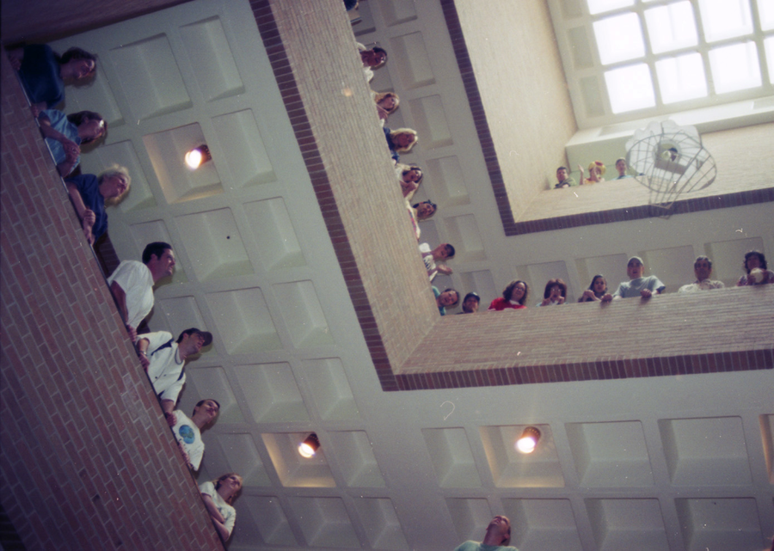
二、理論：空氣阻力 ｜ Theory: Air Resistance
物體在空氣中下落時，空氣會施加與運動方向相反的阻力，稱為空氣阻力（air resistance）。阻力大小與迎風面積及速度有關：降落傘面積愈大，空氣阻力愈大，下墜速度愈慢。物體最終會達到一個等速下降的「終端速度」—— 降落傘的設計目標，就是把這個速度降到雞蛋可承受的範圍。
A falling object experiences air resistance opposing its motion. Resistance depends on frontal area and speed: a larger parachute gives greater resistance and slower descent. The object eventually falls at a constant "terminal velocity" — the parachute's job is to bring this speed down to what the egg can survive.
關鍵：降落傘必須順利張開。傘面太小或未能張開，減速效果都十分有限。
Key point: the parachute must open properly. A canopy that is too small or fails to open gives little slowing effect.
三、理論：緩衝吸震 ｜ Theory: Cushioning and Shock Absorption
雞蛋撞擊地面時受到衝擊力。根據衝量概念：衝擊力 × 撞擊時間 ＝ 動量變化。動量變化固定，要減低衝擊力，就要延長撞擊時間 —— 這正是緩衝物料（棉花、氣泡紙、報紙）的作用：讓雞蛋「慢慢停下來」。
On impact the egg experiences an impact force. From impulse: force × impact time = change in momentum. With momentum change fixed, the way to cut the force is to lengthen the impact time — exactly what cushioning (cotton wool, bubble wrap, newspaper) does: it lets the egg "stop slowly".
一隻 0.05 公斤的雞蛋以約 10 m/s 撞地：若在 0.01 秒內停下，平均衝擊力約 50 N；若緩衝物料把撞擊時間延長至 0.1 秒，衝擊力降至約 5 N —— 相差十倍！
Numerical example: a 0.05 kg egg hitting the ground at about 10 m/s — stopped in 0.01 s, the average force is about 50 N; with cushioning extending the stop to 0.1 s, the force falls to about 5 N — ten times less!
另一要點：雞蛋必須固定於裝置中央，並以軟物料包裹，避免撞擊時移位撞向硬物。
Another key point: fix the egg at the centre of the device and wrap it in soft material, so it cannot shift and strike hard parts on impact.
四、簡單問答題 ｜ Short Questions
1. 降落傘面積與下墜速度有何關係？試解釋。 What is the relationship between parachute area and descent speed? Explain.
2. 緩衝物料如何減低雞蛋所受的衝擊力？試以「撞擊時間」解釋。 How does cushioning reduce the impact force on the egg? Explain using "impact time".
3. 為甚麼雞蛋必須固定於裝置中央？ Why must the egg be fixed at the centre of the device?
4. 裝置中哪部分負責「減速」，哪部分負責「吸震」？ Which part of the device is responsible for "slowing" and which for "shock absorption"?
五、思考題 ｜ Thinking Questions
1. 有同學把雞蛋包了很厚，但裝置整體變得很重。為甚麼過重反而可能令雞蛋更危險？ A classmate wraps the egg very thickly, making the whole device heavy. Why might extra weight put the egg in more danger?
2. 如果降落傘在半空未能張開，你會如何改良設計，令它較大機會順利張開？ If the parachute fails to open mid-air, how would you improve the design so it opens more reliably?
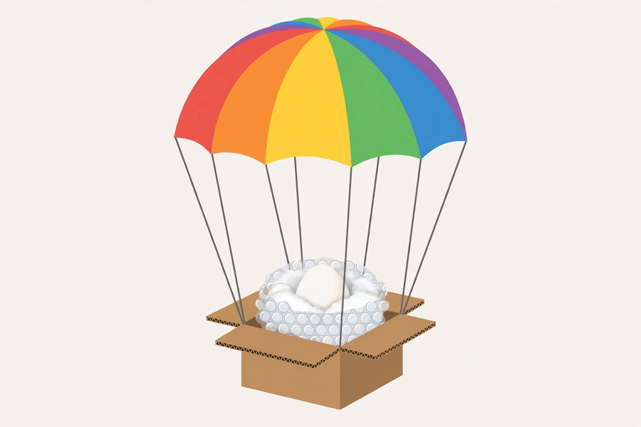
六、分組活動：設計與掉落測試 ｜ Group Activity: Design and Drop Test
- 繪畫設計圖，標示減速部分（降落傘）及吸震部分（緩衝物料），列出所用物料，寫下預測。 Draw the design, labelling the slowing part (parachute) and shock-absorbing part (cushioning); list materials and write a prediction.
- 製作要點：降落傘面積要足夠大，傘繩長度均等；雞蛋固定於中央，以軟物料包裹。 Build: canopy large enough, equal-length shroud lines; egg fixed at the centre, wrapped softly.
- 測試：只可在教師指定的地點掉落；圍觀須保持距離；掉落範圍必須清空。 Test: drop only at the teacher-designated location; spectators keep their distance; the drop zone must be clear.
- 記錄預測與實際結果、雞蛋狀況；測試後提出一項具體改良。 Record predicted vs actual results and the egg's condition; propose one specific improvement afterwards.
七、安全須知及物料 ｜ Safety Notes and Materials
- 只可在教師指定的地點進行掉落測試，嚴禁在課室或走廊自行掉落。 Drop only at the designated location — never in classrooms or corridors.
- 圍觀時保持距離，掉落範圍必須清空。 Spectators keep their distance; the drop zone must be clear.
- 小心輕放雞蛋，避免在課室內打破；打破了須即時通知教師清理。 Handle eggs gently; report any breakage in the classroom to the teacher immediately.
物料（每組，大約成本，僅供參考）：雞蛋 2 隻（1 隻後備）約 HK$4；飲管、報紙、膠袋（循環再用）約 HK$5；膠紙、繩、棉花約 HK$8；氣泡紙 1 小塊約 HK$3。
Materials (per group, approximate costs for reference only): 2 eggs (1 spare) ≈ HK$4; straws, newspaper, plastic bags (reused) ≈ HK$5; tape, string, cotton wool ≈ HK$8; a small piece of bubble wrap ≈ HK$3.
八、總結 ｜ Summary
- 空氣阻力：降落傘面積愈大，減速效果愈明顯；傘必須順利張開。 Air resistance: larger canopy, greater slowing; it must open properly.
- 緩衝吸震：延長撞擊時間，減低衝擊力。 Cushioning: lengthen impact time to cut impact force.
- 雞蛋固定於中央，避免撞擊時移位。 Fix the egg at the centre to prevent shifting on impact.
- 「預測—測試—改良」是工程師常用的工作循環。 "Predict–test–improve" is the engineer's working cycle.
九、小測驗 ｜ Mini Quiz
（一）選擇題 Multiple choice（每題 2 分）
1. 降落傘能減慢下墜速度，主要是因為：(A) 降落傘較輕 (B) 傘面增大空氣阻力 (C) 降落傘較美觀 (D) 傘繩拉住雞蛋。 A parachute slows descent mainly because: (A) it is light (B) the canopy increases air resistance (C) it looks nice (D) the lines hold the egg.
2. 緩衝物料保護雞蛋的原理是：(A) 令雞蛋變輕 (B) 延長撞擊時間，減低衝擊力 (C) 令雞蛋變硬 (D) 吸收水分。 Cushioning protects the egg by: (A) making it lighter (B) lengthening impact time to reduce impact force (C) hardening it (D) absorbing water.
3. 下列哪個做法最可能令測試失敗？(A) 降落傘面積足夠大 (B) 雞蛋固定於中央 (C) 降落傘未能張開 (D) 以棉花包裹雞蛋。 Which is most likely to cause failure? (A) large canopy (B) egg fixed at centre (C) parachute fails to open (D) egg wrapped in cotton wool.
（二）問答題 Short questions（每題 2 分）
1. 解釋裝置中「減速」與「吸震」分別由哪部分負責，以及各自的原理。 Explain which parts handle "slowing" and "shock absorption", and the principle of each.
2. 測試後你的雞蛋破裂了，提出一項具體改良並說明理據。 Your egg broke in the test. Propose one specific improvement with justification.

