聖公會呂明才中學
S.K.H. Lui Ming Choi Secondary School
創科班 S1 Unit 1：創科人出發
Little Makers Class S1 Unit 1: Innovators Set Off
第 1 堂：歡迎來到創科班——工程師思維（紙塔挑戰）
Lesson 1: Welcome to the Little Makers Class — Thinking Like an Engineer (Paper Tower Challenge)
學生筆記
Student Notes
姓名 Name：＿＿＿＿＿＿ 班別 Class：＿＿ 日期 Date：＿＿＿＿＿＿
本堂物資表 Materials List
以下為本堂分組活動所需物資（每組一份）。請在老師派發時核對。
品名 Item | 數量（每組） Quantity (per group) | 安全注意 Safety notes
A4 白紙 A4 paper | 10 張 10 sheets | 紙邊較鋒利，提醒學生小心輕放。 Paper edges can be sharp; remind students to handle with care.
皺紋膠紙 Masking tape | 1 卷 1 roll | — —
一元硬幣（測試用） $1 coins (for load test) | 20 枚 20 coins | 硬幣細小，不可放入口中；測試後點算交還。 Small parts — do not put in mouth; count and return after testing.
直尺（30 厘米） Ruler (30 cm) | 1 把 1 each | — —
剪刀 Scissors | 1 把 1 each | 使用時注意安全，用完立即收好。 Use with care; put away immediately after use.
計時器 Timer | 全班 1 個 1 per class | — —
工作紙 Worksheet | 每人 1 張 1 per student | — —

一、本課簡介
1. Introduction
歡迎加入創科班！本學年我們的主題是「正能量——用創科關愛弱勢社群」。在這一年的學習裡，我們會親自動手、勇於嘗試，把創意和科技結合，為有需要的人帶來幫助。本課是第一課，我們會透過「紙塔挑戰」，學習工程師的工作方法。
Welcome to the Little Makers Class! Our theme this year is "Positive Energy — Using Innovation and Technology to Care for Disadvantaged Groups". This year we will make things with our own hands, dare to try, and combine creativity with technology to help people in need. In this first lesson, we will learn how engineers work through the "Paper Tower Challenge".
二、甚麼是工程師思維？
2. What is thinking like an engineer?
工程師的工作，是把意念變成有用的東西：橋樑、大廈、手機、輪椅，都是工程師設計出來的。工程師遇到難題時，不會只靠空想，而會用一個可靠的方法：先設計，再測試，最後改良。這個方法叫做「工程循環」。
Engineers turn ideas into useful things: bridges, buildings, mobile phones and wheelchairs are all designed by engineers. When engineers face a difficult problem, they do not just daydream — they follow a reliable method: design first, then test, then improve. This method is called the "engineering cycle".
三、工程循環：設計 → 測試 → 改良
3. The engineering cycle: design → test → improve
1. 設計（Design）：先想清楚辦法，把意念畫成草圖。好的設計在動手之前，已經在腦中和紙上試過一次。
Design: think through the solution first and draw it as a sketch. A good design has already been tried once in your head and on paper before you start building.
2. 測試（Test）：動手做出來，用統一的方法量度結果，並且把數據記錄下來。測試的目的是找出真相：設計是否真的可行？
Test: build it, measure the result with a consistent method, and record the data. The purpose of testing is to find out the truth: does the design really work?
3. 改良（Improve）：根據測試結果找出弱點，針對弱點修正，然後再測試一次。記住：改良是在原有基礎上修正弱點，不是把一切推倒重來。
Improve: find the weaknesses from the test results, fix them, and test again. Remember: improvement means fixing weaknesses on what you already have — not throwing everything away and starting over.
工程循環可以不斷重複：每一次改良之後，都可以再測試、再改良。很多了不起的發明，都是經過無數次失敗和改良才成功的。所以工程師相信：失敗不是終點，而是改良的起點。
The engineering cycle can repeat: after each improvement, you can test and improve again. Many great inventions only succeeded after countless failures and improvements. That is why engineers believe: failure is not the end — it is the starting point of improvement.
四、結構小知識：怎樣才站得穩？
4. A little about structures: what makes things stand firm?
- 底座愈闊，站得愈穩。底座闊，重心不容易超出底座範圍，物件就不容易翻倒。想想不倒翁：底部又圓又重，所以推不倒。
- The wider the base, the more stable the structure. With a wide base, the centre of gravity stays within the base, so the object does not topple easily. Think of a tumbler toy: its heavy round bottom keeps it upright.
- 三角形是最穩固的形狀。三條邊的長度固定了，三角形的形狀就不會改變；但四邊形的四條邊長度固定，形狀仍然可以被推歪（變成菱形）。所以工程師常用三角形支撐來加固結構，例如行人天橋的鋼架。
- The triangle is the most rigid shape. Once the three side lengths are fixed, a triangle cannot change shape; a quadrilateral with fixed side lengths can still be pushed out of shape (into a diamond). That is why engineers use triangular bracing to strengthen structures, for example in the steel frames of footbridges.
- 把紙捲成紙筒或摺成三角形，可以增加強度。一張平的紙很容易彎曲，但捲成筒後就不容易被壓彎——形狀改變了，受力能力也改變了。
- Rolling paper into tubes or folding it into triangles increases its strength. A flat sheet bends easily, but once rolled into a tube it resists bending — changing the shape changes how much load it can bear.
五、紙塔挑戰：規則
5. The Paper Tower Challenge: rules
- 四至五人一組，每組會獲發：A4 白紙 10 張、皺紋膠紙 1 卷、剪刀 1 把、直尺 1 把。
- Work in groups of four to five. Each group receives: 10 sheets of A4 paper, 1 roll of masking tape, 1 pair of scissors and 1 ruler.
- 先繪畫設計草圖，才可以動手建造。建造時間有限，要好好分配時間。
- Draw a design sketch before you start building. Building time is limited, so manage your time well.
- 紙塔必須能獨立站立（不用手扶）。
- The tower must stand on its own without being held.
- 評分方法有兩項：高度（以厘米為單位）＋ 承重（能承受的硬幣數目）。又高又穩，才是真正的勝利。
- Scoring has two parts: height (in centimetres) + load (the number of coins it can bear). Tall AND stable is the real victory.
六、量度與記錄
6. Measuring and recording
- 量度高度：把直尺垂直放在桌上，由桌面量度至塔頂，讀數以厘米為單位。
- Measuring height: hold the ruler vertically on the desk and measure from the desk surface to the top of the tower, in centimetres.
- 承重測試：把一元硬幣逐枚輕輕放在塔頂，直至紙塔倒塌。記錄倒塌前能承受的硬幣數目。
- Load test: place $1 coins gently on the top of the tower one by one, until the tower collapses. Record the number of coins it held before collapsing.
- 每一輪測試後，立即把數據填入下表。兩輪都要記錄，才能比較改良的效果。
- After each round of testing, fill in the data in the table below at once. Record both rounds so you can compare the effect of your improvement.
項目 Item  Item | 第一輪 Round 1  Round 1 | 第二輪 Round 2  Round 2
高度（厘米）
Height (cm)
承重（硬幣數目）
Load (no. of coins)
發現的問題
Problems found
改良方法
Improvements made

七、團隊合作三要素
7. Three keys to teamwork
1. 分工：每人負責一項工作，例如有人負責捲紙筒、有人負責黏貼、有人負責量度。
Division of labour: each person takes charge of one job, e.g. rolling paper tubes, taping, measuring.
2. 溝通：有想法要說出來，遇到困難也要說出來，不要自己默默苦惱。
Communication: speak up when you have ideas, and speak up when you run into difficulties — do not suffer in silence.
3. 互相聆聽：先聽完別人的意見才發表自己的看法，尊重不同的想法。
Listening to one another: hear others out before giving your own view, and respect different ideas.
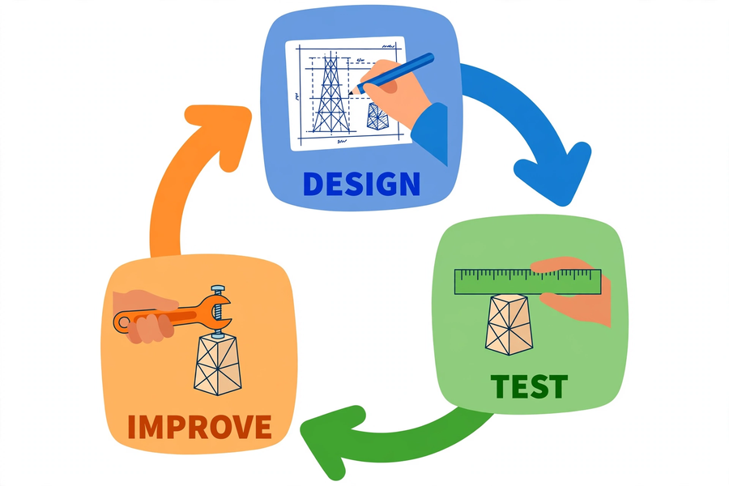
八、例子
8. Example
某一組在第一輪測試中，紙塔高 45 厘米，但只能承受 5 枚硬幣——因為底座太窄，紙塔一直搖晃。他們沒有把紙塔拆掉重做，而是針對弱點改良：把底座加闊，並在底部加上三角形支撐。第二輪測試，紙塔高 48 厘米，能承受 12 枚硬幣。這就是「測試 → 發現弱點 → 改良 → 再測試」的工程循環。
One group built a tower 45 cm tall in Round 1, but it could only bear 5 coins — the base was too narrow and the tower kept wobbling. Instead of tearing it down and starting over, they improved it by targeting the weakness: they widened the base and added triangular bracing at the bottom. In Round 2, the tower was 48 cm tall and bore 12 coins. That is the engineering cycle: test → find weaknesses → improve → test again.
九、簡單問答題
9. Quick questions
1. 工程循環的三個步驟是甚麼？
What are the three steps of the engineering cycle?
2. 為甚麼建造紙塔之前，要先繪畫設計草圖？
Why should you draw a design sketch before building the paper tower?
3. 三角形為甚麼比四邊形更穩固？
Why is a triangle more rigid than a quadrilateral?
4. 承重測試時，硬幣應該怎樣放置？為甚麼要逐枚放置？
How should the coins be placed during the load test? Why place them one by one?
十、思考題
10. Thinking questions
1. 如果你的紙塔在測試時倒塌了，你會先檢查哪一個部分？為甚麼？
If your paper tower collapsed during testing, which part would you check first? Why?
2. 除了把底座加闊，還有甚麼方法可以令紙塔更穩固？試舉出兩個。
Besides widening the base, what other methods can make the paper tower more stable? Give two.
3. 「改良」和「把紙塔拆掉重做」有甚麼分別？為甚麼工程師通常選擇改良？
What is the difference between "improving" and "tearing the tower down and rebuilding"? Why do engineers usually choose to improve?
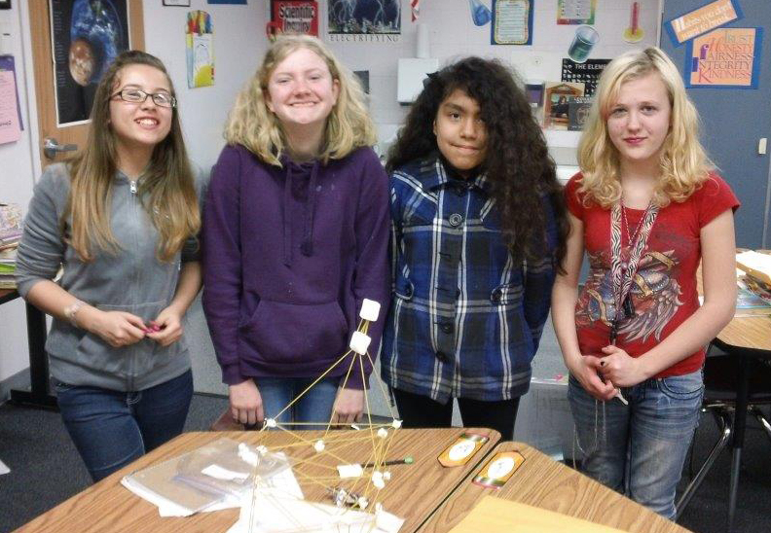
十一、分組題：紙塔挑戰記錄表
11. Group task: Paper Tower Challenge record sheet
以小組為單位完成下表，並在課堂上進行兩輪建造與測試。
Complete the table below as a group, and carry out two rounds of building and testing in class.
項目 Item  Item | 內容 Content  Content
小組名稱
Group name
組員分工
Role assignment
設計草圖（在方格內繪畫）
Design sketch (draw in the box)
第一輪：高度／承重
Round 1: height / load
發現的問題
Problems found
改良方法
Improvements made
第二輪：高度／承重
Round 2: height / load
反思：我學到＿＿＿＿
Reflection: I have learned ____

十二、總結
12. Summary
- 工程師的工作方法是「設計 → 測試 → 改良」的工程循環，失敗是改良的起點。
- Engineers work through the engineering cycle "design → test → improve"; failure is the starting point of improvement.
- 穩固的結構需要闊而穩的底座，三角形支撐能有效加固結構。
- A stable structure needs a wide, steady base, and triangular bracing strengthens it effectively.
- 測試要用統一的方法，並把數據記錄下來，才能比較改良前後的效果。
- Testing must use a consistent method, and data must be recorded, so that before-and-after improvements can be compared.
- 團隊合作靠分工、溝通和互相聆聽；改良是針對弱點修正，不是全部重做。
- Teamwork relies on division of labour, communication and listening to one another; improvement means fixing weaknesses, not starting over.
十三、小測驗
13. Quiz
在十分鐘內完成，不准互相討論。
Finish in 10 minutes. No discussion.
Q1. 寫出工程循環的三個步驟。（3 分 / 3 marks）
Write down the three steps of the engineering cycle.
答 Answer：＿＿＿＿＿＿＿＿＿＿＿＿＿＿＿＿＿＿＿＿＿＿＿＿＿＿＿＿＿＿
Q2. 紙塔挑戰的評分包括哪兩項？單位分別是甚麼？（2 分 / 2 marks）
What are the two scoring items of the Paper Tower Challenge? What are their units?
答 Answer：＿＿＿＿＿＿＿＿＿＿＿＿＿＿＿＿＿＿＿＿＿＿＿＿＿＿＿＿＿＿
Q3. 解釋為甚麼「底座愈闊，紙塔愈穩固」。（2 分 / 2 marks）
Explain why "the wider the base, the more stable the tower".
答 Answer：＿＿＿＿＿＿＿＿＿＿＿＿＿＿＿＿＿＿＿＿＿＿＿＿＿＿＿＿＿＿
Q4. 小組發現紙塔的頂部太重，測試時向前傾。寫出一個針對這個弱點的改良方法。（2 分 / 2 marks）
A group finds the top of their tower too heavy and it leans forward during testing. Suggest one improvement that targets this weakness.
答 Answer：＿＿＿＿＿＿＿＿＿＿＿＿＿＿＿＿＿＿＿＿＿＿＿＿＿＿＿＿＿＿
Q5. 判斷對錯並解釋：紙塔倒塌後，最好的做法是把紙塔全部拆掉，重新再做一次。（2 分 / 2 marks）
True or false, with explanation: after the tower collapses, the best thing to do is to tear it all down and rebuild from scratch.
答 Answer：＿＿＿＿＿＿＿＿＿＿＿＿＿＿＿＿＿＿＿＿＿＿＿＿＿＿＿＿＿＿
十四、延伸學習
14. Extension
在 YouTube 搜尋關鍵字「paper tower challenge」，觀看不同的紙塔設計，思考它們的結構有甚麼特點。（只提供搜尋關鍵字，不設連結。）
Search YouTube with the keyword "paper tower challenge", watch different paper tower designs, and think about the features of their structures. (Search keyword only; no link is provided.)

