聖公會呂明才中學
S.K.H. Lui Ming Choi Secondary School
創科班 S1 Unit 1：創科人出發
Little Makers Class S1 Unit 1: Innovators Set Off
第 1 堂：歡迎來到創科班——工程師思維（紙塔挑戰）
Lesson 1: Welcome to the Little Makers Class — Thinking Like an Engineer (Paper Tower Challenge)
教師筆記（附全部答案）
Teacher Notes (with all answers)
本堂物資表 Materials List（教師版）
請預早一星期準備所需物資；標示「課室現有」之項目請預先清點。
品名 Item | 數量（每組） Quantity (per group) | 大約成本 Est. cost | 安全注意 Safety notes
A4 白紙 A4 paper | 10 張 10 sheets | 約 $1（每張約 $0.1） approx. $1 (about $0.1 per sheet) | 紙邊較鋒利，提醒學生小心輕放。 Paper edges can be sharp; remind students to handle with care.
皺紋膠紙 Masking tape | 1 卷 1 roll | 約 $8–10／卷 approx. $8–10 per roll | — —
一元硬幣（測試用） $1 coins (for load test) | 20 枚 20 coins | —（由教師預備） — (to be prepared by the teacher) | 硬幣細小，不可放入口中；測試後點算交還。 Small parts — do not put in mouth; count and return after testing.
直尺（30 厘米） Ruler (30 cm) | 1 把 1 each | 約 $5／把，可重用 approx. $5 each, reusable | — —
剪刀 Scissors | 1 把 1 each | 約 $8／把，可重用 approx. $8 each, reusable | 使用時注意安全，用完立即收好。 Use with care; put away immediately after use.
計時器 Timer | 全班 1 個 1 per class | —（可用課室時鐘） — (classroom clock may be used) | — —
工作紙 Worksheet | 每人 1 張 1 per student | 約 $0.5／張（影印） approx. $0.5 per sheet (photocopying) | — —
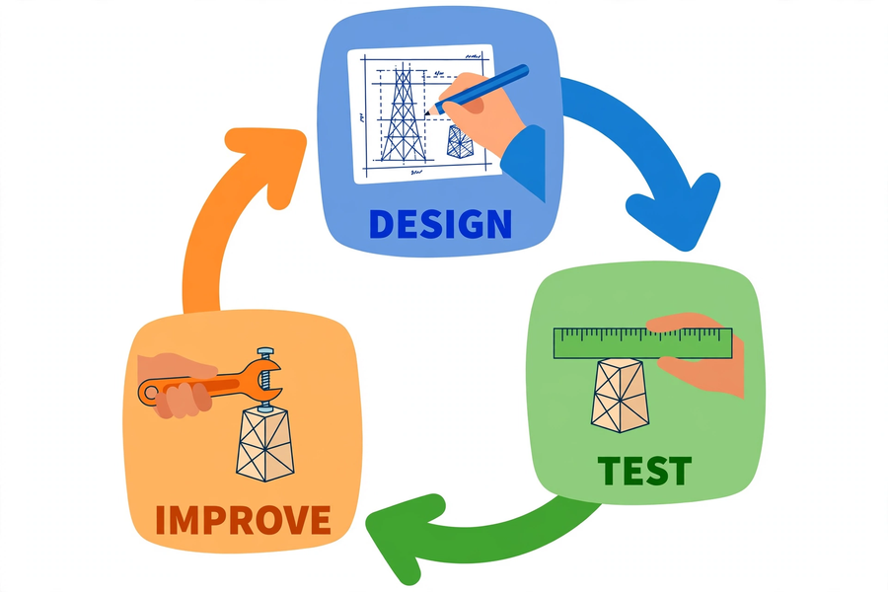
姓名 Name：＿＿＿＿＿＿ 班別 Class：＿＿ 日期 Date：＿＿＿＿＿＿

注意：本文件只供教師使用，不可派發給學生。
Note: for teachers only. Do not distribute to students.
一、學生筆記各題參考答案
1. Model answers for student notes
簡單問答題
Quick questions
參考答案 Reference answer：Q1：設計 → 測試 → 改良。
Q1: Design → Test → Improve.
參考答案 Reference answer：Q2：草圖讓小組在動手前先把意念具體化、統一做法，減少建造時的混亂和物料浪費；也是「先想後做」的工程習慣。
Q2: A sketch turns ideas into something concrete before building, unifies the group's approach, and reduces confusion and material waste — the engineer's habit of thinking before doing.
參考答案 Reference answer：Q3：三角形三條邊長度固定後，形狀就不能改變；四邊形即使四條邊長度固定，仍可被推成菱形而變形，所以三角形更穩固。
Q3: Once a triangle's three side lengths are fixed, its shape cannot change; a quadrilateral with fixed side lengths can still be pushed into a diamond shape, so the triangle is more rigid.
參考答案 Reference answer：Q4：硬幣要逐枚輕輕放在塔頂中央。逐枚放置是為了準確找出紙塔能承受的上限；一次放多枚會令紙塔突然受力，數據不準確，也容易提早倒塌。
Q4: Place coins gently one by one at the centre of the tower top. Placing them one by one finds the exact maximum load; placing several at once applies sudden force, giving inaccurate data and causing early collapse.
思考題（引導方向）
Thinking questions (guiding notes)
參考答案 Reference answer：T1：引導學生先檢查倒塌的起點（通常是底座或最幼的連接位）。因為結構的弱點往往在受力最大或最不穩固之處，找到起點才能對症下藥。
T1: Guide students to check where the collapse started (usually the base or the thinnest joint), because that is where the structure is weakest.
參考答案 Reference answer：T2：可接受答案包括：捲紙筒作支柱、加三角形支撐、減輕頂部重量、把重物放低處、用膠紙加固接駁位等。言之成理即可。
T2: Acceptable answers: rolled paper-tube columns, triangular bracing, reducing top weight, placing heavier parts lower, reinforcing joints with tape, etc.
參考答案 Reference answer：T3：改良是針對弱點修正，保留可行的部分；重做是放棄所有測試得來的資訊。工程師選擇改良，因為測試數據是寶貴的資訊，全部重做等於浪費已知的經驗。
T3: Improvement fixes weaknesses while keeping what works; rebuilding discards everything learned from testing. Engineers improve because test data is valuable — rebuilding wastes it.
小測驗答案
Quiz answers
參考答案 Reference answer：Q1（3分）：設計、測試、改良（次序正確才給滿分）。
Q1 (3 marks): design, test, improve (full marks only for the correct order).
參考答案 Reference answer：Q2（2分）：高度（厘米）＋承重（硬幣數目）。兩項各1分。
Q2 (2 marks): height (cm) + load (number of coins). 1 mark each.
參考答案 Reference answer：Q3（2分）：底座闊，重心較不容易超出底座範圍，所以紙塔不容易翻倒／搖晃。
Q3 (2 marks): a wide base keeps the centre of gravity within the base, so the tower does not topple or wobble easily.
參考答案 Reference answer：Q4（2分）：針對頂部過重的弱點，例如：減輕頂部用料、把較重的部分移低、加闊底座或在底部加三角形支撐。言之成理即可。
Q4 (2 marks): target the top-heavy weakness, e.g. reduce material at the top, move heavier parts lower, widen the base or add triangular bracing at the bottom.
參考答案 Reference answer：Q5（2分）：錯。不應全部拆掉重做，應先找出倒塌原因（弱點），在原有基礎上改良，因為測試已提供了寶貴的資訊。
Q5 (2 marks): False. Do not tear it all down; first find the cause of collapse (the weakness) and improve on the existing tower, because testing has already provided valuable information.
二、家課答案
2. Homework answers
選擇題
Multiple choice
參考答案 Reference answer：Q1：B
Q1: B
參考答案 Reference answer：Q2：C
Q2: C
參考答案 Reference answer：Q3：B
Q3: B
參考答案 Reference answer：Q4：A
Q4: A
參考答案 Reference answer：Q5：D
Q5: D
問答題
Short questions
參考答案 Reference answer：Q1：設計（想出辦法、畫草圖）→ 測試（動手做、量度記錄）→ 改良（找弱點、修正再試）。例子：紙塔第一輪測試後發現底座太窄，於是加闊底座再測試。
Q1: Design (think, sketch) → Test (build, measure, record) → Improve (find weaknesses, fix, retest). Example: after Round 1 the base was found too narrow, so it was widened and tested again.
參考答案 Reference answer：Q2：三角形三邊固定後形狀不變，不會像四邊形般被推歪；用三角形支撐加固接駁位，結構受力時不易變形，所以承重能力提高。
Q2: A triangle's shape is fixed once its sides are fixed, unlike a quadrilateral which can be pushed out of shape; triangular bracing at joints resists deformation under load, raising load capacity.
參考答案 Reference answer：Q3：開放式作答，須包括改良前後數據對比及學到的道理（不少於五十字）。示例：「改良前紙塔高45厘米，只能承受5枚硬幣，因為底座太窄會搖晃；把底座加闊並加三角形支撐後，高48厘米，能承受12枚硬幣。我學到失敗並不可怕，只要找出弱點改良，就可以做得更好。」
Q3: Open-ended; must include before-and-after data comparison and what was learned (≥50 Chinese characters).
三、附加思考題（課堂延伸用）
3. Extra thinking questions (for extension)
1. 如果物料減半（只有 5 張紙），你的設計策略會有甚麼改變？為甚麼？
If materials were halved (only 5 sheets of paper), how would your design strategy change? Why?
2. 現實中的高樓大廈（如香港的摩天大廈）怎樣應付大風？這和紙塔的穩固有甚麼相通之處？
How do real skyscrapers (e.g. in Hong Kong) cope with strong winds? What does this have in common with keeping a paper tower stable?
參考答案 Reference answer：附加題參考：題1——物料減少時更要靠結構設計（捲筒、三角形）而非堆疊物料，草圖規劃更重要。題2——大廈用深地基、對稱結構、阻尼器等抵抗風力；相通之處是「穩固來自設計，而非單靠物料」。
Reference: Q1 — with fewer materials, rely on structural design (tubes, triangles) rather than piling up material; sketch planning matters more. Q2 — buildings use deep foundations, symmetric structures, dampers against wind; the common idea is "stability comes from design, not just materials".
四、建議教導方向
4. Suggested teaching approach
- 計時必須嚴格，營造真實的工程期限壓力；每段時間用計時器提醒。
- Keep strict time to create real engineering deadline pressure; use a timer for each segment.
- 巡視時多用提問引導，代替直接給予答案，例如：「如果把底座加闊，會有甚麼改變？」
- When walking around, guide with questions instead of giving answers, e.g. "What would change if the base were wider?"
- 可提示紙張能捲成紙筒或摺成三角形以增加強度，但不宜直接示範最優解法，以免扼殺創意。
- You may hint that paper can be rolled into tubes or folded into triangles for strength, but avoid demonstrating the optimal solution so as not to stifle creativity.
- 改良環節要強調「針對弱點修正」，阻止學生把紙塔全部拆掉重做；可要求各組先說出弱點才動手改。
- In the improvement stage, stress "fix the weaknesses"; stop students from tearing everything down. Ask each group to state the weakness before they start fixing.
- 測試時維持秩序，確保各組用同一方法測試，數據才可比較。
- Maintain order during testing and ensure every group uses the same method, so data can be compared.
五、常見迷思
5. Common misconceptions
- 學生以為「愈高愈好」，忽略穩固性，結果在測試時倒塌。應引導：評分是高度加承重，倒塌了就甚麼都沒有。
- Students think "the taller the better" and neglect stability, so the tower collapses during testing. Guide them: scoring is height PLUS load — a collapsed tower scores nothing.
- 學生以為膠紙用得愈多愈穩固。其實結構設計比物料多寡更重要，亂貼膠紙反而增加頂部重量。
- Students think more tape means more stability. In fact structural design matters more than the amount of material, and tape added carelessly adds weight to the top.
- 學生把「改良」誤解為「全部重做」。其實改良是在原有基礎上針對弱點修正，測試數據是寶貴的資訊。
- Students mistake "improve" for "redo everything". Improvement actually means fixing weaknesses on the existing structure — test data is valuable information.

