聖公會呂明才中學
S.K.H. Lui Ming Choi Secondary School
創科班 S1 Unit 1：創科人出發
Little Makers Class S1 Unit 1: Innovators Set Off
第 2 堂：設計思維五步——為同學設計理想筆袋
Lesson 2: The Five Steps of Design Thinking — Designing an Ideal Pencil Case for a Classmate
學生筆記
Student Notes
姓名 Name：＿＿＿＿＿＿ 班別 Class：＿＿ 日期 Date：＿＿＿＿＿＿
本堂物資表 Materials List
以下為本堂分組活動所需物資（每組一份）。請在老師派發時核對。
品名 Item | 數量（每組） Quantity (per group) | 安全注意 Safety notes
訪問記錄工作紙 Interview record worksheet | 每人 1 張 1 per student | — —
A4 卡紙（不同顏色） A4 card stock (assorted colours) | 每人 2–3 張 2–3 per student | 紙邊較鋒利，提醒學生小心。 Paper edges can be sharp; remind students to be careful.
皺紋膠紙 Masking tape | 每組 1 卷 1 roll per group | — —
剪刀 Scissors | 每組 2 把 2 per group | 使用時注意安全，用完立即收好。 Use with care; put away immediately after use.
顏色筆 Colour pens | 每組 1 盒 1 box per group | — —
雙面膠紙 Double-sided tape | 每組 1 卷 1 roll per group | — —

一、本課簡介
1. Introduction
上一課我們學了工程師的「設計 → 測試 → 改良」循環。這一課我們學習另一套重要的方法：設計思維（Design Thinking）。我們會兩人一組，透過訪問了解同伴對筆袋的需要，再為對方設計一個「理想筆袋」，並用卡紙做出紙樣原型。記住：好的設計由了解用家的需要開始，而不是由自己的喜好出發。
Last lesson we learned the engineer's "design → test → improve" cycle. This lesson we learn another important method: Design Thinking. In pairs, we will interview each other to understand our partner's pencil case needs, then design an "ideal pencil case" for them and build a paper prototype from card stock. Remember: good design starts from understanding the user's needs, not from your own preferences.
二、設計思維的五個步驟
2. The five steps of design thinking
1. 同理心（Empathise）：用心了解用家。觀察他們怎樣使用物件，聆聽他們的需要和困難，不要憑空假設。
Empathise: understand the user with care. Observe how they use things, listen to their needs and difficulties — do not make assumptions.
2. 定義問題（Define）：把了解到的需要，歸納成一句清晰的「需要陳述」，說出用家真正的需要。
Define: summarise what you learned into one clear "need statement" that states the user's real need.
3. 構思（Ideate）：想出愈多主意愈好。這個階段先求數量，不作批評，再從中選出最有潛力的意念。
Ideate: come up with as many ideas as possible. At this stage aim for quantity without criticism, then pick the most promising idea.
4. 原型（Prototype）：用便宜的物料，快速做出一個可以測試的模型。原型的目的是測試意念，不是一次做到完美。
Prototype: build a testable model quickly with cheap materials. A prototype exists to test ideas — not to be perfect at once.
5. 測試（Test）：把原型交給用家試用，收集回饋意見，作為下一次改良的依據。
Test: let the user try the prototype, collect feedback, and use it as the basis for the next improvement.
五個步驟的次序是：同理心 → 定義問題 → 構思 → 原型 → 測試。測試之後發現新問題，可以回到前面的步驟再走一次——設計思維也是一個循環。
The order of the five steps is: empathise → define → ideate → prototype → test. If testing reveals new problems, you can loop back to earlier steps — design thinking is also a cycle.
三、訪問小貼士：怎樣問出有用的資料
3. Interview tips: how to get useful information
- 多用開放式問題，少用是非題。是非題只能得到「是」或「不是」，開放式問題才能引出原因和細節。
- Use open-ended questions more, and yes/no questions less. Yes/no questions only get "yes" or "no"; open-ended questions reveal reasons and details.
- 不好的問題（是非題）：「你喜歡大筆袋嗎？」 好的問題（開放式）：「你平時帶多少支筆回校？為甚麼？」
- Poor question (yes/no): "Do you like big pencil cases?" Good question (open-ended): "How many pens do you usually bring to school? Why?"
- 多追問「為甚麼」：每聽到一個答案，多問一次為甚麼，往往能挖出真正的需要。
- Keep asking "why": after each answer, ask why once more — it often uncovers the real need.
- 記下對方的原話：對方親口說的描述，比你轉述的更準確。
- Note down the interviewee's own words: their own description is more accurate than your paraphrase.
- 留意對方使用筆袋的習慣：例如筆袋是否常常爆開、拉鏈是否卡住。
- Observe how they use their pencil case: e.g. does it often burst open, does the zip get stuck?
四、需要陳述：用家 ＋ 需要 ＋ 原因
4. Need statement: user + need + reason
把訪問結果歸納為一句「需要陳述」，必須包含三個要素：用家是誰、他有甚麼需要、為甚麼有這個需要。
Summarise the interview findings into one "need statement" containing three elements: who the user is, what they need, and why they need it.
- 公式：需要，因為。
- Formula: [User] needs [what], because [reason].
- 例子：「小文需要一個能同時放十支筆和計算機的筆袋，因為他的筆袋常常爆開。」
- Example: "Man needs a pencil case that holds ten pens and a calculator at the same time, because his pencil case often bursts open."
- 好的需要陳述具體、可觀察；避免空泛的形容，例如「需要一個漂亮的筆袋」就不是好的需要陳述。
- A good need statement is specific and observable; avoid vague descriptions — "needs a pretty pencil case" is not a good need statement.
五、構思：先求數量，不作批評
5. Ideate: quantity first, no criticism
- 根據需要陳述，畫出二至三個不同的設計草圖。
- Based on the need statement, draw two to three different design sketches.
- 構思時不要急於批評自己的主意：先把所有想法畫出來，再選最好的。
- Do not rush to criticise your own ideas: draw out every idea first, then choose the best.
- 每個草圖旁寫一句：這個設計回應了用家的哪一項需要？
- Next to each sketch, write one line: which of the user's needs does this design address?
六、原型：求快不求美
6. Prototype: speed over beauty
- 用卡紙、膠紙等便宜物料，快速做出筆袋的紙樣模型。
- Use cheap materials like card stock and tape to build a paper model of the pencil case quickly.
- 原型的重點是測試意念：大小是否合適？間隔是否夠用？不用花時間裝飾外觀。
- A prototype is for testing ideas: is the size right? Are there enough compartments? Do not spend time decorating it.
- 記住：原型不是成品。粗糙一點沒有關係，能拿去測試就可以。
- Remember: a prototype is not a finished product. It is fine for it to look rough, as long as it can be tested.
七、測試與回饋
7. Test and feedback
- 把原型交給用家（你的同伴）試用，請他說出意見。
- Give the prototype to the user (your partner) to try, and ask for comments.
- 給回饋的方法：先說喜歡之處，再提改善建議。回饋要具體，例如「這個間隔放計算機剛好，但拉鏈位可以再闊一點」。
- How to give feedback: first say what you like, then suggest improvements. Be specific, e.g. "This compartment fits the calculator well, but the zip opening could be wider."
- 收到回饋不要難過：回饋是改良的養分，原型本來就是用來引發意見的。
- Do not feel hurt by feedback: feedback nourishes improvement, and a prototype exists precisely to invite comments.
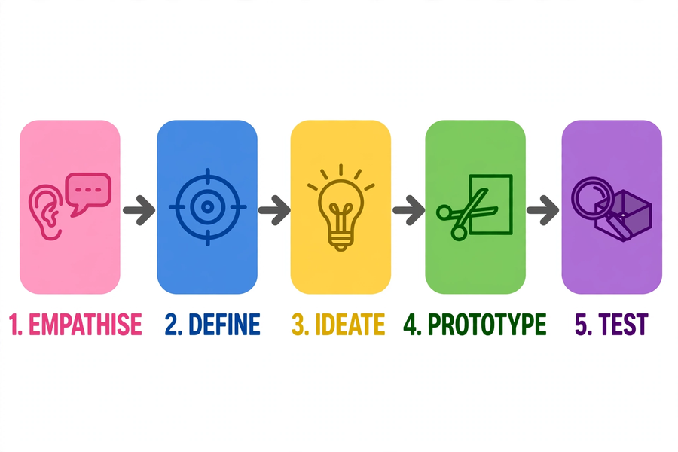
八、例子：走一遍五步
8. Example: walking through the five steps
1. 同理心：訪問同伴，記錄到三項需要——筆常常不見、筆袋拉鏈卡住、想放學生證。
Empathise: interview your partner and record three needs — pens often go missing, the zip gets stuck, wants to keep the student card in it.
2. 定義問題：需要陳述——「小文需要一個有分隔和卡位、拉鏈順滑的筆袋，因為他的筆常常不見，而且想把學生證放在一起。」
Define: need statement — "Man needs a pencil case with dividers, a card slot and a smooth zip, because his pens often go missing and he wants to keep his student card with it."
3. 構思：畫出三個草圖——長形多格款、捲軸款、雙層款；選定長形多格款。
Ideate: draw three sketches — long multi-compartment style, roll-up style, double-layer style; choose the long multi-compartment one.
4. 原型：用卡紙快速做出紙樣，有三個分隔和一個透明卡位。
Prototype: quickly build a card-stock model with three compartments and one transparent card slot.
5. 測試：同伴試用後回饋——「分隔很好，但卡位太緊，學生證難取出。」下次改良把卡位放闊一點。
Test: the partner tries it and feeds back — "The dividers are great, but the card slot is too tight for the student card." Next improvement: make the slot wider.
九、簡單問答題
9. Quick questions
1. 設計思維的五個步驟是甚麼？次序是怎樣的？
What are the five steps of design thinking, and in what order?
2. 為甚麼訪問時要多用開放式問題，少用是非題？
Why should interviews use more open-ended questions and fewer yes/no questions?
3. 「小文需要一個大筆袋」是不是一句好的需要陳述？為甚麼？
Is "Man needs a big pencil case" a good need statement? Why or why not?
4. 為甚麼原型「求快不求美」？
Why does a prototype value "speed over beauty"?
十、思考題
10. Thinking questions
1. 如果你的同伴說「我想要一個和別人不一樣的筆袋」，你會怎樣追問，才能挖出他真正的需要？
If your partner says "I want a pencil case different from everyone else's", how would you follow up to uncover their real need?
2. 構思階段為甚麼「先求數量，不作批評」？太早批評會有甚麼壞處？
Why does the ideation stage ask for "quantity first, no criticism"? What is the harm of criticising too early?
3. 日常生活中，你見過哪些「不好用」的設計？試舉一例，並說明它忽略了用家的甚麼需要。
What poorly designed everyday objects have you come across? Give one example and explain which user need it overlooked.
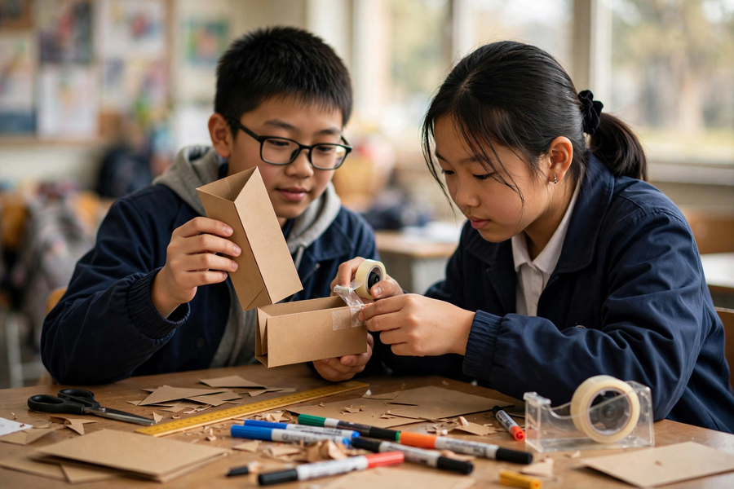
十一、分組題：理想筆袋設計記錄表
11. Group task: ideal pencil case design record
兩人一組，輪流訪問對方，完成下表，並用卡紙製作紙樣原型。
Work in pairs, taking turns to interview each other. Complete the table below and build a paper prototype from card stock.
項目 Item  Item | 內容 Content  Content
訪問記錄一
Interview record 1
訪問記錄二
Interview record 2
訪問記錄三
Interview record 3
需要陳述
（用家＋需要＋原因）
Need statement (user + need + reason)
設計草圖
Design sketch
原型描述
Prototype description
用家回饋
User feedback
下次改良方向
Direction for next improvement

十二、總結
12. Summary
- 設計思維五步：同理心 → 定義問題 → 構思 → 原型 → 測試。
- The five steps of design thinking: empathise → define → ideate → prototype → test.
- 好的設計由了解用家的需要開始，而不是由自己的喜好出發。
- Good design starts from understanding the user's needs, not from your own preferences.
- 訪問多用開放式問題，多追問「為甚麼」，記下對方的原話。
- In interviews, use open-ended questions, keep asking "why", and note the interviewee's own words.
- 需要陳述＝用家＋需要＋原因；原型求快不求美，目的是測試意念；回饋是改良的養分。
- Need statement = user + need + reason; a prototype values speed over beauty and exists to test ideas; feedback nourishes improvement.
十三、小測驗
13. Quiz
在十分鐘內完成，不准互相討論。
Finish in 10 minutes. No discussion.
Q1. 準確列出設計思維的五個步驟（次序須正確）。（5 分 / 5 marks）
List accurately the five steps of design thinking (in the correct order).
答 Answer：＿＿＿＿＿＿＿＿＿＿＿＿＿＿＿＿＿＿＿＿＿＿＿＿＿＿＿＿＿＿
Q2. 把以下需要陳述補完整：「＿＿需要一個＿＿，因為＿＿。」並說明三個空格分別對應哪個要素。（3 分 / 3 marks）
Complete the need statement: "[__] needs [__], because [__]." State which element each blank corresponds to.
答 Answer：＿＿＿＿＿＿＿＿＿＿＿＿＿＿＿＿＿＿＿＿＿＿＿＿＿＿＿＿＿＿
Q3. 判斷對錯並解釋：製作原型時，應該花最多時間把外觀裝飾得漂亮。（2 分 / 2 marks）
True or false, with explanation: when building a prototype, you should spend most of the time making it look beautiful.
答 Answer：＿＿＿＿＿＿＿＿＿＿＿＿＿＿＿＿＿＿＿＿＿＿＿＿＿＿＿＿＿＿
Q4. 你的同伴試用你的筆袋原型後說：「幾好。」這樣的回饋有甚麼不足？你會怎樣引導他給出更具體的意見？（2 分 / 2 marks）
After trying your pencil case prototype, your partner says: "It's fine." What is lacking in this feedback? How would you guide them to give more specific comments?
答 Answer：＿＿＿＿＿＿＿＿＿＿＿＿＿＿＿＿＿＿＿＿＿＿＿＿＿＿＿＿＿＿

