聖公會呂明才中學
S.K.H. Lui Ming Choi Secondary School
創科班 S1 Unit 1：創科人出發
Little Makers Class S1 Unit 1: Innovators Set Off
第 2 堂：設計思維五步——為同學設計理想筆袋
Lesson 2: The Five Steps of Design Thinking — Designing an Ideal Pencil Case for a Classmate
教師筆記（附全部答案）
Teacher Notes (with all answers)
本堂物資表 Materials List（教師版）
請預早一星期準備所需物資；標示「課室現有」之項目請預先清點。
品名 Item | 數量（每組） Quantity (per group) | 大約成本 Est. cost | 安全注意 Safety notes
訪問記錄工作紙 Interview record worksheet | 每人 1 張 1 per student | 約 $0.5／張（影印） approx. $0.5 per sheet (photocopying) | — —
A4 卡紙（不同顏色） A4 card stock (assorted colours) | 每人 2–3 張 2–3 per student | 約 $0.3／張 approx. $0.3 per sheet | 紙邊較鋒利，提醒學生小心。 Paper edges can be sharp; remind students to be careful.
皺紋膠紙 Masking tape | 每組 1 卷 1 roll per group | 約 $8–10／卷 approx. $8–10 per roll | — —
剪刀 Scissors | 每組 2 把 2 per group | 約 $8／把，可重用 approx. $8 each, reusable | 使用時注意安全，用完立即收好。 Use with care; put away immediately after use.
顏色筆 Colour pens | 每組 1 盒 1 box per group | 約 $15／盒，可重用 approx. $15 per box, reusable | — —
雙面膠紙 Double-sided tape | 每組 1 卷 1 roll per group | 約 $6／卷 approx. $6 per roll | — —
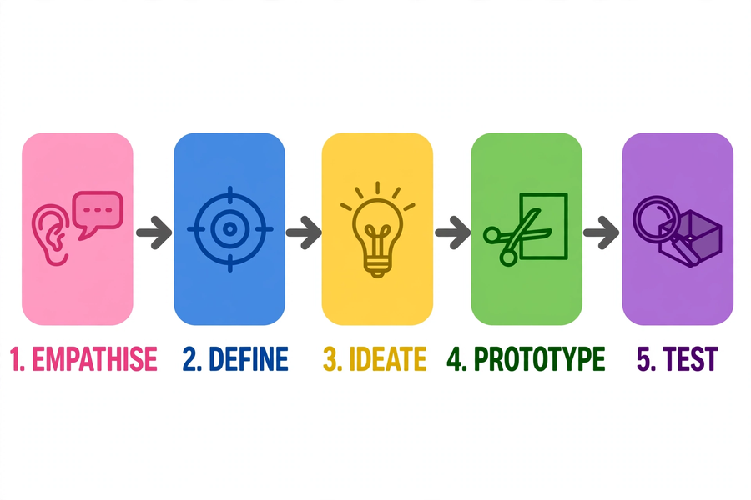
姓名 Name：＿＿＿＿＿＿ 班別 Class：＿＿ 日期 Date：＿＿＿＿＿＿

注意：本文件只供教師使用，不可派發給學生。
Note: for teachers only. Do not distribute to students.
一、學生筆記各題參考答案
1. Model answers for student notes
簡單問答題
Quick questions
參考答案 Reference answer：Q1：同理心 → 定義問題 → 構思 → 原型 → 測試（次序須正確）。
Q1: Empathise → Define → Ideate → Prototype → Test (correct order required).
參考答案 Reference answer：Q2：是非題只能得到「是／不是」，無法得知原因和細節；開放式問題能引出用家的習慣、困難和原因，資料才有用。
Q2: Yes/no questions only yield "yes/no" with no reasons or details; open-ended questions reveal habits, difficulties and reasons, producing useful data.
參考答案 Reference answer：Q3：不是。好的需要陳述須包含用家、需要、原因三個要素，而且要具體；「一個大筆袋」沒有說明為甚麼需要大，也沒有具體指出用家的困難。
Q3: No. A good need statement needs user, need and reason, and must be specific; "a big pencil case" explains neither why it must be big nor the user's difficulty.
參考答案 Reference answer：Q4：因為原型的目的是快速測試意念、引發回饋，而不是一次做到完美；把時間花在裝飾上，會拖慢測試，失去原型的意義。
Q4: Because a prototype exists to test ideas quickly and invite feedback, not to be perfect at once; time spent decorating delays testing and defeats the purpose.
思考題（引導方向）
Thinking questions (guiding notes)
參考答案 Reference answer：T1：引導學生追問「為甚麼」：例如「你覺得現在的筆袋有甚麼不方便？」「你希望筆袋幫你做到甚麼？」把「想要特別」轉化為具體需要。
T1: Guide students to ask "why", e.g. "What inconveniences do you have with your current pencil case?" "What do you want it to do for you?" — turning "wanting to be special" into concrete needs.
參考答案 Reference answer：T2：太早批評會令組員不敢提出大膽的想法，意念數量減少，最後只剩下最保守的方案；先求數量才能擴闊可能性。
T2: Early criticism stops members from offering bold ideas; fewer ideas means only the safest option survives. Quantity first widens the possibilities.
參考答案 Reference answer：T3：開放式作答。可接受例子：拉鏈常卡住的筆袋（忽略了用家需要順滑開合）、沒有分隔的筆袋（忽略了分類需要）等，言之成理即可。
T3: Open-ended. Acceptable examples: a pencil case with a zip that always gets stuck (overlooked the need for smooth opening), one with no dividers (overlooked the need to organise), etc.
小測驗答案
Quiz answers
參考答案 Reference answer：Q1（5分）：同理心、定義問題、構思、原型、測試；每步1分，次序正確才給滿分。
Q1 (5 marks): empathise, define, ideate, prototype, test; 1 mark per step, full marks only for the correct order.
參考答案 Reference answer：Q2（3分）：例如「小文需要一個能放十支筆的筆袋，因為他的筆袋常常爆開。」三個空格分別對應用家、需要、原因，各1分。
Q2 (3 marks): e.g. "Man needs a pencil case that holds ten pens, because his pencil case often bursts open." Blanks correspond to user, need, reason; 1 mark each.
參考答案 Reference answer：Q3（2分）：錯。原型應求快不求美，重點是測試意念；花太多時間裝飾外觀，會拖慢測試，失去原型的意義。
Q3 (2 marks): False. A prototype values speed over beauty and exists to test ideas; decorating wastes time and delays testing.
參考答案 Reference answer：Q4（2分）：「幾好」太空泛，沒有指出喜歡甚麼、有甚麼可改善。可引導：「你最喜歡原型的哪個部分？」「如果只能改一樣東西，你會改甚麼？」
Q4 (2 marks): "It's fine" is too vague — it says nothing about what is liked or improvable. Guide with: "Which part do you like most?" "If you could change one thing, what would it be?"
二、家課答案
2. Homework answers
選擇題
Multiple choice
參考答案 Reference answer：Q1：C
Q1: C
參考答案 Reference answer：Q2：B
Q2: B
參考答案 Reference answer：Q3：A
Q3: A
參考答案 Reference answer：Q4：D
Q4: D
參考答案 Reference answer：Q5：B
Q5: B
問答題
Short questions
參考答案 Reference answer：Q1：同理心（了解用家）→ 定義問題（說出真正的需要）→ 構思（想出多個主意）→ 原型（快速做出模型）→ 測試（給用家試用、收集意見）。每步一句說明。
Q1: Empathise (understand the user) → Define (state the real need) → Ideate (come up with many ideas) → Prototype (build a model quickly) → Test (let the user try it, collect comments). One line per step.
參考答案 Reference answer：Q2：須包含用家、需要、原因三要素，例如：「小文需要一個有分隔的筆袋，因為他的筆常常和擦膠混在一起，難以找到。」
Q2: Must contain user, need and reason, e.g. "Man needs a pencil case with dividers, because his pens get mixed up with erasers and are hard to find."
參考答案 Reference answer：Q3：開放式作答，須整理訪問記錄、寫出需要陳述、用家的一項回饋，以及下次改良方向（不少於五十字）。
Q3: Open-ended; must organise interview records, state the need statement, one piece of user feedback, and the next improvement (≥50 Chinese characters).
三、附加思考題（課堂延伸用）
3. Extra thinking questions (for extension)
1. 訪問時，對方只回答「不知道」「隨便」，你有甚麼方法令他願意多說一點？
During an interview, the interviewee only answers "don't know" or "whatever". How can you get them to say more?
2. 如果時間只夠走完五步中的三步，你會保留哪三步？為甚麼？
If time only allows three of the five steps, which three would you keep? Why?
參考答案 Reference answer：附加題參考：題1——可改用具體情境提問（「你今早找筆時發生了甚麼？」）、請對方示範使用筆袋、從觀察入手。題2——開放式作答；引導方向：同理心和測試最不可少，因為設計必須由用家出發、以用家驗證。
Reference: Q1 — use concrete scenarios ("What happened when you looked for a pen this morning?"), ask for a demonstration, or start from observation. Q2 — open-ended; steer towards: empathise and test are least dispensable, because design must start from and be validated by the user.
四、建議教導方向
4. Suggested teaching approach
- 嚴格控制每段時間：訪問環節最容易超時，須適時提醒，每人訪問約五分鐘。
- Keep each segment to time: the interview stage tends to overrun, so give timely reminders — about five minutes per interview.
- 示範好壞訪問問題時，可邀請學生即場判斷，增強投入感。
- When demonstrating good versus poor interview questions, invite students to judge on the spot to raise engagement.
- 提醒學生原型「求快不求美」，可用膠紙、剪貼快速成形；見到學生花太多時間裝飾，要即時介入。
- Remind students that a prototype values speed over beauty and can be assembled quickly with tape and cut-and-paste; intervene if students spend too long decorating.
- 展示時要求用家先說喜歡之處，再提改善建議，讓回饋具體而有建設性。
- During presentations, ask users to first say what they like before suggesting improvements, so feedback is specific and constructive.
- 總結時點出：設計思維和上一課的工程循環都是「循環」——測試後可以回到前面再走一次。
- In the summary, point out that design thinking, like last lesson's engineering cycle, is a loop — after testing you can return to earlier steps.
五、常見迷思
5. Common misconceptions
- 學生以為設計就是「畫得漂亮」，忽略用家的需要。應強調：設計是為了解決用家的問題。
- Students think design is just "drawing beautifully" and overlook users' needs. Stress: design exists to solve the user's problems.
- 訪問時只問是非題，得不到有用資料。須示範開放式問題，並要求至少三項具體記錄。
- Students ask only yes/no questions in interviews, yielding no useful information. Demonstrate open-ended questions and require at least three specific records.
- 把原型當成成品，花太多時間裝飾外觀，而非測試功能。要不斷提醒：原型是用來測試意念的。
- Students treat the prototype as a finished product and spend too much time decorating it instead of testing its functions. Keep reminding: a prototype is for testing ideas.

