聖公會呂明才中學
S.K.H. Lui Ming Choi Secondary School
創科班 S1 Unit 1：創科人出發
Little Makers Class S1 Unit 1: Innovators Set Off
第 3 堂：認識關愛——弱勢社群的生活體驗
Lesson 3: Understanding Care — Experiencing the Lives of Disadvantaged Groups
家課
Homework
姓名 Name：＿＿＿＿＿＿ 班別 Class：＿＿ 日期 Date：＿＿＿＿＿＿

完成日期 Due date：＿＿＿＿＿＿ 總分 Total：20 分／marks
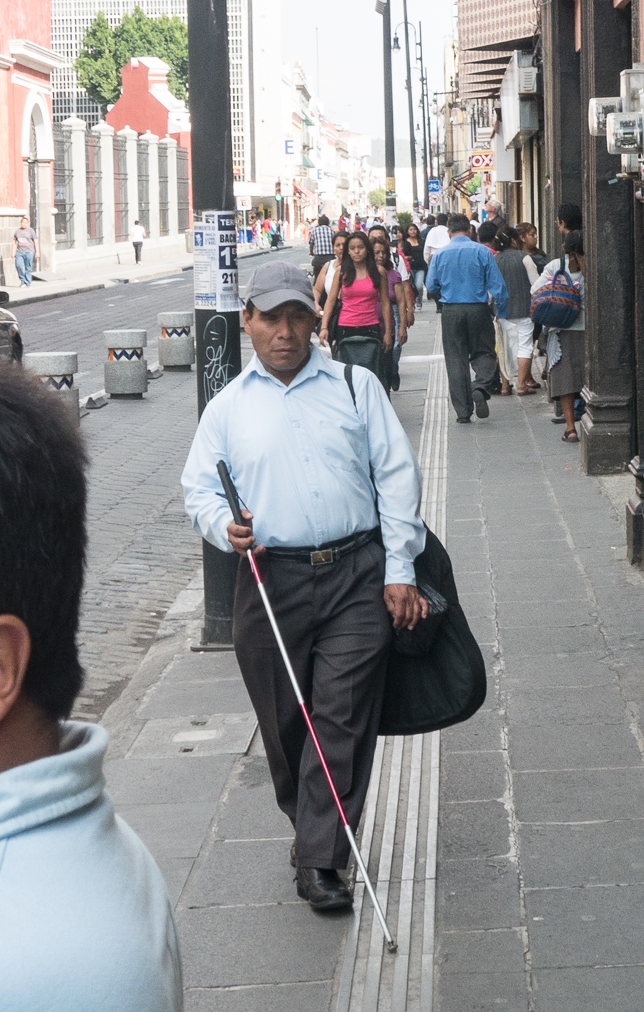
第一部分：選擇題（每題 2 分，共 10 分）
Part 1: Multiple choice (2 marks each, 10 marks total)
選出最適當的一項。
Choose the most appropriate answer.
Q1. 以下哪一項是對「弱勢社群」的正確描述？（2 分 / 2 marks）
Which of the following correctly describes "disadvantaged groups"?
A. 在考試中成績較差的學生
Students with poor exam results
B. 在生活中遇到較多困難、需要社會關懷的人士
People who face more difficulties in life and need care from society
C. 不喜歡和別人合作的人
People who dislike working with others
D. 身體特別強壯的人
People who are physically very strong

Q2. 以下哪一項是輪椅使用者在日常生活中遇到的具體困難？（2 分 / 2 marks）
Which of the following is a specific daily difficulty faced by wheelchair users?
A. 門檻令輪椅難以通過
Door thresholds blocking the wheelchair
B. 看不清細小的文字
Difficulty reading small print
C. 聽不清課室廣播
Difficulty hearing classroom announcements
D. 忘記帶功課回校
Forgetting to bring homework to school

Q3. 蒙眼體驗時，最重要的安全規則是甚麼？（2 分 / 2 marks）
What is the most important safety rule during the blindfold experience?
A. 跑得愈快愈好
Run as fast as possible
B. 必須有同伴從旁陪伴，不適立即除下眼罩舉手
A partner must accompany you; remove the blindfold and raise your hand if unwell
C. 盡量大聲叫喊
Shout as loudly as possible
D. 閉上眼睛就不用理會教師指示
Once blindfolded, you can ignore the teacher's instructions

Q4. 關於體驗活動，以下哪一項理解是正確的？（2 分 / 2 marks）
About the experiential activity, which understanding is correct?
A. 體驗了幾分鐘，就等於完全明白弱勢社群的生活
A few minutes of experience means fully understanding disadvantaged groups' lives
B. 體驗只是起點，真正的了解需要長期接觸與聆聽
The experience is only a starting point; real understanding needs long-term contact and listening
C. 體驗活動是遊戲，愈好玩愈好
The activity is a game — the more fun, the better
D. 體驗時不需要遵守安全規則
Safety rules need not be followed during the experience

Q5. 以下哪一項是好的觀察記錄？（2 分 / 2 marks）
Which of the following is a good observation record?
A. 好辛苦。
"So hard."
B. 唔知。
"Don't know."
C. 坐輪椅上斜道時，我要雙手用力抓住扶手，擔心會向後溜。
"Going up the ramp in the wheelchair, I had to grip the armrests hard with both hands, afraid of sliding backwards."
D. 幾好玩。
"Quite fun."

第二部分：問答題（共 10 分）
Part 2: Short questions (10 marks total)
Q1. 列出三類弱勢社群，並為每類寫出一項具體的日常生活困難。（3 分）（3 分 / 3 marks）
List three types of disadvantaged groups and write one specific daily difficulty for each. (3 marks)
答 Answer：＿＿＿＿＿＿＿＿＿＿＿＿＿＿＿＿＿＿＿＿＿＿＿＿＿＿＿＿＿＿
Q2. 以自己的文字，解釋全年主題「正能量——用創科關愛弱勢社群」的含義（不少於八十字）。（4 分）（4 分 / 4 marks）
Explain in your own words the meaning of the year's theme, "Positive Energy — Using Innovation and Technology to Care for Disadvantaged Groups" (at least 80 Chinese characters). (4 marks)
答 Answer：＿＿＿＿＿＿＿＿＿＿＿＿＿＿＿＿＿＿＿＿＿＿＿＿＿＿＿＿＿＿
Q3. 完成「關愛體驗觀察記錄表」：寫出三項親身觀察或感受，記錄組員分享中最深刻的一項。（3 分）（3 分 / 3 marks）
Complete the "Caring Experience Observation Record": write three first-hand observations or feelings, and record the most memorable point from group sharing. (3 marks)
答 Answer：＿＿＿＿＿＿＿＿＿＿＿＿＿＿＿＿＿＿＿＿＿＿＿＿＿＿＿＿＿＿

