聖公會呂明才中學
S.K.H. Lui Ming Choi Secondary School
創科班 S1 Unit 1：創科人出發
Little Makers Class S1 Unit 1: Innovators Set Off
第 3 堂：認識關愛——弱勢社群的生活體驗
Lesson 3: Understanding Care — Experiencing the Lives of Disadvantaged Groups
學生筆記
Student Notes
姓名 Name：＿＿＿＿＿＿ 班別 Class：＿＿ 日期 Date：＿＿＿＿＿＿
本堂物資表 Materials List
以下為本堂分組活動所需物資（每組一份）。請在老師派發時核對。
品名 Item | 數量（每組） Quantity (per group) | 安全注意 Safety notes
眼罩 Blindfolds | 每組 2–3 個 2–3 per group | 使用前檢查鬆緊；如學生感到頭暈，立即除下。共用前須清潔。 Check the fit before use; remove immediately if a student feels dizzy. Clean before sharing.
輪椅 Wheelchair | 全班 1–2 部（向學校借用） 1–2 per class (borrowed from the school) | 使用前檢查制動；必須有人從旁協助推動，不可讓學生自行高速推動；只在平坦路段使用。 Check the brakes before use; someone must assist alongside at all times — students must not propel it fast on their own; use only on flat routes.
觀察記錄工作紙 Observation record worksheet | 每人 1 張 1 per student | — —
急救箱 First-aid kit | 全班 1 個（由教師攜帶） 1 per class (carried by the teacher) | 以備不時之需。 For emergencies.

一、本課簡介
1. Introduction
本學年創科班的主題是「正能量——用創科關愛弱勢社群」。在動手為別人設計之前，我們要先認識：弱勢社群是誰？他們的日常生活有甚麼困難？本課我們會透過講解和親身體驗（蒙眼行走、乘坐輪椅），去了解視障人士、輪椅使用者和長者的生活挑戰，並正式確立我們的全年主題。
Our theme this year is "Positive Energy — Using Innovation and Technology to Care for Disadvantaged Groups". Before designing for others, we must first understand: who are disadvantaged groups? What difficulties do they face in daily life? In this lesson, through explanation and first-hand experiences (a blindfold walk and a wheelchair ride), we will learn about the life challenges of visually impaired persons, wheelchair users and elderly people, and formally establish our theme for the year.
二、甚麼是弱勢社群？
2. What are disadvantaged groups?
弱勢社群是指在生活中遇到較多困難、需要社會關懷和支援的人士。他們面對的困難，並不是他們的錯，而是環境和設計沒有照顧到他們的需要——而這正是創科可以幫忙的地方。
Disadvantaged groups are people who face more difficulties in life and need care and support from society. Their difficulties are not their fault — the environment and its designs have not catered for their needs. And that is exactly where innovation and technology can help.
- 視障人士：視力有嚴重障礙的人士。具體困難：過馬路時難以判斷車輛位置，上落樓梯容易踏空，在陌生環境中容易迷路。
- Visually impaired persons: people with severe vision impairment. Specific difficulties: judging where vehicles are when crossing roads, missing steps on stairs, getting lost in unfamiliar places.
- 輪椅使用者：需要以輪椅代步的人士。具體困難：門檻和高一級的地面令輪椅難以通過，斜道斜度不足或太斜都不安全，狹窄的通道令輪椅難以轉彎。
- Wheelchair users: people who rely on wheelchairs to get around. Specific difficulties: door thresholds and raised floors block wheelchairs; ramps that are missing or too steep are unsafe; narrow passages make turning difficult.
- 長者：年長的人士，視力、聽力和體力逐漸衰退。具體困難：看不清細小文字、聽不清廣播、提重物和上落樓梯吃力。
- Elderly people: older persons whose vision, hearing and strength gradually decline. Specific difficulties: difficulty reading small print, hearing announcements, carrying heavy objects and climbing stairs.
三、體驗活動安全守則（必須遵守）
3. Safety rules for the experiential activity (must be followed)
以下守則為保障每位同學的安全，必須嚴格遵守：
The following rules protect everyone's safety and must be strictly followed:
1. 全程跟隨教師的指示，只在教師指定的平坦路段活動，不可擅自離開。
Follow the teacher's instructions throughout; stay on the designated flat route and never wander off on your own.
2. 蒙眼時必須有一位同伴從旁陪伴；如感到頭暈或不適，立即除下眼罩並舉手告知教師。
When blindfolded, a partner must accompany you at all times; if you feel dizzy or unwell, remove the blindfold at once and raise your hand to tell the teacher.
3. 輪椅必須有人從旁協助推動，不可自行高速推動；使用前確認制動正常。
The wheelchair must be pushed with someone assisting alongside — never propel it fast on your own; check that the brakes work before use.
4. 眼罩共用前須清潔；活動期間保持安靜，專心體驗。
Blindfolds must be cleaned before sharing; stay quiet and focused during the activity.
5. 這是嚴肅的學習活動，不是遊戲。嬉鬧會令自己和同學受傷。
This is a serious learning activity, not a game. Fooling around can injure you and your classmates.
四、同理心：體驗只是起點
4. Empathy: the experience is only a starting point
- 同理心是指設身處地理解別人的感受。親身體驗（蒙眼幾分鐘、坐幾分鐘輪椅），讓我們感受到不便，比單憑想像更真實。
- Empathy means putting yourself in others' shoes. A first-hand experience — a few minutes blindfolded or in a wheelchair — lets us feel the inconvenience more truly than imagination alone.
- 但要記住：短暫的體驗不等於完全明白。弱勢社群每天、長期面對這些困難；真正的了解，需要長期接觸和聆聽他們的需要。
- But remember: a brief experience does not mean full understanding. Disadvantaged groups face these difficulties every day, over the long term; real understanding requires long-term contact and listening to their needs.
- 體驗的價值在於：它讓我們開始留意平時忽略的細節，例如地面的凹凸、聲音的提示。
- The value of the experience is that it makes us notice details we usually overlook, such as uneven ground or sound cues.
五、觀察與記錄的方法
5. How to observe and record
- 用具體的文字描述所見所感，不要只用空泛的形容詞。
- Describe what you saw and felt in concrete words, not vague adjectives.
- 空泛的例子：「好驚」「好辛苦」——別人看完還是不明白你經歷了甚麼。
- Vague examples: "so scary", "so hard" — readers still do not know what you went through.
- 具體的例子：「蒙眼時聽到身後有腳步聲，我會緊張得停下來」；「輪椅經過門檻時震動很大，我要用力抓住扶手」。
- Concrete examples: "Hearing footsteps behind me while blindfolded made me stop nervously"; "The wheelchair shook badly over the door threshold and I had to grip the armrests hard."
- 記錄時可分三方面：身體的感覺、聽到／摸到的細節、情緒的變化。
- When recording, cover three aspects: physical sensations, details you heard or touched, and changes in your feelings.
六、關愛的行動起點
6. The starting point of caring action
發現真實的需要，是設計幫助的第一步。這和上一課的設計思維互相呼應：設計思維第一步「同理心」，正是要了解用家的真正需要。本學年稍後，我們會運用創科為弱勢社群設計真正有用的東西——而今天的體驗，就是起點。
Discovering real needs is the first step in designing help. This echoes last lesson's design thinking: its first step, "empathise", is precisely about understanding users' real needs. Later this year, we will use innovation and technology to design genuinely useful things for disadvantaged groups — and today's experience is the starting point.
七、全年主題
7. Our theme for the year
「正能量——用創科關愛弱勢社群」的意思是：運用我們的創意和科技，為有需要的人士帶來正能量，改善他們的生活。創科不只是好玩的發明，更可以成為關愛別人的工具。
"Positive Energy — Using Innovation and Technology to Care for Disadvantaged Groups" means: using our creativity and technology to bring positive energy to people in need and improve their lives. Innovation and technology are not just fun inventions — they can be tools for caring for others.
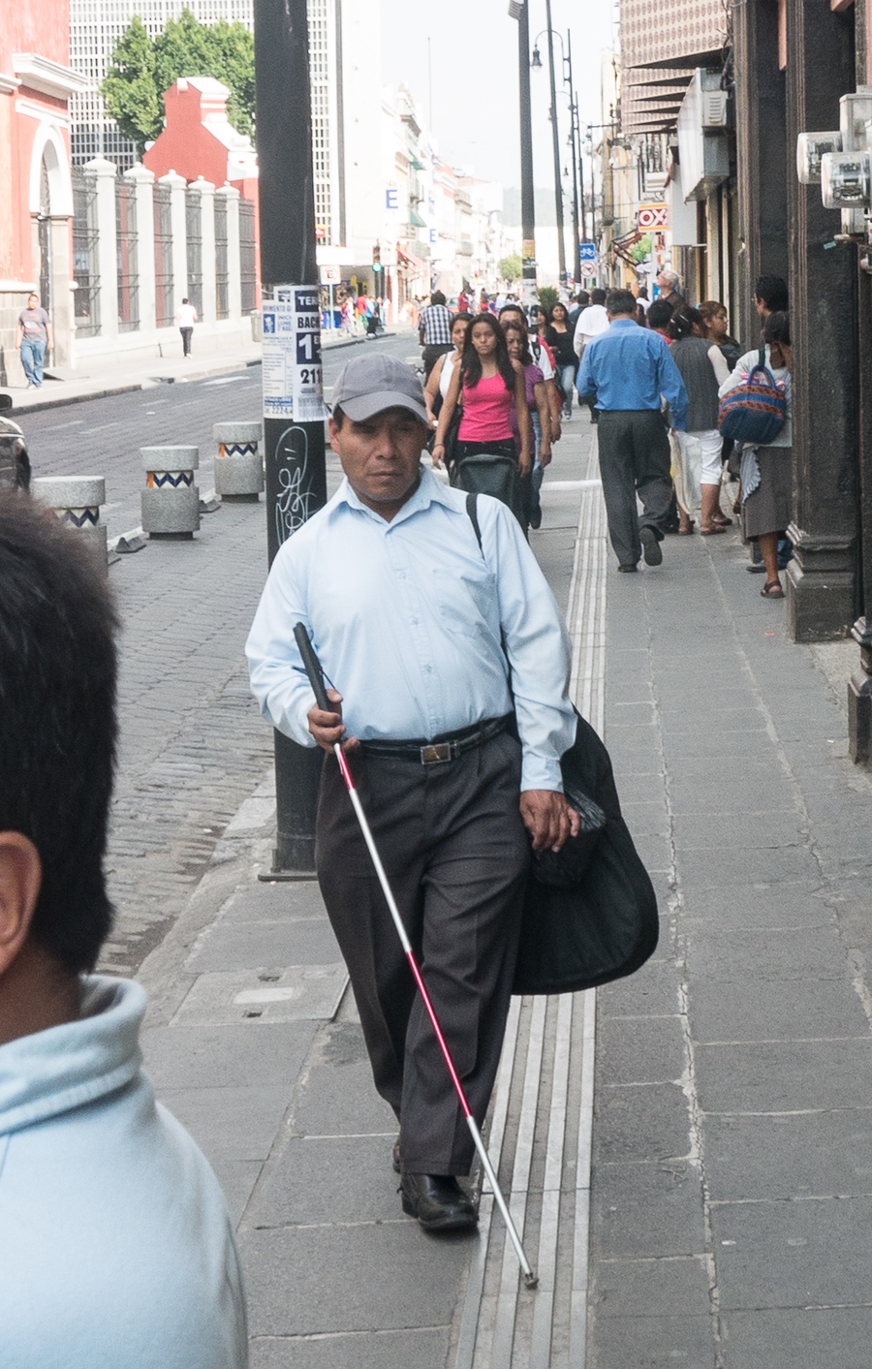
八、簡單問答題
8. Quick questions
1. 試列出三類弱勢社群。
List three types of disadvantaged groups.
2. 輪椅使用者在日常生活中會遇到甚麼具體困難？試舉一例。
What specific difficulty do wheelchair users face in daily life? Give one example.
3. 體驗活動中，有哪四項安全守則必須遵守？
What four safety rules must be followed during the experiential activity?
4. 為甚麼說「短暫的體驗不等於完全明白」？
Why is it said that "a brief experience does not mean full understanding"?
九、思考題
9. Thinking questions
1. 蒙眼行走時，你最依賴哪一種感官來判斷方向？這讓你明白視障人士的生活中，甚麼最重要？
During the blindfold walk, which sense did you rely on most to find your way? What does this tell you about what matters most in a visually impaired person's life?
2. 在校園裡走一圈，找出三個對輪椅使用者不方便的地方，並想想可以怎樣改善。
Walk around the campus and find three places that are inconvenient for wheelchair users. Suggest how each could be improved.
3. 有人說：「體驗了幾分鐘，我已經完全明白視障人士的生活。」你同意嗎？為甚麼？
Someone says: "After a few minutes of experience, I fully understand the life of visually impaired persons." Do you agree? Why or why not?
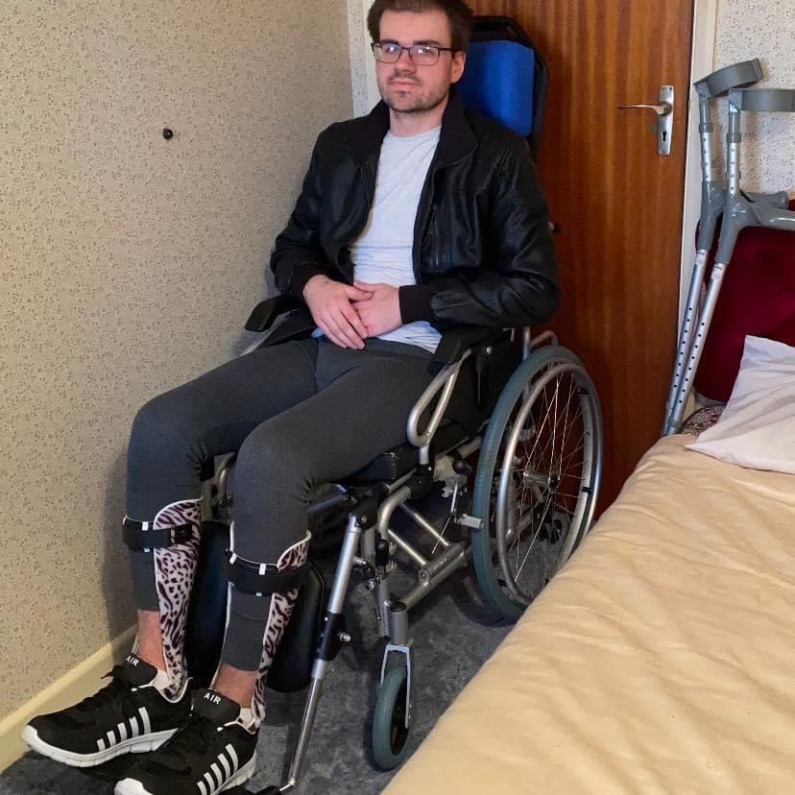
十、分組題：關愛體驗觀察記錄
10. Group task: caring experience observation record
小組討論後，每人完成下表。
After group discussion, each student completes the table below.
項目 Item  Item | 內容 Content  Content
我參加的體驗項目
（蒙眼／輪椅）
The experience I took part in (blindfold / wheelchair)
我的觀察或感受（一）
My observation / feeling (1)
我的觀察或感受（二）
My observation / feeling (2)
我的觀察或感受（三）
My observation / feeling (3)
組員分享中
最深刻的一項
The most memorable point from group sharing
全年主題的意思
The meaning of the year's theme
我的一句承諾
（例如：我想為長者設計＿＿。）
My personal pledge (e.g. I would like to design __ for elderly people.)

十一、總結
11. Summary
- 弱勢社群是在生活中遇到較多困難、需要社會關懷的人士，例如視障人士、輪椅使用者、長者。
- Disadvantaged groups are people who face more difficulties in life and need care from society, e.g. visually impaired persons, wheelchair users and elderly people.
- 體驗活動必須遵守安全守則：跟隨教師指示、只在指定路段活動、輪椅須有人從旁協助、不適立即舉手。
- The experiential activity must follow safety rules: follow the teacher's instructions, stay on the designated route, the wheelchair must be assisted alongside, and raise your hand if unwell.
- 親身體驗幫助我們培養同理心，但體驗只是起點，真正的了解需要長期接觸與聆聽。
- First-hand experience builds empathy, but it is only a starting point; real understanding needs long-term contact and listening.
- 觀察記錄要用具體文字，而非空泛形容詞；發現真實需要，是設計幫助的第一步。
- Observation records must use concrete words, not vague adjectives; discovering real needs is the first step in designing help.
- 全年主題：正能量——用創科關愛弱勢社群。
- Year theme: Positive Energy — Using Innovation and Technology to Care for Disadvantaged Groups.
十二、小測驗
12. Quiz
在十分鐘內完成，不准互相討論。
Finish in 10 minutes. No discussion.
Q1. 列出三類弱勢社群，並為每類寫出一項具體的日常生活困難。（6 分 / 6 marks）
List three types of disadvantaged groups and write one specific daily difficulty for each.
答 Answer：＿＿＿＿＿＿＿＿＿＿＿＿＿＿＿＿＿＿＿＿＿＿＿＿＿＿＿＿＿＿
Q2. 寫出體驗活動的三項安全守則。（3 分 / 3 marks）
Write three safety rules for the experiential activity.
答 Answer：＿＿＿＿＿＿＿＿＿＿＿＿＿＿＿＿＿＿＿＿＿＿＿＿＿＿＿＿＿＿
Q3. 判斷對錯並解釋：蒙眼體驗了十分鐘，就等於完全明白視障人士的生活。（2 分 / 2 marks）
True or false, with explanation: being blindfolded for ten minutes means fully understanding the life of visually impaired persons.
答 Answer：＿＿＿＿＿＿＿＿＿＿＿＿＿＿＿＿＿＿＿＿＿＿＿＿＿＿＿＿＿＿
Q4. 以下哪一項是好的觀察記錄？為甚麼？ 甲：「好辛苦。」 乙：「坐輪椅上斜道時，我要雙手用力抓住扶手，擔心會向後溜。」（2 分 / 2 marks）
Which of the following is a good observation record? Why? A: "So hard." B: "Going up the ramp in the wheelchair, I had to grip the armrests hard with both hands, afraid of sliding backwards."
答 Answer：＿＿＿＿＿＿＿＿＿＿＿＿＿＿＿＿＿＿＿＿＿＿＿＿＿＿＿＿＿＿

