聖公會呂明才中學
S.K.H. Lui Ming Choi Secondary School
創科班 S1 Unit 1：創科人出發
Little Makers Class S1 Unit 1: Innovators Set Off
第 3 堂：認識關愛——弱勢社群的生活體驗
Lesson 3: Understanding Care — Experiencing the Lives of Disadvantaged Groups
教師筆記（附全部答案）
Teacher Notes (with all answers)
本堂物資表 Materials List（教師版）
請預早一星期準備所需物資；標示「課室現有」之項目請預先清點。
品名 Item | 數量（每組） Quantity (per group) | 大約成本 Est. cost | 安全注意 Safety notes
眼罩 Blindfolds | 每組 2–3 個 2–3 per group | 約 $5／個，可重用 approx. $5 each, reusable | 使用前檢查鬆緊；如學生感到頭暈，立即除下。共用前須清潔。 Check the fit before use; remove immediately if a student feels dizzy. Clean before sharing.
輪椅 Wheelchair | 全班 1–2 部（向學校借用） 1–2 per class (borrowed from the school) | $0 $0 | 使用前檢查制動；必須有人從旁協助推動，不可讓學生自行高速推動；只在平坦路段使用。 Check the brakes before use; someone must assist alongside at all times — students must not propel it fast on their own; use only on flat routes.
觀察記錄工作紙 Observation record worksheet | 每人 1 張 1 per student | 約 $0.5／張（影印） approx. $0.5 per sheet (photocopying) | — —
急救箱 First-aid kit | 全班 1 個（由教師攜帶） 1 per class (carried by the teacher) | — — | 以備不時之需。 For emergencies.
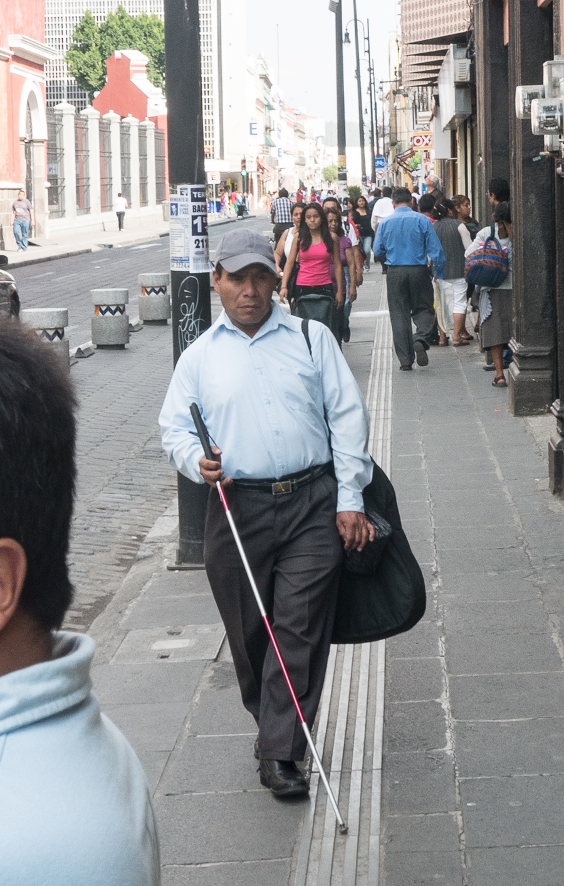
姓名 Name：＿＿＿＿＿＿ 班別 Class：＿＿ 日期 Date：＿＿＿＿＿＿

注意：本文件只供教師使用，不可派發給學生。
Note: for teachers only. Do not distribute to students.
一、行前安全準備（教師必讀）
1. Safety preparation (teachers must read)
- 體驗前必須親自視察路段，確保平坦、無障礙物、無車輛出入。
- Inspect the route in person before the activity: flat, free of obstacles, closed to vehicles.
- 輪椅須向校務處或相關組別借用，並檢查制動正常。
- Borrow the wheelchair from the school office or the relevant team and check that the brakes work.
- 活動期間至少兩位教師在場（一人帶隊、一人殿後）。
- At least two teachers must be present during the activity (one leading, one at the rear).
- 如學生身體不適，立即停止其體驗，改為擔任觀察員。
- If a student feels unwell, stop their experience immediately and reassign them as an observer.
- 攜帶急救箱；眼罩共用前清潔。
- Bring a first-aid kit; clean blindfolds before sharing.
二、學生筆記各題參考答案
2. Model answers for student notes
簡單問答題
Quick questions
參考答案 Reference answer：Q1：視障人士、輪椅使用者、長者。
Q1: Visually impaired persons, wheelchair users, elderly people.
參考答案 Reference answer：Q2：可接受：門檻阻擋輪椅通過、斜道不足或太斜、狹窄通道難以轉彎等，具體一例即可。
Q2: Acceptable: thresholds blocking wheelchairs, missing or steep ramps, narrow passages hard to turn in — one specific example is enough.
參考答案 Reference answer：Q3：任寫四項，例如：跟隨教師指示、只在指定路段活動、蒙眼須有同伴陪伴、不適立即除下眼罩舉手、輪椅須有人從旁協助推動、不可嬉鬧。
Q3: Any four, e.g. follow the teacher's instructions, stay on the designated route, be accompanied when blindfolded, remove the blindfold and raise hand if unwell, wheelchair assisted alongside, no fooling around.
參考答案 Reference answer：Q4：因為弱勢社群是每天、長期面對這些困難，而短暫體驗只有幾分鐘；真正的了解需要長期接觸和聆聽，體驗只是起點。
Q4: Because disadvantaged groups face these difficulties every day over the long term, while the experience lasts only minutes; real understanding needs long-term contact and listening — the experience is only a starting point.
思考題（引導方向）
Thinking questions (guiding notes)
參考答案 Reference answer：T1：多數學生會答聽覺。引導：對視障人士而言，聲音、觸覺等其他感官的訊息非常重要；環境中的聲音提示（如過路處的響聲）設計，正是創科可以幫忙的地方。
T1: Most students will say hearing. Guide: for visually impaired persons, information from other senses such as sound and touch is vital; designing sound cues in the environment (e.g. crossing signals) is where innovation can help.
參考答案 Reference answer：T2：開放式作答。引導學生實地觀察：有級差的門口、沒有斜道的樓梯、太窄的走廊等；改善建議如加設斜道、扶手等，言之成理即可。
T2: Open-ended. Guide students to observe for real: stepped entrances, stairs without ramps, narrow corridors; suggestions like adding ramps or handrails are acceptable if reasonable.
參考答案 Reference answer：T3：不同意。幾分鐘的體驗只能感受部分不便，不能等同長期生活的全部；真正的明白需要長期接觸、聆聽他們的需要。
T3: Disagree. A few minutes can only convey part of the inconvenience, not the whole of a long-term life; real understanding needs long-term contact and listening to their needs.
小測驗答案
Quiz answers
參考答案 Reference answer：Q1（6分）：三類人士各1分，每類一項具體困難各1分。視障人士（過馬路、上落樓梯困難）、輪椅使用者（門檻、斜道問題）、長者（視力聽力衰退、提重物困難）。
Q1 (6 marks): 1 mark per group, 1 mark per specific difficulty. Visually impaired (crossing roads, stairs), wheelchair users (thresholds, ramps), elderly (declining vision/hearing, carrying heavy objects).
參考答案 Reference answer：Q2（3分）：任寫三項安全守則，每項1分。
Q2 (3 marks): any three safety rules, 1 mark each.
參考答案 Reference answer：Q3（2分）：錯。短暫體驗不等於完全明白；弱勢社群長期面對困難，真正的了解需要長期接觸與聆聽。
Q3 (2 marks): False. A brief experience does not equal full understanding; disadvantaged groups face difficulties long-term, and real understanding needs long-term contact and listening.
參考答案 Reference answer：Q4（2分）：乙是好的觀察記錄。因為乙用具體文字描述了身體感覺和情緒，別人能明白經歷了甚麼；甲只有空泛形容詞。
Q4 (2 marks): B is the good record. B uses concrete words describing physical sensation and feelings so readers understand the experience; A has only vague adjectives.
三、家課答案
3. Homework answers
選擇題
Multiple choice
參考答案 Reference answer：Q1：B
Q1: B
參考答案 Reference answer：Q2：C
Q2: C
參考答案 Reference answer：Q3：B
Q3: B
參考答案 Reference answer：Q4：A
Q4: A
參考答案 Reference answer：Q5：C
Q5: C
問答題
Short questions
參考答案 Reference answer：Q1：三類人士各一項具體困難，見小測驗Q1參考答案。
Q1: One specific difficulty per group; see Quiz Q1 model answer.
參考答案 Reference answer：Q2：開放式作答（不少於八十字）。示例：「全年主題的意思是運用我們的創意和科技，幫助在生活中有困難的人，例如視障人士和長者，為他們帶來正能量，改善他們的生活。我希望將來能為長者設計更方便的生活用品。」
Q2: Open-ended (≥80 Chinese characters). Must explain the theme in the student's own words.
參考答案 Reference answer：Q3：開放式作答，須完成觀察記錄表：三項親身觀察或感受、組員分享中最深刻的一項、全年主題的意思。
Q3: Open-ended; must complete the observation record: three first-hand observations/feelings, the most memorable point from group sharing, and the meaning of the theme.
四、附加思考題（課堂延伸用）
4. Extra thinking questions (for extension)
1. 訪問一位長輩（例如祖父母）：他們在日常生活中遇到甚麼不方便？記下三項。
Interview an elderly family member (e.g. a grandparent): what inconveniences do they face in daily life? Note three.
2. 為視障人士設計一個「過馬路小幫手」：它需要解決甚麼問題？用一句需要陳述寫出來。
Design a "road-crossing helper" for visually impaired persons: what problem must it solve? Write it as one need statement.
參考答案 Reference answer：附加題參考：題1——開放式，鼓勵學生聆聽長輩的真實需要。題2——引導學生用「用家＋需要＋原因」格式，例如：「視障人士需要一個能提示車輛接近的裝置，因為他們過馬路時難以判斷車輛位置。」
Reference: Q1 — open-ended; encourage listening to elders' real needs. Q2 — guide students to use the "user + need + reason" format, e.g. "Visually impaired persons need a device that warns of approaching vehicles, because they cannot judge vehicle positions when crossing roads."
五、建議教導方向
5. Suggested teaching approach
- 體驗前用圖片和文字描述，先建立基本認識，再進行體驗，效果更佳。
- Use pictures and descriptions to build basic understanding before the experience — it works better.
- 開始前嚴肅說明活動的意義與安全規則，防止學生把活動當作遊戲嬉鬧。
- Explain the purpose and safety rules seriously before starting, so students do not treat it as a game.
- 體驗後用引導問題帶動討論：「最困難的是甚麼？」「你留意到甚麼平時忽略的細節？」
- After the experience, lead discussion with guiding questions: "What was the most difficult part?" "What details did you notice that you usually overlook?"
- 總結時正式宣布全年主題，並預告下一單元「動手做 STEAM」，讓學生有所期待。
- In the summary, formally announce the year's theme and preview the next unit "Hands-on STEAM" to build anticipation.
- 銜接第二課：指出「發現真實需要」正是設計思維第一步「同理心」的實踐。
- Link to Lesson 2: point out that "discovering real needs" is the practice of design thinking's first step, "empathise".
六、常見迷思
6. Common misconceptions
- 學生以為短暫體驗等於「完全明白」弱勢社群的生活。須引導：體驗只是起點，真正的了解需要長期接觸與聆聽。
- Students may think a brief experience means they "fully understand" disadvantaged groups' lives. Guide them: the experience is only a starting point; real understanding needs long-term contact and listening.
- 學生把活動當作遊戲嬉鬧。須在開始前嚴肅說明意義與安全規則，活動中嚴格執行。
- Students may treat the activity as a game. Explain its purpose and safety rules seriously beforehand and enforce them during the activity.
- 學生寫觀察記錄時只用空泛形容詞（「好驚」「好慘」）。須示範具體描述，並要求至少三項具體記錄。
- Students may write only vague adjectives ("so scary", "so pitiful") in observation records. Demonstrate concrete descriptions and require at least three specific records.

