聖公會呂明才中學
S.K.H. Lui Ming Choi Secondary School
創科班 Little Makers Class
單元二：動手做 STEAM Unit 2: Hands-on STEAM
第 4 堂｜結構力學——紙橋承重挑戰
Lesson 4 | Structural Mechanics — Paper Bridge Load Challenge
學生筆記

Student Notes
姓名 Name：＿＿＿＿＿＿＿＿ 班別 Class：＿＿＿＿ 學號 Class No.：＿＿＿＿ 組別 Group：＿＿＿＿
本堂物資表 Materials List
以下為本堂分組活動所需物資（每組一份）。請在老師派發時核對。
品名 Item | 數量（每組） Quantity (per group) | 安全注意 Safety notes
A4 影印紙 A4 copy paper | 10 張 10 sheets | 紙邊或割傷手指，小心使用 Paper edges may cause small cuts; handle with care
透明膠紙 Adhesive tape | 1 卷 1 roll | 剪刀使用注意安全 Take care when using scissors
硬幣（$1） Coins ($1) | 50 枚（全班共用） 50 pieces (shared by class) | 硬幣細小，課後須點算收回 Small items; count and collect after class
小紙碟 Small paper plates | 每組 2 個 2 per group | — —
剪刀 Scissors | 每組 1 把 1 per group | 刀口鋒利，傳遞時刀柄先行 Blades are sharp; pass handle-first
書桌 Desks | 每組 2 張 2 per group | — —
間尺 Ruler | 每組 1 把 1 per group | — —
日期 Date：＿＿＿＿＿＿＿＿
一、課程內容
1. Lesson Content
1. 甚麼是結構力學？ What is structural mechanics?
結構力學研究「形狀」如何承受重量。同一種材料，做成不同形狀，承重能力可以相差十倍以上。本課我們只用紙和膠紙，看看哪一種形狀的橋最穩固。
Structural mechanics studies how "shape" carries weight. The same material made into different shapes can differ in load capacity by more than ten times. In this lesson we use only paper and tape to find out which bridge shape is the strongest.
2. 三種基本橋樑結構 Three basic bridge structures
- 樑式（Beam）：一條平直的橋面，兩端放在橋墩上。重量直接壓在橋面中央，最容易向下彎曲。
Beam: a flat deck resting on two supports. Weight presses the middle of the deck, which bends downwards most easily.
- 拱形（Arch）：橋面呈弧形，把重量沿弧線傳到兩端的橋墩。拱形擅長承受壓力。
Arch: a curved deck that channels weight along the curve to the supports at both ends. Arches are good at carrying compression.
- 三角形桁架（Triangular truss）：由多個三角形組成框架。三角形三條邊的長度固定後，形狀便唯一確定，不易變形，是最穩固的平面形狀。
Triangular truss: a frame made of triangles. Once the three side lengths of a triangle are fixed, its shape is fixed and resists deformation — the most stable flat shape.
3. 摺疊加固 Folded reinforcement
把紙摺成波浪形或「W」形（手風琴摺），紙張在厚度方向變得更「高」，更難被壓彎。用同樣一張紙，摺疊後的承重能力遠高於平放。這說明：形狀比材料用量更重要。
Folding paper into a wavy or "W" shape (accordion fold) makes the paper "taller" in the thickness direction and harder to bend. Using the same single sheet, the folded version carries far more than the flat one. This shows: shape matters more than the amount of material.
4. 承重的兩個關鍵 Two keys to load-bearing
1. 結構形狀決定承重上限：三角形、拱形、摺疊都是把力分散傳走的方法。
Structural shape sets the load limit: triangles, arches and folds all spread forces away.
2. 重量要放在橋面中央、平均受力：重量集中在一點，紙面容易被壓穿；放在中央的小紙碟上，可避免局部破損。
Place the load at the centre of the deck with even support: a load concentrated at one point can punch through the paper; placing coins on a small paper plate at the centre avoids local damage.
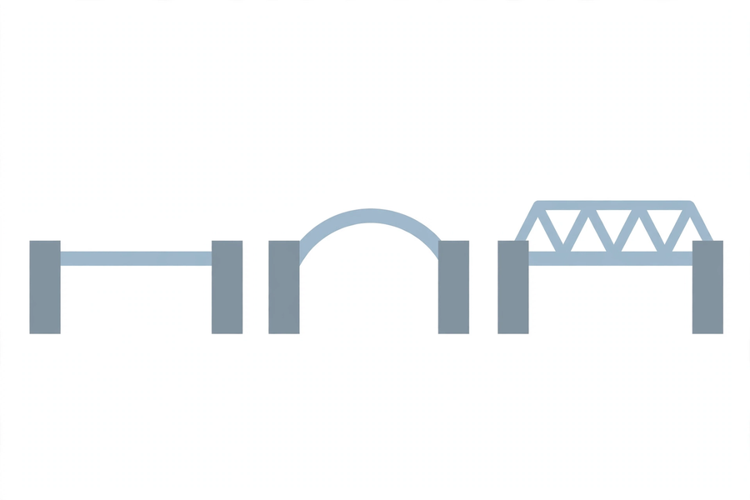
二、例子
2. Examples
例子一：平紙 vs 摺疊紙 Example 1: flat paper vs folded paper
把一張 A4 紙平放在兩張相距 30 厘米的書桌之間，放上 1 枚一元硬幣，紙面立刻下塌。把同一張紙摺成「W」形再架起，可承起 10 枚以上的硬幣。材料完全相同，差別只在形狀。
Lay one A4 sheet flat across two desks 30 cm apart and place one $1 coin on it — the paper collapses at once. Fold the same sheet into a "W" shape and bridge it again — it can now support more than 10 coins. The material is identical; only the shape differs.
例子二：青馬大橋 Example 2: Tsing Ma Bridge
青馬大橋是香港最長的懸索橋之一。粗大的鋼索把橋面的重量吊起，再傳到兩座橋塔和地基。工程師不靠「用更多鋼」，而靠「把力傳到對的地方」。
The Tsing Ma Bridge is one of Hong Kong's longest suspension bridges. Thick steel cables hang the deck and transfer its weight to the two towers and the foundations. Engineers do not rely on "using more steel", but on "sending forces to the right places".
三、簡單問答題（課堂口答）
3. Quick Questions (oral)
1. 橋為甚麼不會塌下？試說出一個原因。
Why doesn't a bridge collapse? Give one reason.
2. 用手推一個四邊形紙框架，它會變成平行四邊形；推一個三角形框架，它會變形嗎？為甚麼？
Push a quadrilateral paper frame and it becomes a parallelogram; push a triangular frame — does it deform? Why?
3. 承重測試時，硬幣為甚麼要放在橋面中央的小紙碟上，而不直接放在紙面上？
In the load test, why are coins placed on a small paper plate at the centre of the deck instead of directly on the paper?
四、思考題
4. Thinking Questions
1. 如果紙張數量不限，你會選擇「加更多紙」還是「改變形狀」來令橋更穩固？為甚麼？
If paper were unlimited, would you "add more paper" or "change the shape" to make the bridge stronger? Why?
2. 有同學把橋做得很厚（疊了五層紙），卻不及另一組摺成波浪形的橋穩固。試解釋原因。
One group made a very thick bridge (five layers of paper) but it was weaker than another group's wavy-folded bridge. Explain why.

五、分組活動：紙橋承重挑戰
5. Group Activity: Paper Bridge Load Challenge
比賽規則 Rules
- 四至五人一組，每組材料：A4 紙 10 張、透明膠紙 1 卷、剪刀 1 把、間尺 1 把、小紙碟 2 個。
Groups of four to five. Materials per group: 10 sheets of A4 paper, 1 roll of adhesive tape, 1 pair of scissors, 1 ruler, 2 small paper plates.
- 橋身跨度須達 30 厘米，兩端各留 5 厘米放在書桌上承托。
The bridge span must reach 30 cm, with 5 cm of support on the desk at each end.
- 測試時把硬幣逐枚放在橋面中央的小紙碟上，直至橋身倒塌或承重量達到上限。
During testing, add coins one by one onto the small paper plate at the centre of the deck, until the bridge collapses or the load limit is reached.
- 硬幣由全班共用，課後須點算收回。
Coins are shared by the whole class and must be counted and collected after the lesson.
設計草圖 Design sketch
在下面方格內畫出本組橋樑的設計草圖，並標示所用的結構類型（樑式／拱形／三角形桁架／混合）。
Draw your group's bridge design in the box below and label the structure type used (beam / arch / triangular truss / mixed).
＿＿＿＿＿＿＿＿＿＿＿＿＿＿＿＿＿＿＿＿＿＿＿＿＿＿＿＿＿＿＿＿＿＿＿＿＿＿＿＿
＿＿＿＿＿＿＿＿＿＿＿＿＿＿＿＿＿＿＿＿＿＿＿＿＿＿＿＿＿＿＿＿＿＿＿＿＿＿＿＿
＿＿＿＿＿＿＿＿＿＿＿＿＿＿＿＿＿＿＿＿＿＿＿＿＿＿＿＿＿＿＿＿＿＿＿＿＿＿＿＿
＿＿＿＿＿＿＿＿＿＿＿＿＿＿＿＿＿＿＿＿＿＿＿＿＿＿＿＿＿＿＿＿＿＿＿＿＿＿＿＿
＿＿＿＿＿＿＿＿＿＿＿＿＿＿＿＿＿＿＿＿＿＿＿＿＿＿＿＿＿＿＿＿＿＿＿＿＿＿＿＿
＿＿＿＿＿＿＿＿＿＿＿＿＿＿＿＿＿＿＿＿＿＿＿＿＿＿＿＿＿＿＿＿＿＿＿＿＿＿＿＿
數據記錄表 Data record table
項目 Item | 本組數據 Our data
結構類型 Structure type
A4 紙用量（張） A4 paper used (sheets)
膠紙用量（約） Tape used (approx.)
承重硬幣數目（枚） Coins supported
倒塌情況描述 Description of collapse
六、總結
6. Summary
- 結構形狀比材料用量更重要：同樣的紙，不同形狀，承重能力完全不同。
Structural shape matters more than material quantity: the same paper in different shapes carries completely different loads.
- 三角形是最穩固的平面形狀；拱形擅長把壓力傳到兩端。
The triangle is the most stable flat shape; the arch is good at channelling pressure to both ends.
- 摺疊加固（波浪形／W 形）能大幅提高紙張的抗彎能力。
Folded reinforcement (wavy / W shape) greatly increases paper's resistance to bending.
- 重量應放在橋面中央並平均受力，避免局部壓穿紙面。
Weight should rest at the centre of the deck with even support, avoiding local puncture of the paper.
- 做實驗要準確記錄數據，才能從數據中比較並得出結論。
Record data accurately in experiments so that comparisons and conclusions can be drawn from the data.
七、課堂小測驗
7. Class Quiz
1. 下列哪一種平面形狀最穩固，不易變形？ A. 正方形 B. 長方形 C. 三角形 D. 圓形
Which flat shape is the most stable and resists deformation? A. Square B. Rectangle C. Triangle D. Circle
2. 把一張紙摺成「W」形後承重能力大增，主要原因是甚麼？ A. 紙變重了 B. 紙在厚度方向變得更難被壓彎 C. 紙變得更光滑 D. 膠紙黏得更牢
Why does folding paper into a "W" shape greatly increase its load capacity? A. The paper becomes heavier B. The paper becomes harder to bend in the thickness direction C. The paper becomes smoother D. The tape sticks better
3. 承重測試時，硬幣應放在哪裡？ A. 橋面中央的小紙碟上 B. 橋的其中一端 C. 直接撒在紙面上 D. 放在書桌上
In the load test, where should the coins be placed? A. On the small paper plate at the centre of the deck B. At one end of the bridge C. Scattered directly on the paper D. On the desk
4. 解釋：為甚麼工程師設計橋樑時，重視「形狀」多於「用料多少」？（30 字以上）
Explain: why do engineers designing bridges care more about "shape" than "amount of material"? (At least 30 Chinese words)
5. 下表是兩組的測試數據。哪一組的設計較有效率（用較少紙承起較多硬幣）？試用數據說明。
甲組：用紙 10 張，承重 12 枚 乙組：用紙 6 張，承重 15 枚
The table shows test data from two groups. Which group's design is more efficient (fewer sheets, more coins)? Explain using the data.
Group A: 10 sheets, 12 coins Group B: 6 sheets, 15 coins

