聖公會呂明才中學
S.K.H. Lui Ming Choi Secondary School
創科班 Little Makers Class
單元二：動手做 STEAM Unit 2: Hands-on STEAM
第 5 堂｜能量轉換——橡筋動力車
Lesson 5 | Energy Conversion — Rubber-band Powered Car
家課

Homework
姓名 Name：＿＿＿＿＿＿＿＿ 班別 Class：＿＿＿＿ 學號 Class No.：＿＿＿＿ 組別 Group：＿＿＿＿
日期 Date：＿＿＿＿＿＿＿＿
本家課包括甲部選擇題及乙部問答題，請用完整句子作答。
This homework has Section A (multiple choice) and Section B (written questions). Answer in complete sentences.
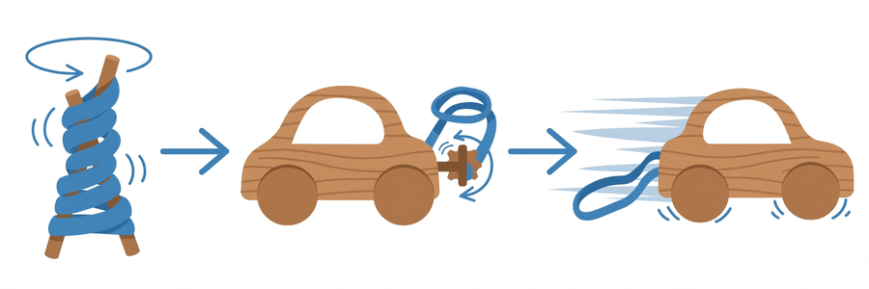
甲部：選擇題（每題 4 分，共 20 分）
Section A: Multiple Choice (4 marks each, 20 marks total)
1. 扭緊橡筋時，能量以甚麼形式儲存？ A. 動能 B. 彈性勢能 C. 熱能 D. 聲能
When the rubber band is twisted, in what form is energy stored? A. Kinetic energy B. Elastic potential energy C. Heat energy D. Sound energy
2. 橡筋動力車前進時，車輪具有 A. 動能 B. 彈性勢能 C. 磁能 D. 光能
As the rubber-band car moves forward, its wheels possess A. kinetic energy B. elastic potential energy C. magnetic energy D. light energy
3. 把橡筋扭得太多圈，車輛反而可能走不遠，原因是 A. 橡筋變輕了 B. 車身變重了 C. 車軸打滑，浪費能量 D. 車輪變大了
Twisting the band too many times may shorten the run because A. the band becomes lighter B. the body becomes heavier C. the axle slips, wasting energy D. the wheels become bigger
4. 公平測試「扭轉圈數對行走距離的影響」時，必須保持不變的是 A. 行走距離 B. 同一跑道、同一條橡筋、相同扭轉圈數 C. 車輛顏色 D. 測試日期
In a fair test of "how twists affect distance", what must be kept unchanged? A. Travel distance B. The same track, the same band, the same number of twists C. Car colour D. Test date
5. 下列哪一項正確？ A. 能量會用完消失 B. 車停下是因為能量變成了磁力 C. 能量不會消失，只會轉換形式 D. 摩擦力可以製造能量
Which is correct? A. Energy is used up and disappears B. The car stops because energy became magnetism C. Energy never disappears, only changes form D. Friction can create energy
乙部：問答題
Section B: Written Questions
1. (8 分) 繪畫能量轉換流程圖（扭緊橡筋 → 鬆手釋放 → 車輛前進 → 車輛停下），並以文字說明每一步的能量形式。
(8 marks) Draw an energy conversion flowchart (twist the band → release → car moves → car stops) and describe the form of energy at each step in words.
2. (6 分) 為甚麼比賽時每組扭轉橡筋的圈數要相同？試從「公平測試」的角度解釋。
(6 marks) Why must every group twist the band the same number of times in the race? Explain from the "fair test" perspective.
3. (6 分) 以文字說明：由扭緊橡筋到車輛停下，能量經歷了怎樣的轉換？（不少於 60 字）
(6 marks) Describe in words: from twisting the band to the car stopping, what conversions did the energy go through? (At least 60 Chinese words)
—— 全卷 40 分 ——
—— Total: 40 marks ——

