聖公會呂明才中學
S.K.H. Lui Ming Choi Secondary School
創科班 Little Makers Class
單元二：動手做 STEAM Unit 2: Hands-on STEAM
第 5 堂｜能量轉換——橡筋動力車
Lesson 5 | Energy Conversion — Rubber-band Powered Car
學生筆記

Student Notes
姓名 Name：＿＿＿＿＿＿＿＿ 班別 Class：＿＿＿＿ 學號 Class No.：＿＿＿＿ 組別 Group：＿＿＿＿
日期 Date：＿＿＿＿＿＿＿＿
本堂物資表 Materials List
以下為本堂分組活動所需物資（每組一份）。請在老師派發時核對。
品名 Item | 數量（每組） Quantity (per group) | 安全注意 Safety notes
小紙盒 Small cardboard box | 每組 1 個 1 per group | — —
橡筋 Rubber bands | 每組 5 條 5 per group | 不可彈射傷人 Do not aim at people
竹籤／飲管 Bamboo skewers / straws | 每組 4 支 4 per group | 竹籤尖銳，小心使用 Skewers are sharp; handle with care
瓶蓋（車輪） Bottle caps (wheels) | 每組 4 個 4 per group | — —
膠紙、剪刀 Tape, scissors | 課室現有 Available in classroom | 剪刀使用注意安全 Take care when using scissors
捲尺 Measuring tape | 每組 1 個 1 per group | — —
粉筆／膠紙（起跑線） Chalk / tape (start line) | 全班共用 Shared by class | — —
一、課程內容
1. Lesson Content
1. 甚麼是能量？ What is energy?
能量是「做事情的能力」。車輛前進、燈泡發光，都需要能量。能量有很多形式，本課的主角是彈性勢能和動能。
Energy is the "ability to do things". A moving car and a glowing bulb both need energy. Energy takes many forms; this lesson stars elastic potential energy and kinetic energy.
2. 彈性勢能 Elastic potential energy
把橡筋扭緊，你的手對橡筋做了功，能量便以「彈性勢能」的形式儲存在橡筋裡。扭得愈多圈，儲存的彈性勢能愈多。鬆手後，橡筋會設法恢復原狀。
When you twist a rubber band, your hand does work on it and energy is stored in the band as "elastic potential energy". More twists mean more stored elastic potential energy. When released, the band tries to return to its original shape.
3. 動能 Kinetic energy
運動中的物體帶有「動能」。車輪轉動、車身前進，都是動能的表現。車走得愈快，動能愈大。
A moving object carries "kinetic energy". Spinning wheels and a moving car are both displays of kinetic energy. The faster the car, the greater its kinetic energy.
4. 能量轉換：由扭緊到前進 Energy conversion: from twisting to moving
1. 扭緊橡筋：手施力做功 → 橡筋儲存彈性勢能。
Twist the band: the hand does work → the band stores elastic potential energy.
2. 鬆手釋放：彈性勢能 → 車輪轉動的動能 → 車輛前進。
Release: elastic potential energy → kinetic energy of the spinning wheels → the car moves forward.
3. 車輛最終停下：部分能量因摩擦變成熱散失到空氣中。
The car finally stops: some energy is lost as heat through friction into the air.
能量不會無故消失，只會由一種形式轉成另一種形式。
Energy never disappears for no reason; it only changes from one form to another.
5. 摩擦力 Friction
摩擦力是阻礙運動的力。車輪與地面、車軸與車身之間都有摩擦。適當的摩擦令車輪抓地前進；摩擦太大，車輛走不遠；車輪打滑（例如橡筋扭得太多、車軸空轉），能量便浪費了。
Friction is the force that opposes motion — between wheels and ground, and between axles and the body. Proper friction lets wheels grip and drive forward; too much friction shortens the run; slipping wheels (e.g. an over-twisted band spinning the axle freely) waste energy.
6. 公平測試 Fair test
要公平比較各組的車，必須控制變量：
To compare groups' cars fairly, variables must be controlled:
- 改變的變量（自變量）：橡筋扭轉圈數。
Changed variable: number of rubber-band twists.
- 保持不變的變量：同一跑道、同一條起跑線、同一條橡筋、同一部車。
Kept-the-same variables: the same track, the same starting line, the same rubber band, the same car.
- 量度的結果（因變量）：車輛行走距離（米）。
Measured result: the distance the car travels (metres).
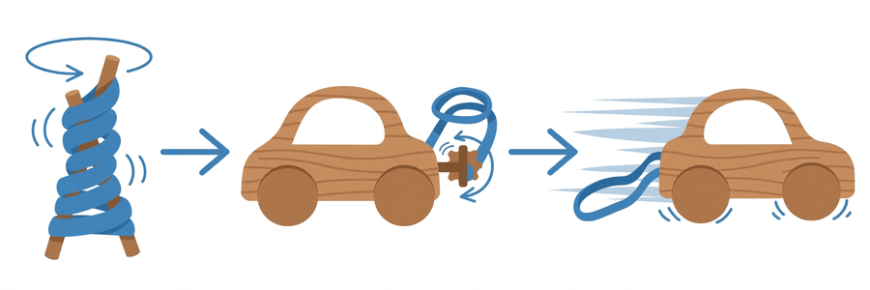
二、例子
2. Examples
例子一：上緊發條的玩具車 Example 1: a wind-up toy car
扭緊發條 → 發條儲存彈性勢能 → 鬆手後齒輪帶動車輪 → 玩具車前進。原理與橡筋動力車完全相同。
Wind the spring → the spring stores elastic potential energy → on release, gears drive the wheels → the toy car moves. The principle is exactly the same as the rubber-band car.
例子二：拉弓射箭 Example 2: drawing a bow
拉開弓弦：手做功，弓儲存彈性勢能；放手：彈性勢能轉為箭的動能，箭飛出去。橡筋就是我們的「弓弦」。
Drawing the bow: the hand does work and the bow stores elastic potential energy; releasing: the elastic potential energy becomes the arrow's kinetic energy and the arrow flies. Our rubber band is the "bowstring".
三、簡單問答題（課堂口答）
3. Quick Questions (oral)
1. 橡筋扭得愈多圈，車輛一般會怎樣？為甚麼？
The more twists in the band, the car generally does what? Why?
2. 車輛最後停了下來，橡筋裡的能量去了哪裡？
The car finally stops. Where did the energy in the band go?
3. 比賽時，為甚麼每組扭轉橡筋的圈數要相同？
In the race, why must every group twist the band the same number of times?
四、思考題
4. Thinking Questions
1. 如果把橡筋扭到極限（太多圈），可能會發生甚麼事？對車輛前進有甚麼影響？
If the band is twisted to its limit (too many twists), what might happen? How would it affect the car?
2. 有同學說「車身愈重，車走得愈快」。你同意嗎？試用摩擦力的概念解釋。
A classmate says "the heavier the car, the faster it goes". Do you agree? Explain using the idea of friction.
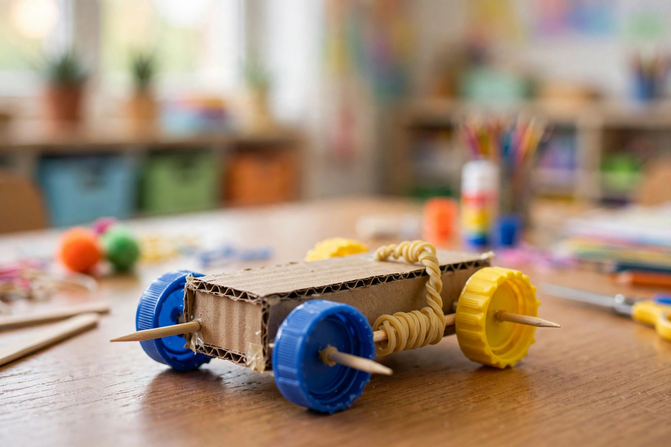
五、分組活動：製作與測試
5. Group Activity: Build and Test
製作要點 Making tips
- 車身：小紙盒；車軸：竹籤或飲管，要穿過車身並能自由轉動。
Body: small cardboard box; axles: bamboo skewers or straws, passing through the body and spinning freely.
- 車輪：四個瓶蓋，左右車輪要對齊，否則車輛會偏離跑道。
Wheels: four bottle caps; left and right wheels must be aligned or the car will veer off track.
- 橡筋一端固定在車身前端，另一端繞在後軸上；扭緊後軸儲能，鬆手釋放。
Fix one end of the band to the front of the body and wind the other end around the rear axle; twist the rear axle to store energy, then release.
- 注意安全：橡筋不可對著人彈射；竹籤尖銳，小心使用。
Safety: never aim the band at people; skewers are sharp — handle with care.
數據記錄表：扭轉圈數 vs 行走距離 Data table: twists vs distance
測試次數 Trial | 橡筋扭轉圈數 Number of twists | 行走距離（米） Distance (m) | 備註 Remarks
1
2
3
六、總結
6. Summary
- 扭緊橡筋時，手做功，能量以彈性勢能儲存；釋放後轉為車輪的動能，推動車輛前進。
Twisting the band: the hand does work and energy is stored as elastic potential energy; on release it becomes the wheels' kinetic energy, driving the car forward.
- 能量不會消失，只會轉換形式；部分能量因摩擦變成熱散失。
Energy never disappears, only changes form; some is lost as heat through friction.
- 摩擦力太小會打滑、太大走不遠；車輪要對齊。
Too little friction causes slipping, too much shortens the run; wheels must be aligned.
- 公平測試要控制變量：改變扭轉圈數，保持跑道、橡筋、起跑線不變，量度行走距離。
A fair test controls variables: change the number of twists, keep the track, band and starting line unchanged, and measure the distance.
七、課堂小測驗
7. Class Quiz
1. 扭緊橡筋時，能量以甚麼形式儲存？ A. 動能 B. 彈性勢能 C. 熱能 D. 光能
When the rubber band is twisted, in what form is energy stored? A. Kinetic energy B. Elastic potential energy C. Heat energy D. Light energy
2. 車輛前進時，橡筋的彈性勢能主要轉化為 A. 車輪轉動的動能 B. 聲音 C. 光能 D. 磁力
As the car moves, the band's elastic potential energy mainly becomes A. kinetic energy of the spinning wheels B. sound C. light D. magnetism
3. 公平測試中，以下哪一項應該保持不變？ A. 扭轉圈數 B. 行走距離 C. 跑道和起跑線 D. 車輛顏色
In a fair test, which should be kept unchanged? A. Number of twists B. Travel distance C. Track and starting line D. Car colour
4. 解釋：為甚麼比賽時每組扭轉橡筋的圈數要相同？（30 字以上）
Explain: why must every group twist the band the same number of times in the race? (At least 30 Chinese words)
5. 下表是某組的測試數據，試描述扭轉圈數與行走距離的關係。
10 圈 → 1.5 米；20 圈 → 3.2 米；30 圈 → 4.6 米
The table shows one group's data. Describe the relationship between twists and distance.
10 twists → 1.5 m; 20 twists → 3.2 m; 30 twists → 4.6 m

