聖公會呂明才中學
S.K.H. Lui Ming Choi Secondary School
創科班 Little Makers Class
單元二：動手做 STEAM Unit 2: Hands-on STEAM
第 6 堂｜電與磁——電磁鐵拾物比賽＋磁浮貓
Lesson 6 | Electricity and Magnetism — Electromagnet Pick-up Contest and Levitating Cat
家課

Homework
姓名 Name：＿＿＿＿＿＿＿＿ 班別 Class：＿＿＿＿ 學號 Class No.：＿＿＿＿ 組別 Group：＿＿＿＿
日期 Date：＿＿＿＿＿＿＿＿
本家課包括甲部選擇題及乙部問答題。完成後請簽署電池安全承諾。
This homework has Section A (multiple choice) and Section B (written questions). Sign the battery safety pledge when finished.
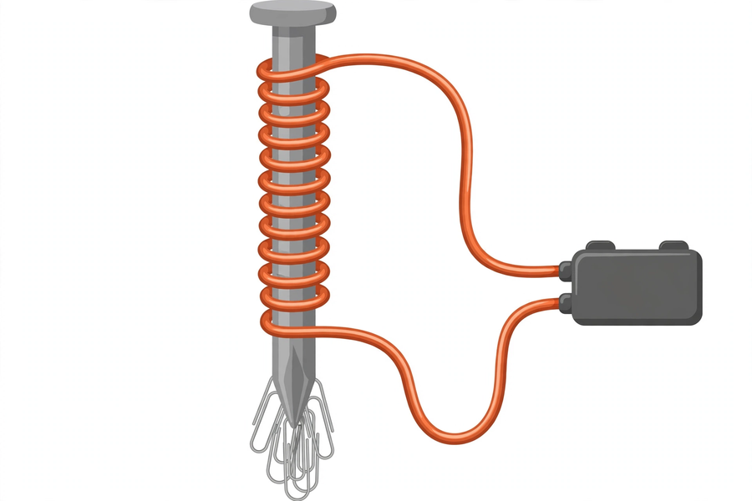
甲部：選擇題（每題 4 分，共 20 分）
Section A: Multiple Choice (4 marks each, 20 marks total)
1. 把兩塊磁石的 N 極互相靠近，它們會 A. 互相吸引 B. 互相排斥 C. 黏在一起 D. 失去磁力
Bringing the N poles of two magnets together, they will A. attract B. repel C. stick together D. lose magnetism
2. 「電生磁」是指 A. 磁石可以發電 B. 電流通過導線會產生磁場 C. 電池本身有磁力 D. 電線會吸起回形針
"Electricity produces magnetism" means A. magnets can generate electricity B. current through a wire creates a magnetic field C. batteries are magnetic D. wires attract paper clips
3. 在電池數量相同下，線圈匝數愈多，電磁鐵的磁力 A. 愈弱 B. 一般愈強 C. 不變 D. 完全消失
With the same batteries, more coil turns make the electromagnet A. weaker B. generally stronger C. unchanged D. lose magnetism completely
4. 電磁鐵斷電後 A. 磁力更強 B. 磁力消失 C. 變成永久磁石 D. 會發熱
After an electromagnet is disconnected A. magnetism strengthens B. magnetism disappears C. it becomes a permanent magnet D. it heats up
5. 下列哪一項是短路，有危險？ A. 電池經線圈接駁 B. 用完即拆電池 C. 用導線直接連接電池正負極 D. 用電池盒接駁
Which is a dangerous short circuit? A. Batteries connected via the coil B. Disconnecting after use C. Wiring battery terminals directly together D. Using a battery holder
乙部：問答題
Section B: Written Questions
1. (8 分) 以文字回答：為甚麼電磁鐵斷電後便吸不起回形針？（不少於 50 字）
(8 marks) Answer in writing: why can't an electromagnet attract paper clips after it is disconnected? (At least 50 Chinese words)
2. (6 分) 完成下表（填上本組的真實數據），並寫出一句結論，說明線圈匝數與吸起回形針數目的關係。
(6 marks) Complete the table below (with your group's real data) and write one concluding sentence on the relationship between coil turns and paper clips attracted.
測試 Test | 線圈匝數（約） Coil turns (approx.) | 吸起回形針數目 Paper clips attracted
1
2
1. (6 分) 寫出電池安全三規則，並在下面簽署承諾。 簽署：＿＿＿＿＿＿＿＿
(6 marks) Write down the three battery safety rules and sign the pledge below. Signature: ____________
—— 全卷 40 分 ——
—— Total: 40 marks ——

