聖公會呂明才中學
S.K.H. Lui Ming Choi Secondary School
創科班 Little Makers Class
單元二：動手做 STEAM Unit 2: Hands-on STEAM
第 6 堂｜電與磁——電磁鐵拾物比賽＋磁浮貓
Lesson 6 | Electricity and Magnetism — Electromagnet Pick-up Contest and Levitating Cat
學生筆記

Student Notes
姓名 Name：＿＿＿＿＿＿＿＿ 班別 Class：＿＿＿＿ 學號 Class No.：＿＿＿＿ 組別 Group：＿＿＿＿
日期 Date：＿＿＿＿＿＿＿＿
本堂物資表 Materials List
以下為本堂分組活動所需物資（每組一份）。請在老師派發時核對。
品名 Item | 數量（每組） Quantity (per group) | 安全注意 Safety notes
漆包線 Enamelled copper wire | 每組約 2 米 approx. 2 m per group | 線頭或刺手，小心使用 Wire ends may prick; handle with care
大鐵釘 Large iron nail | 每組 1 枚 1 per group | 尖銳，小心使用 Sharp; handle with care
AA 電池 AA batteries | 每組 2 粒 2 per group | 嚴禁短路，用完即拆，教師統一回收 Never short-circuit; disconnect immediately after use; teacher collects all batteries
電池盒 Battery holder | 每組 1 個 1 per group | — —
回形針 Paper clips | 每組 20 枚 20 per group | 細小，課後點算收回 Small items; count and collect after class
圓形磁石 Disc magnets | 每組 4 粒 4 per group | 磁石易碎，避免撞擊；遠離電子產品 Fragile; avoid impact; keep away from electronic devices
紙杯、卡紙（磁浮貓底座及貓形） Paper cup and card (base and cat shape) | 每組 1 套 1 set per group | — —
砂紙（小塊） Sandpaper (small piece) | 每組 1 小塊 1 small piece per group | — —
一、課程內容
1. Lesson Content
1. 磁石與磁極 Magnets and magnetic poles
每塊磁石都有兩個磁極：N 極（北極）和 S 極（南極）。磁力在兩極最強，中央最弱。
Every magnet has two magnetic poles: the N pole (north) and the S pole (south). Magnetism is strongest at the poles and weakest in the middle.
2. 同極相斥、異極相吸 Like poles repel, unlike poles attract
- N 極靠近 N 極 → 互相排斥；S 極靠近 S 極 → 互相排斥。
N pole near N pole → repel; S pole near S pole → repel.
- N 極靠近 S 極 → 互相吸引。
N pole near S pole → attract.
3. 電生磁 Electricity produces magnetism
電流通過導線時，會在導線周圍產生磁場——這就是「電生磁」。把導線繞成線圈，磁場會集中增強；線圈中間插一枚鐵釘（鐵芯），磁力再進一步加強，這就是電磁鐵。
When electric current flows through a wire, it creates a magnetic field around the wire — "electricity producing magnetism". Winding the wire into a coil concentrates and strengthens the field; inserting an iron nail (iron core) strengthens it further. That is an electromagnet.
4. 電磁鐵的構造 Structure of an electromagnet
- 線圈：漆包線緊密纏繞在鐵釘上（兩端須刮除漆皮，否則不能導電）。
Coil: enamelled wire wound tightly around the nail (scrape the insulation off both ends or it will not conduct).
- 鐵芯：大鐵釘，負責集中磁場。
Iron core: a large iron nail, which concentrates the magnetic field.
- 電源：兩粒 AA 電池（經電池盒接駁，只在測試時接上）。
Power source: two AA batteries (connected via a battery holder, only during testing).
5. 線圈匝數與磁力 Coil turns and magnetic strength
在電池數量相同下，線圈纏繞的匝數愈多，磁力一般愈強，能吸起的回形針愈多。這是本課拾物比賽要驗證的規律。
With the same number of batteries, more coil turns generally mean stronger magnetism and more paper clips attracted. This is the pattern the pick-up contest will verify.
6. 斷電後磁力消失 Magnetism disappears when disconnected
電磁鐵的磁力來自電流；電池一拆除，電流停止，磁力便消失，回形針紛紛掉下。這是電磁鐵與永久磁石最大的分別：電磁鐵的磁力可以開關。
An electromagnet's magnetism comes from electric current; once the batteries are removed, the current stops, the magnetism vanishes, and the paper clips fall. This is the biggest difference from a permanent magnet: an electromagnet can be switched on and off.
7. 磁浮貓的原理 How the levitating cat works
磁浮貓利用「同極相斥」：底座的磁石與小貓底部的磁石以相同磁極相對，互相排斥，把小貓托在半空，呈現懸浮效果。調校磁石位置，令排斥力剛好抵銷小貓的重量。
The levitating cat uses "like-pole repulsion": the magnet in the base and the magnet under the cat face each other with like poles, repelling and holding the cat in mid-air. Adjust the magnets so the repulsion just balances the cat's weight.
8. 電池安全三規則 Three battery safety rules
1. 不可短路：切勿用導線直接連接電池正負極，會發熱甚至漏液。
No short circuits: never connect the battery terminals directly with a wire — it heats up and may leak.
2. 不可長時間接駁：只在測試時接上電池。
No prolonged connection: connect batteries only during testing.
3. 用完即拆：測試完畢立即拆除電池，由教師統一回收。
Disconnect immediately after use: remove batteries when testing ends; the teacher collects them all.
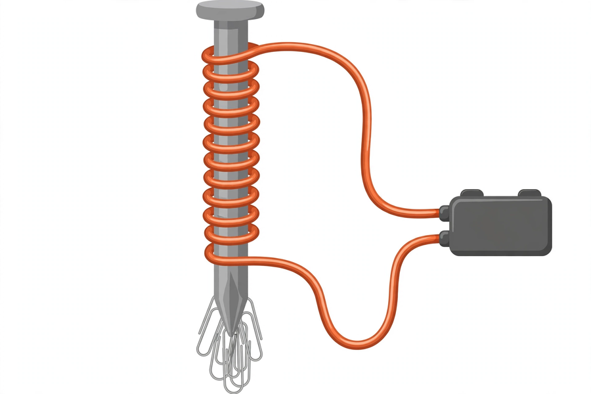
二、例子
2. Examples
例子一：廢鐵場的起重電磁鐵 Example 1: scrapyard lifting electromagnet
廢鐵場用巨型電磁鐵吸起整輛報廢汽車：通電就有磁力吸起廢鐵，斷電磁力消失，廢鐵掉下。開關自如，正是電磁鐵勝過永久磁石之處。
Scrapyards use giant electromagnets to lift whole scrapped cars: power on to attract the scrap, power off and the magnetism vanishes so the scrap drops. Being switchable is exactly where electromagnets beat permanent magnets.
例子二：磁浮列車 Example 2: maglev train
磁浮列車利用磁石同極相斥把車身托起，懸浮在路軌上行走，減少摩擦，速度極快。我們的磁浮貓用的正是同一原理。
Maglev trains use like-pole repulsion to lift the train body, floating above the track with little friction at very high speed. Our levitating cat uses exactly the same principle.
三、簡單問答題（課堂口答）
3. Quick Questions (oral)
1. 把兩塊磁石的 N 極互相靠近，會發生甚麼事？N 極靠近 S 極又如何？
What happens when the N poles of two magnets are brought together? What about N near S?
2. 電磁鐵與普通磁石最大的分別是甚麼？
What is the biggest difference between an electromagnet and an ordinary magnet?
3. 為甚麼漆包線兩端要刮除漆皮才能接駁電池？
Why must the insulation be scraped off both ends of the enamelled wire before connecting the battery?
四、思考題
4. Thinking Questions
1. 如果把線圈匝數加倍，吸起的回形針數目一定加倍嗎？為甚麼？（提示：想想電池提供的電流有沒有變）
If the coil turns are doubled, will the number of paper clips attracted definitely double? Why? (Hint: has the current from the batteries changed?)
2. 為甚麼電磁鐵斷電後便吸不起回形針？試用「電生磁」解釋。
Why can't an electromagnet attract paper clips after it is disconnected? Explain using "electricity produces magnetism".
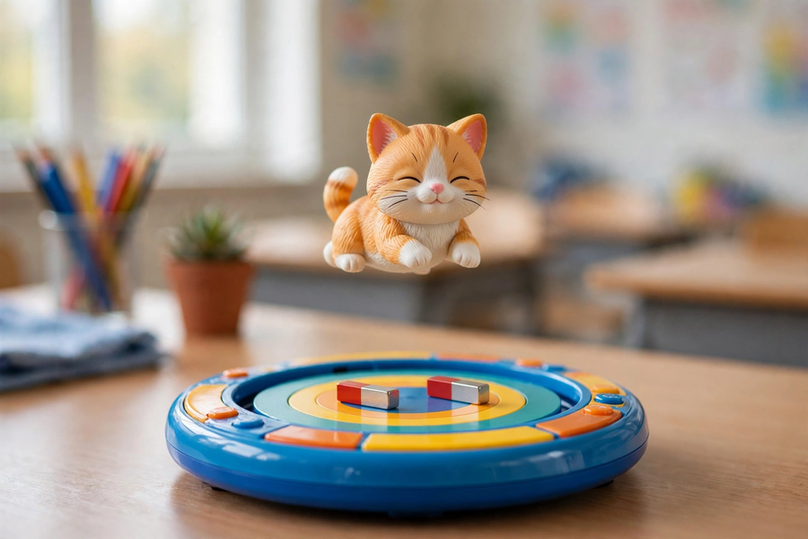
五、分組活動
5. Group Activities
活動一：製作電磁鐵 Activity 1: make the electromagnet
- 把漆包線緊密纏繞在大鐵釘上，兩端各留約 5 厘米，並用砂紙刮除漆皮。
Wind the enamelled wire tightly around the large nail, leaving about 5 cm at each end, and scrape off the insulation with sandpaper.
- 把線兩端接入電池盒，裝上兩粒 AA 電池，只在測試時接通。
Connect the wire ends to the battery holder with two AA batteries; connect only during testing.
- 用釘頭去吸回形針，測試磁力。
Use the nail head to attract paper clips and test the magnetism.
活動二：拾物比賽數據記錄表 Activity 2: pick-up contest data table
計時一分鐘，記錄吸起的回形針數目。可改變線圈匝數再試，比較結果。
Time one minute and record the number of paper clips attracted. Try different coil turns and compare.
測試 Test | 線圈匝數（約） Coil turns (approx.) | 吸起回形針數目 Paper clips attracted | 備註 Remarks
1
2
活動三：磁浮貓 Activity 3: levitating cat
- 用紙杯做底座，卡紙剪出小貓形狀。
Make the base from a paper cup and cut a cat shape from card.
- 底座磁石與小貓底部磁石以同極相對，利用相斥力把小貓托起；慢慢調校位置直至懸浮。
Face like poles of the base magnet and the cat magnet towards each other; use repulsion to lift the cat, adjusting slowly until it levitates.
- 磁石易碎，避免撞擊；遠離電子產品。
Magnets are fragile — avoid impact and keep them away from electronic devices.
磁極特性填充題 Fill in the blanks: magnetic poles
1. N 極靠近 N 極會互相＿＿＿＿；N 極靠近 S 極會互相＿＿＿＿。
N pole near N pole: they ＿＿＿＿ each other; N pole near S pole: they ＿＿＿＿ each other.
2. 電磁鐵的磁力來自＿＿＿＿；拆除電池後，磁力會＿＿＿＿。
An electromagnet's magnetism comes from ＿＿＿＿; after the batteries are removed, the magnetism will ＿＿＿＿.
電池安全承諾 Battery safety pledge
本人承諾遵守電池安全三規則：不短路、不長時間接駁、用完即拆。 簽署：＿＿＿＿＿＿＿＿
I pledge to follow the three battery safety rules: no short circuits, no prolonged connection, disconnect immediately after use. Signature: ____________
六、總結
6. Summary
- 磁石有 N、S 兩極：同極相斥、異極相吸。
Magnets have N and S poles: like poles repel, unlike poles attract.
- 電流產生磁場——電生磁；線圈＋鐵芯＋電池＝電磁鐵。
Current creates a magnetic field — electricity produces magnetism; coil + iron core + batteries = electromagnet.
- 匝數愈多，磁力一般愈強；斷電後磁力消失，磁力可開關。
More turns generally mean stronger magnetism; magnetism vanishes when disconnected — it is switchable.
- 磁浮貓利用同極相斥懸浮；電池安全三規則：不短路、不長時間接駁、用完即拆。
The levitating cat floats on like-pole repulsion; the three battery safety rules: no short circuits, no prolonged connection, disconnect immediately after use.
七、課堂小測驗
7. Class Quiz
1. 把兩塊磁石的 S 極互相靠近，它們會 A. 互相吸引 B. 互相排斥 C. 沒有反應 D. 失去磁力
Bringing the S poles of two magnets together, they will A. attract B. repel C. not react D. lose magnetism
2. 電磁鐵的磁力來自 A. 鐵釘本身 B. 通過線圈的電流 C. 膠紙 D. 回形針
An electromagnet's magnetism comes from A. the nail itself B. the current through the coil C. the tape D. the paper clips
3. 在電池數量相同下，線圈匝數愈多 A. 磁力愈弱 B. 磁力一般愈強 C. 磁力不變 D. 電池愈快沒電（主要）
With the same batteries, more coil turns A. weaken magnetism B. generally strengthen magnetism C. change nothing D. mainly drain the batteries faster
4. 下列哪一項違反電池安全規則？ A. 測試時才接上電池 B. 用完立即拆除 C. 用導線直接連接電池正負極 D. 由教師統一回收電池
Which violates battery safety rules? A. Connecting batteries only during testing B. Disconnecting immediately after use C. Connecting battery terminals directly with a wire D. Teacher collecting all batteries
5. 解釋：為甚麼磁浮貓能夠懸浮在半空？（30 字以上）
Explain: why can the levitating cat float in mid-air? (At least 30 Chinese words)

