聖公會呂明才中學
S.K.H. Lui Ming Choi Secondary School
創科班 Little Makers Class
單元二：動手做 STEAM Unit 2: Hands-on STEAM
第 6 堂｜電與磁——電磁鐵拾物比賽＋磁浮貓
Lesson 6 | Electricity and Magnetism — Electromagnet Pick-up Contest and Levitating Cat
教師筆記

Teacher Notes
本堂物資表 Materials List（教師版）
請預早一星期準備所需物資；標示「課室現有」之項目請預先清點。
品名 Item | 數量（每組） Quantity (per group) | 大約成本 Est. cost | 安全注意 Safety notes
漆包線 Enamelled copper wire | 每組約 2 米 approx. 2 m per group | 約 HK$4 approx. HK$4 | 線頭或刺手，小心使用 Wire ends may prick; handle with care
大鐵釘 Large iron nail | 每組 1 枚 1 per group | 約 HK$2 approx. HK$2 | 尖銳，小心使用 Sharp; handle with care
AA 電池 AA batteries | 每組 2 粒 2 per group | 約 HK$4 approx. HK$4 | 嚴禁短路，用完即拆，教師統一回收 Never short-circuit; disconnect immediately after use; teacher collects all batteries
電池盒 Battery holder | 每組 1 個 1 per group | 約 HK$5 approx. HK$5 | — —
回形針 Paper clips | 每組 20 枚 20 per group | 約 HK$2 approx. HK$2 | 細小，課後點算收回 Small items; count and collect after class
圓形磁石 Disc magnets | 每組 4 粒 4 per group | 約 HK$8 approx. HK$8 | 磁石易碎，避免撞擊；遠離電子產品 Fragile; avoid impact; keep away from electronic devices
紙杯、卡紙（磁浮貓底座及貓形） Paper cup and card (base and cat shape) | 每組 1 套 1 set per group | 約 HK$2 approx. HK$2 | — —
砂紙（小塊） Sandpaper (small piece) | 每組 1 小塊 1 small piece per group | 約 HK$1 approx. HK$1 | — —
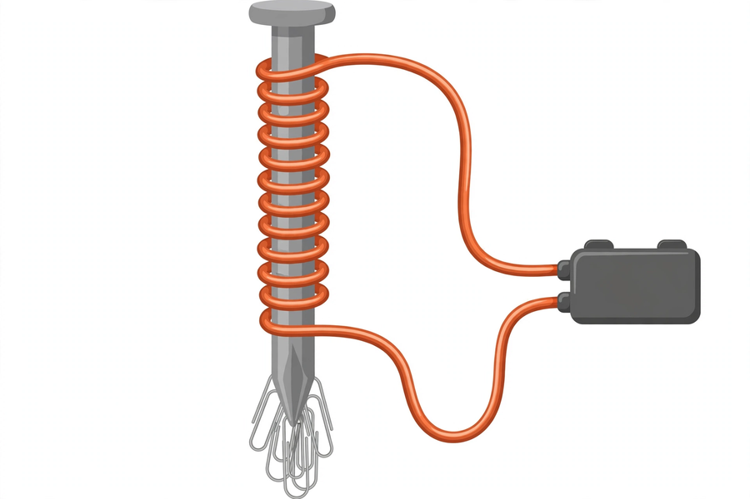
本文件包含學生筆記所有題目的參考答案、家課答案、附加思考題、建議教導方向及常見迷思，僅供教師使用，切勿派發給學生。
This document contains reference answers to all student-note questions, homework answers, extra thinking questions, teaching suggestions and common misconceptions. For teachers only — do not distribute to students.
一、學生筆記參考答案
1. Student Notes — Reference Answers
簡單問答題 Quick questions
■ 參考答案 Reference answers
1. N 極靠近 N 極會互相排斥；N 極靠近 S 極會互相吸引。
N near N: repel; N near S: attract.
2. 電磁鐵的磁力來自電流，可以開關：通電有磁力，斷電磁力消失；普通磁石（永久磁石）的磁力長期存在，不能開關。
An electromagnet's magnetism comes from current and is switchable: on with power, gone without; an ordinary (permanent) magnet stays magnetic all the time and cannot be switched.
3. 因為漆包線表面的漆是絕緣體，不刮除便不能導電，電路不通，電磁鐵不會有磁力。
Because the enamel coating is an insulator; without scraping it off, the wire cannot conduct, the circuit is incomplete, and the electromagnet has no magnetism.
思考題 Thinking questions
■ 參考答案 Reference answers
1. 不一定。匝數增加磁場增強，但電池提供的電流不變，總磁力增幅有限；而且鐵釘的磁化會飽和，太多匝數效益遞減。所以數目會增加，但未必剛好加倍。
Not necessarily. More turns strengthen the field, but the current from the batteries is unchanged, so the gain is limited; the nail's magnetisation also saturates, giving diminishing returns. The count rises, but not necessarily doubles.
2. 因為電磁鐵的磁力來自通過線圈的電流（電生磁）；斷電後電流停止，磁場消失，鐵釘不再是磁石，自然吸不起回形針。
Because the electromagnet's magnetism comes from current through the coil (electricity produces magnetism); when disconnected the current stops, the field disappears, the nail is no longer magnetic, and clips cannot be attracted.
磁極填充題參考答案 Fill-in-the-blanks — reference answers
■ 參考答案 Reference answers
1. 排斥；吸引（N–N 排斥，N–S 吸引）
repel; attract (N–N repels, N–S attracts)
2. 電流；消失
electric current; disappear
課堂小測驗參考答案 Class quiz — reference answers
■ 參考答案 Reference answers
1. B（互相排斥）
B (repel)
2. B（通過線圈的電流）
B (the current through the coil)
3. B（磁力一般愈強）
B (generally stronger magnetism)
4. C（用導線直接連接電池正負極＝短路）
C (wiring the terminals directly = short circuit)
5. 參考答案：磁浮貓底座磁石與小貓底部磁石以同極相對，同極相斥產生向上的排斥力，抵銷小貓的重量，把小貓托在半空。評分：說出「同極相斥」得滿分。
Reference: the base magnet and the cat magnet face each other with like poles; like-pole repulsion pushes upward, balancing the cat's weight and holding it in mid-air. Full marks for "like poles repel".
二、家課參考答案
2. Homework — Reference Answers
■ 參考答案 Reference answers
1. B（互相排斥）
B (repel)
2. B（電生磁：電流產生磁場）
B (electricity produces magnetism: current creates a magnetic field)
3. B（磁力一般愈強）
B (generally stronger magnetism)
4. B（斷電後磁力消失）
B (magnetism disappears when disconnected)
5. C（短路）
C (short circuit)
6. 參考答案：因為電磁鐵的磁力來自電流；拆除電池後電流停止，磁場消失，鐵釘不再帶磁，所以吸不起回形針。評分：說出「電流停止／磁場消失」。
Reference: the electromagnet's magnetism comes from current; removing the batteries stops the current, the field disappears, the nail is no longer magnetic, so clips cannot be attracted. Mark: mentions "current stops / field disappears".
7. 數據記錄評分：表格填寫完整（匝數、數目）；能指出「匝數愈多，吸起數目一般愈多」的大致關係。
Data table marking: table complete (turns, counts); correctly states the general relationship "more turns, more clips attracted".
8. 安全承諾評分：已簽署；能覆述三項規則（不短路、不長時間接駁、用完即拆），缺一扣一分。
Pledge marking: signed; can restate the three rules (no shorts, no prolonged connection, disconnect after use); one mark off per missing rule.
三、附加思考題
3. Extra Thinking Questions
■ 參考答案 Reference answers
1. 廢鐵場的起重機為甚麼用電磁鐵而不用永久磁石？參考答案：電磁鐵可開關——通電吸起廢鐵，移到目的地後斷電放下；永久磁石不能開關，吸上便放不下。
Why do scrapyard cranes use electromagnets instead of permanent magnets? Reference: electromagnets are switchable — power on to lift scrap, power off to drop it at the destination; a permanent magnet cannot be switched off once it grabs.
2. 如果把電池反接（正負極調轉），電磁鐵還能吸起回形針嗎？參考答案：能。電流方向改變只會改變磁場的 N、S 極方向，磁力強弱不變，仍能吸起回形針。
If the batteries are reversed, can the electromagnet still attract clips? Reference: yes. Reversing current only flips the N–S direction of the field; strength is unchanged, so clips are still attracted.
3. 磁浮貓調校了很久都浮不起來，可能的原因有甚麼？參考答案：磁石放反了（異極相對變成吸引）；磁石距離太遠，排斥力不足；小貓太重；底座不穩。
The levitating cat won't float after long adjusting. Possible causes? Reference: magnets placed backwards (unlike poles facing = attraction); magnets too far apart so repulsion is too weak; cat too heavy; base unstable.
四、建議教導方向
4. Suggested Teaching Approach
1. 引入（0–10 分鐘）：先用磁石吸回形針提問，再展示電磁鐵，點出「電可以產生磁」；講解電池安全三規則，要求學生覆述。
Introduction (0–10 min): pick up clips with a magnet, then show the electromagnet to introduce "electricity can produce magnetism"; explain the three battery safety rules and have students restate them.
2. 製作（10–30 分鐘）：重點示範刮漆皮（最常見失敗原因）；電池只在測試時接駁，巡視時檢查有否長時間接駁。
Making (10–30 min): focus the demo on scraping the insulation (the most common failure point); batteries only during testing — check for prolonged connections while visiting groups.
3. 拾物比賽（30–40 分鐘）：計時一分鐘，記錄各組數據；即時收回並拆除電池。
Pick-up contest (30–40 min): time one minute, record each group's data; disconnect and collect batteries immediately afterwards.
4. 磁浮貓（40–50 分鐘）：示範同極相斥裝置；提醒磁石易碎、遠離電子產品。
Levitating cat (40–50 min): demonstrate the like-pole repulsion set-up; remind students magnets are fragile and to keep them away from electronics.
5. 總結（50–60 分鐘）：總結電生磁與磁極特性，重申安全規則，並即時收回所有電池。
Conclusion (50–60 min): summarise electromagnetism and pole properties, restate safety rules, and collect all batteries immediately.
五、常見迷思
5. Common Misconceptions
1. 「電池愈多磁力愈強就是好」→ 強調安全上限：只准用指定數量的電池；私自加電池有短路、發熱風險。
"More batteries and stronger magnetism is always better" → stress the safety limit: only the specified number of batteries; adding batteries risks short circuits and overheating.
2. 以為磁石「用得多會失去磁力」→ 說明永久磁石磁力長期存在；電磁鐵斷電後磁力消失，是因為電流停止，不是「用完」。
Thinking magnets "lose magnetism with use" → explain permanent magnets stay magnetic long-term; an electromagnet loses magnetism when disconnected because the current stops, not because it is "used up".
3. 以為線不用刮漆皮也能導電 → 讓學生試不刮直接接駁，觀察吸不起回形針，再刮除後對比，親身驗證絕緣體的概念。
Thinking unscraped wire still conducts → let students try connecting without scraping, observe no attraction, then scrape and compare — verifying the insulator concept first-hand.

