聖公會呂明才中學
S.K.H. Lui Ming Choi Secondary School
創科班 Little Makers Class
單元二：動手做 STEAM Unit 2: Hands-on STEAM
第 7 堂｜光與影——自製萬花筒／潛望鏡＋光影攝影
Lesson 7 | Light and Shadow — DIY Kaleidoscope / Periscope and Light-shadow Photography
家課

Homework
姓名 Name：＿＿＿＿＿＿＿＿ 班別 Class：＿＿＿＿ 學號 Class No.：＿＿＿＿ 組別 Group：＿＿＿＿
日期 Date：＿＿＿＿＿＿＿＿
本家課包括甲部選擇題及乙部問答題，請用完整句子作答。
This homework has Section A (multiple choice) and Section B (written questions). Answer in complete sentences.
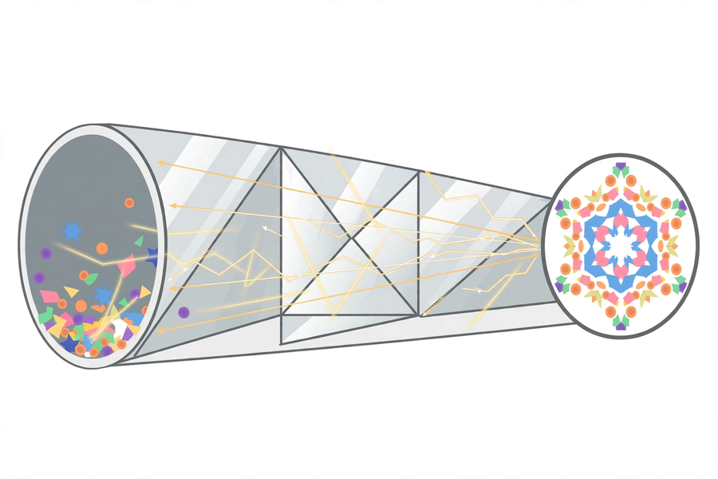
甲部：選擇題（每題 4 分，共 20 分）
Section A: Multiple Choice (4 marks each, 20 marks total)
1. 反射定律是指 A. 入射角等於反射角 B. 入射角小於反射角 C. 光線不會反射 D. 所有物體都吸光
The law of reflection states A. angle of incidence equals angle of reflection B. incidence is smaller than reflection C. light never reflects D. all objects absorb light
2. 萬花筒的對稱圖案主要來自 A. 顏料彩繪 B. 三片鏡互相多重反射 C. 紙筒的顏色 D. 燈光照射
A kaleidoscope's symmetrical patterns mainly come from A. painted colours B. repeated reflections among three mirrors C. the tube's colour D. lamplight
3. 潛望鏡內兩片鏡的正確裝法是 A. 互相平行、各成 45 度 B. 互相垂直 C. 面對面緊貼 D. 背對背擺放
A periscope's two mirrors must be A. parallel, each at 45 degrees B. perpendicular C. face-to-face touching D. back to back
4. 影子形成的原因是 A. 物體發出黑光 B. 光被不透明物體擋住 C. 空氣太暗 D. 眼睛疲勞
Shadows form because A. objects emit black light B. light is blocked by an opaque object C. the air is too dark D. eyes are tired
5. 關於潛望鏡，下列哪一項正確？ A. 能放大影像 B. 只改變光路，不會放大影像 C. 需要用電 D. 只能在水下使用
About periscopes, which is correct? A. It magnifies images B. It only changes the light path; it does not magnify C. It needs electricity D. It only works underwater
乙部：問答題
Section B: Written Questions
1. (8 分) 完成觀察記錄：描述你自製的教具所呈現的圖案／影像，並試用光的反射原理解釋成因。
(8 marks) Complete the observation record: describe the patterns/images your DIY instrument produces, and explain the cause using the principle of light reflection.
2. (6 分) 從課堂拍攝的相片中選出最滿意的一張，寫出 50 字以上的說明（說明光影效果與自己的感受）。
(6 marks) Select your most satisfying photo from the lesson and write a caption of at least 50 Chinese words (describing the light-shadow effect and your feelings).
3. (6 分) 以文字解釋：你製作的是萬花筒還是潛望鏡？它的成像原理是甚麼？（不少於 60 字）
(6 marks) Explain in words: did you make a kaleidoscope or a periscope? What is its imaging principle? (At least 60 Chinese words)
—— 全卷 40 分 ——
—— Total: 40 marks ——

