聖公會呂明才中學
S.K.H. Lui Ming Choi Secondary School
創科班 Little Makers Class
單元二：動手做 STEAM Unit 2: Hands-on STEAM
第 7 堂｜光與影——自製萬花筒／潛望鏡＋光影攝影
Lesson 7 | Light and Shadow — DIY Kaleidoscope / Periscope and Light-shadow Photography
學生筆記

Student Notes
姓名 Name：＿＿＿＿＿＿＿＿ 班別 Class：＿＿＿＿ 學號 Class No.：＿＿＿＿ 組別 Group：＿＿＿＿
日期 Date：＿＿＿＿＿＿＿＿
本堂物資表 Materials List
以下為本堂分組活動所需物資（每組一份）。請在老師派發時核對。
品名 Item | 數量（每組） Quantity (per group) | 安全注意 Safety notes
鏡面紙／小鏡片 Mirror paper / small mirrors | 每組 3 片（萬花筒）或 2 片（潛望鏡） 3 per group (kaleidoscope) or 2 per group (periscope) | 鏡片邊緣或割手，小心使用 Mirror edges may cut; handle with care
硬卡紙筒 Cardboard tube | 每組 1 個 1 per group | — —
長紙盒（潛望鏡用） Long box (for periscope) | 每組 1 個 1 per group | — —
彩色碎紙／珠仔 Coloured paper scraps / beads | 每組 1 小包 1 small pack per group | 細小，課後清理 Small items; tidy up after class
透明膠片 Transparent film | 每組 1 片 1 per group | — —
膠紙、剪刀、間尺 Tape, scissors, ruler | 課室現有 Available in classroom | 剪刀使用注意安全 Take care when using scissors
手機／平板 Mobile phone / tablet | 學生自備或小組共用 Students' own or group-shared | 拍攝時注意安全，不可只顧螢幕而忽略路面 Watch your step while photographing; do not stare at the screen only
一、課程內容
1. Lesson Content
1. 光的反射 Reflection of light
光以直線前進；遇到鏡面時會改變方向，這就是「反射」。我們能從鏡中看到自己，正是因為光經鏡面反射進入眼睛。
Light travels in straight lines; when it meets a mirror it changes direction — this is "reflection". We see ourselves in a mirror precisely because light reflects off it into our eyes.
2. 反射定律 Law of reflection
反射定律：入射角等於反射角。光以甚麼角度射向鏡面，就會以相同角度反射出去，方向對稱。
Law of reflection: the angle of incidence equals the angle of reflection. Light striking a mirror at a certain angle reflects off at the same angle, symmetrically.
3. 萬花筒的原理 How a kaleidoscope works
萬花筒由三片長鏡組成三角形筒，反光面朝內。筒底的彩色碎紙和珠仔經三片鏡互相多重反射，形成對稱的圖案。轉動筒身，碎紙位置改變，圖案便不斷變化，永不重複。
A kaleidoscope is a triangular tube of three long mirrors with reflective sides facing inwards. Coloured scraps and beads at the end reflect repeatedly among the three mirrors, forming symmetrical patterns. Rotating the tube moves the scraps, so the patterns keep changing and never repeat.
4. 潛望鏡的原理 How a periscope works
1. 潛望鏡內有兩片互相平行的鏡片，各與鏡筒成 45 度。
A periscope holds two parallel mirrors, each at 45 degrees to the tube.
2. 上方的光先射到頂部鏡片，經第一次反射轉向下方；再射到底部鏡片，經第二次反射轉向眼睛。
Light from above hits the top mirror and reflects downwards (first reflection); it then hits the bottom mirror and reflects into the eye (second reflection).
3. 經過兩次反射，光線平行移位，讓我們看到被牆壁、書堆等障礙物擋住的景象。潛望鏡只改變光路，不會放大影像。
After two reflections the light rays shift in parallel, letting us see views blocked by walls, book piles and other obstacles. A periscope only changes the path of light; it does not magnify images.
5. 光與影 Light and shadow
光被不透明的物體擋住，後方便形成影子。影子的形狀和方向隨光源位置改變；強光下的影子邊緣清晰、對比強烈，是拍攝光影相片的好題材。
When light is blocked by an opaque object, a shadow forms behind it. A shadow's shape and direction change with the light source; strong light gives sharp-edged, high-contrast shadows — ideal subjects for light-shadow photography.
6. 拍攝小技巧 Photography tips
- 尋找光影對比強烈的地方：窗邊、走廊欄杆、樹蔭。
Look for strong light-shadow contrast: windows, corridor railings, tree shade.
- 拍攝時注意安全，不可只顧螢幕而忽略路面。
Stay safe while photographing; do not stare at the screen and ignore where you walk.
- 為每張相片寫一句說明，說出光影效果和你的感受。
Write one caption per photo, describing the light-shadow effect and your feelings.
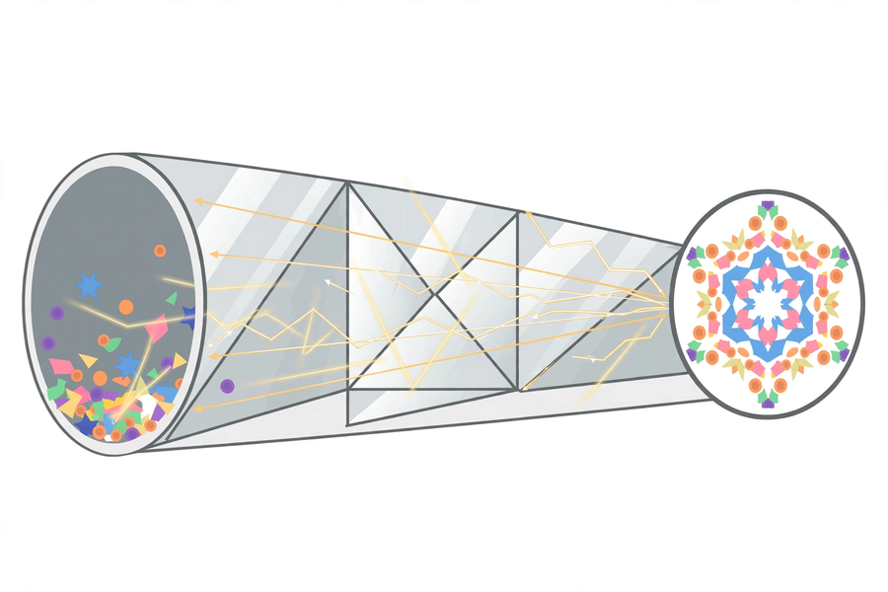
二、例子
2. Examples
例子一：汽車倒後鏡 Example 1: car rear-view mirror
司機透過倒後鏡看到車後的情況：車尾的光經鏡面反射進入司機眼睛。鏡子改變了光的方向，讓司機「看到背後」。
A driver sees behind the car through the rear-view mirror: light from the rear reflects off the mirror into the driver's eyes. The mirror changes the direction of light, letting the driver "see behind".
例子二：潛水艇的潛望鏡 Example 2: submarine periscope
潛水艇潛在水下，用升出水面的潛望鏡觀察海面：海面的光經兩次反射傳到艇內人員眼中。這正是我們今天自製的教具在真實世界中的應用。
A submerged submarine observes the sea surface with a periscope raised above water: light from the surface reaches the crew's eyes after two reflections. This is the real-world application of the instrument we make today.
三、簡單問答題（課堂口答）
3. Quick Questions (oral)
1. 鏡子如何改變光的方向？試用「反射」一詞回答。
How does a mirror change the direction of light? Answer using the word "reflection".
2. 轉動萬花筒的筒身，圖案會怎樣？這說明圖案是畫上去的，還是來自鏡面反射？
What happens to the patterns when you rotate a kaleidoscope? Does this show the patterns are painted on, or come from mirror reflection?
3. 潛望鏡能把影像放大嗎？為甚麼？
Can a periscope magnify images? Why?
四、思考題
4. Thinking Questions
1. 為甚麼潛望鏡的兩片鏡必須互相平行？如果其中一片歪了，會發生甚麼事？
Why must a periscope's two mirrors be parallel? What happens if one is tilted?
2. 如果萬花筒只有兩片鏡（而不是三片），圖案會有甚麼不同？為甚麼？
If a kaleidoscope had only two mirrors instead of three, how would the patterns differ? Why?

五、分組活動
5. Group Activities
活動一：製作（二選一） Activity 1: make one instrument
- 萬花筒：三片鏡面紙組成三角形筒，反光面朝內；一端裝彩色碎紙／珠仔＋透明膠片，另一端開觀察孔。
Kaleidoscope: form a triangular tube from three mirror strips, reflective sides inwards; load coloured scraps/beads with transparent film at one end and cut a viewing hole at the other.
- 潛望鏡：長紙盒兩端各開孔，兩片鏡平行黏貼、各成 45 度，反光面相對。
Periscope: cut holes at both ends of a long box; stick two mirrors parallel to each other, each at 45 degrees, reflective sides facing each other.
- 鏡面保持清潔；鏡片邊緣或割手，小心使用。
Keep mirror surfaces clean; mirror edges may cut — handle with care.
活動二：觀察記錄 Activity 2: observation record
寫出你看到的圖案／影像，並試用反射原理解釋。
Describe the patterns/images you see and explain them with the principle of reflection.
觀察項目 Observation | 我的記錄 My record
我看到的圖案／影像
The patterns / images I see
圖案／影像有何特點
Their special features
用反射原理解釋
Explain with reflection
活動三：光影攝影 Activity 3: light-shadow photography
以自製教具觀察光影，用手機或小組共用的平板拍攝最少三張光影相片，並為每張寫一句說明。
Observe light and shadow with your DIY instrument; take at least three light-shadow photos with a mobile phone or group-shared tablet, and write one caption per photo.
相片 1 說明：
＿＿＿＿＿＿＿＿＿＿＿＿＿＿＿＿＿＿＿＿＿＿＿＿＿＿＿＿＿＿＿＿＿＿＿＿＿＿＿＿
＿＿＿＿＿＿＿＿＿＿＿＿＿＿＿＿＿＿＿＿＿＿＿＿＿＿＿＿＿＿＿＿＿＿＿＿＿＿＿＿
相片 2 說明：
＿＿＿＿＿＿＿＿＿＿＿＿＿＿＿＿＿＿＿＿＿＿＿＿＿＿＿＿＿＿＿＿＿＿＿＿＿＿＿＿
＿＿＿＿＿＿＿＿＿＿＿＿＿＿＿＿＿＿＿＿＿＿＿＿＿＿＿＿＿＿＿＿＿＿＿＿＿＿＿＿
相片 3 說明：
＿＿＿＿＿＿＿＿＿＿＿＿＿＿＿＿＿＿＿＿＿＿＿＿＿＿＿＿＿＿＿＿＿＿＿＿＿＿＿＿
＿＿＿＿＿＿＿＿＿＿＿＿＿＿＿＿＿＿＿＿＿＿＿＿＿＿＿＿＿＿＿＿＿＿＿＿＿＿＿＿
六、總結
6. Summary
- 光遇到鏡面會反射；反射定律：入射角等於反射角。
Light reflects off mirrors; law of reflection: angle of incidence equals angle of reflection.
- 萬花筒：三片鏡互相多重反射，形成對稱圖案；圖案來自反射，不是畫上去的。
Kaleidoscope: three mirrors reflect repeatedly off one another, forming symmetrical patterns; patterns come from reflection, not paint.
- 潛望鏡：兩片平行鏡各成 45 度，經兩次反射使光線平行移位；只改變光路，不放大影像。
Periscope: two parallel mirrors at 45 degrees shift light rays in parallel through two reflections; it only changes the light path and does not magnify.
- 影子是光被不透明物體擋住而形成；強光下的光影對比是好的拍攝題材。
Shadows form when light is blocked by opaque objects; strong light-shadow contrast makes good photo subjects.
七、課堂小測驗
7. Class Quiz
1. 反射定律是指 A. 入射角等於反射角 B. 入射角大於反射角 C. 光不會反射 D. 鏡子會吸光
The law of reflection states A. angle of incidence equals angle of reflection B. incidence is greater than reflection C. light does not reflect D. mirrors absorb light
2. 萬花筒的對稱圖案來自 A. 畫上去的顏料 B. 三片鏡互相多重反射 C. 彩色碎紙本身發光 D. 透明膠片的顏色
A kaleidoscope's symmetrical patterns come from A. painted colours B. repeated reflections among three mirrors C. the scraps glowing D. the film's colour
3. 潛望鏡內兩片鏡的正確裝法是 A. 互相垂直 B. 互相平行、各成 45 度 C. 重疊在一起 D. 隨意擺放
A periscope's two mirrors must be A. perpendicular B. parallel, each at 45 degrees C. stacked together D. placed randomly
4. 潛望鏡不能放大影像，原因是 A. 鏡片太小 B. 它只改變光路，不改變影像大小 C. 紙盒不夠長 D. 光線太暗
A periscope cannot magnify because A. the mirrors are too small B. it only changes the light path, not the image size C. the box is too short D. the light is too dim
5. 解釋：為甚麼轉動萬花筒，圖案會不斷變化？（30 字以上）
Explain: why do a kaleidoscope's patterns keep changing when the tube is rotated? (At least 30 Chinese words)

