聖公會呂明才中學
S.K.H. Lui Ming Choi Secondary School
創科班 Little Makers Class
單元二：動手做 STEAM Unit 2: Hands-on STEAM
第 7 堂｜光與影——自製萬花筒／潛望鏡＋光影攝影
Lesson 7 | Light and Shadow — DIY Kaleidoscope / Periscope and Light-shadow Photography
教師筆記

Teacher Notes
本堂物資表 Materials List（教師版）
請預早一星期準備所需物資；標示「課室現有」之項目請預先清點。
品名 Item | 數量（每組） Quantity (per group) | 大約成本 Est. cost | 安全注意 Safety notes
鏡面紙／小鏡片 Mirror paper / small mirrors | 每組 3 片（萬花筒）或 2 片（潛望鏡） 3 per group (kaleidoscope) or 2 per group (periscope) | 約 HK$6 approx. HK$6 | 鏡片邊緣或割手，小心使用 Mirror edges may cut; handle with care
硬卡紙筒 Cardboard tube | 每組 1 個 1 per group | 約 HK$3 approx. HK$3 | — —
長紙盒（潛望鏡用） Long box (for periscope) | 每組 1 個 1 per group | 回收免費 Recycled; free | — —
彩色碎紙／珠仔 Coloured paper scraps / beads | 每組 1 小包 1 small pack per group | 約 HK$2 approx. HK$2 | 細小，課後清理 Small items; tidy up after class
透明膠片 Transparent film | 每組 1 片 1 per group | 約 HK$1 approx. HK$1 | — —
膠紙、剪刀、間尺 Tape, scissors, ruler | 課室現有 Available in classroom | — — | 剪刀使用注意安全 Take care when using scissors
手機／平板 Mobile phone / tablet | 學生自備或小組共用 Students' own or group-shared | — — | 拍攝時注意安全，不可只顧螢幕而忽略路面 Watch your step while photographing; do not stare at the screen only
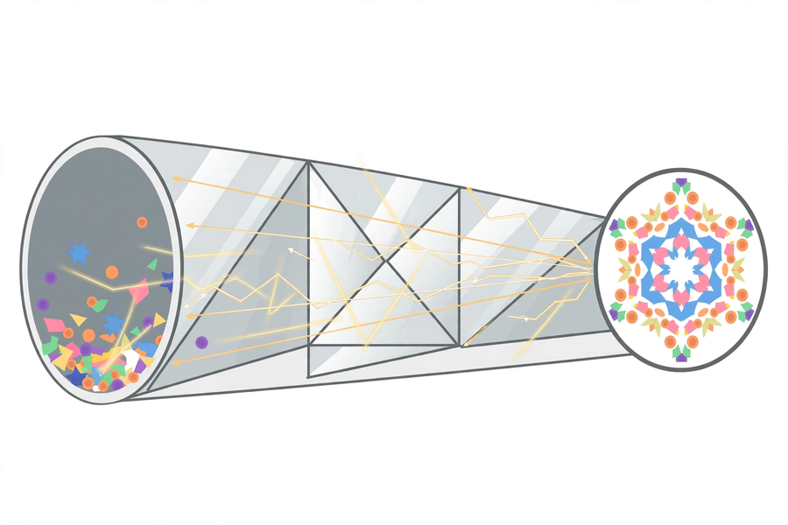
本文件包含學生筆記所有題目的參考答案、家課答案、附加思考題、建議教導方向及常見迷思，僅供教師使用，切勿派發給學生。
This document contains reference answers to all student-note questions, homework answers, extra thinking questions, teaching suggestions and common misconceptions. For teachers only — do not distribute to students.
一、學生筆記參考答案
1. Student Notes — Reference Answers
簡單問答題 Quick questions
■ 參考答案 Reference answers
1. 鏡子使光發生反射，改變光的前進方向；根據反射定律，入射角等於反射角。
A mirror reflects light, changing its direction of travel; by the law of reflection, the angle of incidence equals the angle of reflection.
2. 轉動筒身圖案會不斷變化，說明圖案不是畫上去的，而是來自三片鏡對彩色碎紙的多重反射；碎紙位置一變，反射形成的圖案隨之改變。
Rotating the tube changes the patterns continuously, showing they are not painted on but come from the three mirrors' repeated reflections of the scraps; when the scraps move, the reflected patterns change.
3. 不能。潛望鏡只經兩次反射改變光路、使光線平行移位，沒有使用凸透鏡等放大元件，所以影像大小不變。
No. A periscope only changes the light path through two reflections, shifting rays in parallel; with no magnifying lens, the image size stays the same.
思考題 Thinking questions
■ 參考答案 Reference answers
1. 兩片鏡必須平行，才能使光經兩次反射後保持原來方向、平行移位進入眼睛；若其中一片歪了，反射角改變，光線偏離，眼睛便看不見影像（或只見部分）。
The mirrors must be parallel so that after two reflections the light keeps its original direction, shifted in parallel into the eye; if one tilts, the reflection angle changes, rays deviate, and the eye sees nothing (or only part of the view).
2. 兩片鏡只能形成單一方向的對稱，圖案的對稱性大減，不如三片鏡互相反射般豐富多變；三片鏡圍成封閉三角形，多重反射次數更多，圖案更複雜美麗。
Two mirrors give symmetry in only one direction with far less variety; three mirrors enclose a triangle, producing more repeated reflections and richer, more beautiful patterns.
課堂小測驗參考答案 Class quiz — reference answers
■ 參考答案 Reference answers
1. A（入射角等於反射角）
A (angle of incidence equals angle of reflection)
2. B（三片鏡互相多重反射）
B (repeated reflections among three mirrors)
3. B（互相平行、各成 45 度）
B (parallel, each at 45 degrees)
4. B（它只改變光路，不改變影像大小）
B (it only changes the light path, not the image size)
5. 參考答案：筒底的彩色碎紙位置隨轉動改變，經三片鏡多重反射後形成的對稱圖案也隨之改變，所以圖案不斷變化、永不重複。評分：說出「碎紙移動＋多重反射」得滿分。
Reference: rotating moves the coloured scraps at the tube end, so the symmetrical patterns formed by repeated reflections among the three mirrors change too — endlessly and never repeating. Full marks for "moving scraps + repeated reflections".
二、家課參考答案
2. Homework — Reference Answers
■ 參考答案 Reference answers
1. A（入射角等於反射角）
A (angle of incidence equals angle of reflection)
2. B（三片鏡互相多重反射）
B (repeated reflections among three mirrors)
3. B（互相平行、各成 45 度）
B (parallel, each at 45 degrees)
4. B（光被不透明物體擋住）
B (light is blocked by an opaque object)
5. B（它只改變光路，不會放大影像）
B (it only changes the light path; it does not magnify)
6. 觀察記錄評分：有具體描述所見圖案／影像；能用反射原理解釋成因（滿分須扣連反射）。
Observation marking: concrete description of patterns/images seen; explains the cause with reflection (full marks require linking to reflection).
7. 相片說明評分：選出一張相片；說明不少於 50 字，內容扣連光影效果，並寫出個人感受。
Caption marking: one photo selected; caption of at least 50 Chinese words linking to the light-shadow effect with personal feelings.
8. 短文評分：能正確解釋所選教具的成像原理（萬花筒：三鏡多重反射成對稱圖案；潛望鏡：兩次反射平行移位），語句通順。
Passage marking: correctly explains the chosen instrument's imaging principle (kaleidoscope: three-mirror repeated reflections give symmetrical patterns; periscope: two reflections shift rays in parallel); coherent writing.
三、附加思考題
3. Extra Thinking Questions
■ 參考答案 Reference answers
1. 為甚麼萬花筒的圖案左右對稱？參考答案：因為圖案是鏡面反射的結果；鏡面反射本身左右對稱，多重反射把對稱性層層複製，形成高度對稱的圖案。
Why are kaleidoscope patterns left-right symmetrical? Reference: because the patterns result from mirror reflection, which is itself left-right symmetrical; repeated reflections copy that symmetry layer by layer.
2. 站在鏡前舉起右手，鏡中的你舉起哪隻手？這說明了甚麼？參考答案：鏡中人舉起左手；說明鏡面反射造成左右對調（鏡像）。
Raising your right hand before a mirror, which hand does your image raise? What does this show? Reference: the image raises its left hand — showing that mirror reflection swaps left and right (mirror image).
3. 影子在甚麼時候最長、最短？為甚麼？參考答案：太陽位置低（早晨、黃昏）時影子最長，正午太陽最高時影子最短；因為光源角度愈斜，影子拉得愈長。
When are shadows longest and shortest? Why? Reference: longest when the sun is low (morning/evening), shortest at noon when the sun is highest; the more slanted the light, the longer the shadow stretches.
四、建議教導方向
4. Suggested Teaching Approach
1. 引入（0–10 分鐘）：展示萬花筒圖案相片與潛望鏡實物，提問「鏡子如何改變光的方向」。
Introduction (0–10 min): show kaleidoscope photos and a real periscope; ask "How does a mirror change the direction of light?".
2. 製作（10–35 分鐘）：示範鏡片黏貼角度（萬花筒反光面朝內；潛望鏡兩片鏡平行、各 45 度）；巡視協助，重點檢查潛望鏡兩鏡是否平行。
Making (10–35 min): demo mirror angles (kaleidoscope: reflective sides inwards; periscope: two parallel mirrors at 45°); assist groups, checking periscope mirrors are parallel.
3. 光影攝影（35–50 分鐘）：講解取景技巧，帶領學生在課室及走廊尋找題材；提醒拍攝安全；小組共用手機／平板（學校不能每人一部電腦，手機拍攝亦以小組共用為原則）。
Photography (35–50 min): explain framing, lead students to find subjects in classrooms and corridors; remind them of safety; phones/tablets shared per group.
4. 分享總結（50–60 分鐘）：主持作品分享，總結反射定律；預告下堂關愛夜燈。
Sharing and conclusion (50–60 min): host sharing, summarise the law of reflection; preview the caring night light lesson.
五、常見迷思
5. Common Misconceptions
1. 以為萬花筒圖案是「畫上去」的 → 引導學生轉動筒身，觀察圖案隨碎紙移動而變化，理解圖案來自鏡面反射。
Thinking kaleidoscope patterns are "painted on" → guide students to rotate the tube and watch patterns change as the scraps move, understanding patterns come from mirror reflection.
2. 以為潛望鏡能「放大」影像 → 澄清它只改變光路、平行移位光線；讓學生比較直接看與經潛望鏡看的物件大小。
Thinking a periscope "magnifies" → clarify it only changes the light path, shifting rays in parallel; have students compare object sizes seen directly versus through the periscope.
3. 以為影子是「黑色物體」→ 說明影子只是光被擋住的區域，本身不是物體；改變光源位置，影子隨之改變。
Thinking a shadow is a "black object" → explain a shadow is only the region where light is blocked, not an object itself; move the light source and the shadow changes.

