聖公會呂明才中學
S.K.H. Lui Ming Choi Secondary School
創科班 Little Makers Class
單元二：動手做 STEAM Unit 2: Hands-on STEAM
第 8 堂｜簡單電路——關愛夜燈（長者夜光門牌）
Lesson 8 | Simple Circuits — Caring Night Light (Glow Doorplate for the Elderly)
家課

Homework
姓名 Name：＿＿＿＿＿＿＿＿ 班別 Class：＿＿＿＿ 學號 Class No.：＿＿＿＿ 組別 Group：＿＿＿＿
日期 Date：＿＿＿＿＿＿＿＿
本家課包括甲部選擇題及乙部問答題，請用完整句子作答。
This homework has Section A (multiple choice) and Section B (written questions). Answer in complete sentences.
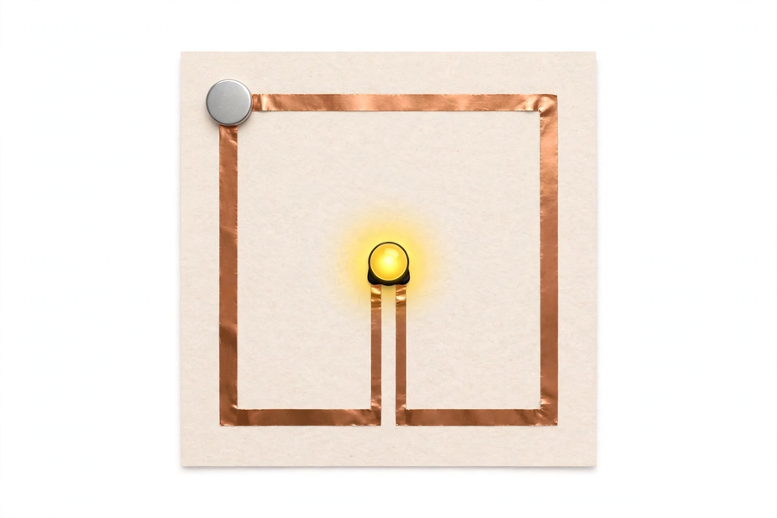
甲部：選擇題（每題 4 分，共 20 分）
Section A: Multiple Choice (4 marks each, 20 marks total)
1. 電路的三要素是 A. 電池、燈泡、開關 B. 電源、導線、負載 C. 正極、負極、地線 D. 電壓、電流、電阻
The three elements of a circuit are A. battery, bulb, switch B. power source, conductor, load C. positive, negative, earth D. voltage, current, resistance
2. LED 的長腳是 A. 正極，接電池正極 B. 負極，接電池負極 C. 沒有特別意思 D. 用來固定的
An LED's long leg is A. positive, connecting to the battery's positive side B. negative, connecting to negative C. meaningless D. for fixing only
3. LED 接反了會怎樣？ A. 正常發光 B. 單向導電，所以不會發光 C. 立即爆炸 D. 變成普通燈泡
What if an LED is reversed? A. It lights normally B. One-way conduction, so it won't light C. It explodes D. It becomes an ordinary bulb
4. 門牌燈不亮，最可能的原因是 A. 停電 B. 太陽太猛 C. 銅箔接觸不良造成斷路 D. 卡紙太厚
A dark doorplate lamp is most likely caused by A. power cut B. strong sunlight C. poor foil contact creating an open circuit D. card too thick
5. 檢查不亮的燈，合理的次序是 A. 先換電池，再檢查接駁 B. 先檢查接駁，再考慮電池 C. 直接重做 D. 用水沖洗
A sensible order for checking a dark lamp is A. replace the cell first, then check connections B. check connections first, then consider the cell C. redo everything D. rinse with water
乙部：問答題
Section B: Written Questions
1. (6 分) 寫出你的門牌設計意念：你的門牌如何幫助長者？
(6 marks) Write your design concept: how does your doorplate help the elderly?
2. (8 分) 為你的門牌創作一句關懷長者的標語，並解釋這句標語想傳達甚麼訊息。
(8 marks) Create a caring slogan for your doorplate and explain what message it conveys.
3. (6 分) 以不少於 80 字寫出短文：「長者夜晚最需要甚麼幫助？我的門牌可以怎樣幫忙？」（可訪問一位家人或鄰舍長者，或憑設想作答。）
(6 marks) Write a passage of at least 80 Chinese words: "What help do elderly people most need at night? How can my doorplate help?" (You may interview an elderly family member or neighbour, or answer from imagination.)
—— 全卷 40 分 ——
—— Total: 40 marks ——

