聖公會呂明才中學
S.K.H. Lui Ming Choi Secondary School
創科班 Little Makers Class
單元二：動手做 STEAM Unit 2: Hands-on STEAM
第 8 堂｜簡單電路——關愛夜燈（長者夜光門牌）
Lesson 8 | Simple Circuits — Caring Night Light (Glow Doorplate for the Elderly)
學生筆記

Student Notes
姓名 Name：＿＿＿＿＿＿＿＿ 班別 Class：＿＿＿＿ 學號 Class No.：＿＿＿＿ 組別 Group：＿＿＿＿
日期 Date：＿＿＿＿＿＿＿＿
本堂物資表 Materials List
以下為本堂分組活動所需物資（每組一份）。請在老師派發時核對。
品名 Item | 數量（每組） Quantity (per group) | 安全注意 Safety notes
銅箔膠帶 Copper foil tape | 每組約 50 厘米 approx. 50 cm per group | — —
LED（3mm 或 5mm） LED (3 mm or 5 mm) | 每組 2 粒 2 per group | 細小，課後點算收回 Small items; count and collect after class
CR2032 鈕扣電池 CR2032 button cell | 每組 1 粒 1 per group | 不可放入口；用完由教師回收 Do not ingest; teacher collects used cells
厚卡紙 Thick card | 每組 1 張 1 per group | — —
顏色筆 Colour pens | 課室現有 Available in classroom | — —
膠紙、剪刀 Tape, scissors | 課室現有 Available in classroom | 剪刀使用注意安全 Take care when using scissors
一、課程內容
1. Lesson Content
1. 甚麼是電路？ What is a circuit?
電路是電流流通的通路。電流從電源正極出發，經導線流過用電裝置（負載），再回到電源負極，形成一個完整的圈，電器才會運作。
A circuit is the path that electric current flows along. Current leaves the positive terminal of the power source, travels through wires and the device (load), and returns to the negative terminal, forming a complete loop — only then does the device work.
2. 電路三要素 Three elements of a circuit
- 電源：提供電能，例如鈕扣電池（CR2032）。
Power source: supplies electrical energy, e.g. a button cell (CR2032).
- 導線：傳送電流，例如銅箔膠帶（銅是良好的導體）。
Conductor: carries the current, e.g. copper foil tape (copper is a good conductor).
- 負載：使用電能的裝置，例如 LED 燈（把電能轉為光能）。
Load: the device using the energy, e.g. an LED lamp (converting electrical energy into light).
3. 通路與斷路 Closed and open circuits
電路完整接通、電流流通，稱為「通路」，LED 會發光；電路中間斷開、電流不通，稱為「斷路」，LED 不會發光。銅箔沒有壓實、LED 接反，都會造成斷路。
A complete, current-flowing circuit is "closed" and the LED lights; a broken circuit with no current is "open" and the LED stays dark. Loose copper foil or a reversed LED both create an open circuit.
4. LED 的特性 Characteristics of LEDs
- LED 是發光二極管，只容許電流單向通過：接對正負極才會發光，接反了不會亮（也不會燒毀，調轉再接即可）。
An LED is a light-emitting diode: current flows one way only. It lights only with correct polarity; reversed, it stays dark (it won't burn out — just flip it).
- 辨認正負極：長腳為正極，接電池正極；短腳為負極，接電池負極。
Identifying terminals: the longer leg is positive and connects to the battery's positive side; the shorter leg is negative.
- LED 省電、壽命長，一粒鈕扣電池已足夠點亮，適合做夜光門牌。
LEDs save power and last long; one button cell is enough to light them — ideal for a glow doorplate.
5. 銅箔膠帶作導線 Copper foil tape as wire
銅箔膠帶一面帶黏性，可直接貼在卡紙上鋪設電路。轉彎處要把銅箔摺疊壓實，否則接觸不良造成斷路。先測試 LED 發光，才黏貼裝飾。
Copper foil tape is sticky on one side and can be laid directly on card as a circuit. At corners, fold and press the foil firmly or poor contact creates an open circuit. Test that the LED lights before adding decorations.
6. 以用家為本的設計：關愛長者 User-centred design: caring for the elderly
長者夜晚起身，常常要在黑暗中摸索，容易跌倒。我們的夜光門牌在夜間發光，照亮門口和通道，讓長者不用摸黑。這就是「用創科關愛弱勢社群」——設計之前，先想想用家的需要。
Elderly people getting up at night often grope in the dark and may fall. Our glow doorplate shines at night, lighting the doorway and passage so they need not feel around in darkness. This is "using innovation and technology to care for the underprivileged" — before designing, first think about the user's needs.
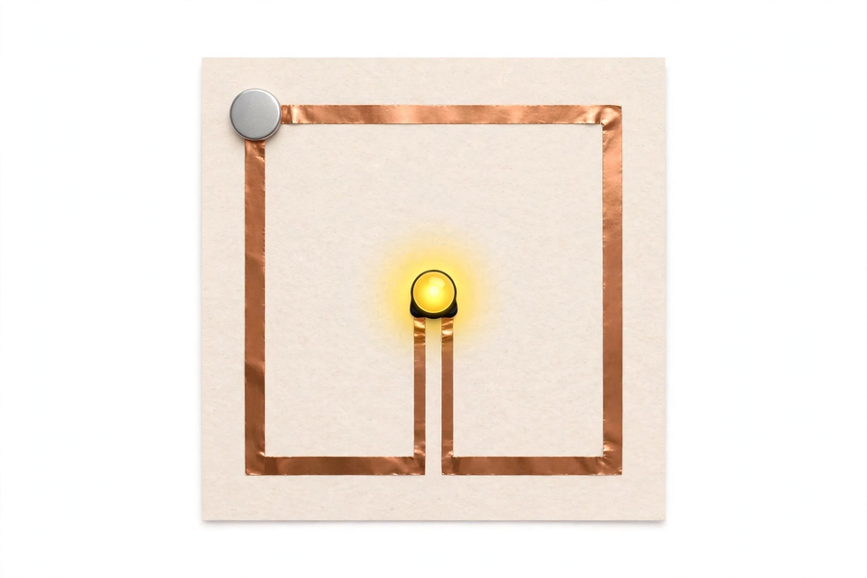
二、例子
2. Examples
例子一：聖誕燈飾 Example 1: Christmas lights
一串小燈泡順序相連：電池（電源）→ 電線（導線）→ 燈泡（負載）→ 回到電池。其中一處鬆開，整串燈便不亮——這就是斷路。
A string of small bulbs connected in order: battery (source) → wires (conductors) → bulbs (load) → back to the battery. If one point loosens, the whole string goes dark — that is an open circuit.
例子二：家中的電燈開關 Example 2: the light switch at home
按下開關，電路接通（通路），燈亮；關掉開關，電路斷開（斷路），燈熄。我們的門牌電路沒有開關，靠的是銅箔有沒有完整接通。
Press the switch: the circuit closes and the lamp lights; switch off: the circuit opens and the lamp goes out. Our doorplate circuit has no switch — it depends on whether the copper foil is fully connected.
三、簡單問答題（課堂口答）
3. Quick Questions (oral)
1. 電路的三要素是甚麼？
What are the three elements of a circuit?
2. LED 的兩隻腳有甚麼分別？哪一隻接電池正極？
What is the difference between an LED's two legs? Which connects to the battery's positive side?
3. 門牌的燈不亮，你第一件事會檢查甚麼？為甚麼？
The doorplate lamp doesn't light. What is the first thing you would check? Why?
四、思考題
4. Thinking Questions
1. 為甚麼 LED 接反了不會發光？試用「單向導電」解釋。
Why doesn't an LED light when connected the wrong way round? Explain with "one-way conduction".
2. 銅箔轉彎處為甚麼要摺疊壓實？如果沒有壓實，會發生甚麼事？
Why must copper foil be folded and pressed firmly at corners? What happens if it isn't?
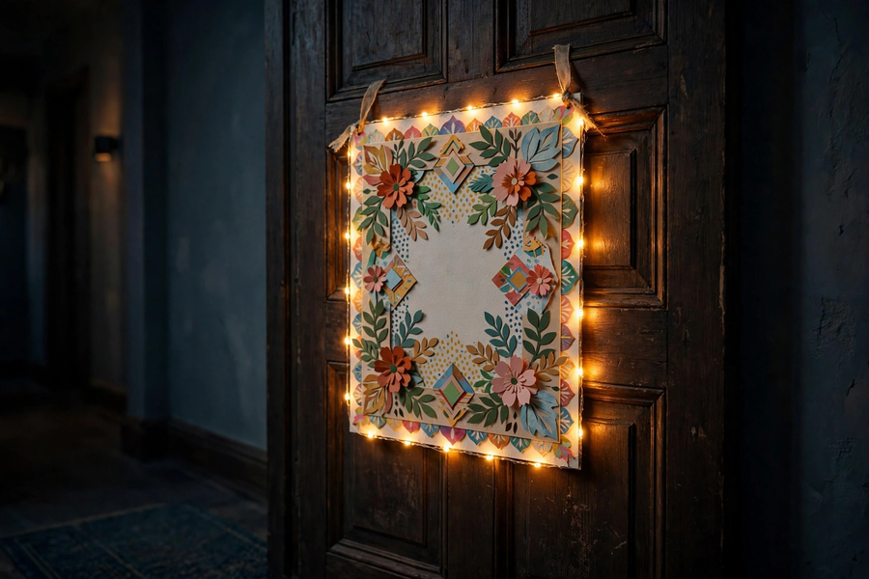
五、分組活動：製作長者夜光門牌
5. Group Activity: Make a Glow Doorplate for the Elderly
製作步驟 Steps
1. 在厚卡紙上設計門牌圖案，預留貼銅箔的位置。
Design the doorplate pattern on thick card, leaving room for the copper foil.
2. 用銅箔膠帶由電池位置鋪設到 LED 位置，再回到電池，形成完整迴路；轉彎處摺疊壓實。
Lay copper foil tape from the battery position to the LED position and back to the battery, forming a complete loop; fold and press firmly at corners.
3. 辨認 LED 正負極：長腳接電池正極，短腳接電池負極；把 LED 腳壓貼在銅箔上。
Identify the LED terminals: long leg to the battery's positive side, short leg to negative; press the LED legs onto the foil.
4. 放入 CR2032 鈕扣電池，測試 LED 是否發光；發光後才黏貼裝飾。
Insert the CR2032 button cell and test whether the LED lights; add decorations only after it lights.
5. 為門牌創作一句關懷長者的標語，寫在門牌上。
Create a caring slogan for the elderly and write it on the doorplate.
安全注意：鈕扣電池不可放入口；用完的電池由教師回收。
Safety: do not put button cells in the mouth; used cells are collected by the teacher.
設計意念欄 Design concept box
我的門牌如何幫助長者？（寫出你的設計意念）
How does my doorplate help the elderly? (Write your design idea)
＿＿＿＿＿＿＿＿＿＿＿＿＿＿＿＿＿＿＿＿＿＿＿＿＿＿＿＿＿＿＿＿＿＿＿＿＿＿＿＿
＿＿＿＿＿＿＿＿＿＿＿＿＿＿＿＿＿＿＿＿＿＿＿＿＿＿＿＿＿＿＿＿＿＿＿＿＿＿＿＿
＿＿＿＿＿＿＿＿＿＿＿＿＿＿＿＿＿＿＿＿＿＿＿＿＿＿＿＿＿＿＿＿＿＿＿＿＿＿＿＿
關懷標語創作欄 Caring slogan box
為門牌設計一句關懷長者的標語：
Design a caring slogan for the doorplate:
＿＿＿＿＿＿＿＿＿＿＿＿＿＿＿＿＿＿＿＿＿＿＿＿＿＿＿＿＿＿＿＿＿＿＿＿＿＿＿＿
＿＿＿＿＿＿＿＿＿＿＿＿＿＿＿＿＿＿＿＿＿＿＿＿＿＿＿＿＿＿＿＿＿＿＿＿＿＿＿＿
示例：「夜裡起身不用怕，門燈為您照亮路。」
Example: "No need to fear getting up at night; the door light brightens your way."
六、總結
6. Summary
- 電路三要素：電源（鈕扣電池）、導線（銅箔膠帶）、負載（LED）。
Three circuit elements: power source (button cell), conductor (copper foil tape), load (LED).
- 電流從正極出發，經導線和負載回到負極，形成完整迴路才會運作；斷開即成斷路。
Current flows from the positive terminal through the conductor and load back to the negative terminal; only a complete loop works — a break means an open circuit.
- LED 單向導電：長腳正極接電池正極，接反不會亮。
LEDs conduct one way: long (positive) leg to the battery's positive side; reversed, it won't light.
- 銅箔轉彎要摺疊壓實；先測試發光，才加裝飾。
Fold and press foil firmly at corners; test the light before decorating.
- 好設計從用家需要出發：夜光門牌讓長者夜晚不用摸黑。
Good design starts from user needs: the glow doorplate frees the elderly from groping in the dark.
七、課堂小測驗
7. Class Quiz
1. 電路的三要素是 A. 電池、電線、開關 B. 電源、導線、負載 C. 正極、負極、中極 D. 銅、鐵、鋁
The three elements of a circuit are A. battery, wire, switch B. power source, conductor, load C. positive, negative, middle poles D. copper, iron, aluminium
2. LED 的長腳是 A. 正極 B. 負極 C. 沒有分別 D. 裝飾
An LED's longer leg is the A. positive terminal B. negative terminal C. no difference D. decoration
3. LED 接反了會怎樣？ A. 照常發光 B. 立即燒毀 C. 不會發光，調轉再接即可 D. 電池爆炸
What if an LED is connected backwards? A. It lights normally B. It burns out at once C. It won't light; just flip it round D. The battery explodes
4. 銅箔轉彎處要摺疊壓實，原因是 A. 比較美觀 B. 避免接觸不良造成斷路 C. 節省銅箔 D. 令電流加快
Foil must be folded and pressed at corners A. to look nicer B. to avoid poor contact causing an open circuit C. to save foil D. to speed up current
5. 解釋：門牌的燈不亮，你會如何逐步檢查？（30 字以上）
Explain: the doorplate lamp doesn't light — how would you check step by step? (At least 30 Chinese words)

