聖公會呂明才中學
S.K.H. Lui Ming Choi Secondary School
創科班 Little Makers Class
單元二：動手做 STEAM Unit 2: Hands-on STEAM
第 8 堂｜簡單電路——關愛夜燈（長者夜光門牌）
Lesson 8 | Simple Circuits — Caring Night Light (Glow Doorplate for the Elderly)
教師筆記

Teacher Notes
本堂物資表 Materials List（教師版）
請預早一星期準備所需物資；標示「課室現有」之項目請預先清點。
品名 Item | 數量（每組） Quantity (per group) | 大約成本 Est. cost | 安全注意 Safety notes
銅箔膠帶 Copper foil tape | 每組約 50 厘米 approx. 50 cm per group | 約 HK$6 approx. HK$6 | — —
LED（3mm 或 5mm） LED (3 mm or 5 mm) | 每組 2 粒 2 per group | 約 HK$3 approx. HK$3 | 細小，課後點算收回 Small items; count and collect after class
CR2032 鈕扣電池 CR2032 button cell | 每組 1 粒 1 per group | 約 HK$4 approx. HK$4 | 不可放入口；用完由教師回收 Do not ingest; teacher collects used cells
厚卡紙 Thick card | 每組 1 張 1 per group | 約 HK$2 approx. HK$2 | — —
顏色筆 Colour pens | 課室現有 Available in classroom | — — | — —
膠紙、剪刀 Tape, scissors | 課室現有 Available in classroom | — — | 剪刀使用注意安全 Take care when using scissors
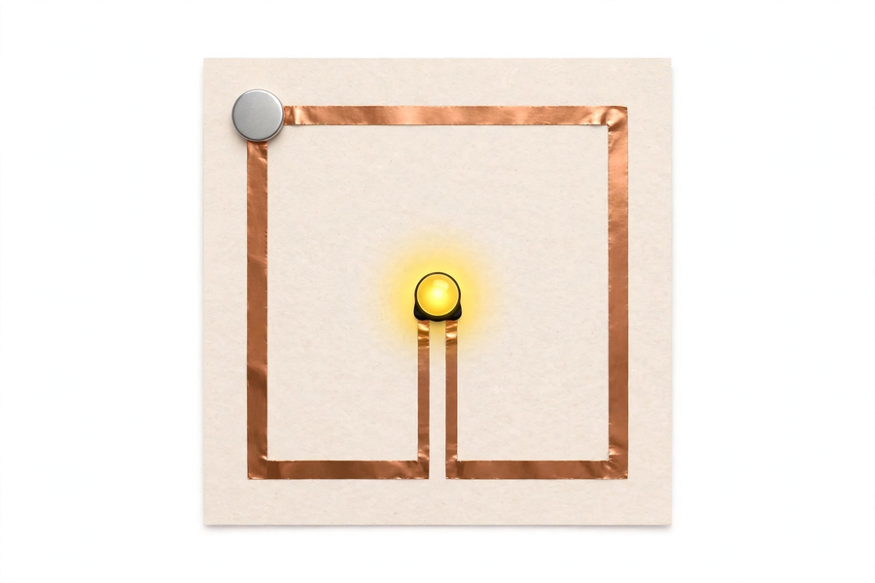
本文件包含學生筆記所有題目的參考答案、家課答案、附加思考題、建議教導方向及常見迷思，僅供教師使用，切勿派發給學生。
This document contains reference answers to all student-note questions, homework answers, extra thinking questions, teaching suggestions and common misconceptions. For teachers only — do not distribute to students.
一、學生筆記參考答案
1. Student Notes — Reference Answers
簡單問答題 Quick questions
■ 參考答案 Reference answers
1. 電源、導線、負載。
Power source, conductor, load.
2. 長腳為正極，短腳為負極；長腳接電池正極。
The long leg is positive, the short leg negative; the long leg connects to the battery's positive side.
3. 第一件事檢查銅箔接駁：轉彎處有否壓實、LED 正負極有否接反。因為燈不亮最常見原因是斷路（接觸不良或接反），而非電池沒電；先檢查接駁可快速排除。
First check the foil connections: whether corners are pressed firmly and whether the LED polarity is correct. The most common cause of a dark lamp is an open circuit (poor contact or reversed LED), not a dead battery; checking connections rules this out fastest.
思考題 Thinking questions
■ 參考答案 Reference answers
1. 因為 LED 是二極管，只容許電流單向通過；接反時電流不能通過，電能無法轉為光能，所以不會發光。
Because an LED is a diode allowing current one way only; reversed, no current flows, electrical energy cannot become light, so it stays dark.
2. 因為轉彎時銅箔容易翹起、接觸不良；沒有壓實會造成斷路，電流不通，LED 不會發光。
Because foil lifts easily at corners, causing poor contact; without firm pressing the circuit opens, no current flows, and the LED stays dark.
課堂小測驗參考答案 Class quiz — reference answers
■ 參考答案 Reference answers
1. B（電源、導線、負載）
B (power source, conductor, load)
2. A（正極）
A (positive terminal)
3. C（不會發光，調轉再接即可）
C (won't light; just flip it)
4. B（避免接觸不良造成斷路）
B (avoid poor contact causing an open circuit)
5. 參考答案：先檢查銅箔轉彎處有否壓實；再檢查 LED 長腳是否接電池正極；然後檢查電池有否放好、正負極方向；最後才考慮電池沒電。評分：檢查次序合理、有具體檢查點。
Reference: first check foil corners are pressed; then check the LED's long leg is on the battery's positive side; then check the cell is seated with correct polarity; only then consider a dead battery. Mark: sensible order with concrete checkpoints.
二、家課參考答案
2. Homework — Reference Answers
■ 參考答案 Reference answers
1. B（電源、導線、負載）
B (power source, conductor, load)
2. A（長腳為正極）
A (long leg is positive)
3. B（單向導電，接反不亮）
B (one-way conduction; reversed it won't light)
4. C（銅箔接觸不良造成斷路）
C (poor foil contact causing an open circuit)
5. B（先檢查接駁，再考慮電池）
B (check connections first, then the battery)
6. 設計意念評分：能具體說出門牌如何幫助長者（例如夜間發光照亮門口、讓長者不用摸黑），扣連長者需要。
Design concept marking: concretely states how the doorplate helps the elderly (e.g. glowing at night to light the doorway so they need not grope in the dark), linked to elderly needs.
7. 標語評分：標語通順、具關懷意味（示例：「夜裡起身不用怕，門燈為您照亮路」）；創意加分。
Slogan marking: fluent and caring (sample: "No need to fear getting up at night; the door light brightens your way"); bonus for creativity.
8. 短文評分：不少於 80 字；能具體說出長者夜晚的需要及門牌的幫助（可訪問家人／鄰舍長者或憑設想作答）；語句通順。
Passage marking: at least 80 Chinese words; concretely describes elderly night-time needs and how the doorplate helps (may interview an elderly family member/neighbour or answer from imagination); coherent writing.
三、附加思考題
3. Extra Thinking Questions
■ 參考答案 Reference answers
1. 如果想在門牌上加第二粒 LED，應該怎樣接？參考答案：把第二粒 LED 的長腳同樣接到正極銅箔、短腳接到負極銅箔（並聯），兩粒都會亮；注意電池負擔增加，亮度可能稍降。
How to add a second LED to the doorplate? Reference: connect the second LED's long leg to the positive foil and short leg to the negative foil as well (in parallel); both will light, though brightness may dip slightly as the cell works harder.
2. 為甚麼用鈕扣電池而不用兩粒 AA 電池？參考答案：鈕扣電池薄而輕，適合貼在卡紙門牌上；電壓約 3V 足以點亮 LED；AA 電池體積大，不便固定在門牌上。
Why a button cell rather than two AA batteries? Reference: the button cell is thin and light, suiting a card doorplate; about 3V is enough for the LED; AA batteries are bulky and hard to mount on a doorplate.
3. 門牌長期掛在門上，LED 會一直亮著把電池耗盡。有甚麼簡單改良？參考答案：加一個小開關或把電池設計成可抽出式，晚上才接通；或用感光元件（進階）。
An LED left on would drain the cell. Any simple improvement? Reference: add a small switch or make the cell removable/slidable so it connects only at night; or use a light sensor (advanced).
四、建議教導方向
4. Suggested Teaching Approach
1. 引入（0–10 分鐘）：講述長者夜晚摸黑的處境，提問「我們可以用電路幫助他們嗎」；介紹紙電路與 LED，扣連全年主題「用創科關愛弱勢社群」。
Introduction (0–10 min): describe elderly people groping in the dark; ask "Can we help them with circuits?"; introduce paper circuits and LEDs, linking the yearly theme of caring through innovation.
2. 電路示範（10–15 分鐘）：示範銅箔鋪設、LED 正負極辨認、電池接駁；強調轉彎處摺疊壓實。
Circuit demo (10–15 min): demonstrate laying foil, identifying LED terminals, connecting the cell; stress folding and pressing at corners.
3. 製作（15–45 分鐘）：派發材料，巡視協助，逐組檢查電路；提醒先測試發光才加裝飾。
Making (15–45 min): distribute materials, assist groups, check each circuit; remind them to test the light before decorating.
4. 分享（45–55 分鐘）：關燈測試各組門牌，主持分享，邀請學生讀出關懷標語。
Sharing (45–55 min): test doorplates with lights off, host sharing, invite students to read their slogans.
5. 總結（55–60 分鐘）：總結電路三要素與 LED 特性，再次扣連關愛主題。
Conclusion (55–60 min): summarise the three elements and LED characteristics; link back to the caring theme.
五、常見迷思
5. Common Misconceptions
1. 以為 LED 兩極可隨便接 → 強調二極管單向導電；讓學生試接反，親眼看見不亮，調轉後亮起。
Thinking LED legs are interchangeable → stress one-way conduction; let students try it reversed, see it stay dark, then flip it and watch it light.
2. 以為「燈不亮就是電池沒電」→ 引導先檢查銅箔接駁和 LED 正負極；建立「先查斷路，後查電源」的檢查習慣。
Thinking "dark lamp means dead battery" → guide them to check foil connections and LED polarity first; build the habit of "check for open circuits before suspecting the power".
3. 以為銅箔隨便貼上就有電 → 說明轉彎處翹起等於斷路；用「電流要走完整一圈」來檢查鋪設。
Thinking foil stuck anywhere conducts → explain lifted corners equal an open circuit; use "current must travel a complete loop" to check the laying.

