聖公會呂明才中學
S.K.H. Lui Ming Choi Secondary School
創科班 Little Makers Class
單元二：動手做 STEAM Unit 2: Hands-on STEAM
第 9 堂｜動手大挑戰——水火箭發射（戶外）
Lesson 9 | Grand Hands-on Challenge — Water Rocket Launch (Outdoor)
家課

Homework
姓名 Name：＿＿＿＿＿＿＿＿ 班別 Class：＿＿＿＿ 學號 Class No.：＿＿＿＿ 組別 Group：＿＿＿＿
日期 Date：＿＿＿＿＿＿＿＿
本家課包括甲部選擇題及乙部問答題，請用完整句子作答。
This homework has Section A (multiple choice) and Section B (written questions). Answer in complete sentences.
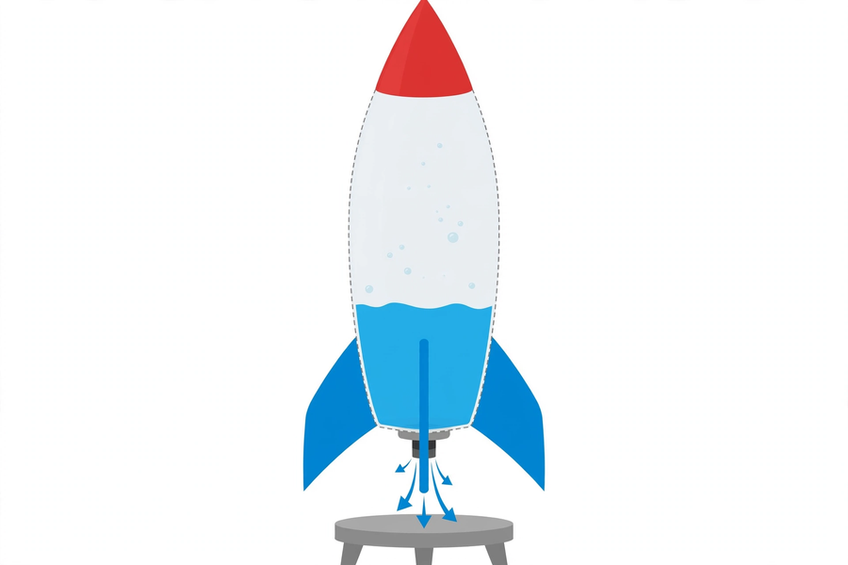
甲部：選擇題（每題 4 分，共 20 分）
Section A: Multiple Choice (4 marks each, 20 marks total)
1. 水火箭升空的主要原理是 A. 浮力 B. 作用力與反作用力 C. 磁力 D. 靜電
The main principle behind a water rocket's launch is A. buoyancy B. action and reaction C. magnetism D. static electricity
2. 發射時，壓縮空氣的作用是 A. 把樽吹脹 B. 把水向下推出 C. 把火箭拉高 D. 令水變輕
At launch, the compressed air A. inflates the bottle B. forces the water downwards C. pulls the rocket up D. makes the water lighter
3. 效果較佳的水量約為 A. 裝滿全樽 B. 約樽身三分之一 C. 幾滴水 D. 不加水
The better water volume is about A. a full bottle B. one-third of the bottle C. a few drops D. no water
4. 飛行距離最遠的發射角度約為 A. 水平 B. 45 度 C. 垂直向上 D. 向下
The launch angle giving the longest distance is about A. horizontal B. 45 degrees C. straight up D. downwards
5. 關於水火箭安全，下列哪一項正確？ A. 學生可自行打氣 B. 可用有裂痕的樽 C. 只准老師操作打氣 D. 可站在發射區內觀看
About water rocket safety, which is correct? A. Students may pump themselves B. Cracked bottles are fine C. Only the teacher operates the pump D. Watching inside the launch area is fine
乙部：問答題
Section B: Written Questions
1. (6 分) 完成發射數據記錄表（填上本組的真實數據，最少兩次發射）。
(6 marks) Complete the launch data record table (your group's real data; at least two launches).
發射次數 Launch no. | 水量（約） Water (approx.) | 發射角度 Launch angle | 飛行距離（米） Distance (m)
1
2
1. (8 分) 寫出本組的改良方案：改良了甚麼？為甚麼？（改良必須有數據支持，並指出最少兩個影響飛行距離的因素。）
(8 marks) Write your group's improvement plan: what did you improve? Why? (Support it with data and identify at least two factors affecting flight distance.)
2. (6 分) 繪畫水火箭受力示意圖，標示水向下噴出與火箭向上的方向，並以文字解釋兩者的關係。（不少於 50 字）
(6 marks) Draw a force diagram of the water rocket, labelling the downward water jet and the upward rocket direction, and explain their relationship in words. (At least 50 Chinese words)
—— 全卷 40 分 ——
—— Total: 40 marks ——

