聖公會呂明才中學
S.K.H. Lui Ming Choi Secondary School
創科班 Little Makers Class
單元二：動手做 STEAM Unit 2: Hands-on STEAM
第 9 堂｜動手大挑戰——水火箭發射（戶外）
Lesson 9 | Grand Hands-on Challenge — Water Rocket Launch (Outdoor)
學生筆記

Student Notes
姓名 Name：＿＿＿＿＿＿＿＿ 班別 Class：＿＿＿＿ 學號 Class No.：＿＿＿＿ 組別 Group：＿＿＿＿
日期 Date：＿＿＿＿＿＿＿＿
本堂物資表 Materials List
以下為本堂分組活動所需物資（每組一份）。請在老師派發時核對。
品名 Item | 數量（每組） Quantity (per group) | 安全注意 Safety notes
1.25L／2L 汽水樽 1.25 L / 2 L soft-drink bottle | 每組 2 個 2 per group | 使用前檢查樽身無裂痕 Check the bottle for cracks before use
軟木塞／發射塞 Cork / launch stopper | 每組 1 個 1 per group | — —
單車打氣筒 Bicycle pump | 全班共用 2 個 2 shared by class | 只准老師操作 Only the teacher may operate the pump
硬卡紙（尾翼） Card (fins) | 每組 1 張 1 per group | — —
膠紙、剪刀 Tape, scissors | 課室現有 Available in classroom | 剪刀使用注意安全 Take care when using scissors
捲尺（量度距離） Measuring tape (for distance) | 每組 1 個 1 per group | — —
水 Water | 適量 As needed | — —
一、課程內容
1. Lesson Content
1. 甚麼是水火箭？ What is a water rocket?
水火箭用回收汽水樽做箭身，加入適量的水，再打入壓縮空氣。發射時，壓縮空氣把水從樽口向下猛力推出，火箭便沖天而起。
A water rocket uses a recycled soft-drink bottle as its body, filled with a suitable amount of water plus compressed air. At launch, the compressed air forces the water violently downwards out of the bottle mouth, and the rocket shoots skywards.
2. 氣壓原理 Principle of air pressure
用打氣筒把空氣打入樽內，樽內空氣被壓縮，氣壓升高。氣壓愈高，推水的力量愈大。但氣壓有安全上限，必須由老師控制，不可自行加壓。
Pumping air into the bottle compresses the air inside and raises the air pressure. Higher pressure pushes the water out more forcefully. But air pressure has a safety limit and must be controlled by the teacher — never pressurise it yourself.
3. 作用力與反作用力 Action and reaction
水被向下推出（作用力），同時水對火箭產生一個大小相等、方向相反的推力（反作用力），把火箭向上推。這就是火箭升空的原因，也是真實火箭的原理。
Water is pushed downwards (action), while the water pushes back on the rocket with an equal and opposite force (reaction), driving the rocket upwards. This is why the rocket launches — and the same principle behind real rockets.
4. 水量：三分之一最理想 Water volume: one-third is ideal
水量約為樽身三分之一時效果較佳。水太多，樽內壓縮空氣不足，推力弱；水太少，可推的水不足，推力維持時間短。同學可從數據中驗證。
About one-third of a bottle of water works best. Too much water leaves too little compressed air, weakening the push; too little water means too little to push, so the thrust lasts only briefly. Verify this from your data.
5. 發射角度 Launch angle
發射角度約 45 度時，飛行距離最遠。角度太直（接近垂直），火箭飛得高但落得近；角度太平，火箭很快落地。
A launch angle of about 45 degrees gives the longest flight distance. Too steep (near vertical) and the rocket goes high but lands near; too flat and it lands quickly.
6. 尾翼 Fins
尾翼要對稱黏貼，幫助火箭在飛行中保持方向穩定。尾翼不對稱，火箭會偏航、打轉，飛不遠。
Fins must be attached symmetrically to keep the rocket flying straight. Asymmetric fins make the rocket veer and spin, shortening the flight.
7. 安全規則 Safety rules
1. 發射區必須清空，無關人員不可進入。
The launch area must be cleared; no one unrelated may enter.
2. 只准老師操作打氣加壓，學生不可自行打氣。
Only the teacher may operate the pump; students must not pressurise the rocket themselves.
3. 發射時所有人退到安全線後，不可站在火箭前方。
During launches everyone stays behind the safety line; never stand in front of the rocket.
4. 使用前檢查樽身無裂痕，有裂痕的樽不可使用。
Check the bottle for cracks before use; cracked bottles must not be used.
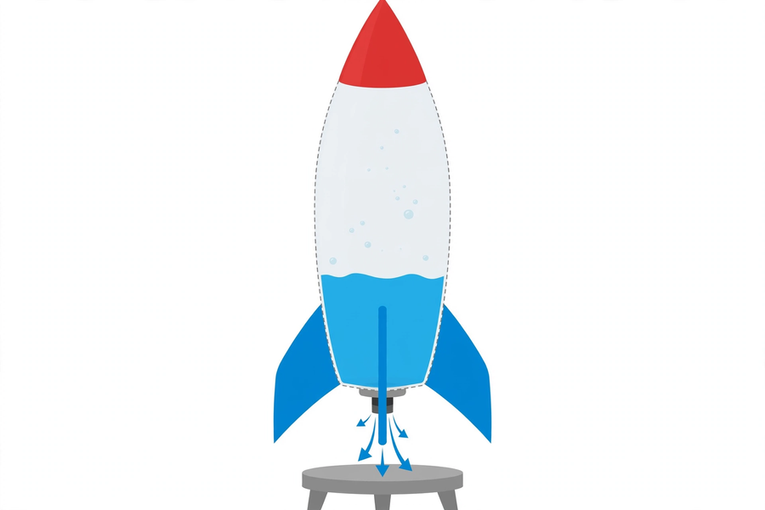
二、例子
2. Examples
例子一：真實火箭 Example 1: real rockets
真實火箭向下噴出高溫燃氣（作用力），燃氣的反作用力把火箭向上推。水火箭只是把「燃氣」換成「水」，原理完全相同。
A real rocket ejects hot exhaust gases downwards (action), and the gases' reaction force pushes the rocket upwards. A water rocket simply replaces "exhaust gas" with "water" — the principle is identical.
例子二：吹氣球鬆手 Example 2: releasing an inflated balloon
把吹脹的氣球鬆手，氣從氣球口向下向後噴出，氣球便亂飛。這也是作用力與反作用力：氣被推出，氣球被反推。
Let go of an inflated balloon and air jets out of its mouth while the balloon darts around. This is also action and reaction: air pushed out, balloon pushed back.
三、簡單問答題（課堂口答）
3. Quick Questions (oral)
1. 水火箭靠甚麼升空？試用「作用力與反作用力」回答。
What lifts a water rocket? Answer using "action and reaction".
2. 為甚麼水裝得太滿，火箭反而飛不遠？
Why does overfilling with water make the rocket fly a shorter distance?
3. 發射時，同學應該站在哪裡？為甚麼？
During a launch, where should students stand? Why?
四、思考題
4. Thinking Questions
1. 如果尾翼貼得不對稱，火箭飛行時會有甚麼影響？為甚麼？
If the fins are attached asymmetrically, how will the flight be affected? Why?
2. 為甚麼規則訂明「只准老師操作打氣」？試從安全角度解釋。
Why do the rules state that "only the teacher may operate the pump"? Explain from a safety perspective.
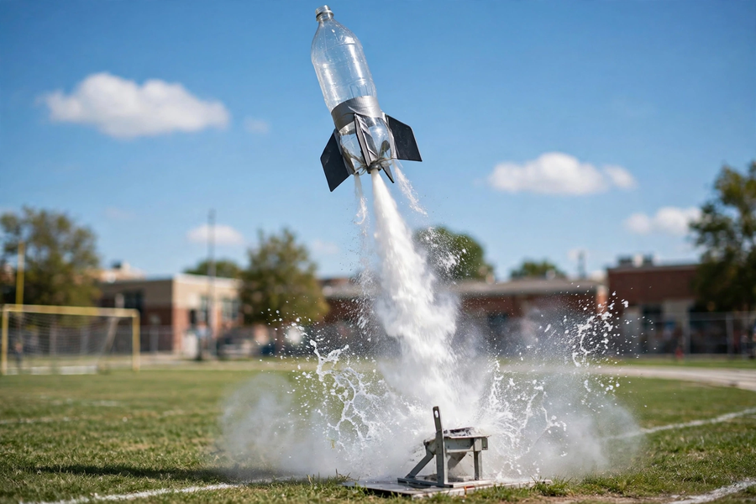
五、分組活動：水火箭發射
5. Group Activity: Water Rocket Launch
水火箭結構 Water rocket structure
- 樽身：1.25L 或 2L 汽水樽（檢查無裂痕），樽口朝下。
Body: 1.25 L or 2 L soft-drink bottle (check for cracks), mouth facing down.
- 尾翼：硬卡紙剪出 3–4 片，對稱黏貼在樽身下部。
Fins: 3–4 pieces cut from card, attached symmetrically near the lower body.
- 錐頭：卡紙做成錐形，裝在樽底（即火箭頂部），減少空氣阻力。
Nose cone: a cone made of card, fitted to the bottle base (the rocket's top) to reduce air resistance.
- 發射塞：軟木塞／發射塞塞住樽口，連接打氣筒（由老師操作）。
Launch stopper: a cork/stopper sealing the mouth, connected to the pump (operated by the teacher).
發射數據記錄表 Launch data record table
發射次數 Launch no. | 水量（約） Water (approx.) | 發射角度 Launch angle | 飛行距離（米） Distance (m) | 備註 Remarks
1
2
3
改良方案欄 Improvement plan box
我們改良了甚麼？為甚麼？（改良必須有數據支持）
What did we improve? Why? (Improvements must be supported by data)
＿＿＿＿＿＿＿＿＿＿＿＿＿＿＿＿＿＿＿＿＿＿＿＿＿＿＿＿＿＿＿＿＿＿＿＿＿＿＿＿
＿＿＿＿＿＿＿＿＿＿＿＿＿＿＿＿＿＿＿＿＿＿＿＿＿＿＿＿＿＿＿＿＿＿＿＿＿＿＿＿
＿＿＿＿＿＿＿＿＿＿＿＿＿＿＿＿＿＿＿＿＿＿＿＿＿＿＿＿＿＿＿＿＿＿＿＿＿＿＿＿
＿＿＿＿＿＿＿＿＿＿＿＿＿＿＿＿＿＿＿＿＿＿＿＿＿＿＿＿＿＿＿＿＿＿＿＿＿＿＿＿
六、總結
6. Summary
- 打氣令樽內氣壓升高；壓縮空氣把水向下推出。
Pumping raises the air pressure inside the bottle; compressed air forces the water downwards.
- 作用力與反作用力：水向下噴，反作用力把火箭向上推。
Action and reaction: water jets down, the reaction force pushes the rocket up.
- 水量約三分之一最理想；發射角度約 45 度最遠；尾翼要對稱。
About one-third water is ideal; about 45 degrees flies furthest; fins must be symmetric.
- 安全第一：發射區清空、只准老師打氣、退到安全線後。
Safety first: clear the launch area, only the teacher pumps, stay behind the safety line.
- 工程思維：量度 → 分析數據 → 改良 → 再測試。
Engineering mindset: measure → analyse data → improve → test again.
七、課堂小測驗
7. Class Quiz
1. 水火箭升空的主要原理是 A. 磁力 B. 作用力與反作用力 C. 光的反射 D. 電生磁
The main principle behind a water rocket's launch is A. magnetism B. action and reaction C. reflection of light D. electricity producing magnetism
2. 水量太多時，火箭飛不遠，原因是 A. 水太重 B. 樽內壓縮空氣不足，推力弱 C. 尾翼濕了 D. 樽口太大
Too much water shortens the flight because A. the water is too heavy B. too little compressed air remains, weakening the thrust C. the fins get wet D. the mouth is too big
3. 飛行距離最遠的發射角度約為 A. 10 度 B. 45 度 C. 90 度 D. 180 度
The launch angle giving the longest distance is about A. 10° B. 45° C. 90° D. 180°
4. 下列哪一項符合安全規則？ A. 學生自行打氣加壓 B. 站在火箭前方觀看 C. 只准老師操作打氣，所有人退到安全線後 D. 用有裂痕的樽發射
Which follows the safety rules? A. Students pressurise the pump themselves B. Standing in front of the rocket to watch C. Only the teacher operates the pump; everyone stays behind the safety line D. Launching a cracked bottle
5. 解釋：為甚麼尾翼要對稱黏貼？（30 字以上）
Explain: why must fins be attached symmetrically? (At least 30 Chinese words)

