聖公會呂明才中學
S.K.H. Lui Ming Choi Secondary School
創科班 Little Makers Class
單元二：動手做 STEAM Unit 2: Hands-on STEAM
第 9 堂｜動手大挑戰——水火箭發射（戶外）
Lesson 9 | Grand Hands-on Challenge — Water Rocket Launch (Outdoor)
教師筆記

Teacher Notes
本堂物資表 Materials List（教師版）
請預早一星期準備所需物資；標示「課室現有」之項目請預先清點。
品名 Item | 數量（每組） Quantity (per group) | 大約成本 Est. cost | 安全注意 Safety notes
1.25L／2L 汽水樽 1.25 L / 2 L soft-drink bottle | 每組 2 個 2 per group | 回收免費 Recycled; free | 使用前檢查樽身無裂痕 Check the bottle for cracks before use
軟木塞／發射塞 Cork / launch stopper | 每組 1 個 1 per group | 約 HK$5 approx. HK$5 | — —
單車打氣筒 Bicycle pump | 全班共用 2 個 2 shared by class | 約 HK$60（可重用） approx. HK$60 (reusable) | 只准老師操作 Only the teacher may operate the pump
硬卡紙（尾翼） Card (fins) | 每組 1 張 1 per group | 約 HK$2 approx. HK$2 | — —
膠紙、剪刀 Tape, scissors | 課室現有 Available in classroom | — — | 剪刀使用注意安全 Take care when using scissors
捲尺（量度距離） Measuring tape (for distance) | 每組 1 個 1 per group | 課室現有 Available in classroom | — —
水 Water | 適量 As needed | — — | — —
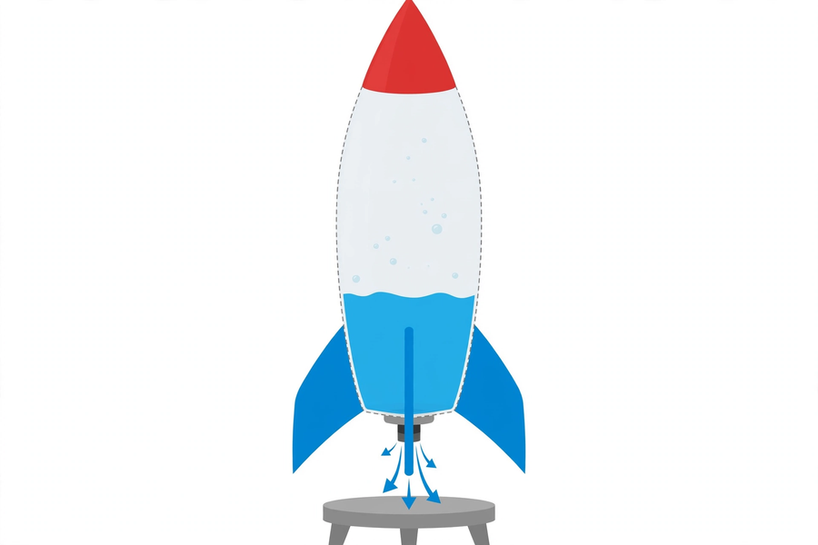
本文件包含學生筆記所有題目的參考答案、家課答案、附加思考題、建議教導方向及常見迷思，僅供教師使用，切勿派發給學生。
This document contains reference answers to all student-note questions, homework answers, extra thinking questions, teaching suggestions and common misconceptions. For teachers only — do not distribute to students.
一、學生筆記參考答案
1. Student Notes — Reference Answers
簡單問答題 Quick questions
■ 參考答案 Reference answers
1. 靠作用力與反作用力：壓縮空氣把水向下推出（作用力），水對火箭產生方向相反的推力（反作用力），把火箭向上推。
By action and reaction: compressed air pushes water downwards (action), and the water pushes back on the rocket in the opposite direction (reaction), driving it upwards.
2. 因為樽內空間有限，水太多，壓縮空氣的空間不足，氣壓推力弱；而且過重的水也增加負擔，所以反而飛不遠。
Because bottle space is limited: too much water leaves too little room for compressed air, weakening the thrust; the extra water weight is also a burden, so the flight is shorter.
3. 退到安全線後。因為火箭發射方向和距離難以完全預計，站在安全線後可避免被火箭或噴出的水擊中。
Behind the safety line. The rocket's direction and distance cannot be fully predicted; staying behind the line avoids being hit by the rocket or ejected water.
思考題 Thinking questions
■ 參考答案 Reference answers
1. 火箭會偏航、打轉，飛行不穩定，距離縮短。因為不對稱的尾翼令空氣阻力分布不均，火箭無法保持直線飛行。
The rocket will veer and spin, flying unstably over a shorter distance. Asymmetric fins make air resistance uneven, so the rocket cannot hold a straight flight.
2. 因為氣壓過高有爆樽危險；老師能控制安全壓力上限，學生自行打氣可能過度加壓，造成意外。
Because excessive pressure risks bursting the bottle; the teacher controls the safe pressure limit, while students pumping themselves might over-pressurise and cause accidents.
課堂小測驗參考答案 Class quiz — reference answers
■ 參考答案 Reference answers
1. B（作用力與反作用力）
B (action and reaction)
2. B（樽內壓縮空氣不足，推力弱）
B (too little compressed air remains, weakening thrust)
3. B（45 度）
B (45 degrees)
4. C（只准老師操作打氣，所有人退到安全線後）
C (only the teacher operates the pump; everyone stays behind the safety line)
5. 參考答案：對稱的尾翼令火箭兩側所受的空氣阻力平均，飛行時保持方向穩定，不偏航打轉，才能飛得遠。評分：說出「阻力平均／保持方向穩定」得滿分。
Reference: symmetric fins even out air resistance on both sides, keeping the rocket stable and straight instead of veering and spinning, so it flies further. Full marks for "even resistance / stable direction".
二、家課參考答案
2. Homework — Reference Answers
■ 參考答案 Reference answers
1. B（作用力與反作用力）
B (action and reaction)
2. B（壓縮空氣把水向下推出）
B (compressed air forces water downwards)
3. B（約樽身三分之一）
B (about one-third of the bottle)
4. B（45 度）
B (45 degrees)
5. C（只准老師操作打氣）
C (only the teacher operates the pump)
6. 數據記錄評分：最少記錄兩次發射的數據（水量、角度、距離）；數據真實合理。
Data marking: at least two launches recorded (water, angle, distance); data realistic.
7. 改良方案評分：改良有數據支持（例如「第一次水太多只飛 8 米，減至三分之一後飛 14 米」）；能指出最少兩個影響因素（水量、角度、尾翼、樽重任選其二）。
Improvement marking: supported by data (e.g. "too much water flew 8 m; reduced to one-third flew 14 m"); identifies at least two factors (any two of water volume, angle, fins, bottle weight).
8. 受力示意圖評分：圖中標示水向下噴出的方向（作用力）與火箭向上的方向（反作用力）；文字解釋正確說明兩者關係。
Force diagram marking: labels the downward water jet (action) and the upward rocket direction (reaction); written explanation correctly describes their relationship.
三、附加思考題
3. Extra Thinking Questions
■ 參考答案 Reference answers
1. 同樣條件下，2L 大樽和 1.25L 小樽，哪個可能飛得遠？為甚麼？參考答案：不一定；大樽可裝更多壓縮空氣但較重，小樽較輕但儲氣少；要從實驗數據比較，不能單憑大小判斷。
Under identical conditions, would a 2 L or 1.25 L bottle fly further? Why? Reference: not certain — the bigger bottle holds more compressed air but is heavier; the smaller is lighter but stores less air; compare from experimental data, not size alone.
2. 火箭升空後，水用完了，火箭靠甚麼繼續向上飛？參考答案：靠慣性。水噴完後推力停止，但火箭已有向上的速度，會因慣性繼續上升，直至重力令它減速掉下。
After the water is spent, what keeps the rocket rising? Reference: inertia. Once the water is gone the thrust stops, but the rocket already has upward velocity and keeps rising by inertia until gravity slows it down.
3. 為甚麼發射前要檢查樽身有否裂痕？參考答案：有裂痕的樽在高壓下可能爆裂，碎片有危險；檢查是為了安全。
Why check the bottle for cracks before launch? Reference: a cracked bottle may burst under high pressure, sending fragments flying; the check is for safety.
四、建議教導方向
4. Suggested Teaching Approach
1. 引入與安全講解（0–10 分鐘，課室）：講解氣壓原理與安全規則，要求學生覆述要點；強調只准老師操作打氣。
Introduction and safety briefing (0–10 min, classroom): explain air pressure and safety rules; have students restate key points; stress only the teacher operates the pump.
2. 製作（10–25 分鐘）：示範火箭組裝（樽身、尾翼、錐頭）；提醒尾翼對稱、水量約三分之一。
Making (10–25 min): demonstrate assembly (body, fins, nose cone); remind them fins must be symmetric and water about one-third.
3. 移師戶外（25–30 分鐘）：帶隊到操場，劃定發射區與安全線。
Move outdoors (25–30 min): lead the class to the playground; mark the launch area and safety line.
4. 發射與量度（30–50 分鐘）：操作加壓，逐組發射，維持秩序；指導量度飛行距離（由發射點到首次落地點）。
Launch and measure (30–50 min): operate the pump, launch group by group, maintain order; guide measuring flight distance (launch point to first landing point).
5. 改良再射與總結（50–60 分鐘）：引導各組分析數據、提出改良，安排第二輪發射；總結氣壓原理與作用力反作用力。
Improve, relaunch, conclude (50–60 min): guide groups to analyse data and propose improvements; arrange round two; summarise air pressure and action–reaction.
五、常見迷思
5. Common Misconceptions
1. 「水愈多飛得愈遠」→ 引導學生從數據發現：水量過多，壓縮空氣不足，推力反而弱；讓他們試不同水量比較。
"More water flies further" → guide students to discover from data: too much water leaves too little compressed air, weakening thrust; have them try different volumes and compare.
2. 「打氣愈多愈好」→ 強調安全壓力上限由老師控制；過度加壓有爆樽危險，不是「愈多愈好」。
"More pumping is always better" → stress the teacher controls the safe pressure limit; over-pressurising risks bursting the bottle — more is not better.
3. 以為火箭靠「水很重」升空 → 澄清關鍵是水被高速向下推出產生的反作用力，不是水的重量；水太重反而是負擔。
Thinking the rocket rises "because water is heavy" → clarify the key is the reaction force from water jetted downwards at speed, not the water's weight; excess water weight is actually a burden.

