聖公會呂明才中學
S.K.H. Lui Ming Choi Secondary School
創科班 Little Makers Class
單元二：動手做 STEAM Unit 2: Hands-on STEAM
第 10 堂｜發明家日記——整理作品、反思與單元小結
Lesson 10 | Inventor's Diary — Organising Work, Reflection, and Unit Review
家課

Homework
姓名 Name：＿＿＿＿＿＿＿＿ 班別 Class：＿＿＿＿ 學號 Class No.：＿＿＿＿ 組別 Group：＿＿＿＿
日期 Date：＿＿＿＿＿＿＿＿
本家課是單元總結：完成「發明家日記」工作紙，並提交個人作品集。
This homework concludes the unit: complete the "Inventor's Diary" worksheet and submit your personal portfolio.
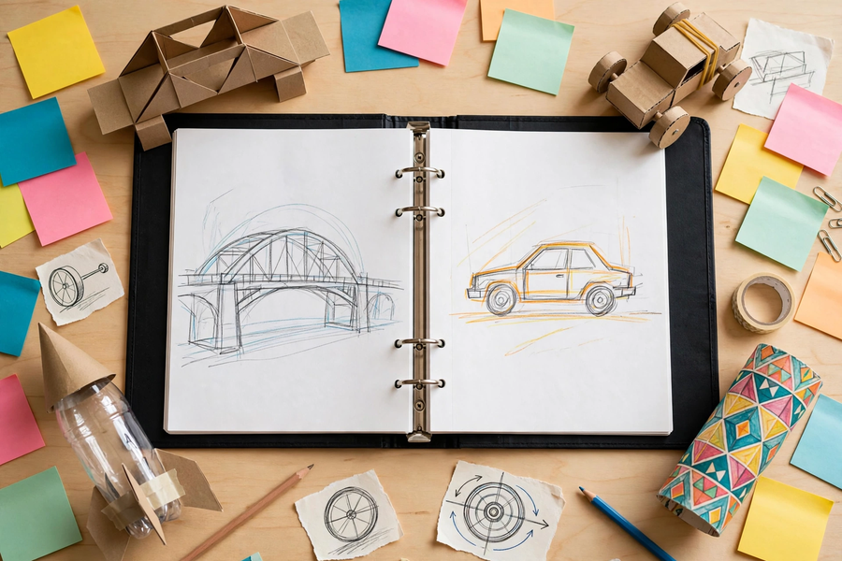
甲部：單元概念測驗（每題 4 分，共 20 分）
Section A: Unit Concept Quiz (4 marks each, 20 marks total)
1. 紙橋承重挑戰中，最穩固的平面形狀是 A. 正方形 B. 三角形 C. 圓形 D. 橢圓形
In the paper bridge challenge, the most stable flat shape is A. square B. triangle C. circle D. oval
2. 橡筋動力車前進時，橡筋的彈性勢能主要轉化為 A. 光能 B. 車輪的動能 C. 磁能 D. 熱能（主要）
As the rubber-band car moves, the band's elastic potential energy mainly becomes A. light B. kinetic energy of the wheels C. magnetic energy D. heat (mainly)
3. 電磁鐵斷電後會 A. 磁力更強 B. 磁力消失 C. 變成永久磁石 D. 發出聲音
After an electromagnet is disconnected, it will A. become more magnetic B. lose its magnetism C. become a permanent magnet D. make a sound
4. 潛望鏡內兩片鏡的正確裝法是 A. 互相垂直 B. 互相平行、各成 45 度 C. 重疊 D. 隨意擺放
A periscope's two mirrors must be A. perpendicular B. parallel, each at 45 degrees C. stacked D. placed randomly
5. 關於潛望鏡，下列哪一項正確？ A. 能放大影像 B. 只改變光路，不會放大影像 C. 需要用電 D. 只能在晚上使用
About periscopes, which is correct? A. It magnifies images B. It only changes the light path; it does not magnify C. It needs electricity D. It only works at night
乙部：發明家日記
Section B: Inventor's Diary
1. (6 分) 寫出本單元學到的三個科學概念，並各舉一堂活動為例。
(6 marks) Write down three science concepts learned in this unit, each with one lesson activity as an example.
2. (8 分) 以文字寫出你的反思：包括一件具體事例、它令你明白的科學概念，以及你的不足與改進方向。（不少於 100 字）
(8 marks) Write your reflection in words: include one concrete example, the science concept it taught you, and your shortcomings with directions for improvement. (At least 100 Chinese words)
3. (6 分) 整理並提交個人作品集（最少包含四堂的作品記錄，每件作品加一句說明）。
(6 marks) Organise and submit your personal portfolio (work records from at least four lessons, one caption per piece).
—— 全卷 40 分 ——
—— Total: 40 marks ——

