聖公會呂明才中學
S.K.H. Lui Ming Choi Secondary School
創科班 Little Makers Class
單元二：動手做 STEAM Unit 2: Hands-on STEAM
第 10 堂｜發明家日記——整理作品、反思與單元小結
Lesson 10 | Inventor's Diary — Organising Work, Reflection, and Unit Review
教師筆記

Teacher Notes
本堂物資表 Materials List（教師版）
請預早一星期準備所需物資；標示「課室現有」之項目請預先清點。
品名 Item | 數量（每組） Quantity (per group) | 大約成本 Est. cost | 安全注意 Safety notes
「發明家日記」工作紙 “Inventor's Diary” worksheet | 每人 1 份 1 per student | 約 HK$2 approx. HK$2 | — —
膠水 Glue | 每組 1 支 1 per group | 課室現有 Available in classroom | — —
顏色筆 Colour pens | 課室現有 Available in classroom | — — | — —
學生作品相片 Photos of students' work | — — | 課堂拍攝（打印或電子版） Taken in class (printed or digital) | — —
釘書機 Stapler | 全班共用 Shared by class | 課室現有 Available in classroom | 小心使用 Use with care
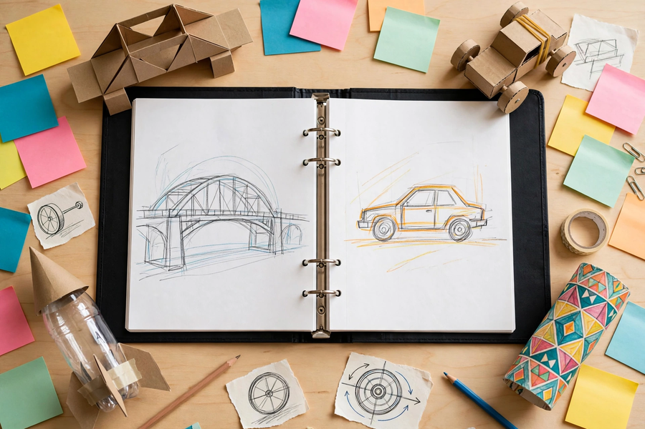
本文件包含學生筆記所有題目的參考答案、家課答案、附加思考題、建議教導方向及常見迷思，僅供教師使用，切勿派發給學生。
This document contains reference answers to all student-note questions, homework answers, extra thinking questions, teaching suggestions and common misconceptions. For teachers only — do not distribute to students.
一、學生筆記參考答案
1. Student Notes — Reference Answers
簡單問答題 Quick questions
■ 參考答案 Reference answers
1. 反思包括承認不足和提出改進，是誠實的自我檢視；「讚美自己」只說好話，迴避問題，對進步沒有幫助。
Reflection includes admitting shortcomings and proposing improvements — honest self-examination; "praising yourself" only says nice things, avoids problems, and does not help progress.
2. 因為空泛的句子（如「我學到很多」）無法證明學了甚麼；具體事例能呈現真實經歷，也讓教師看到學生的思考過程。
Because vague sentences ("I learned a lot") prove nothing; concrete examples present real experiences and let the teacher see the student's thinking.
3. 可接受答案示例：結構力學（第 4 堂紙橋）、能量轉換（第 5 堂橡筋車）、電生磁（第 6 堂電磁鐵）、光的反射（第 7 堂萬花筒／潛望鏡）、簡單電路（第 8 堂關愛夜燈）、氣壓與反作用力（第 9 堂水火箭）。
Acceptable samples: structural mechanics (L4 paper bridge), energy conversion (L5 rubber-band car), electricity producing magnetism (L6 electromagnet), reflection of light (L7 kaleidoscope/periscope), simple circuits (L8 night light), air pressure and reaction (L9 water rocket).
思考題 Thinking questions
■ 參考答案 Reference answers
1. 開放式；評分看是否有具體事例支撐（例如「第 6 堂刮漆皮失敗了三次，第四次才成功」），以及有否寫出克服方法。
Open-ended; mark on whether concrete examples support it (e.g. "In Lesson 6 I failed scraping the insulation three times and succeeded on the fourth") and whether the solution is described.
2. 開放式；評分看原因是否具體（例如「想學太陽能車，因為想知光能怎樣變成動能」），而非「好玩」一類空泛答案。
Open-ended; mark on whether the reason is concrete (e.g. "I want to learn about solar cars, to see how light becomes motion") rather than vague answers like "fun".
單元小測驗參考答案 Unit quiz — reference answers
■ 參考答案 Reference answers
1. B（三角形）
B (triangle)
2. B（車輪的動能）
B (kinetic energy of the wheels)
3. B（磁力消失）
B (magnetism disappears)
4. A（兩次反射）
A (two reflections)
5. A（電源、導線、負載）
A (power source, conductor, load)
6. B（作用力與反作用力）
B (action and reaction)
7. 評分：每個概念 2 分——概念正確 1 分，舉例正確（對應堂次活動）1 分。示例：結構力學——紙橋承重（三角形最穩固）；能量轉換——橡筋動力車（勢能轉動能）；電生磁——電磁鐵；光的反射——萬花筒／潛望鏡；簡單電路——關愛夜燈；氣壓——水火箭。
Marking: 2 marks per concept — 1 for the correct concept, 1 for a correct example (matching lesson activity). Samples: structural mechanics — paper bridge (triangles most stable); energy conversion — rubber-band car (potential to kinetic); electricity producing magnetism — electromagnet; reflection of light — kaleidoscope/periscope; simple circuits — night light; air pressure — water rocket.
二、家課參考答案
2. Homework — Reference Answers
■ 參考答案 Reference answers
1. B（三角形）
B (triangle)
2. B（車輪的動能）
B (kinetic energy of the wheels)
3. B（磁力消失）
B (magnetism disappears)
4. B（互相平行、各成 45 度）
B (parallel, each at 45 degrees)
5. B（它只改變光路，不會放大影像）
B (it only changes the light path; it does not magnify)
6. 三個科學概念評分：每個概念正確且例子對應，2 分；概念正確但例子錯配，1 分。
Three-concepts marking: 2 marks per correct concept with matching example; 1 mark if the concept is right but the example mismatched.
7. 反思短文評分：須包含具體事例、概念連結、改進方向三部分；語句通順。每缺一部分扣約三分之一分數。
Reflection marking: must include concrete examples, concept links, and improvements; coherent writing. Deduct about one-third per missing part.
8. 作品集評分：見下方評分準則「作品集完整性」一項。
Portfolio marking: see the "Portfolio completeness" criterion in the rubric below.
三、附加思考題
3. Extra Thinking Questions
■ 參考答案 Reference answers
1. 六個科學概念中，哪兩個概念在本單元的不同堂次都出現過？參考答案：例如「能量轉換」在第 5 堂（橡筋車）和第 9 堂（水火箭：壓縮空氣的能量轉為動能）都出現；「結構」概念在第 4 堂（紙橋）和第 9 堂（尾翼對稱）都出現。
Which two science concepts appear in different lessons of this unit? Reference: e.g. "energy conversion" in L5 (rubber-band car) and L9 (water rocket: compressed-air energy into motion); "structure" in L4 (paper bridge) and L9 (symmetric fins).
2. 有同學說「動手做只是玩」。你會怎樣反駁？參考答案：每堂動手做都有數據記錄和原理解釋，例如水火箭要量度距離、分析水量影響，是貨真價實的科學探究，不只是玩。
A classmate says "hands-on is just playing". How would you counter? Reference: every lesson involves data recording and explaining principles — e.g. water rockets require measuring distance and analysing water volume — genuine scientific inquiry, not just play.
3. 為下一單元設計一個動手做活動，寫出活動名稱和想學的科學概念。參考答案：開放式；須有具體活動名稱和對應的科學概念（例如「太陽能小車——光能轉換」）。
Design a hands-on activity for the next unit: give the activity name and the science concept to learn. Reference: open-ended; must name a concrete activity with a matching concept (e.g. "solar car — light energy conversion").
四、建議教導方向
4. Suggested Teaching Approach
1. 回顧（0–10 分鐘）：展示本單元各堂活動相片，提問「你還記得每堂做了甚麼嗎」，喚起記憶。
Review (0–10 min): show photos from each lesson and ask "Can you still remember what we did in each lesson?".
2. 整理與撰寫（10–35 分鐘）：派發「發明家日記」工作紙，講解撰寫要求（具體事例、概念連結、改進方向）；巡視指導，對寫得空泛的學生即時追問「舉個例」。
Organise and write (10–35 min): distribute the "Inventor's Diary" worksheet and explain the writing requirements (concrete examples, concept links, improvements); visit students and promptly ask those writing vaguely to "give an example".
3. 小組分享（35–50 分鐘）：主持小組分享，每人約兩分鐘；邀請代表向全班介紹，互相欣賞。
Group sharing (35–50 min): host sharing, about two minutes per person; invite representatives to present to the class; appreciate each other.
4. 單元小結（50–60 分鐘）：總結七堂學習重點，點出全年主題「正能量——用創科關愛弱勢社群」（關愛夜燈），預告下一單元；收集作品集。
Unit conclusion (50–60 min): summarise the seven lessons, highlight the yearly theme "Positive Energy — Using Innovation and Technology to Care for the Underprivileged" (night light), preview the next unit; collect portfolios.
五、常見迷思
5. Common Misconceptions
1. 以為反思就是「讚美自己」→ 說明反思包括不足與改進；展示「空泛 vs 具體」對比例句，讓學生分辨。
Thinking reflection means "praising yourself" → explain reflection includes shortcomings and improvements; show the "vague vs concrete" example pair for students to distinguish.
2. 只寫結果不寫過程 → 提醒加入動手做的經歷：遇到甚麼困難、怎樣解決、數據說明了甚麼。
Writing only results without process → remind them to include the hands-on experience: what difficulties arose, how they were solved, what the data showed.
3. 以為概念只要「背出名詞」→ 要求每個概念配一堂活動為例，證明真正理解概念在真實情境中的意思。
Thinking concepts only need "memorised terms" → require each concept to be paired with one lesson activity as an example, proving real understanding in context.

