創科班 Little Makers Class｜單元三：編程思維（不插電） Little Makers Class | Unit 3: Computational Thinking (Unplugged)
第 11 堂：演算法——人體機械人 Lesson 11: Algorithms — Human Robots
姓名 Name：＿＿＿＿ 班別 Class：＿＿＿＿ 學號 No.：＿＿＿＿ 日期 Date：＿＿＿＿
本堂物資表 Materials List
以下為本堂分組活動所需物資（每組一份）。請在老師派發時核對。
品名 Item | 數量（每組） Quantity (per group) | 安全注意 Safety notes
迷宮格線紙（A3） Maze grid paper (A3) | 每組 2 張 2 per group | 無 None
指令寫作紙／「為長者設計」指令卡 Instruction sheets / "design for the elderly" cards | 每組 4 張 4 per group | 無 None
原子筆 Ballpoint pens | 每人 1 支 1 per student | 無 None
計時器 Timer | 老師 1 個 1 for the teacher | 無 None
迷宮起點／終點標記貼紙 Start/finish marker stickers | 每組 2 張 2 per group | 活動時注意桌椅擺位，保持通道暢通 Keep walkways clear of desks and chairs during the activity

一、本課目標
1. Learning objectives
完成本課後，你能夠：
By the end of this lesson, you will be able to:
- 用自己的語言解釋何謂「演算法」，並指出「精確性」與「序列」兩個要點； ／ explain in your own words what an “algorithm” is, naming the two key ideas of precision and sequencing;
- 為指定任務撰寫一組完整、精確的指令（不少於五步），使「機械人」能順利完成任務； ／ write a complete, precise set of instructions (at least five steps) for a given task so that the “robot” can complete it;
- 指出一段給定指令中含糊或遺漏之處，並提出具體修正。 ／ spot vague or missing parts in a given set of instructions and suggest concrete corrections.

二、理論：什麼是演算法？
2. Theory: What is an algorithm?
演算法是為了解決某個問題或完成某項任務而定出的一組明確步驟。
An algorithm is a clear set of steps designed to solve a problem or complete a task.

演算法的兩個要點
Two key ideas of an algorithm
- 精確性（Precision）：每一步只能包含一個動作，用詞必須清楚明確，不可以含糊。例如「向前行一格」是精確的，「行過去嗰邊」是含糊的。 ／ Precision: each step contains only one action and must be worded clearly. “Move forward one square” is precise; “walk over there” is vague.
- 序列（Sequencing）：步驟必須按正確的先後次序執行。次序調亂了，結果可能完全不同。 ／ Sequencing: steps must be carried out in the correct order. Change the order and the result can be completely different.

為什麼電腦需要演算法？
Why do computers need algorithms?
電腦和機械人一樣，只會依照指令的字面意思執行，不會猜測你心裡真正想說什麼。指令寫得含糊，電腦便會做錯。因此，學會寫出精確、有次序的指令，就是學習編程思維的第一步。
A computer, like a robot, follows only the literal meaning of instructions and cannot guess what you really mean. Vague instructions lead to wrong results. Learning to write precise, well-ordered instructions is the first step in computational thinking.

生活中的演算法
Algorithms in everyday life
食譜就是演算法的一個好例子。以「泡茶」為例：
A recipe is a good example of an algorithm. Take “making tea”:
- 把水煲滾； ／ Boil the water;
- 把茶包放入杯中； ／ Put a tea bag into the cup;
- 把滾水倒入杯中； ／ Pour the boiling water into the cup;
- 等待三分鐘； ／ Wait for three minutes;
- 取出茶包。 ／ Take out the tea bag.
摺紙步驟、傢具組裝說明書，也都是演算法。
Origami steps and furniture assembly instructions are algorithms too.
次序重要的例子：穿襪和穿鞋。正確次序是先穿襪子，後穿鞋子。若把次序調亂（先穿鞋子），襪子便穿不上了。可見步驟的先後次序會直接影響結果。
An example where order matters: putting on socks and shoes. The correct order is socks first, then shoes. Reverse the order and the socks cannot be put on. The order of steps directly affects the result.
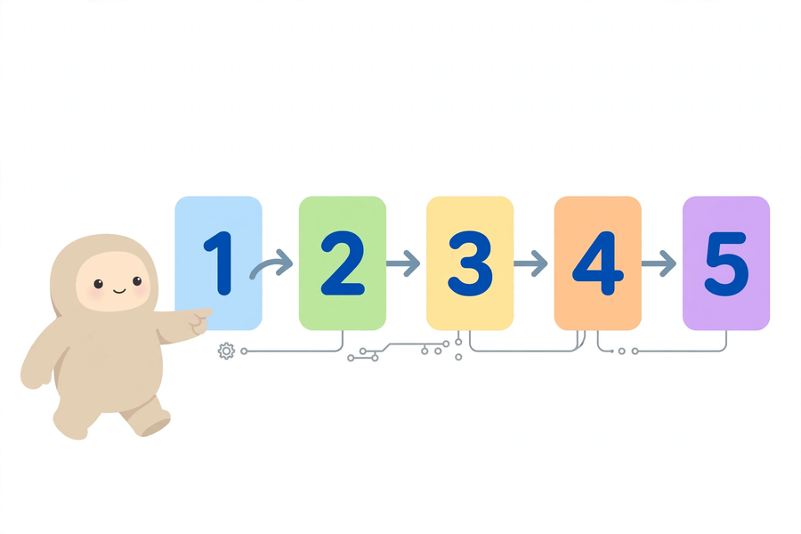

三、例子：走出迷宮
3. Example: getting through the maze
下圖是一個迷宮。綠色 START 格是起點（機械人起步時面向右方），紅色 GOAL 格是終點，黑色格是牆壁，不可進入。藍色虛線是最短路線。
Below is a maze. The green START square is the starting point (the robot starts facing right), the red GOAL square is the finish, and black squares are walls. The blue dotted line shows the shortest route.
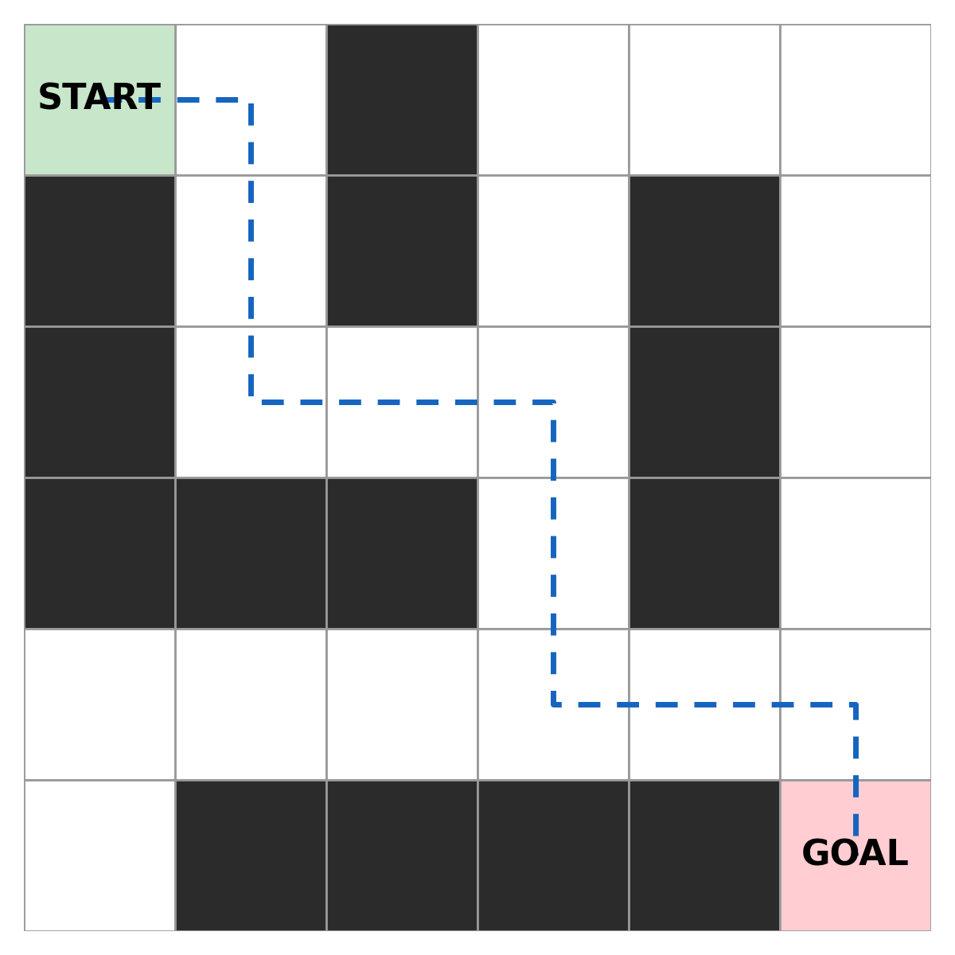
引導機械人走完全程的一組精確指令（共 11 步）：
A precise set of instructions guiding the robot through (11 steps):
- 向前行一格； ／ Move forward one square;
- 向右轉； ／ Turn right;
- 向前行兩格； ／ Move forward two squares;
- 向左轉； ／ Turn left;
- 向前行兩格； ／ Move forward two squares;
- 向右轉； ／ Turn right;
- 向前行兩格； ／ Move forward two squares;
- 向左轉； ／ Turn left;
- 向前行兩格； ／ Move forward two squares;
- 向右轉； ／ Turn right;
- 向前行一格。 ／ Move forward one square.
留意：每一步只有一個動作，轉彎和前行分開寫，步數具體寫明（「一格」「兩格」），機械人完全不用猜測。
Note: each step contains only one action; turning and moving are written separately, and the number of squares is stated exactly (“one square”, “two squares”), so the robot never has to guess.

四、簡單問答題
4. Quick questions
- 試用自己的話解釋：什麼是演算法？ ／ Explain in your own words: what is an algorithm?
- 演算法有哪兩個要點？ ／ What are the two key ideas of an algorithm?
- 為什麼電腦需要精確的指令？ ／ Why do computers need precise instructions?
- 以下哪一句指令比較精確？A. 走過去那邊 B. 向前走三格，然後向右轉 ／ Which instruction is more precise? A. Walk over there. B. Walk forward three squares, then turn right.
- 寫出穿襪、穿鞋的正確次序，並用一句話說明次序為何重要。 ／ Write the correct order for putting on socks and shoes, and explain in one sentence why the order matters.

五、思考題
5. Thinking question
有人說：「機械人應該聰明一點，自動明白含糊的指令。」你同意這個說法嗎？試說明你的理由。
Some people say: “Robots should be smart enough to understand vague instructions automatically.” Do you agree? Give your reasons.
你的看法：＿＿＿＿＿＿＿＿＿＿＿＿＿＿＿＿＿＿＿＿＿＿＿＿＿＿＿＿＿＿＿＿
Your view:
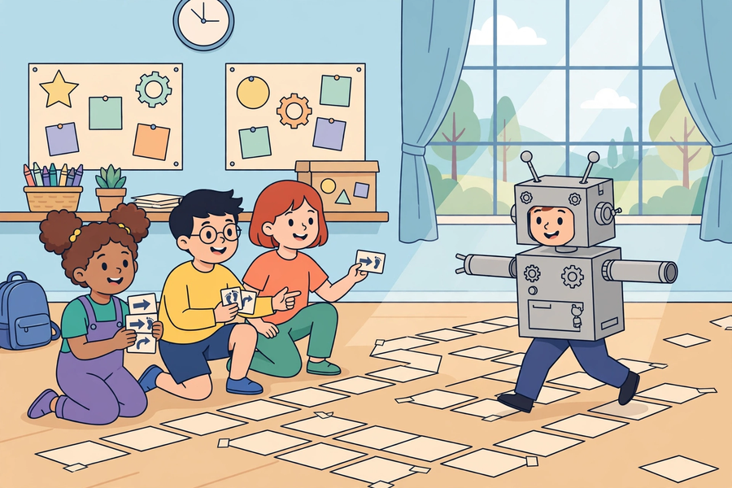

六、分組題：人體機械人
6. Group activity: human robots

遊戲規則
Game rules
- 每組 4–5 人，一人扮演「機械人」，其餘組員負責撰寫指令。 ／ In groups of 4–5, one student plays the “robot” and the rest write the instructions.
- 機械人只可以依照指令的字面意思行動，不可以自行判斷或修正指令——即使明知指令有問題，也要照做。（注意安全，不可衝撞他人或物件。） ／ The robot may only follow the literal meaning of the instructions and must not judge or correct them — even when the instructions are clearly wrong. (Stay safe: do not bump into people or objects.)
- 組員把寫好的指令逐句讀出，機械人在迷宮紙上執行。 ／ Group members read the instructions out one by one while the robot carries them out on the maze sheet.
- 若機械人走錯或撞牆，全組一起討論：是「指令寫得差」，還是「機械人行錯」？把原因記錄下來，修改指令後再試一次。 ／ If the robot goes wrong or hits a wall, discuss as a group: were the instructions poorly written, or did the robot move wrongly? Record the cause, revise the instructions and try again.

失敗原因記錄
Failure log
- □ 指令含糊 □ 次序錯誤 □ 遺漏步驟 □ 機械人行錯 ／ ☐ vague instruction ☐ wrong order ☐ missing step ☐ robot moved wrongly
- 其他原因：＿＿＿＿＿＿＿＿ ／ Other cause:

關愛任務：為長者設計一組日常指令
Caring task: design everyday instructions for the elderly
任務 Task：＿＿＿＿＿＿＿＿（例如：使用遙控器開啟電視 e.g. turning on the TV with the remote control）
指令步驟（1–6）：
Instruction steps (1–6):
1. ＿＿＿＿＿＿＿＿＿＿＿＿＿＿＿＿＿＿＿＿＿＿
2. ＿＿＿＿＿＿＿＿＿＿＿＿＿＿＿＿＿＿＿＿＿＿
3. ＿＿＿＿＿＿＿＿＿＿＿＿＿＿＿＿＿＿＿＿＿＿
4. ＿＿＿＿＿＿＿＿＿＿＿＿＿＿＿＿＿＿＿＿＿＿
5. ＿＿＿＿＿＿＿＿＿＿＿＿＿＿＿＿＿＿＿＿＿＿
6. ＿＿＿＿＿＿＿＿＿＿＿＿＿＿＿＿＿＿＿＿＿＿
檢查清單 Checklist：□ 每步只有一個動作 □ 用詞是長者能明白的 □ 次序正確
☐ each step contains only one action ☐ wording the elderly can understand ☐ correct order

七、正能量／關愛連結
7. Positivity and caring connection
今天學到的「精確表達」，可以怎樣幫助身邊的長者或有需要的人？請寫一至兩句。
How can the “precise expression” you learnt today help elderly people or others in need around you? Write one or two sentences.
＿＿＿＿＿＿＿＿＿＿＿＿＿＿＿＿＿＿＿＿＿＿＿＿＿＿＿＿＿＿＿＿＿＿＿＿

八、總結
8. Summary
- 演算法是解決問題的一組明確步驟，兩個要點是精確性與序列。 ／ An algorithm is a clear set of steps for solving a problem; the two key ideas are precision and sequencing.
- 電腦只會照字面執行指令，不會猜測人的意思。 ／ Computers follow instructions literally and cannot guess what we mean.
- 把大任務拆成小步驟，是重要的思考習慣。 ／ Breaking a large task into small steps is an important thinking habit.
- 精確清晰的表達，可以幫助長者等有需要的人。 ／ Precise, clear expression can help elderly people and others in need.

九、小測驗
9. Quiz
- （選擇題）以下哪一項最符合「演算法」的定義？
A. 電腦程式的代號 B. 解決問題的一組明確步驟 C. 一種電腦病毒 D. 運算速度很快的電腦 ／ (MC) Which best matches the definition of an “algorithm”? A. A code name for a computer program B. A clear set of steps for solving a problem C. A computer virus D. A very fast computer
- （判斷題）演算法的步驟次序可以隨意調換，結果不會改變。（正確／錯誤） ／ (True/False) The order of an algorithm’s steps can be changed freely without affecting the result. (True / False)
- 指出下面指令含糊之處，並改寫得更精確：「把東西放好。」
含糊之處：＿＿＿＿＿＿＿＿ 改寫：＿＿＿＿＿＿＿＿ ／ Point out the vague part of “Put the things away properly.” and rewrite it more precisely. Vague part: ____ Rewrite: ____
- 為「使用微波爐翻熱飯盒」寫出五步精確的指令。
1. ＿＿＿＿＿＿ 2. ＿＿＿＿＿＿ 3. ＿＿＿＿＿＿ 4. ＿＿＿＿＿＿ 5. ＿＿＿＿＿＿ ／ Write five precise steps for “reheating a lunch box in a microwave oven”.
- 機械人收到「向前行兩格」的指令，卻只行了一格。請寫出兩個可能的原因。
原因一：＿＿＿＿＿＿＿＿ 原因二：＿＿＿＿＿＿＿＿ ／ A robot received “Move forward two squares” but moved only one square. Give two possible causes.

