創科班 Little Makers Class｜單元三：編程思維（不插電） Little Makers Class | Unit 3: Computational Thinking (Unplugged)
第 11 堂：演算法——人體機械人 Lesson 11: Algorithms — Human Robots
姓名 Name：＿＿＿＿ 班別 Class：＿＿＿＿ 學號 No.：＿＿＿＿ 日期 Date：＿＿＿＿

教師筆記（內含全部答案）
Teacher notes (with all answers)
本堂物資表 Materials List（教師版）
請預早一星期準備所需物資；標示「課室現有」之項目請預先清點。
品名 Item | 數量（每組） Quantity (per group) | 大約成本 Est. cost | 安全注意 Safety notes
迷宮格線紙（A3） Maze grid paper (A3) | 每組 2 張 2 per group | 影印成本每張約 $1 About $1 per copy | 無 None
指令寫作紙／「為長者設計」指令卡 Instruction sheets / "design for the elderly" cards | 每組 4 張 4 per group | 影印成本每張約 $0.5 About $0.5 per copy | 無 None
原子筆 Ballpoint pens | 每人 1 支 1 per student | 課室現有 Available in classroom | 無 None
計時器 Timer | 老師 1 個 1 for the teacher | 課室現有／手機 Available / mobile phone | 無 None
迷宮起點／終點標記貼紙 Start/finish marker stickers | 每組 2 張 2 per group | 每張約 $0.2 About $0.2 each | 活動時注意桌椅擺位，保持通道暢通 Keep walkways clear of desks and chairs during the activity
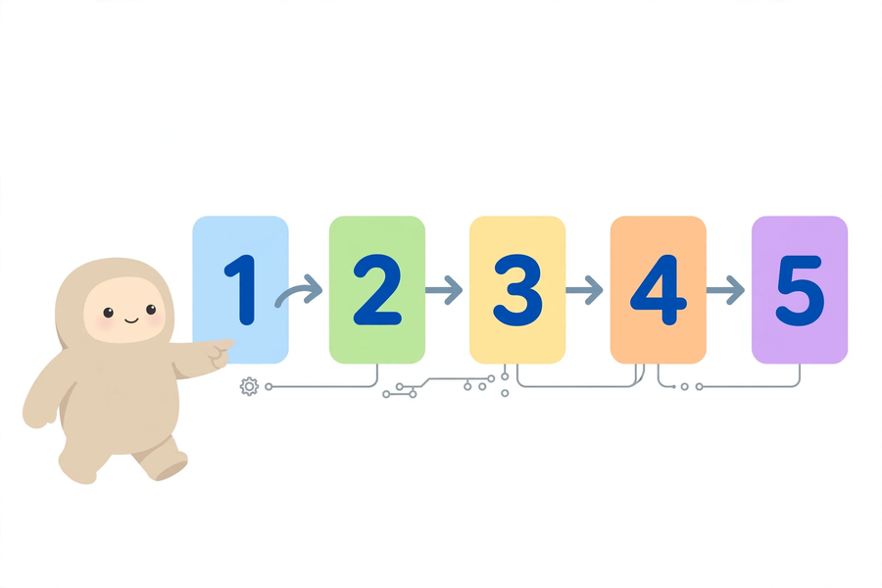

建議教學流程（60 分鐘）
Suggested lesson flow (60 min)
時段  Time | 教學重點  Focus
0–5 分鐘 | 示範：請一位學生依含糊口頭指令（如「行過去嗰邊」）行動，展示必然失敗；再以精確指令重做一次。
5–15 分鐘 | 講解演算法定義（精確性、序列），舉生活例子（食譜、摺紙）；派發迷宮紙，說明遊戲規則與安全注意。
15–45 分鐘 | 分組活動：巡視並擔任裁判，協助判斷是「指令寫得差」還是「機械人行錯」，提示記錄失敗原因。
45–55 分鐘 | 兩組分享「最離譜的一次失敗」及修正；關愛延伸：為長者設計日常指令，全班評分夠不夠清楚。
55–60 分鐘 | 總結要點（精確、序列），派發家課並說明要求。

教學提示
Teaching tips
- 機械人角色必須嚴格「扮蠢」，即使明知指令意思不對也不得自行修正，這是遊戲最有教育意義之處。 ／ The “robot” must strictly “play dumb” and never correct an instruction, even when its intent is obvious — this is the most educational part of the game.
- 若學生爭論不休，應介入引導，把焦點放回「指令寫法」而非針對人。 ／ If students argue, intervene and redirect the focus to how the instructions are written, not the person.
- 巡視時多問：「這一步機械人會怎樣理解？」引導學生從執行者角度檢查指令。 ／ While circulating, ask: “How would the robot understand this step?” to get students checking instructions from the executor’s view.

常見迷思
Common misconceptions
- 學生以為「機械人」應該聰明到能理解含糊指令——須強調電腦只會照字面執行，這正是學習演算法的原因。 ／ Students assume the “robot” should understand vague instructions — stress that computers only follow instructions literally, which is exactly why we learn algorithms.
- 學生以為演算法等於電腦程式——指出食譜、摺紙步驟也是演算法；程式只是用程式語言寫成的演算法。 ／ Students think algorithm = computer program — point out that recipes and origami steps are algorithms too; a program is an algorithm written in a programming language.
- 學生以為步驟愈多愈好——重點是每步精確、次序正確，而非數量。 ／ Students think more steps are always better — what matters is that each step is precise and correctly ordered.

學生筆記參考答案
Reference answers for student notes

簡單問答題 Quick questions
- 演算法是為了解決某個問題或完成某項任務而定出的一組明確步驟。（意思相近即可） ／ An algorithm is a clear set of steps for solving a problem or completing a task.
- 精確性與序列。 ／ Precision and sequencing.
- 因為電腦只會照字面意思執行指令，不會猜測人的意思；指令含糊便會做錯。 ／ Computers only follow the literal meaning of instructions; vague instructions lead to wrong results.
- B。 ／ B.
- 先穿襪子，後穿鞋子；次序調亂便做不成／結果不同。 ／ Socks first, then shoes; reversing the order makes it impossible.

思考題 Thinking question
參考答案：不同意。電腦／機械人只能執行明確的指令，無法猜測含糊用語背後的意思；若要求機械人「自動明白」，結果便無法預測和控制，這正是我們需要學習寫精確演算法的原因。（言之成理即可）
Sample answer: Disagree. Computers/robots can only carry out precise instructions and cannot guess the meaning behind vague wording; asking them to “understand automatically” makes results unpredictable — which is why we must learn to write precise algorithms.

小測驗答案 Quiz answers
- B。 ／ B.
- 錯誤。 ／ False.
- 含糊之處：「東西」指什麼不清楚，「放好」放在哪裡、怎樣放也不清楚。改寫示例：「把桌上的書本整齊地疊放在書架第二層。」（意思相近即可） ／ Vague: what “things” means and where/how to put them are unclear. Rewrite e.g.: “Stack the books on the desk neatly on the second shelf of the bookcase.”
- 示例：1. 打開微波爐門；2. 把飯盒放入微波爐中央；3. 關上微波爐門；4. 選擇高火並設定 3 分鐘；5. 聽到提示聲後戴隔熱手套取出飯盒。（每步單一動作、次序合理即可） ／ e.g. 1. Open the microwave door; 2. Place the lunch box in the centre; 3. Close the door; 4. Select high power for 3 minutes; 5. When it beeps, take the box out with oven gloves.
- 原因一：指令寫得不清楚（例如沒有說明「格」有多大）；原因二：機械人執行錯誤（沒有數清楚步數）。（合理即可） ／ Cause 1: the instruction was unclear (e.g. the size of a “square” was undefined); cause 2: the robot executed it wrongly (miscounted the steps).

家課參考答案
Reference answers for homework
選擇題答案：1. B 2. B 3. B 4. B
MC answers: 1. B 2. B 3. C 4. B
註：第 3 題問「機械人只會……」，答案為 B（照字面執行指令）。
Note: Q3 asks what a robot does — answer B (follows instructions literally).

問答題參考 Open questions — reference
Q1＋Q2 示例（為長輩泡茶）：1. 把電水煲裝水至「最高水位」線以下；2. 按下開關把水煲滾；3. 拿出一個杯子放在桌上；4. 把一個茶包放入杯中；5. 水滾後把滾水慢慢倒入杯中至八分滿；6. 等待三分鐘後取出茶包。最易被誤解的是第 5 步「八分滿」——長輩可能不清楚八分滿是多少。改寫：「把滾水倒入杯中，距離杯口約兩隻手指闊度便停手。」
Sample (making tea for a grandparent): 1. Fill the kettle below the MAX line; 2. Switch it on to boil; 3. Place a cup on the table; 4. Put a tea bag in the cup; 5. Pour in boiling water until 80% full; 6. After three minutes, remove the tea bag. Step 5 “80% full” is most likely misunderstood — rewrite: “Pour until the water is about two finger-widths below the rim.”
Q3 參考：因為很多任務的步驟有先後依賴關係，後一步需要前一步的結果；例子如先穿襪後穿鞋、先把米洗淨才煲飯。
Q3 sample: many tasks have dependencies — a later step needs the earlier step’s result; e.g. socks before shoes, washing rice before cooking it.

附加思考題
Extra thinking questions
- 食譜寫著「加入適量鹽」。對機械人廚師來說，這句指令有什麼問題？應如何改寫？
參考答案：「適量」含糊，機械人無法判斷；應改寫為具體份量，如「加入一茶匙鹽」。 ／ A recipe says “add salt to taste”. What is wrong with this instruction for a robot chef? How would you rewrite it?
Sample: “to taste” is vague — a robot cannot judge it; rewrite with an exact amount, e.g. “add one teaspoon of salt”.
- 老師的含糊指令「行過去嗰邊」為什麼一定失敗？試從「精確性」和「序列」分析。
參考答案：「嗰邊」方向不明確（欠精確性）；亦沒有說明走幾步、何時停下（欠完整序列），機械人無法執行。 ／ Why does the vague instruction “walk over there” always fail? Analyse it using “precision” and “sequencing”.
Sample: “there” gives no clear direction (lacks precision); the number of steps and when to stop are missing (incomplete sequence), so the robot cannot act.

評分提示
Marking tips
- 批改重點看指令是否「機械人能照做」，而非文筆優美； ／ Mark on whether the robot could actually follow the instructions, not on elegant writing;
- 「為長者設計」部分重點看用詞是否淺白、每步是否只有一個動作； ／ For the elderly version, focus on plain wording and one action per step;
- 小測驗第 3、4、5 題意思相近即給分，鼓勵學生用自己的話表達。 ／ For quiz Q3–Q5, accept any reasonable wording — encourage students to express ideas in their own words.

