第 14 堂家課：演算法效率
Lesson 14 Homework: Algorithmic Efficiency
姓名：＿＿＿＿＿＿ 班別：＿＿＿＿ 學號：＿＿＿＿ 日期：＿＿＿＿＿＿
Name: ________ Class: ______ No.: ______ Date: __________
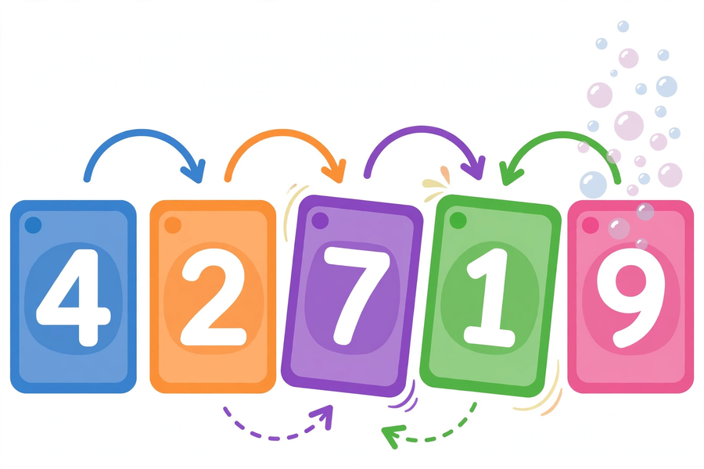
甲部：選擇題（每題 2 分，共 8 分）
Section A: Multiple choice (2 marks each, 8 marks total)
- 「演算法」是指？ A. 電腦品牌 B. 解決問題的一系列明確步驟 C. 一種程式語言 D. 電腦病毒 / What is an "algorithm"? A. A computer brand B. A precise sequence of steps for solving a problem C. A programming language D. A computer virus
- 8 張牌用本堂的氣泡排序方法，共比較幾次？ A. 28 B. 56 C. 64 D. 49 / With 8 cards, how many comparisons does this lesson's bubble sort make? A. 28 B. 56 C. 64 D. 49
- 8 張牌用選擇排序，交換次數最多是？ A. 28 B. 7 C. 14 D. 8 / With 8 cards, at most how many swaps does selection sort make? A. 28 B. 7 C. 14 D. 8
- 比較兩種排序法效率時，最客觀的證據是？ A. 個人感覺 B. 比較次數和多次實測的平均時間 C. 牌的顏色 D. 同學的意見 / The most objective evidence when comparing the two sorts is? A. Feeling B. Comparison counts and averaged timings C. Card colours D. Classmates' opinions
乙部：問答題（共 12 分）
Section B: Short questions (12 marks total)
- 用氣泡排序把 [5, 2, 8, 1, 4] 由小排到大：寫出每一輪的比較和交換過程，以及總比較次數和總交換次數。（8 分） / Use bubble sort to order [5, 2, 8, 1, 4] ascending: show each round's comparisons and swaps, and give the total comparisons and swaps. (8 marks)
- 單元反思：以 150–200 字寫出本單元印象最深的一個概念，並舉一個生活例子說明。（4 分） / Unit reflection: in 150–200 words, write about the concept from this unit that impressed you most, with one real-life example. (4 marks)
（下堂課前交回）
(Submit before the next lesson)

