品名 Item | 數量（每組） Quantity (per group) | 安全注意 Safety notes
撲克牌（每組取 A 至 8 共 8 張） Playing cards (8 cards, A–8, per group) | 每組 1 副（課室常用，可重用；如需購買約 HK$10／副） 1 pack per group (reusable classroom stock; approx. HK$10 per pack if purchased) | 卡片勿放入口；保持桌面整潔，避免卡片散落引致滑倒 Do not put cards in mouths; keep desks tidy to avoid slipping on scattered cards
大示範紙牌（教師自製） Large demonstration cards (teacher-made) | 教師 1 套 1 set for the teacher | — —
數據紀錄表（列印） Data record sheets (printed) | 每組 1 份 1 per group | — —
計時器 Timer | 每組 1 個（可用課室時鐘或教師手機） 1 per group (classroom clock or teacher's phone may be used) | — —
以下為本堂分組活動所需物資（每組一份）。請在老師派發時核對。
本堂物資表 Materials List
第 14 堂：演算法效率
Lesson 14: Algorithmic Efficiency
中二創科班｜Unit 3 進階編程思維｜不插電課堂
S2 Little Makers Class | Unit 3 Advanced Programming Thinking | Unplugged Lesson
一、課程內容理論 Theory
什麼是演算法？ What is an algorithm?
演算法是解決問題的一系列明確步驟。排序（把東西由小排到大）是電腦科學中最基本的演算法問題之一。同一個問題可以有多種解法，而效率各異 —— 本堂親手驗證。
An algorithm is a precise sequence of steps for solving a problem. Sorting (ordering things from smallest to largest) is one of the most fundamental algorithmic problems in computer science. One problem can have multiple solutions of different efficiency — verify it by hand today.
兩種排序法 Two sorting methods
- 氣泡排序：相鄰兩張兩張比較，若左邊大於右邊就交換；每完成一輪，最大的牌便「浮」到最右。
- Bubble sort: compare adjacent pairs; swap if the left card is larger. After each round, the largest card "bubbles" to the right end.
- 選擇排序：每一輪從未排序的牌中選出最小的一張，放到最前面。
- Selection sort: each round, pick the smallest card from the unsorted cards and put it at the front.
如何量度效率？ How do we measure efficiency?
- 比較次數：兩張牌比一次，數一數共比了多少次。比較次數只取決於方法本身，最客觀。
- Number of comparisons: count every pair compared. It depends only on the method itself — the most objective measure.
- 所需時間：用計時器量度。時間受手法快慢影響，只作參考。
- Time taken: measured with a timer. Affected by hand speed — for reference only.
- n 張牌的比較次數（本堂方法）：(n−1)＋(n−2)＋…＋1 ＝ n(n−1)／2。8 張牌 → 28 次。
- Comparisons for n cards (this lesson's method): (n−1)+(n−2)+…+1 = n(n−1)/2. For 8 cards → 28 comparisons.
實證精神 The empirical spirit
親手實驗、忠實記錄數據、用證據而非感覺下結論；重複實驗取平均，可減少誤差。
Experiment hands-on, record data faithfully, and conclude from evidence rather than feeling; repeating trials and averaging reduces error.
效率的應用 Efficiency in action
高效率的演算法節省時間與資源：例如為長者中心快速配對義工、緊急情況下迅速調配救援，背後都是效率的較量。
Efficient algorithms save time and resources: quickly matching volunteers for an elderly centre, or dispatching rescue swiftly in emergencies, are all contests of efficiency.
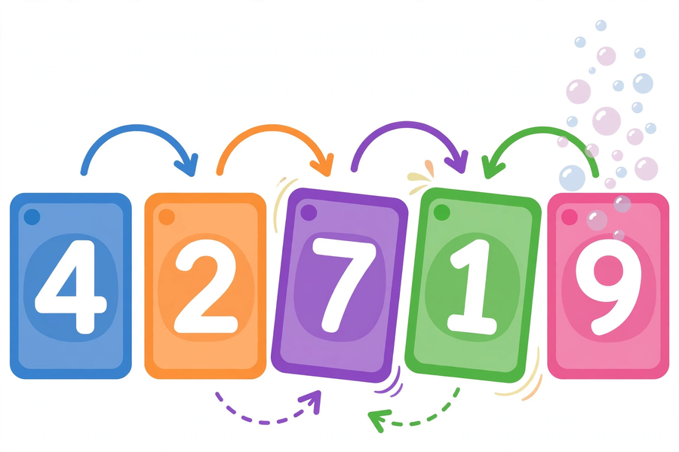
二、例子 Examples
例一：氣泡排序（牌：3、1、4、2，由小排到大） Example 1: Bubble sort (cards 3, 1, 4, 2)
- 開始：[3, 1, 4, 2]
- Start: [3, 1, 4, 2]
- 第 1 輪：比較 3 和 1 → 交換 → [1, 3, 4, 2]；比較 3 和 4 → 不交換；比較 4 和 2 → 交換 → [1, 3, 2, 4]（比較 3 次，交換 2 次）
- Round 1: compare 3 and 1 → swap → [1, 3, 4, 2]; compare 3 and 4 → no swap; compare 4 and 2 → swap → [1, 3, 2, 4] (3 comparisons, 2 swaps)
- 第 2 輪：比較 1 和 3 → 不交換；比較 3 和 2 → 交換 → [1, 2, 3, 4]（比較 2 次，交換 1 次）
- Round 2: compare 1 and 3 → no swap; compare 3 and 2 → swap → [1, 2, 3, 4] (2 comparisons, 1 swap)
- 第 3 輪：比較 1 和 2 → 不交換（比較 1 次，交換 0 次）
- Round 3: compare 1 and 2 → no swap (1 comparison, 0 swaps)
- 完成：[1, 2, 3, 4]；共比較 6 次，交換 3 次。
- Done: [1, 2, 3, 4]; 6 comparisons, 3 swaps in total.
例二：選擇排序（牌：3、1、4、2，由小排到大） Example 2: Selection sort (cards 3, 1, 4, 2)
- 開始：[3, 1, 4, 2]
- Start: [3, 1, 4, 2]
- 第 1 輪：在全部四張中找最小 → 1，與第 1 張交換 → [1, 3, 4, 2]（比較 3 次，交換 1 次）
- Round 1: find the smallest of all four → 1, swap with the 1st card → [1, 3, 4, 2] (3 comparisons, 1 swap)
- 第 2 輪：在 [3, 4, 2] 中找最小 → 2，與第 2 張交換 → [1, 2, 4, 3]（比較 2 次，交換 1 次）
- Round 2: find the smallest of [3, 4, 2] → 2, swap with the 2nd card → [1, 2, 4, 3] (2 comparisons, 1 swap)
- 第 3 輪：在 [4, 3] 中找最小 → 3，與第 3 張交換 → [1, 2, 3, 4]（比較 1 次，交換 1 次）
- Round 3: find the smallest of [4, 3] → 3, swap with the 3rd card → [1, 2, 3, 4] (1 comparison, 1 swap)
- 完成：[1, 2, 3, 4]；共比較 6 次，交換 3 次。
- Done: [1, 2, 3, 4]; 6 comparisons, 3 swaps in total.
比較：4 張牌兩種方法都是 6 次比較；8 張牌兩種方法都是 28 次比較，但選擇排序的交換次數較少（最多 7 次）。牌數愈多，效率差異愈值得研究。
Compare: with 4 cards both methods make 6 comparisons; with 8 cards both make 28 comparisons, but selection sort swaps less (at most 7 swaps). The more cards, the more the efficiency gap matters.
三、簡單問答題 Quick questions
- 用自己的話解釋什麼是「演算法」。 / In your own words, explain what an "algorithm" is.
- 氣泡排序每一步比較的是哪兩張牌？什麼情況下會交換？ / In bubble sort, which two cards are compared each time? When does a swap happen?
- 5 張牌用本堂的氣泡排序方法，共比較幾次？（列式計算） / With 5 cards, how many comparisons does this lesson's bubble sort make? (Show your working.)
- 為什麼說「比較次數」比「時間」更客觀？ / Why is the "number of comparisons" more objective than "time taken"?
四、思考題 Thinking questions
- 牌數由 8 張增至 16 張，比較次數由 28 次增至 120 次。這個數字告訴我們什麼？ / When cards increase from 8 to 16, comparisons rise from 28 to 120. What does this tell us?
- 除了比較次數和時間，還可以用什麼來量度演算法的效率？ / Besides comparisons and time, what else could measure an algorithm's efficiency?

五、分組題：排序實測 Group task: sorting trials
每組獲發 8 張撲克牌（A 至 8）。每種方法各排 3 次，記錄每次的時間及比較次數。
Each group gets 8 playing cards (A to 8). Sort 3 times with each method, recording the time and comparison count each time.
- 分工：一人排序、一人計時、一人記錄；每完成一輪交換崗位。
- Divide roles: one sorts, one times, one records; rotate after each round.
- 先用 4 張牌熟習手法，再用 8 張牌正式實測。
- Practise the moves with 4 cards first, then run the formal test with 8.
- 如實記錄每一次的數據，不可編造。
- Record every trial faithfully — never make up data.
- 完成後計算平均值，準備向全班匯報。
- Calculate the averages and prepare to report to the class.
數據紀錄表 Data record sheet
方法  Method | 第幾次  Trial | 時間（秒）  Time (s) | 比較次數  Comparisons | 備註  Remarks
氣泡排序  Bubble sort | 1
氣泡排序  Bubble sort | 2
氣泡排序  Bubble sort | 3
選擇排序  Selection sort | 1
選擇排序  Selection sort | 2
選擇排序  Selection sort | 3
平均值  Average | —  —

六、總結 Summary
- 同一問題可有多種解法，而效率各異 —— 要用數據比較，而非憑感覺。
- One problem can have multiple solutions of different efficiency — compare with data, not feeling.
- 比較次數比時間更客觀；重複實驗取平均可減少誤差。
- Comparison counts are more objective than time; repeating trials and averaging reduces error.
- 單元四堂串連：流程圖 → 條件與迴圈 → 密碼學 → 演算法效率。
- The unit in review: flowcharts → conditions and loops → cryptography → algorithmic efficiency.
- 運算思維四要素：分解、模式識別、抽象化、演算法設計。
- The four elements of computational thinking: decomposition, pattern recognition, abstraction, algorithm design.
七、小測驗 Quiz
（滿分 12 分）
(Total: 12 marks)
- 氣泡排序每一步比較的是？ A. 任意兩張牌 B. 相鄰兩張牌 C. 第一張和最後一張 D. 隨機兩張（2 分） / In bubble sort, each step compares? A. Any two cards B. Adjacent cards C. First and last cards D. Two random cards (2 marks)
- 6 張牌用本堂方法排序，共比較幾次？ A. 12 B. 15 C. 30 D. 36（2 分） / With 6 cards, how many comparisons? A. 12 B. 15 C. 30 D. 36 (2 marks)
- 選擇排序每一輪做什麼？（2 分） / What does selection sort do each round? (2 marks)
- 判斷對錯：計時一次，就可以下結論說哪種排序法較快。（圈出：對／錯）（2 分） / True or false: one timed trial is enough to conclude which sort is faster. (Circle: True / False) (2 marks)
- 用數據比較兩種方法效率時，為什麼要重複多次並取平均？（4 分） / When comparing the two methods with data, why repeat the trials and take the average? (4 marks)
八、延伸探索（自選） Extension (optional)
Google Teachable Machine（https://teachablemachine.withgoogle.com/）：回家用電腦體驗演算法如何讓電腦學會分類物件，感受課堂所學的演算法在真實人工智能中的應用。
Google Teachable Machine (https://teachablemachine.withgoogle.com/): try at home on a computer how algorithms let a machine learn to classify objects — classroom algorithms at work in real artificial intelligence.

