聖公會呂明才中學
S.K.H. Lui Ming Choi Secondary School
S2 單元四：AI 進階與倫理深化｜家課
S2 Unit 4: Advanced AI and Deepening of AI Ethics | Homework
第 15 堂｜AI 如何學習：Teachable Machine 姿勢／聲音分類
Lesson 15 | How AI Learns: Pose / Audio Classification with Teachable Machine
姓名 Name：＿＿＿＿ 班別 Class：＿＿＿＿ 學號 No.：＿＿＿＿ 日期 Date：＿＿＿＿

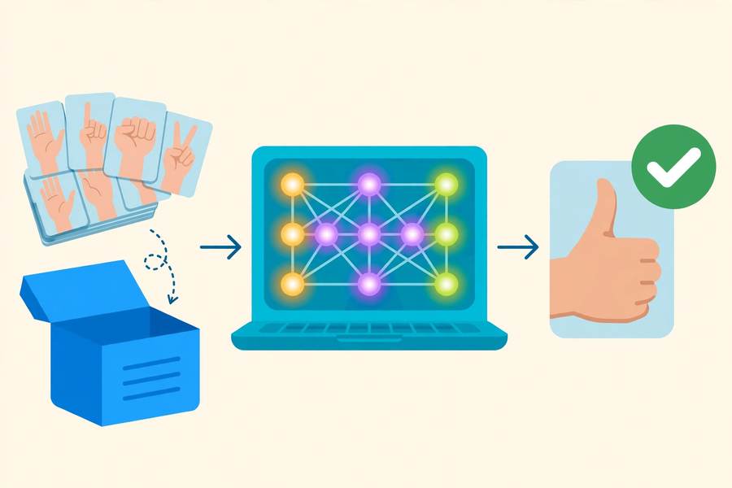
第一部分：選擇題
Part 1: Multiple Choice
Q1. 以下哪一項不是模型訓練的三個階段之一？
Which of the following is NOT one of the three stages of model training?
A. 收集資料
Data collection
B. 訓練模型
Model training
C. 測試評估
Testing and evaluation
D. 刪除資料
Deleting data
Q2. 關於「模型學到的是規律，而不是背誦」，以下哪個說法正確？
About "the model learns patterns rather than memorising", which statement is correct?
A. 模型把每個樣本的圖片都存起來比對
The model stores every sample image for comparison
B. 沒見過的人做同一個動作，模型也有機會認出
The model may recognise the same action by a person it has never seen
C. 測試時必須用訓練用過的同一批樣本
Testing must reuse the exact training samples
D. 樣本一經訓練就不能再改
Samples can never be changed once trained
Q3. 以下哪個情況最可能令聲音分類模型出錯？
Which situation is most likely to make an audio classification model fail?
A. 在安靜的課室錄音
Recording in a quiet classroom
B. 每類錄了 50 個樣本
Recording 50 samples per class
C. 訓練時很安靜，測試時背景非常嘈雜
Quiet during training but very noisy during testing
D. 測試員換了另一位組員
A different group member runs the test
第二部分：問答題
Part 2: Short Questions
Q1. 【反思寫作，約 150 字】以文字描述一個日常生活中「因訓練資料不足或偏差而導致 AI 出錯」的假想例子（例如：只用成年人聲音訓練的語音助手認不出小童的聲音），並提出一個具體的改善方法。
[Reflection, about 150 words] Describe in words a hypothetical everyday example of "AI failing because of insufficient or biased training data" (e.g. a voice assistant trained only on adult voices failing to recognise children's voices), and propose one concrete improvement.
Q2. 承上題：如果要為你的例子收集更好的訓練資料，你會找哪三類不同的人或情境來錄製樣本？為甚麼？
Following on: if you were to collect better training data for your example, which three different groups of people or situations would you record samples from? Why?

