聖公會呂明才中學
S.K.H. Lui Ming Choi Secondary School
S2 單元四：AI 進階與倫理深化｜學生筆記
S2 Unit 4: Advanced AI and Deepening of AI Ethics | Student Notes
第 15 堂｜AI 如何學習：Teachable Machine 姿勢／聲音分類
Lesson 15 | How AI Learns: Pose / Audio Classification with Teachable Machine
姓名 Name：＿＿＿＿ 班別 Class：＿＿＿＿ 學號 No.：＿＿＿＿ 日期 Date：＿＿＿＿
本堂物資表 Materials List
以下為本堂分組活動所需物資（每組一份）。請在老師派發時核對。
品名 Item | 數量（每組） Quantity (per group) | 安全注意 Safety notes
可上網手提電腦或平板電腦（具鏡頭及麥克風） | 每組 1 部，全班約 6–8 部 | 鏡頭拍攝只限課堂內小組成員；使用學校 Wi-Fi；裝置由老師統一保管及收回。
工作紙「AI 模型訓練紀錄表」 | 每人 1 張 | 不適用

一、課程內容理論
1. Course Content
- 1. 甚麼是機器學習？機器學習是人工智能的一個分支：電腦不是由人逐條寫死規則，而是從大量例子（資料）中自己歸納出規律，再用這些規律去判斷新的例子。
What is machine learning? Machine learning is a branch of artificial intelligence: instead of following rules written out one by one by humans, the computer generalises patterns from a large number of examples (data), and then uses those patterns to judge new examples.
- 2. 模型訓練的三個階段。第一，收集資料：為每個類別準備足夠的例子，例如「舉手」錄 50 個樣本、「放下手」錄 50 個樣本。第二，訓練模型：電腦調整內部參數，學會分辨各類別的特徵。第三，測試評估：用全新的例子測試模型，計算準確率。
The three stages of model training. First, data collection: prepare enough examples for each class, e.g. 50 samples of "hand raised" and 50 samples of "hand down". Second, model training: the computer adjusts its internal parameters and learns to tell the classes apart. Third, testing and evaluation: test the model with brand-new examples and calculate its accuracy.
- 3. 準確率的計算方法。準確率＝答對次數 ÷ 測試總次數。例如測試 10 次、答對 8 次，準確率就是 8 ÷ 10 ＝ 80%。
How accuracy is calculated. Accuracy = number of correct predictions ÷ total number of tests. For example, 8 correct out of 10 tests gives 8 ÷ 10 = 80% accuracy.
- 4. 「垃圾進，垃圾出」。如果訓練資料質素差（模糊、錯誤、單一），模型的表現必然差。資料是模型的「課本」：課本寫錯，學生自然學錯。
"Garbage in, garbage out." If the training data is poor (blurry, wrong or one-sided), the model is bound to perform poorly. Data is the model's "textbook": mistakes in the textbook mean the student learns mistakes.
- 5. 模型學到的是規律，而不是背誦每個樣本。模型歸納的是整體特徵（例如舉手時手臂的形狀），所以只要新例子符合規律，即使是沒見過的人做的動作，也能認出來。
The model learns patterns; it does not memorise each sample. The model generalises overall features (e.g. the shape of a raised arm), so as long as a new example follows the pattern, the model can recognise it even from a person it has never seen.
- 6. 樣本的多樣性比數量更重要。同一動作由不同的人、用不同的速度、站在不同的背景前去錄，模型才學得穩。200 個一模一樣的樣本，不如 60 個多樣化的樣本。
Diversity of samples matters more than quantity. Recording the same action performed by different people, at different speeds and against different backgrounds makes the model robust. Two hundred identical samples are worth less than sixty diverse ones.
- 7. 資料偏差會令模型出錯。如果訓練資料只來自單一來源（例如全部由同一位同學提供），模型在面對其他人、其他環境時就容易判斷錯誤。這是第 18 堂「演算法偏見」的起點。
Biased data makes models fail. If training data comes from a single source (e.g. all provided by the same classmate), the model is likely to misjudge other people and other environments. This is the starting point of "algorithmic bias" in Lesson 18.
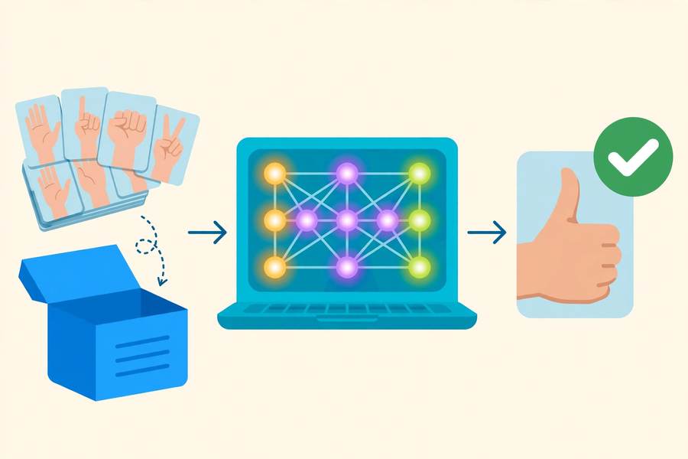
二、例子
2. Examples
- 例子一：姿勢分類。類別 A「舉起右手」、類別 B「雙手自然放下」。每類錄 50 個樣本，按下「訓練模型」，再請另一位組員站在鏡頭前測試 10 次。若答對 8 次，準確率為 80%。
Example 1: pose classification. Class A: "right hand raised"; Class B: "hands down by the sides". Record 50 samples per class, press "Train Model", then ask another group member to stand before the webcam for 10 tests. If 8 are correct, the accuracy is 80%.
- 例子二：聲音分類。類別 A「拍手聲」、類別 B「口哨聲」。在較安靜的角落輪流錄音，每類錄 40 個樣本。測試時若背景嘈雜，模型容易把拍手誤判，原因正是訓練資料中沒有包含嘈雜背景的情況。
Example 2: audio classification. Class A: "clapping"; Class B: "whistling". Record in a quiet corner in turn, 40 samples per class. During testing, a noisy background easily causes misclassification — precisely because the training data contained no noisy-background cases.
課堂工具：Google Teachable Machine（老師會在課堂上示範操作，網址：https://teachablemachine.withgoogle.com/）
Class tool: Google Teachable Machine (your teacher will demonstrate it in class; website: https://teachablemachine.withgoogle.com/)
三、簡單問答題
3. Quick Questions
Q1. 列出模型訓練的三個階段。
List the three stages of model training.
Q2. 「垃圾進，垃圾出」是甚麼意思？試用自己的文字解釋。
What does "garbage in, garbage out" mean? Explain in your own words.
Q3. 寫出準確率的計算公式。
Write down the formula for accuracy.
Q4. 為甚麼訓練樣本需要多樣性？
Why do training samples need to be diverse?
四、思考題
4. Thinking Questions
Q1. 如果全班每一組都只用同一位同學的動作做訓練樣本，模型可能會出現甚麼問題？為甚麼？
If every group in the class uses only the same classmate's movements as training samples, what problems might the models have? Why?
Q2. 有人說：「樣本愈多，模型一定愈準。」你同意嗎？試舉例說明你的看法。
Someone says: "The more samples, the more accurate the model must be." Do you agree? Give an example to support your view.

五、分組活動：AI 模型訓練紀錄表
5. Group Task: AI Model Training Record
- 小組分工（4–5 人共用一部裝置，輪流操作）：操作員負責錄樣本及按鍵；紀錄員填寫下表；測試員負責測試；匯報員向全班匯報結果。
Group roles (4–5 students share one device, taking turns): operator records samples and clicks buttons; recorder fills in the table below; tester runs the tests; presenter reports the results to the class.
- 題目二選一：姿勢分類（鏡頭）或聲音分類（麥克風）。請先到老師指定的網站開啟 Teachable Machine：https://teachablemachine.withgoogle.com/
Choose one task: pose classification (webcam) or audio classification (microphone). Open Teachable Machine at the website designated by your teacher: https://teachablemachine.withgoogle.com/
小組資料
項目 Item | 內容 Content
組別 Group
選擇題目 Task（姿勢／聲音）
操作員 Operator
紀錄員 Recorder
測試員 Tester
匯報員 Presenter

訓練紀錄
類別名稱 Class name | 樣本數目 No. of samples

測試紀錄
測試次數 No. of tests | 答對次數 No. correct | 準確率 Accuracy（答對 ÷ 測試）

反思問題
Q1. 我們的模型在甚麼情況下最容易出錯？為甚麼？
In what situations does our model fail most easily? Why?
Q2. 如果再多 10 分鐘，你會如何改善訓練資料？請寫出兩個具體做法。
If you had 10 more minutes, how would you improve the training data? Give two concrete steps.
六、總結
6. Summary
- 機器學習＝電腦從大量例子中歸納規律，而不是由人逐條寫死規則。
Machine learning = computers generalise patterns from many examples, not from hand-written rules.
- 訓練三階段：收集資料 → 訓練模型 → 測試評估；準確率＝答對 ÷ 測試總數。
Three training stages: collect data → train the model → test and evaluate; accuracy = correct ÷ total tests.
- 垃圾進，垃圾出：資料的質素與多樣性，直接決定模型的表現。
Garbage in, garbage out: the quality and diversity of data directly determine model performance.
- 資料偏差是真實存在的風險：單一來源的資料，會令模型在現實中出錯。
Data bias is a real risk: single-source data makes models fail in the real world.
七、小測驗
7. Quiz
Q1. 以下哪一項是模型訓練的第一個階段？
Which of the following is the FIRST stage of model training?
A. 測試評估
Testing and evaluation
B. 收集資料
Data collection
C. 訓練模型
Model training
D. 發佈模型
Publishing the model
Q2. 小組測試 20 次，模型答對 15 次，準確率是多少？
A group tests 20 times and the model is correct 15 times. What is the accuracy?
A. 15%
15%
B. 35%
35%
C. 75%
75%
D. 80%
80%
Q3. 「垃圾進，垃圾出」主要說明甚麼？
What does "garbage in, garbage out" mainly illustrate?
A. 電腦的記憶體不足
The computer does not have enough memory
B. 訓練資料的質素直接影響模型的表現
The quality of training data directly affects model performance
C. 模型訓練需要很長時間
Model training takes a very long time
D. 測試時要把垃圾清走
Rubbish must be cleared away during testing
Q4. 以下哪種做法最能提升模型的準確率？
Which practice best improves model accuracy?
A. 同一個動作由同一人重複錄 200 次
Recording the same action by the same person 200 times
B. 不同的人、用不同速度、在不同背景下錄製多樣化樣本
Recording diverse samples by different people, at different speeds and backgrounds
C. 只錄 5 個非常清晰的樣本
Recording only 5 very clear samples
D. 訓練時把鏡頭遮住
Covering the webcam during training
Q5. 模型「學會」分辨舉手和放下手，意思是甚麼？
What does it mean when a model has "learnt" to tell hand-raised from hand-down?
A. 記住了每一個訓練樣本
It has memorised every training sample
B. 歸納出分辨兩者的整體規律
It has generalised the overall pattern that distinguishes the two
C. 把答案寫死在程式碼裡
The answers are hard-coded into the program
D. 每次隨機猜測
It guesses randomly each time
Q1. 解釋為甚麼訓練資料需要多樣性，試舉一個具體例子。
Explain why training data needs to be diverse, with a concrete example.
Q2. 你的模型在測試時把「舉手」誤判為「放下手」。列出兩個可能的原因，並各寫一個改善方法。
Your model misclassified "hand raised" as "hand down" during testing. List two possible causes, and one improvement for each.

