聖公會呂明才中學
S.K.H. Lui Ming Choi Secondary School
S2 單元四：AI 進階與倫理深化｜教師筆記
S2 Unit 4: Advanced AI and Deepening of AI Ethics | Teacher Notes
本堂物資表 Materials List（教師版）
請預早一星期準備所需物資；標示「課室現有」之項目請預先清點。
品名 Item | 數量（每組） Quantity (per group) | 大約成本 Est. cost | 安全注意 Safety notes
可上網手提電腦或平板電腦（具鏡頭及麥克風） | 每組 1 部，全班約 6–8 部 | 學校現有設備，HK$0 | 鏡頭拍攝只限課堂內小組成員；使用學校 Wi-Fi；裝置由老師統一保管及收回。
工作紙「AI 模型訓練紀錄表」 | 每人 1 張 | 影印約每張 HK$0.2 | 不適用
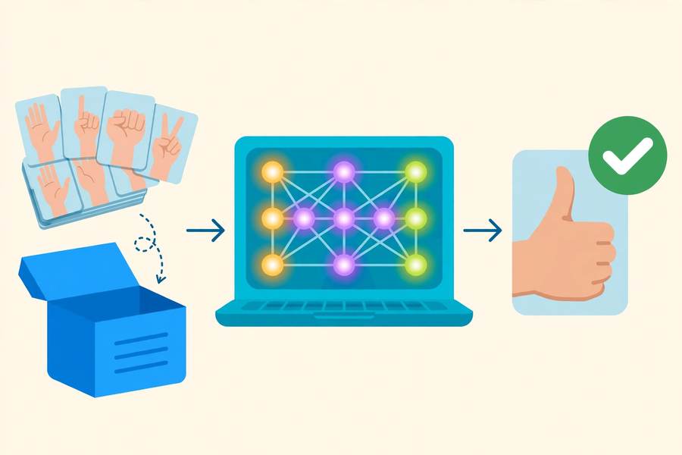
第 15 堂｜AI 如何學習：Teachable Machine 姿勢／聲音分類
Lesson 15 | How AI Learns: Pose / Audio Classification with Teachable Machine
姓名 Name：＿＿＿＿ 班別 Class：＿＿＿＿ 學號 No.：＿＿＿＿ 日期 Date：＿＿＿＿

本教師筆記包含：學生筆記全部題目參考答案、家課參考答案、附加思考題、建議教導方向及常見迷思。
These teacher notes contain: suggested answers to all student-notes questions, homework answers, extra thinking questions, teaching guidance and common misconceptions.
甲部：學生筆記參考答案
Part A: Student Notes — Suggested Answers
簡單問答題
- 三個階段：①收集資料 ②訓練模型 ③測試評估。
The three stages: (1) data collection, (2) model training, (3) testing and evaluation.
- 意思是訓練資料質素差，模型表現必然差；就如課本寫錯，學生自然學錯。
It means poor-quality training data inevitably produces a poor model — like a student learning from a textbook full of errors.
- 準確率＝答對次數 ÷ 測試總次數。
Accuracy = number of correct predictions ÷ total number of tests.
- 因為現實情況多變；只有多樣化的樣本（不同人、速度、背景）才能令模型在各種情況下都表現穩定。
Because real situations vary; only diverse samples (different people, speeds, backgrounds) keep the model robust in all kinds of situations.
思考題（參考答案）
- 模型可能只認得該同學的動作特徵（身形、速度、習慣），換人或換背景就容易出錯，因為訓練資料未能覆蓋實際使用情境，屬於資料偏差。
The model may only recognise that classmate's movement traits (build, speed, habits) and fail with other people or backgrounds — the training data does not cover real usage scenarios. This is data bias.
- 不同意。例如同一動作由同一人重複錄 200 次，樣本單一，模型準確率未必提升；反而 60 個多樣化樣本效果更好。關鍵在多樣性，而非單純數量。
Disagree. For example, recording the same action by the same person 200 times gives uniform samples and may not improve accuracy, while 60 diverse samples can do better. Diversity, not sheer quantity, is the key.
分組活動指導
- 課前先在課室電腦開啟 Teachable Machine 並測試鏡頭及麥克風。
Before the lesson, open Teachable Machine on the classroom computer and test the webcam and microphone.
- 參考答案示例：模型在背景雜亂或動作不標準時最易出錯，因為訓練資料中沒有包含這類情況。
Sample answer: the model fails most easily with cluttered backgrounds or non-standard movements, because the training data did not cover such cases.
- 巡堂時留意各組樣本多樣性，適時提示換人、換位置再錄。
While circulating, check each group's sample diversity and prompt them to switch people and positions.
小測驗答案
Q1 答案 Answer：B
第一階段是收集資料。
The first stage is data collection.
Q2 答案 Answer：C
15 ÷ 20 ＝ 75%。
15 ÷ 20 = 75%.
Q3 答案 Answer：B
訓練資料的質素直接影響模型的表現。
The quality of training data directly affects model performance.
Q4 答案 Answer：B
多樣化樣本最能提升準確率。
Diverse samples best improve accuracy.
Q5 答案 Answer：B
模型歸納出整體規律，而非逐一背誦。
The model generalises overall patterns rather than memorising samples.
- 參考答案：現實情況多變（不同人、環境、角度），單一的訓練資料無法覆蓋；例如只錄一位同學的舉手動作，換人做就可能認不出。
Sample answer: real situations vary (people, environments, angles); uniform training data cannot cover them. E.g. a model trained only on one classmate's raised hand may fail with someone else.
- 參考答案：原因一：訓練樣本中兩類動作不夠分明（例如舉手不夠高）；改善：重新錄製動作差異更大的樣本。原因二：測試時背景或站位與訓練時差異大；改善：在多個背景下補錄樣本。
Sample answer: Cause 1 — the two classes' samples were not distinct enough (e.g. hand not raised high); fix by re-recording more distinct movements. Cause 2 — test background/position differed from training; fix by adding samples in varied backgrounds.
乙部：家課參考答案
Part B: Homework — Suggested Answers
Q1 答案 Answer：D
刪除資料不是三個階段之一。
Deleting data is not one of the three stages.
Q2 答案 Answer：B
模型學到規律，所以能認出沒見過的人做的同一動作。
The model learns patterns, so it can recognise the same action by an unseen person.
Q3 答案 Answer：C
訓練與測試環境差異大，最易令模型出錯。
A big gap between training and testing environments most easily causes failure.
- 反思寫作評分要點：例子須具體合理（如只用男聲訓練的語音助手認不出女聲）；改善方法須針對資料問題（如加入不同年齡、性別的聲音樣本）。
Marking points for the reflection: the example must be concrete and reasonable (e.g. a voice assistant trained only on male voices failing with female voices); the improvement must target the data problem (e.g. adding voice samples of different ages and genders).
- 參考答案：三類對象示例——小童、長者、不同口音的人士；因為語音特徵隨年齡、性別、口音而變，多樣化樣本才能覆蓋真實用家。
Sample answer: three groups — children, elderly people, speakers of different accents; because voice features vary with age, gender and accent, diverse samples are needed to cover real users.
丙部：附加思考題
Part C: Extra Thinking Questions
Q1. Teachable Machine 在瀏覽器內完成訓練，樣本不上傳。從私隱角度看，這有甚麼好處？
Teachable Machine trains inside the browser without uploading samples. From a privacy point of view, what is the benefit?
Q2. 如果要用 Teachable Machine 幫學校圖書館做一個「舉手即靜音提示」裝置，你會設計哪兩個類別？每類要收集甚麼樣的樣本？
If you used Teachable Machine to build a "raise your hand for silence" reminder for the school library, which two classes would you design, and what samples would you collect for each?
參考答案：1. 樣本不上傳即個人影像／聲音不會離開電腦，減低私隱外洩風險。2. 類別示例：「舉手」與「沒有舉手」；樣本須包括不同身高、坐姿／站姿、不同光線下的例子。
Suggested answers: 1. Samples never leave the computer, so personal images/voices are not exposed — lower privacy risk. 2. Example classes: "hand raised" vs "hand not raised"; samples should cover different heights, sitting/standing postures and lighting.
丁部：建議教導方向
Part D: Teaching Guidance
- 用「學生學英文生字」作比喻：背生字表是死記，歸納文法規則才是學會規律；模型做的是後者。
Use an analogy: memorising a vocabulary list is rote learning, but generalising grammar rules is learning patterns — the model does the latter.
- 示範時刻意用少量單一樣本先訓練一次，讓學生親眼看到模型出錯，再引導他們自行發現「多樣性」的重要。
Demonstrate by first training with few uniform samples so students watch the model fail, then guide them to discover the importance of diversity themselves.
- 把本堂的「資料偏差」與第 18 堂個案二（AI 招聘偏見）扣連，預告倫理討論。
Link this lesson's "data bias" with Lesson 18 Case 2 (AI hiring bias) to foreshadow the ethics discussion.
戊部：常見迷思
Part E: Common Misconceptions
- 迷思：「樣本愈多一定愈準。」正解：重複而單一的樣本無助提升準確率，樣本的多樣性同樣重要。
Myth: "More samples always means higher accuracy." Correction: repetitive, uniform samples do not help; diversity matters equally.
- 迷思：「模型記住了每個樣本。」正解：模型學到的是整體規律，而非逐一背誦。
Myth: "The model memorises each sample." Correction: the model learns overall patterns, not individual samples.

