聖公會呂明才中學
S.K.H. Lui Ming Choi Secondary School
S2 單元四：AI 進階與倫理深化｜學生筆記
S2 Unit 4: Advanced AI and Deepening of AI Ethics | Student Notes
第 16 堂｜AI 生成影片／音樂：為關愛對象製作正能量作品
Lesson 16 | AI-Generated Video / Music: Creating Positivity Works for People We Care About
姓名 Name：＿＿＿＿ 班別 Class：＿＿＿＿ 學號 No.：＿＿＿＿ 日期 Date：＿＿＿＿
本堂物資表 Materials List
以下為本堂分組活動所需物資（每組一份）。請在老師派發時核對。
品名 Item | 數量（每組） Quantity (per group) | 安全注意 Safety notes
可上網手提電腦或平板電腦 | 每組 1 部，全班約 6–8 部 | 只使用老師指定的生成工具；不隨意瀏覽其他網站；裝置由老師統一保管及收回。
工作紙「正能量作品企劃表」 | 每人 1 張 | 不適用
課室喇叭（播放作品用） | 1 套 | 音量適中，避免影響鄰班。

一、課程內容理論
1. Course Content
- 1. 甚麼是生成式 AI？生成式 AI 是能夠創造全新內容的人工智能：它先從大量現有作品中學習規律，然後根據用家的文字提示（prompt），生成新的文字、圖像、影片或音樂。輸出是「新造」的，而不是複製貼上。
What is generative AI? Generative AI can create brand-new content: it first learns patterns from large numbers of existing works, then generates new text, images, video or music from the user's text prompt. The output is newly made, not copied and pasted.
- 2. 多媒體生成的兩種應用。本堂聚焦兩種：影片生成（由文字描述產生短片）與音樂生成（由文字描述產生歌曲或配樂）。兩者都由提示詞驅動。
Two applications of multimedia generation. This lesson focuses on two: video generation (producing a short video from a text description) and music generation (producing a song or background music from a text description). Both are driven by prompts.
- 3. 提示詞的具體程度決定結果質素。具體的提示詞（對象是誰、甚麼場景、甚麼氣氛）會得到更貼合需要的結果。但具體不等於冗長：關鍵是提供關鍵資訊，而不是把句子寫得愈長愈好。
The specificity of a prompt determines output quality. A specific prompt (who the audience is, what scene, what mood) gives results closer to what you need. But specific does not mean wordy: the key is giving the essential information, not writing the longest possible sentence.
- 4. 受眾意識：為關愛對象而設計。以社區獨居長者為例：字幕字體要大、旁白語速要慢、用語要親切、訊息要簡單直接（一句話能說完）。好的作品不是技術最炫，而是最讓對象看得明白、感到溫暖。
Audience awareness: design for the people you care about. For elderly people living alone in the community: subtitles must be large, narration slow, language warm, and the message simple and direct (sayable in one sentence). A good work is not the flashiest, but the one the audience understands and feels warmed by.
- 5. 誠信：必須標示 AI 生成內容。作品中由 AI 產生的部分，必須註明「本作品含有 AI 生成內容」。不可把 AI 生成的內容冒充為全人手創作，更不可用 AI 偽造的影音去欺騙別人（例如冒充真人演出）。
Integrity: AI-generated content must be labelled. Parts of the work produced by AI must carry the label "This work contains AI-generated content". Never pass AI-generated content off as entirely human-made, and never use AI-generated audio/video to deceive others (e.g. impersonating a real performer).
- 6. 呼應全年主題。本堂作品服務全年主題「正能量——用創科關愛弱勢社群」：用科技把關懷送到有需要的人手上。
Echoing the year theme. This lesson's works serve the year theme "Positivity — caring for the underprivileged through innovation and technology": using technology to deliver care to people in need.

二、例子
2. Examples
- 企劃表示例。關愛對象：社區獨居長者。訊息（一句話）：「天氣轉涼，記得加衣，你並不孤單。」形式：30 秒短片，配大字字幕及慢速旁白。AI 負責：背景影片、配樂。老師／學生人手負責：訊息構思、字幕文稿、旁白錄音。AI 生成標示：本作品含有 AI 生成內容（背景影片及配樂）。
Sample plan. Audience: elderly people living alone in the community. Message (one sentence): "The weather is turning cold; remember to keep warm. You are not alone." Format: a 30-second video with large subtitles and slow narration. AI handles: background video and music. Humans handle: message design, subtitle script, narration recording. AI label: This work contains AI-generated content (background video and music).
- 提示詞對比例子。較弱：「做一段開心的影片。」較佳：「為獨居長者製作 30 秒短片，溫暖色調，慢節奏，配柔和音樂，傳達『你並不孤單』的訊息。」後者具體說明了對象、長度、風格與訊息。
Prompt comparison. Weaker: "Make a happy video." Better: "Create a 30-second video for elderly people living alone, warm tones, slow pace, gentle music, conveying the message 'You are not alone'." The latter specifies the audience, length, style and message.
三、簡單問答題
3. Quick Questions
Q1. 說出多媒體生成式 AI 的兩種應用。
Name two applications of multimedia generative AI.
Q2. 為甚麼提示詞「具體」比「冗長」更重要？
Why is a "specific" prompt more important than a "long" one?
Q3. 為獨居長者製作短片時，字幕和旁白各有甚麼要注意的地方？
When making a video for elderly people living alone, what should you watch out for in subtitles and narration?
Q4. 作品使用了 AI 生成的配樂，應該怎樣處理才符合誠信要求？
If your work uses AI-generated music, what should you do to meet the integrity requirement?
四、思考題
4. Thinking Questions
Q1. 有人把 AI 生成的圖畫不經標示就當作自己畫的去參賽。你認為有甚麼問題？試從「誠信」和「對其他參賽者是否公平」兩方面分析。
Someone submits an AI-generated picture as their own hand-drawn entry without declaring it. What is wrong with this? Analyse it from "integrity" and "fairness to other entrants".
Q2. 如果關愛對象由「獨居長者」改為「視障人士」，你的作品設計會有甚麼不同？為甚麼？
If the audience changed from "elderly people living alone" to "visually impaired persons", how would your work design change? Why?
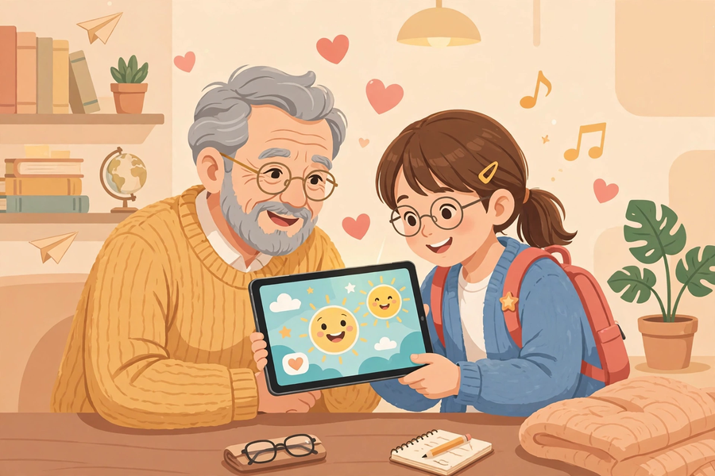
五、分組活動：正能量作品企劃表
5. Group Task: Positivity Work Plan
- 小組分工（4–5 人共用一部裝置，輪流操作）：企劃負責構思訊息與受眾；提示詞撰寫員撰寫及輸入提示詞；字幕／旁白員撰寫文稿及錄音；匯報員展示作品。
Group roles (4–5 students share one device, taking turns): planner designs the message and audience; prompt writer drafts and enters prompts; subtitle/narration member writes the script and records; presenter shows the work.
- 所用生成工具由老師課前選定並在課堂示範，同學不需自行上網搜尋工具。
The generation tools are pre-selected by the teacher and demonstrated in class; students do not need to search for tools online.
- 作品要求：約 30 秒短片或一首歌曲；有清晰具體的正能量訊息；加上字幕或旁白；註明「本作品含有 AI 生成內容」。
Work requirements: a video of about 30 seconds or a song; a clear, concrete positivity message; subtitles or narration; and the label "This work contains AI-generated content".
企劃表（每組填寫一份）
項目 Item | 內容 Content
關愛對象 Audience
想傳達的訊息（一句話）Message (one sentence)
形式 Format（30 秒短片／歌曲）
提示詞草稿 Prompt draft
字幕／旁白文稿 Subtitle / narration script
AI 負責的部分 Parts done by AI
人手創作的部分 Human-made parts
AI 生成標示 AI-generation label | 本作品含有 AI 生成內容

自評欄 Self-evaluation
Q1. 我們的訊息是否清晰具體？
Is our message clear and concrete?
Q2. 關愛對象看得明白嗎？有甚麼可以改善？
Can the audience understand it? What could be improved?
六、總結
6. Summary
- 生成式 AI 由文字提示產生全新影音內容；提示詞的具體程度決定結果質素。
Generative AI produces brand-new audio-visual content from text prompts; prompt specificity determines output quality.
- 為關愛對象設計：大字、慢速、親切、訊息簡單直接。
Design for the people you care about: large text, slow pace, warm language, simple direct message.
- 誠信要求：必須標示 AI 生成內容，不可冒充全人手創作。
Integrity: AI-generated content must be labelled; never pass it off as fully human-made.
- 科技的價值在於把關懷送到有需要的人手上。
The value of technology lies in delivering care to people in need.
七、小測驗
7. Quiz
Q1. 以下哪兩項是本堂所學的多媒體生成式 AI 應用？
Which two are the multimedia generative AI applications learnt in this lesson?
A. 影片生成、音樂生成
Video generation, music generation
B. 試算表、文書處理
Spreadsheets, word processing
C. 掃描器、打印機
Scanners, printers
D. 防毒軟件、防火牆
Antivirus software, firewalls
Q2. 關於提示詞，以下哪個說法正確？
About prompts, which statement is correct?
A. 提示詞愈長，結果一定愈好
The longer the prompt, the better the result must be
B. 關鍵在具體而非冗長，要提供關鍵資訊
Specificity, not length, is the key: give the essential information
C. 提示詞只可以寫一個字
A prompt can only be one word
D. 提示詞對結果沒有影響
Prompts have no effect on results
Q3. 為獨居長者製作短片，以下哪個做法最合適？
When making a video for elderly people living alone, which is most appropriate?
A. 用細字字幕、快速旁白，顯得專業
Small subtitles and fast narration to look professional
B. 大字字幕、慢速旁白、親切用語
Large subtitles, slow narration, warm language
C. 全片只用英文，顯得高級
Use only English throughout to look premium
D. 訊息愈多愈好，一次講十個道理
The more messages the better — pack in ten morals at once
Q4. 作品使用了 AI 生成的背景音樂，正確的做法是？
Your work uses AI-generated background music. The correct practice is?
A. 不用標示，當作自己作曲
No need to label it; claim it as your own composition
B. 註明「本作品含有 AI 生成內容」
Label it "This work contains AI-generated content"
C. 把音樂刪掉
Delete the music
D. 只告訴老師，不告訴觀眾
Tell only the teacher, not the audience
Q5. 生成式 AI 的輸出是甚麼？
What is the output of generative AI?
A. 從網上複製貼上的現成內容
Ready-made content copied from the internet
B. 根據學到的規律新生成的內容
Newly generated content based on learnt patterns
C. 隨機亂碼
Random gibberish
D. 只能輸出文字
It can only output text
Q1. 把以下弱提示詞改寫為具體的提示詞，並說明你加了哪些關鍵資訊：「整首開心歌。」
Rewrite this weak prompt into a specific one, and state what key information you added: "Make a happy song."
Q2. 你的小組想為住院兒童製作打氣短片。寫出一句正能量訊息，並說明字幕和旁白應如何配合這群觀眾。
Your group wants to make an encouraging video for hospitalised children. Write one positivity message, and explain how subtitles and narration should suit this audience.

