聖公會呂明才中學
S.K.H. Lui Ming Choi Secondary School
S2 單元四：AI 進階與倫理深化｜學生筆記
S2 Unit 4: Advanced AI and Deepening of AI Ethics | Student Notes
第 17 堂｜Prompt 進階：角色扮演＋多輪對話，生成「社區關愛計劃書」初稿
Lesson 17 | Advanced Prompting: Role-Play and Multi-Turn Dialogue for a "Community Care Plan" Draft
姓名 Name：＿＿＿＿ 班別 Class：＿＿＿＿ 學號 No.：＿＿＿＿ 日期 Date：＿＿＿＿
本堂物資表 Materials List
以下為本堂分組活動所需物資（每組一份）。請在老師派發時核對。
品名 Item | 數量（每組） Quantity (per group) | 安全注意 Safety notes
可上網手提電腦或平板電腦 | 每組 1 部，全班約 6–8 部 | 只使用老師指定的 AI 對話工具；不輸入個人私隱資料；裝置由老師統一保管及收回。
工作紙「進階提示詞實戰紀錄」 | 每人 1 張 | 不適用
「對話起點卡」 | 每組 1 張（老師預先印製，可重用） | 不適用

一、課程內容理論
1. Course Content
- 1. 三種進階提示詞策略。第一，角色扮演：指定 AI 扮演某個身份（例如社區中心社工），AI 的回答會更貼合該身份的處境和用語。第二，多輪對話：分多輪追問、修正與收窄範圍，而不是一次問完就收貨。第三，設定限制條件：訂明對象、預算、人數、時間，令計劃更具體可行。
Three advanced prompting strategies. First, role-play: assign the AI an identity (e.g. a community centre social worker) so its answers fit that role's situation and language. Second, multi-turn dialogue: ask follow-up questions, revise and narrow the scope over several turns instead of settling for one answer. Third, setting constraints: spell out the audience, budget, headcount and time so the plan is concrete and feasible.
- 2. 角色扮演為甚麼有效？當 AI 被指定身份後，它會調用與該身份相關的知識和表達方式。例如「扮演社工」會令 AI 更關注長者的實際需要，而不是給出空泛的活動建議。
Why does role-play work? Once given an identity, the AI draws on knowledge and expressions linked to that role. For example, "acting as a social worker" makes the AI focus on elderly people's real needs instead of offering vague activity ideas.
- 3. 多輪對話的三個動作：追問（問得更深）、修正（指出不對的地方請 AI 重寫）、收窄範圍（由大方向逐步落到細節）。示例追問句式：「如果預算減半，活動可以怎樣調整？」「這個時間長者方便出席嗎？」
Three moves in multi-turn dialogue: follow up (go deeper), revise (point out what is wrong and ask the AI to rewrite), and narrow the scope (move from the big picture to details). Example follow-ups: "If the budget were halved, how could the activity be adjusted?" "Is this timing convenient for elderly participants?"
- 4. 限制條件令計劃落地。沒有預算、人數和時間限制的計劃書，多數流於空想。把限制寫進提示詞，AI 才會給出在現實中做得到的建議。
Constraints make plans realistic. A plan without budget, headcount or time limits usually stays wishful thinking. Writing the constraints into the prompt is what gets the AI to suggest things that can actually be done.
- 5. 最重要的觀念：AI 初稿必須經過人工審核與修改。AI 有時會「一本正經地出錯」——用流暢自信的語氣寫出錯誤或不合理的內容（這種現象稱為「幻覺」）。所以計劃書的每一部分，人都要檢查、改寫、刪減，並能說出修改了甚麼、為甚麼修改。
The most important principle: AI drafts must always be reviewed and revised by humans. AI sometimes "produces errors with a straight face" — writing wrong or unreasonable content in a fluent, confident tone (this is called "hallucination"). So every part of the plan must be checked, rewritten and trimmed by a human, who can say what was changed and why.
- 6. 抄襲與誠信的界線。直接複製 AI 全文當作自己作品，是不誠實的。正確做法：把 AI 當作「草稿助手」，最後的定稿必須經過你的思考和改寫。
The line between assistance and plagiarism. Copying the AI's full text as your own work is dishonest. The correct approach: treat AI as a "drafting assistant" — the final version must go through your own thinking and rewriting.

二、例子
2. Examples
- 對話起點卡示例。「請你扮演社區中心社工，為 70 歲以上獨居長者設計一個半日關愛活動，預算 500 元，參加人數約 20 人。」這句起點同時用了三種策略：角色扮演（社工）、多輪對話的起點、限制條件（對象、預算、人數、時間）。
Sample dialogue starter card. "Please act as a community centre social worker and design a half-day care activity for elderly people aged 70 or above who live alone, with a budget of $500 for about 20 participants." This starter uses all three strategies: role-play (social worker), the start of a multi-turn dialogue, and constraints (audience, budget, headcount, time).
- 多輪對話示例。第一輪：用起點卡取得活動大綱。第二輪追問：「預算只有 500 元，茶點和物資怎樣分配？請列出預算表。」第三輪修正：「下午 2 時至 5 時對長者會不會太長？請加入休息時間並重寫時間表。」
Sample multi-turn dialogue. Round 1: use the starter card to get an activity outline. Round 2 follow-up: "With only $500, how should refreshments and materials be split? Please list a budget breakdown." Round 3 revision: "Is 2 pm to 5 pm too long for elderly participants? Add break times and rewrite the schedule."
- 計劃書初稿架構示例。目標：讓獨居長者感受社區關懷。對象：70 歲以上獨居長者 20 人。活動內容：健康操、茶聚分享、義工探訪配對。時間表：下午 2 時至 5 時，設休息時間。
Sample first-draft structure. Objectives: help elderly people living alone feel community care. Target participants: 20 elderly people aged 70+ living alone. Activities: health exercises, tea gathering and sharing, volunteer visit pairing. Schedule: 2 pm to 5 pm with breaks.
三、簡單問答題
3. Quick Questions
Q1. 準確列出三種進階提示詞策略。
Accurately list the three advanced prompting strategies.
Q2. 「角色扮演」策略為甚麼能令 AI 的輸出更貼合情境？
Why does the "role-play" strategy make AI output fit the context better?
Q3. 多輪對話中的三個動作是甚麼？
What are the three moves in multi-turn dialogue?
Q4. 為甚麼 AI 生成的初稿必須經過人工審核？「一本正經地出錯」是甚麼意思？
Why must AI drafts be reviewed by humans? What does "producing errors with a straight face" mean?
四、思考題
4. Thinking Questions
Q1. 以下兩個提示詞，哪一個較好？為甚麼？A：「搞個長者活動。」B：「請你扮演社區中心社工，為 70 歲以上獨居長者設計一個半日關愛活動，預算 500 元，參加人數約 20 人。」
Which of these two prompts is better? Why? A: "Organise an elderly activity." B: "Please act as a community centre social worker and design a half-day care activity for elderly people aged 70 or above who live alone, with a budget of $500 for about 20 participants."
Q2. AI 在計劃書初稿中建議「早上 6 時集合，步行 5 公里」。作為審核的人，你會如何修正？這例子說明了 AI 的甚麼局限？
The AI's draft suggests "assemble at 6 am for a 5 km walk". As the human reviewer, how would you revise this? What limitation of AI does this example show?
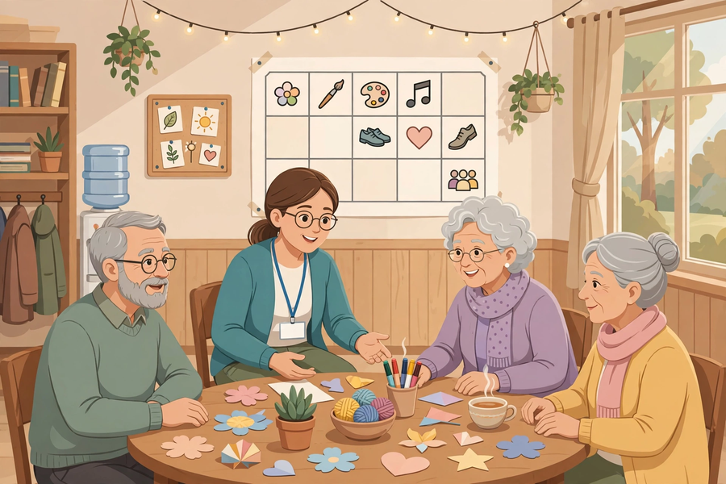
五、分組活動：進階提示詞實戰紀錄
5. Group Task: Advanced Prompting Practice Record
- 小組分工（4–5 人共用一部裝置，輪流操作）：提問員負責輸入問題；紀錄員記錄每輪對話摘要；審核員負責找出不合理之處；匯報員整理計劃書初稿。
Group roles (4–5 students share one device, taking turns): questioner enters the questions; recorder logs each round's summary; reviewer spots unreasonable points; presenter compiles the first draft.
- 要求：對話達三輪或以上，並運用至少兩種進階策略；最後整理出包含目標、對象、活動內容、時間表的計劃書初稿。
Requirements: at least three rounds of dialogue using at least two advanced strategies; finish with a first draft covering objectives, target participants, activity details and a schedule.
使用的策略（剔選） Strategies used (tick)
策略 Strategy | 有否使用 Used?
角色扮演 Role-play | ☐
多輪對話 Multi-turn dialogue | ☐
設定限制條件 Setting constraints | ☐

三輪對話紀錄 Dialogue log
輪次 Round | 我們的問題 Our question | AI 回應摘要 AI response summary
第一輪 Round 1
第二輪 Round 2
第三輪 Round 3

計劃書初稿四部分 First draft (four parts)
部分 Part | 內容 Content
目標 Objectives
對象 Target participants
活動內容 Activities
時間表 Schedule

互評檢查表 Peer-review checklist
Q1. 四部分是否齊全？
Are all four parts present?
Q2. 有沒有不合理之處？請寫出一項。
Anything unreasonable? Write down one.
Q3. 一項具體修改建議：
One concrete revision suggestion:
六、總結
6. Summary
- 三種進階策略：角色扮演、多輪對話（追問／修正／收窄）、設定限制條件。
Three advanced strategies: role-play, multi-turn dialogue (follow up / revise / narrow), setting constraints.
- 起點具體，後續追問才有方向；限制具體，計劃才做得到。
A concrete starting point gives follow-ups direction; concrete constraints make plans doable.
- AI 會一本正經地出錯：初稿必須人工審核、改寫，並說得出改了甚麼。
AI produces errors with a straight face: drafts must be human-reviewed and rewritten, with changes explained.
- AI 是草稿助手，不是代筆：直接複製全文當作自己作品是不誠實的。
AI is a drafting assistant, not a ghostwriter: copying its full text as your own is dishonest.
七、小測驗
7. Quiz
Q1. 以下哪一項不是本堂所學的進階提示詞策略？
Which of the following is NOT an advanced prompting strategy learnt in this lesson?
A. 角色扮演
Role-play
B. 多輪對話
Multi-turn dialogue
C. 設定限制條件
Setting constraints
D. 把問題寫得愈短愈好
Making the question as short as possible
Q2. 「請你扮演社區中心社工……」這句提示詞主要運用了哪種策略？
The prompt "Please act as a community centre social worker…" mainly uses which strategy?
A. 角色扮演
Role-play
B. 隨機抽獎
Random draw
C. 語音輸入
Voice input
D. 複製貼上
Copy and paste
Q3. 多輪對話中，「這個時間長者方便出席嗎？」屬於哪個動作？
In multi-turn dialogue, "Is this timing convenient for elderly participants?" is which move?
A. 追問
Follow-up
B. 關機
Shutting down
C. 刪除對話
Deleting the dialogue
D. 更換主題
Changing the topic
Q4. 為甚麼要在提示詞中寫明預算和人數？
Why state the budget and headcount in the prompt?
A. 令 AI 回答得更慢
To make the AI answer more slowly
B. 限制條件令計劃更具體可行
Constraints make the plan concrete and feasible
C. 純粹為了增加字數
Just to add more words
D. 沒有特別原因
No particular reason
Q5. 關於 AI 初稿，以下哪個做法正確？
About AI drafts, which practice is correct?
A. 直接複製全文當作自己作品
Copy the full text as your own work
B. 審核、改寫、刪減，並說得出修改了甚麼
Review, rewrite and trim it, and explain what was changed
C. AI 寫的一定正確，不用檢查
The AI is always right; no need to check
D. 把初稿刪掉，全部自己重寫但說是 AI 寫的
Delete the draft, rewrite everything yourself but claim the AI wrote it
Q1. 為「為社區兒童設計暑期閱讀活動」寫一張對話起點卡，要求同時運用角色扮演和設定限制條件（至少列明對象、人數、預算三項）。
Write a dialogue starter card for "designing a summer reading activity for children in the community", using both role-play and constraints (state at least the audience, headcount and budget).
Q2. 解釋「AI 會一本正經地出錯」是甚麼意思，並說明為甚麼這令人工審核變得必要。
Explain what "AI produces errors with a straight face" means, and why this makes human review necessary.

