聖公會呂明才中學
S.K.H. Lui Ming Choi Secondary School
S2 單元四：AI 進階與倫理深化｜家課
S2 Unit 4: Advanced AI and Deepening of AI Ethics | Homework
第 18 堂｜AI 倫理個案研討：deepfake 騙案與 AI 招聘偏見
Lesson 18 | AI Ethics Case Study: Deepfake Fraud and AI Hiring Bias
姓名 Name：＿＿＿＿ 班別 Class：＿＿＿＿ 學號 No.：＿＿＿＿ 日期 Date：＿＿＿＿

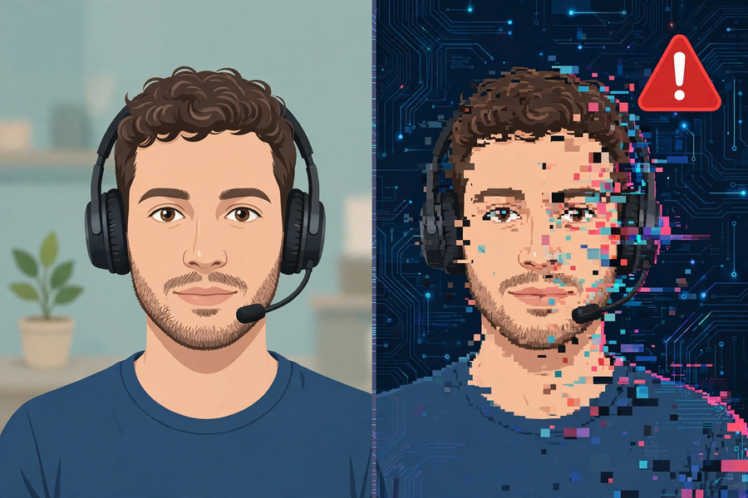
第一部分：選擇題
Part 1: Multiple Choice
Q1. 以下哪項是「演算法偏見」的正確理解？
Which is the correct understanding of "algorithmic bias"?
A. AI 故意歧視某些人
AI deliberately discriminates against certain people
B. 有偏差的訓練資料令 AI 複製甚至放大了人類社會原有的偏見
Biased training data causes AI to copy or even amplify existing human prejudice
C. 演算法寫錯了數學公式
The algorithm has a wrong maths formula
D. 偏見只存在於人類社會，與 AI 無關
Bias exists only in human society and has nothing to do with AI
Q2. 在辯論中提出立場時，最重要的要求是？
When stating a position in a debate, the most important requirement is?
A. 聲量夠大
Speaking loudly enough
B. 有理據支持，而非純粹表態
Being supported by reasoning, not merely stating an opinion
C. 跟大多數人立場一致
Agreeing with most people
D. 愈快講完愈好
Finishing as fast as possible
第二部分：問答題
Part 2: Short Questions
Q1. 【資料搜集，約 100 字】搜集一個近期與 AI 倫理相關的新聞例子（報章或網上新聞均可，註明出處及日期），以約 100 字說明事件經過及你的看法，並試用「道德判斷三問」作一句分析。
[Research, about 100 words] Find one recent news example related to AI ethics (newspaper or online news; cite the source and date). In about 100 words describe what happened and give your view, and apply the "three questions of moral judgement" in one sentence of analysis.
Q2. 承上題：你認為該事件的責任主要在哪一層（技術／設計者／使用者）？為甚麼？
Following on: which layer (technology / designers / users) bears the main responsibility in that incident? Why?

