聖公會呂明才中學
S.K.H. Lui Ming Choi Secondary School
S2 單元四：AI 進階與倫理深化｜學生筆記
S2 Unit 4: Advanced AI and Deepening of AI Ethics | Student Notes
第 18 堂｜AI 倫理個案研討：deepfake 騙案與 AI 招聘偏見
Lesson 18 | AI Ethics Case Study: Deepfake Fraud and AI Hiring Bias
姓名 Name：＿＿＿＿ 班別 Class：＿＿＿＿ 學號 No.：＿＿＿＿ 日期 Date：＿＿＿＿
本堂物資表 Materials List
以下為本堂分組活動所需物資（每組一份）。請在老師派發時核對。
品名 Item | 數量（每組） Quantity (per group) | 安全注意 Safety notes
個案資料及工作紙 | 每人 1 份 | 個案內容涉及騙案，提醒學生只作課堂討論，不模仿。
白板／投影（展示辯論規則及計時） | 課室現有 | 不適用
計時器（老師手機） | 1 部 | 課堂期間只作計時用途。

一、課程內容理論
1. Course Content
- 1. 甚麼是 deepfake？Deepfake（深偽技術）是人工智能生成的合成媒體：模型先從大量樣本中學習某人的容貌和聲音特徵，再生成全新的影像或聲音。它可以用於正當創作（例如電影特效），但也可被濫用於詐騙和造假。
What is deepfake? Deepfake is AI-generated synthetic media: a model first learns a person's facial and voice features from many samples, then generates brand-new images or audio. It can be used legitimately (e.g. film effects) but can also be abused for fraud and fabrication.
- 2. 個案一：deepfake 視像會議騙案（根據 2024 年香港真實新聞改編，細節已簡化作課堂討論用）。2024 年初，香港一間跨國企業的財務部職員收到偽冒英國總部財務總監的電郵，被邀請參加視像會議。會議中出現的財務總監及多名同事，全部是 AI 深偽偽造的假影像。職員按指示分 15 次轉帳，合共 2 億港元，至 5 個本地戶口；一星期後向總部查證，才發現受騙。警方指出，騙徒利用公開影片及 AI 偽造聲音，以假亂真。
Case 1: deepfake video-conference fraud (adapted from real Hong Kong news in 2024; details simplified for class discussion). In early 2024, a finance employee of a multinational company in Hong Kong received an email impersonating the UK chief financial officer and was invited to a video conference. The CFO and colleagues on the call were all AI deepfake fabrications. Following instructions, the employee made 15 transfers totalling HK$200 million to five local accounts; only a week later, checking with head office, was the fraud discovered. Police said the scammers used publicly available footage plus AI-generated voices to make the fakes convincing.
- 3. 演算法偏見的成因。AI 從人類資料中學習；如果資料本身反映現實中的不平等，AI 不但會複製這些偏見，更可能把它們放大。這不是 AI「有心歧視」，而是它忠實地學會了資料中的規律——包括不公平的規律。
Causes of algorithmic bias. AI learns from human data; if the data reflects real-world inequality, AI will not only copy the bias but may amplify it. This is not AI "deliberately discriminating" — it faithfully learnt the patterns in the data, including the unfair ones.
- 4. 個案二：AI 招聘系統的性別偏見（根據 2018 年路透社報導改編）。某大型科技公司自 2014 年起開發 AI 招聘系統，用公司過去十年收到的履歷來訓練，自動為求職者評一至五星。2015 年公司發現：系統對女性求職者出現系統性偏低評分。原因是訓練用的履歷大多來自男性，系統於是學會了「男性較優勝」的規律，甚至把含有「女子」字眼（如女子西洋棋學會）的履歷扣分。公司最終放棄了這個系統。
Case 2: gender bias in an AI recruitment system (adapted from a 2018 Reuters report). A large technology company developed an AI hiring system from 2014, training it on resumes received over the previous ten years to score applicants from one to five stars. In 2015 the company found the system systematically scored female applicants lower. The cause: most training resumes came from men, so the system learnt the pattern that "men are preferable" — even penalising resumes containing the word "women's" (e.g. women's chess club). The company eventually scrapped the system.
- 5. 道德判斷三問。分析 AI 倫理個案的框架：第一，誰受影響？第二，是否公平？為甚麼？第三，誰應負責？為甚麼？三問缺一不可：只說「不公平」而不說原因，不算完成分析。
The three questions of moral judgement. A framework for analysing AI ethics cases: (1) Who is affected? (2) Is it fair? Why? (3) Who should be held responsible? Why? All three are needed — writing only "unfair" without reasons does not count as analysis.
- 6. 三層責任：技術、設計者、使用者。「技術無罪」不等於「無人需要負責」。個案一的責任在騙徒（使用者作惡）；個案二的責任在採用未經偏見檢測系統的企業及設計者。
Three layers of responsibility: the technology, its designers, and its users. "Technology is blameless" does not mean "no one is responsible". In Case 1, responsibility lies with the fraudsters (users committing wrongdoing); in Case 2, with the company that deployed a system never tested for bias, and with its designers.
- 7. 批判性思考：不盲從「AI 說的」。AI 的輸出可能出錯、可能有偏見。對 AI 輸出保持合理懷疑，重要決定要有人類把關，這是本單元由第 15 堂起一再強調的觀念。
Critical thinking: do not blindly follow "what the AI says". AI output can be wrong and can be biased. Keep reasonable scepticism towards AI output, and keep humans in charge of important decisions — a point stressed throughout this unit since Lesson 15.
注意：本堂個案一律以文字描述呈現，不提供任何連結。
Note: all cases in this lesson are presented as written descriptions; no links are provided.
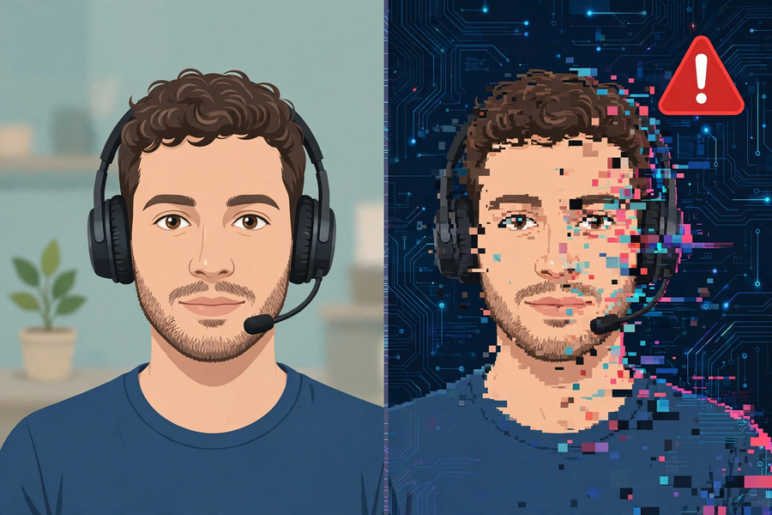
二、例子：兩個個案的文字資料
2. Examples: Written Accounts of the Two Cases
個案一：deepfake 視像會議騙案（根據 2024 年香港真實新聞改編）
Case 1: Deepfake video-conference fraud (adapted from real Hong Kong news, 2024)
- 事發：2024 年初，香港。
When and where: early 2024, Hong Kong.
- 經過：跨國企業財務部職員收到偽冒英國總部財務總監的電郵，被邀請參加視像會議；會議中出現的財務總監及多名同事，全屬 AI 深偽偽造。
What happened: a finance employee received an email impersonating the UK CFO and joined a video conference; the CFO and colleagues on the call were all AI deepfake fabrications.
- 損失：職員按指示分 15 次轉帳，合共 2 億港元，至 5 個本地戶口。
Loss: following instructions, the employee made 15 transfers totalling HK$200 million to five local accounts.
- 識破：一星期後向總部查證，才發現整場會議純屬假造。
Exposed: only a week later, when checking with head office, was the whole meeting found to be fake.
- 手法：騙徒利用公開影片及 AI 偽造聲音，以假亂真。
Method: scammers used publicly available footage plus AI-generated voices to make the fakes convincing.
個案二：AI 招聘系統的性別偏見（根據 2018 年路透社報導改編）
Case 2: Gender bias in an AI recruitment system (adapted from a 2018 Reuters report)
- 系統：某大型科技公司自 2014 年起開發的 AI 招聘系統，用過去十年收到的履歷訓練，自動為求職者評一至五星。
The system: an AI hiring system developed from 2014 by a large technology company, trained on resumes received over ten years, scoring applicants one to five stars.
- 發現：2015 年公司發現系統對女性求職者出現系統性偏低評分。
Discovery: in 2015 the company found the system systematically scored female applicants lower.
- 成因：訓練用的履歷大多來自男性，系統學會了「男性較優勝」的規律；含有「女子」字眼（如女子西洋棋學會）的履歷會被扣分。
Cause: most training resumes came from men, so the system learnt that "men are preferable"; resumes containing the word "women's" (e.g. women's chess club) were penalised.
- 結果：公司最終放棄了這個系統。
Outcome: the company eventually scrapped the system.
三、簡單問答題
3. Quick Questions
Q1. 用兩句話複述個案一的事實重點。
Recount the key facts of Case 1 in two sentences.
Q2. 用兩句話複述個案二的事實重點。
Recount the key facts of Case 2 in two sentences.
Q3. 寫出「道德判斷三問」。
Write down the "three questions of moral judgement".
Q4. 個案二的偏見是怎樣產生的？
How did the bias in Case 2 arise?
四、思考題
4. Thinking Questions
Q1. 有人說：「AI 沒有感情，所以做決定最公平。」請用個案二反駁這個說法。
Someone says: "AI has no feelings, so its decisions are the fairest." Refute this using Case 2.
Q2. 辯題：AI 技術本身是中立的嗎？請先寫下你的初步立場及一個理由，留待辯論時發表。
Debate motion: Is AI technology itself neutral? Write down your preliminary stance and one reason, to be presented in the debate.
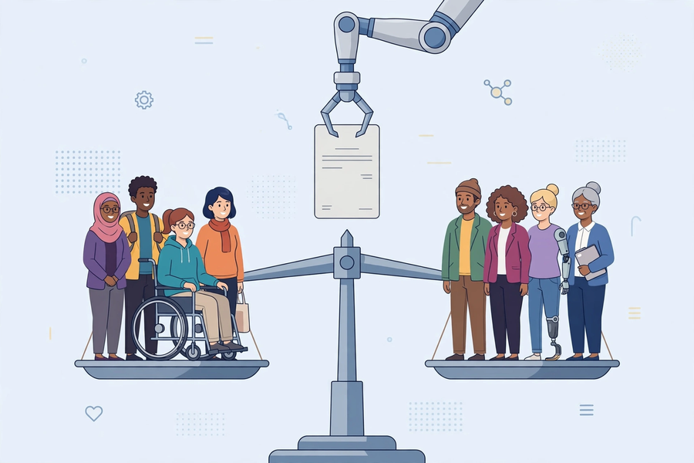
五、分組活動：道德判斷三問分析表
5. Group Task: Three Questions of Moral Judgement
- 小組研讀兩個個案的文字資料，以「道德判斷三問」為框架完成下表。
Groups study the written materials of both cases and complete the table below using the "three questions of moral judgement" framework.
- 然後進行小組辯論，辯題為「AI 技術本身是中立的嗎？」。每組需提出至少一個有理據支持的立場，而非純粹表態。
Then hold a group debate on the motion "Is AI technology itself neutral?". Each group must put forward at least one evidence-backed position, not merely state an opinion.
- 本堂個案一律以文字描述呈現，不提供任何連結；辯論前先訂立規則，保持理性氣氛。
All cases in this lesson are presented as written descriptions with no links; set debate rules beforehand to keep the discussion rational.
個案一分析表
三問 Three questions | 我們的分析 Our analysis
誰受影響？Who is affected?
是否公平？為甚麼？Is it fair? Why?
誰應負責？為甚麼？Who should be responsible? Why?

個案二分析表
三問 Three questions | 我們的分析 Our analysis
誰受影響？Who is affected?
是否公平？為甚麼？Is it fair? Why?
誰應負責？為甚麼？Who should be responsible? Why?

辯論準備：AI 技術本身是中立的嗎？
我方立場 Our stance（中立／不中立） | 理由一 Reason 1 | 引用的個案事實 Supporting case facts

個人立場題
Q1. 我認為 AI 技術是否中立？我的原因：＿＿＿＿＿＿＿＿＿＿＿＿＿＿＿＿＿＿＿＿
Do I think AI technology is neutral? My reasons: ______________________________
六、總結
6. Summary
- Deepfake 可造福也可作惡；演算法偏見源於有偏差的訓練資料。
Deepfake can benefit or harm; algorithmic bias comes from biased training data.
- 道德判斷三問：誰受影響？是否公平？誰應負責？
Three questions of moral judgement: Who is affected? Is it fair? Who is responsible?
- 責任分三層：技術、設計者、使用者；「技術無罪」不等於無人負責。
Responsibility has three layers: technology, designers, users; "technology is blameless" does not mean no one is responsible.
- 不盲從「AI 說的」：對 AI 輸出保持合理懷疑。
Do not blindly follow "what the AI says": keep reasonable scepticism towards AI output.
七、小測驗
7. Quiz
Q1. Deepfake 是甚麼？
What is deepfake?
A. 人工智能生成的合成媒體
AI-generated synthetic media
B. 一種新的電腦病毒
A new computer virus
C. 深海拍攝技術
Deep-sea filming technology
D. 假冒的手機充電線
Counterfeit phone chargers
Q2. 個案二中，AI 招聘系統出現性別偏見的主要原因是？
In Case 2, the main cause of gender bias in the AI hiring system was?
A. 工程師故意寫入歧視規則
Engineers deliberately wrote discriminatory rules
B. 訓練用的履歷大多來自男性，系統學會了有偏差的規律
Most training resumes came from men, so the system learnt a biased pattern
C. 女性求職者能力較低
Female applicants were less capable
D. 電腦中毒
The computer had a virus
Q3. 「道德判斷三問」不包括以下哪一問？
Which is NOT one of the "three questions of moral judgement"?
A. 誰受影響？
Who is affected?
B. 是否公平？
Is it fair? Why?
C. 誰應負責？
Who should be responsible? Why?
D. AI 的電費多少？
How much is the AI's electricity bill?
Q4. 關於「AI 沒有感情，所以最公平」，正確的反駁是？
About "AI has no feelings, so it is the fairest", the correct rebuttal is?
A. AI 其實很有感情
AI actually has lots of feelings
B. AI 從人類資料中學習；若資料有偏見，AI 只會複製甚至放大偏見
AI learns from human data; if the data is biased, AI merely copies or even amplifies the bias
C. AI 從不犯錯
AI never makes mistakes
D. 這個說法完全正確，不用反駁
The statement is completely correct; no rebuttal needed
Q5. 個案一中，誰應負主要責任？
In Case 1, who bears the main responsibility?
A. 使用 deepfake 行騙的騙徒
The fraudsters who used deepfake to scam
B. 發明視像會議的人
The inventor of video conferencing
C. 受騙的職員
The deceived employee
D. 沒有人需要負責
No one needs to be responsible
Q1. 以個案二為例，完成「道德判斷三問」分析：誰受影響？是否公平（原因）？誰應負責（原因）？
Using Case 2, complete the "three questions" analysis: Who is affected? Is it fair (why)? Who should be responsible (why)?
Q2. 辯題「AI 技術本身是中立的嗎？」：寫出你的立場，並用個案一或個案二的事實支持你的立場。
Motion "Is AI technology itself neutral?": state your stance and support it with facts from Case 1 or Case 2.

